

We make a living by what we get; we make a life by what we give: Winston Churchill

Website here: [http://patronus1234.s3-website-us-west-2.amazonaws.com/#](http://patronus1234.s3-website-us-west-2.amazonaws.com/)

Team Members:

*Praveen Kumar:*

Tel. Ph. 480-652-4716

Email: [Pkumar88@uw.edu](mailto:Pkumar88@uw.edu)

**Problem Statement**

The annual donation among American households is approximately worth $175 billion [1] and around 55% of Americans donated to charity in 2015 [2]. Recent trends however are showing a drop in the percentage of households donating to charity [3]. Upon investigation, the reasons for this include:

1. Many cases of charity fraud where the donation money was used for personal gains (e.g. Secretary of the Cripples’ Welfare Society) increasing public mistrust.
2. Recent changes to the tax law changes, which reduces incentives for people to donate. [4]
3. The reduction in the overall savings potential among Americans due to factors like the financial crisis. [5]

We hope to reverse this trend and increase both per capita charitable and overall donation by

1. Incentivizing the American public to donate through promised stock market returns rewarding them for their donation.
2. Providing a platform for customers to evaluate the different charities across several domains.

**The Market**

Due to factors mentioned above, the average rate of decline in the number of donors is approximately 6% from 2006 to 2012. This is true across the income spectrum [2]. We believe streamlining the donations process and providing an incentive for donation will reverse this trend and subsequently, we estimate our solution to add 1.7 Million new donors (an 0.75 – 1.25% increase in number of donors) while also increasing the per capita donation amount. Please refer to our projected financials section for detailed calculations.

**Our philosophy**

We believe in:

1. The benefits of donations to charity. We think humans are charitable by nature and want to help others [6]
2. The adage that “Incentives drive human behavior [7]”. Maximizing personal returns will lead to greater charitable donations.
3. Investing in long-term assets.
4. Investing in quality assets.
5. Passive investment strategies.

**Strategy Statement**

*“Incentivize non-donor households to start donating to charities and current donors to increase donations through our state of the art software platform that provides positive gains for its investors. Our propriety software platform is safe, easy and combines philanthropy, psychology, sociology and investment fundamentals towards the betterment of society”*

**Solution/Business Model**

Our model is a win-win for all the involved players.

1. Charities: We will only include renowned charities with a proven track record to reduce the probability of fraud. We will also give the flexibility for the donor to choose the charity he/she wants to donate to through an easy-to-use interface.
2. Donors: We will require the donor to invest a minimum of 1.5% returns into charity and we will nudge him/her into donating more. Our investment strategy promises a 6-7% return through efficient diversification and asset allocation in the stock market (see Investment strategy for more details). After donating a user-allocated amount to charity and after deducting 1% fees, the rest of the returns will go back to the investor after a year.
3. Patronus: We will be collecting a fee of 1% of the returns for the work needed for efficient rebalancing of the investor’s portfolio (see Investment strategy for more details).

We will be providing these services through a software app, which will be available across platforms and browsers. We have deployed our services to the cloud (AWS), which guarantees us with a 99.99% uptime and low latency ensuring great customer experience. We decided to call our platform “Patronus” after the Harry Potter creature, which symbolizes a positive force of good, and a projection of hope, happiness and a desire for life, something we aspire to be in the world of charitable giving.

The mocked version of our app has been deployed here: [http://patronus1234.s3-website-us-west-2.amazonaws.com/#](http://patronus1234.s3-website-us-west-2.amazonaws.com/) . New features to enable live customer traffic are currently being worked on. The following flowchart shows the detailed app workflow. The following section will discuss our investment strategy promising 6-7% annual returns.

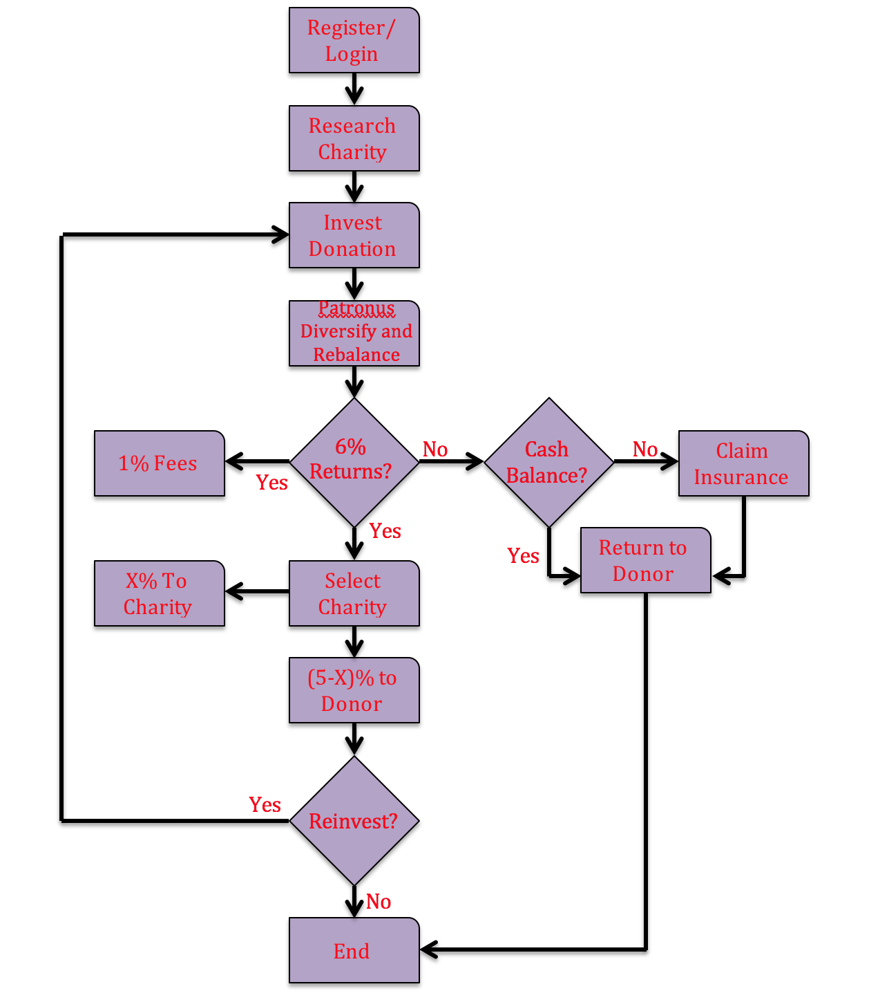

**Investment Strategy**

Based on historical returns from the US stock market, an optimally diversified portfolio is expected to generate an annual pre-tax return of 4-7% depending on the risk the customer is willing to take. Although past returns are not indicative of future returns and it is hard to accurately predict expected returns, we can be certain that returns are maximized through efficient asset allocation (diversification), security selection (minimum fees) and good execution (tax reduction strategies, daily rebalancing etc.). Consequently, our investment strategy is:

1. We will pick good investments and rebalance the portfolio daily for the customer through our state of the art algorithm.
2. We will invest for a long-term time horizon although we will give the customer the ability to redeem his returns, 1 year from his original investment.
3. We will use a quantitative approach towards asset selection. After detailed research into multiple models available for returns based on risk (like the Arbitrage pricing model, multi-factor model and other proxy models), we decided to use expected returns implied by CAPM (capital asset pricing model) due to its simplicity and efficiency over the past several years.
4. The different asset classes we will consider are a) stocks; b) bonds; and c) real assets. Within stocks we will consider both US and emerging market stocks, bonds can be treasury or corporate bonds and we will start with commodities and real estate as real assets to begin with.
5. We will use the covariance among asset classes and the expected volatility of each asset class in the portfolio to be a measure of risk in the CAPM model.

Asset picking approach:

1. We collect a pool of around 1000 assets based on this standard deviation. This is done through a daily AWS lambda job and the yahoo finance API.
2. We look for stock returns matching 6-7% in the pool based on the customer’s standard deviation.
3. We allocate these assets into the respective categories and make sure the portfolio is efficiently diversified. We then repeat this process everyday based on daily stock returns. According to CAPM, the efficient set of stocks lies on or close to the tangent to the Mean Variance Frontier shown below.

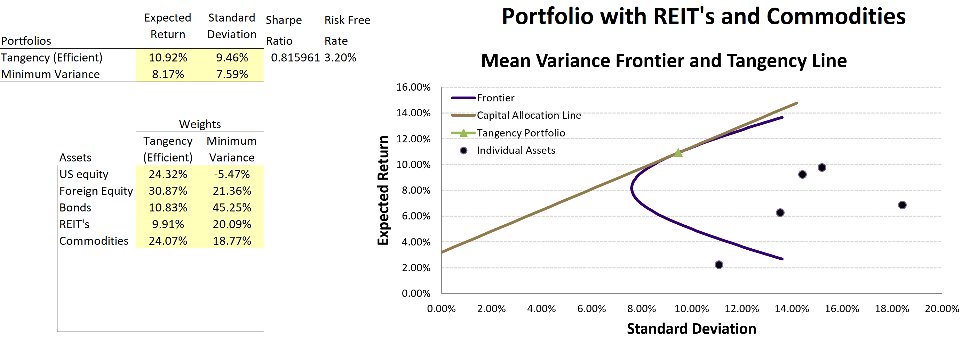

**Go-To-Market Strategy**

Porter’s 5 Forces (Supplier power, buyer power, threat of new entrant, substitutes and rival power) were analyzed to understand the competitive landscape. Our business model reduces the initial supplier power (since the platform is built and controlled in-house with the support of cloud (AWS) technologies) and we except the supplier power to stay low (since there are many server providers to choose from). The threat of new entry is also expected to be low, as we have first-mover advantage. It will also be tough for new entrants to develop and beat our propriety investment algorithm. The real substitute to our business model is either for households to invest in the financial market or to donate money through charity through exhaustive research. Our strategy alleviates these pain points thereby eliminating the threat of substitutes.

Buyer power is considered low as we are catering to households that would like to donate and earn dividend at the same time. Several financial platforms exist, but none offer a solution to social wellbeing. Our solution donates money to charity while benefiting our donors too. The threat of rivals is considered low as we have first-mover advantage. Also, our strategy and our propriety software is not easily imitable making our organization rare and high in value. Based on VRIO analysis, we consider our organization to achieve sustained competitive advantage through our business model and strategy.

Our business model is crafted to serve a niche market, which allows us to take advantage of a large unchartered customer base while serving a greater social good. The key impediment for our customers will be to believe that our financial investment tool actually works and that their donations will not be lost in the financial market. Majority of financial platforms expand customer base through word-of-mouth, we will have to rely on similar strategy. To reduce our impediment, we will have to promote our idea through a 50-50-communication mix. Social media platforms will be used to spread the benefits of our business model and our brand name. Simultaneously, we will invest in targeted online marketing through dedicated ad campaigns. We will also participate in charity galas and fundraising campaigns; having a celebrity advocate represent us at galas and fundraisers will boost our image and expand our market presence and brand awareness. 10% of our revenue (~$170k) will be dedicated for our marketing campaign; we expect this number to decline in the future and our marketing mix to change as per need.

**Projected Financials**

The number of Americans donating to charity is projected to decrease due to changes in the tax code [3] and changing standard of living of the American middle class [4]. Table below shows the breakdown in 2015 based on numbers from the IRS website [5].

|  |  |  |  |
| --- | --- | --- | --- |
| **Category of personal income (USD)** | **Number of tax returns** | **Average charitable donation** | **Total Charitable Donations (USD)** |
| 0-25k | 57,034,742 | $1,800 | $102,662,535,600 |
| 25-50K | 55,352,290 | $2,594 | $143,583,840,260 |
| 50-75K | 19,980,117 | $2,970 | $59,340,947,490 |
| 75-100K | 12,821,791 | $3,356 | $43,029,930,596 |
| 100-200K | 18,532,593 | $4,130 | $76,539,609,090 |
| 200-500K | 5,428,176 | $7,424 | $40,298,778,624 |
| 500k-1000k | 884,335 | $18,615 | $16,461,896,025 |
| 1M-2M | 275,876 | $43,944 | $12,123,094,944 |
| >2M | 163,459 | $382,953 | $62,597,114,427 |
| **Total Donors** | **170,473,379** | **Total Charity donations (USD)** | **$556,637,747,056** |

Let’s make the following assumptions:

1. 80% of the American workforce is eligible to donate. This comes to 264 Million more people eligible to donate. This shows enormous potential in our idea if we provide people with the right incentives to donate.
2. Let’s assume that the target audience of middle class Americans willing to donate increases by 1% in the long run due to incentives provided by our app. This is after taking into account the competition (discussed in the Go To market strategy section above).
3. Let’s also assume each of these customers donate a minimum of $1
4. Let’s assume customer growth rates and donation growth rates shown below. These numbers are very conservative and research shows customers are usually willing to donate much more if given the right incentives [7]

|  |  |  |  |  |  |
| --- | --- | --- | --- | --- | --- |
|  | **Year 1** | **Year 2** | **Year 3** | **Year 4** | **Year 5** |
| **Customer Growth** | 0.25% | 0.50% | 1% | 1.50% | 1.50% |
| **Contribution growth** | 5% | 6% | 7% | 10% | 12.50% |

**Macro-economic conditions and cash flow split:**

The current US corporate tax rate is taken to be 25% [9]. We are also assuming a 1.25% bank interest rate, which can be made higher based on negotiations [10]. From our business model referenced above, for a 6% market return, we are promising a minimum of 1.5% returns to charity (which can be increased), a 1% fees for rebalancing the loaner’s portfolio and the rest of the returns to the donor.

Based on all the assumptions, cash flow split and macro-economic factors please see table below for our projected cash flows showing the sustainability of our business model.

|  |  |
| --- | --- |
| **Bare minimum contribution requested from each donor** | $1 |
| **Minimum target revenue after year 1** | $1,704,734 |
|  |  |
| **Costs as % of revenue** | 15% |
| **Cash reserves as % of revenue** | 25% |

|  |  |  |  |  |  |
| --- | --- | --- | --- | --- | --- |
| **Year** | **1** | **2** | **3** | **4** | **5-10 years** |
| **Revenue** | $ 1,704,734 | $1,794,445 | $1,934,641 | $2,151,652 | $2,420,608 |
| **Costs (SG&A+Op. Exp.)** | $255,710 | $269,167 | $290,196 | $322,748 | $363,091 |
| **Cash reserve today** | **$426,183** | **$448,611** | **$483,660** | **$537,913** | **$605,152** |
| **Cash after interest** | $431,511 | $454,219 | $489,706 | $544,637 | $612,717 |
| **Amount ready for investment** | $1,022,840 | $1,076,667 | $1,160,785 | $1,290,991 | $1,452,365 |
| **% Market Returns after year 1** | 6% | 6% | 6% | 6% | 6% |
| **$ Market Returns after year 1** | $61,370 | $64,600 | $69,647 | $77,459 | $87,142 |
| **$ Returns to donor** | $  30,685 | $32,300 | $34,824 | $38,730 | $43,571 |
| **$ Returns to charity** | $   20,457 | $21,533 | $23,216 | $25,820 | $29,047 |
| **$ Returns to Patronus** | $10,228 | $10,767 | $11,608 | $12,910 | $14,524 |
| **Total cash after returns** | $390,597 | $411,152 | $443,275 | $492,997 | $554,622 |
| **Total cash after taxes** | $292,948 | $308,364 | $332,456 | $369,748 | $415,966 |
| **Cash expected @t={1,2,3,4,…}** | **$292,948** | **$308,364** | **$332,456** | **$369,748** | **$415,966** |
| **Growth rate for reinvestment** |  | 1.05 | 1.07 | 1.11 | 1.12 |

The table above shows our 10-year cash flow projection. We expect our costs (administrative, marketing costs) to be 15% of revenue and we would like to hold 25% of the revenue as cash. The revenue number was derived from the forecast that our app will nudge atleast 1% of non-donors to invest a minimum of $1.From the table above, the cash reserves at the end of years 1 and beyond continues to grow showing the sustainability of our business model. We intend to reinvest our profits back into the company to increase our customer reach, give more to charities and give back more to the investor.

Sensitivity analysis for several invested amounts versus returns for our donor, the charity and Partonus is shown in the plot below. The analysis assumes a 25% tax rate and a 6% return on investment form the financial market. 100% of the donated amount is invested in the financial market. These returns are split 3:2:1 amongst donor, charity and Patronus. From the plot it can be seen that, all parties have a positive return for all investment scenarios.

**Our Team**

Praveen Kumar: Praveen is a 2nd year MBA student at the Foster School of Business. Currently employed at Expedia Inc., Praveen is a mechanical engineer by training and a software engineer by profession. He has over 8 years of software engineering experience and would like to use his analytical and quant background to help make social change. Praveen also believes in education for children and has been the treasurer for the ASHA foundation as ASU and a volunteer for the Boys and Girls Club. When not building software or studying, Praveen likes to train for marathons and hopes to do an iron man someday.

**References**

[1] <http://nccs.urban.org/data-statistics/charitable-giving-america-some-facts-and-figures>

[2] <https://www.irs.gov/statistics/soi-tax-stats-individual-statistical-tables-by-size-of-adjusted-gross-income>

[3] <https://www.theatlantic.com/business/archive/2016/12/americans-donate-less-to-charity/511397/>   
[4] <https://www.forbes.com/sites/beltway/2018/01/11/21-million-taxpayers-will-stop-taking-charitable-deductions-under-the-new-tax-law/#592fabcb238f>

[5] <https://en.wikipedia.org/wiki/Financial_crisis_of_2007%E2%80%932008>

[6] <http://time.com/4070299/secret-to-happiness/>

[7] <https://link.springer.com/chapter/10.1007/978-3-662-03750-8_19>

[8] <https://www.fool.com/retirement/2016/11/27/the-average-americans-charitable-donations-how-do.aspx>

[9] <https://taxfoundation.org/us-corporate-income-tax-more-competitive/>

[10] <https://www.forbes.com/sites/robertberger/2017/07/02/7-of-the-best-savings-accounts-with-high-interest-rates/#5070210e7b0e>