Name: M.PRAVEENA
Reg No: 1925260238

CSA5107- CRYPTOGRAPHY AND NETWORK SECURITY
LAB EXPERIMENTS

EXPERIMENT 1
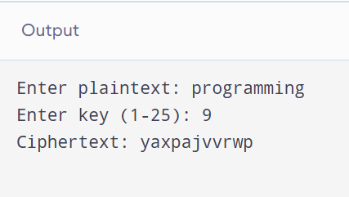

EXPERIMENT 2
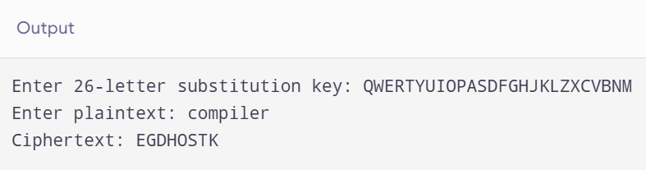

EXPERIMENT 3
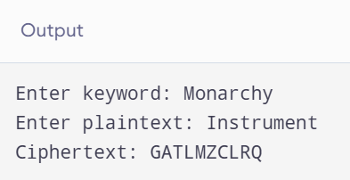

EXPERIMENT 4
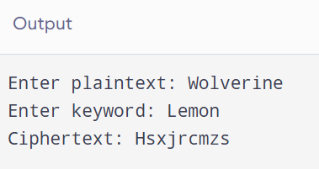
EXPERIMENT 5
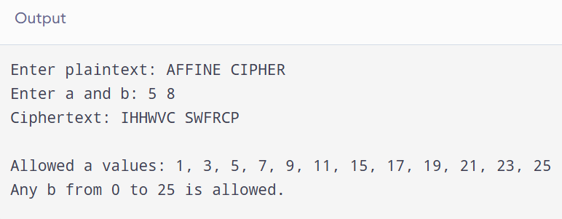

EXPERIMENT 6
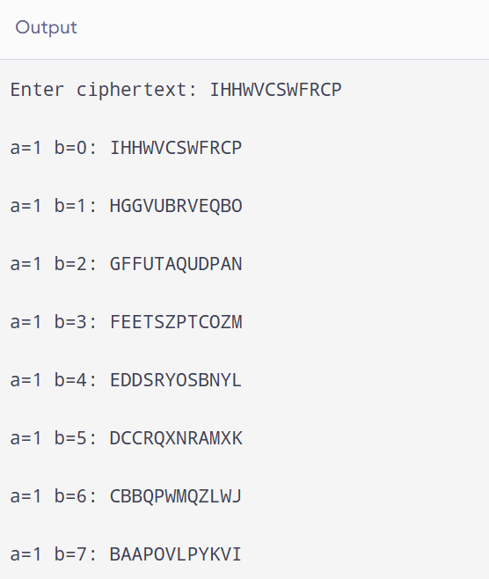

EXPERIMENT 8
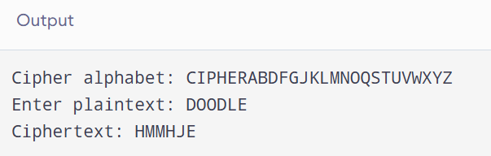

EXPERIMENT 9
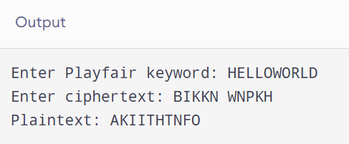

EXPERIMENT 10
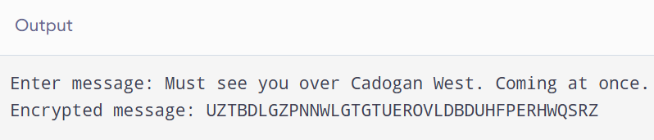

EXPERIMENT 11
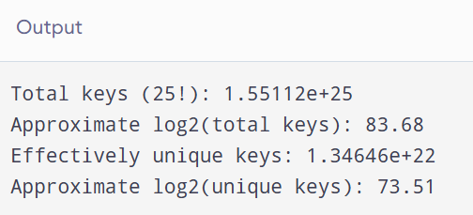

EXPERIMENT 12
a.
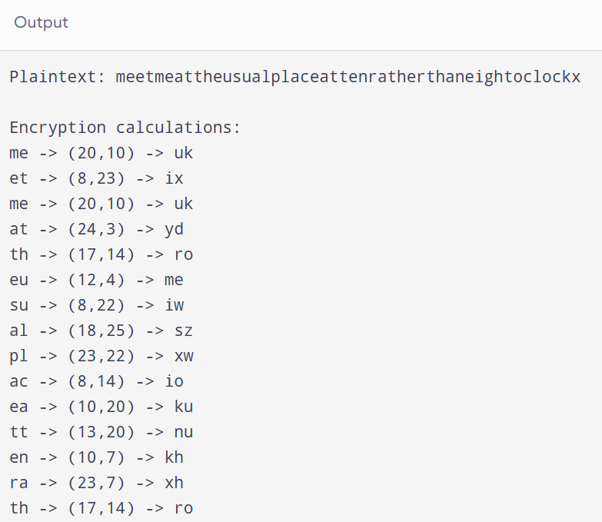

b.
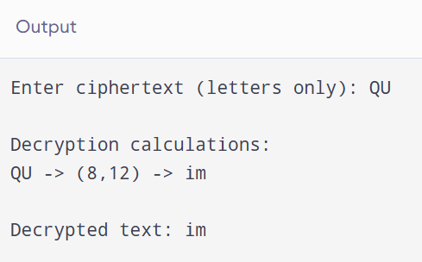

EXPERIMENT 13
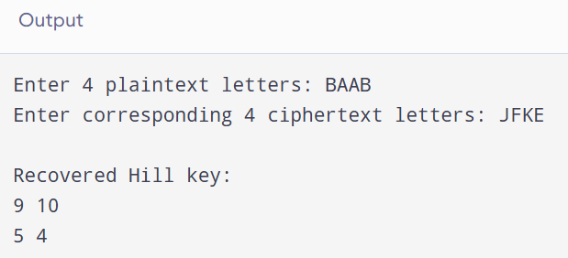

EXPERIMENT 14
a.
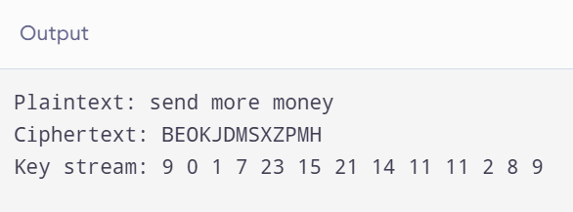

b.
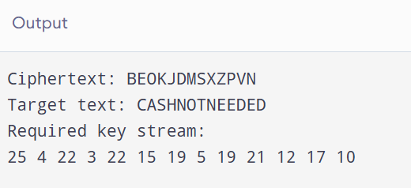

EXPERIMENT 15
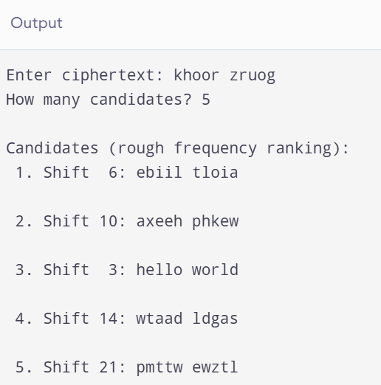

EXPERIMENT 16
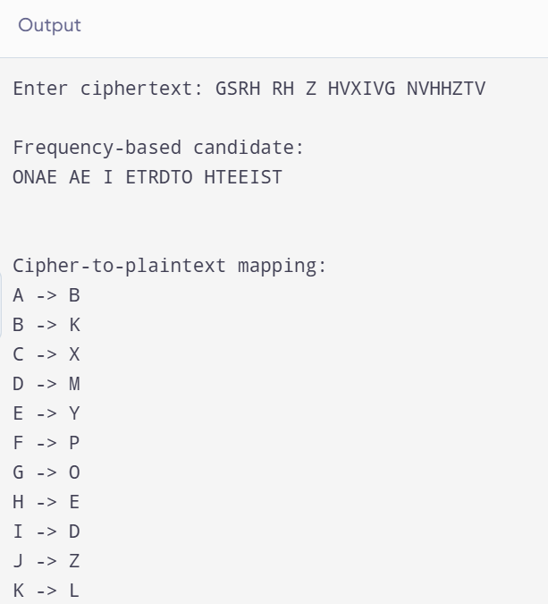
EXPERIMENT 17
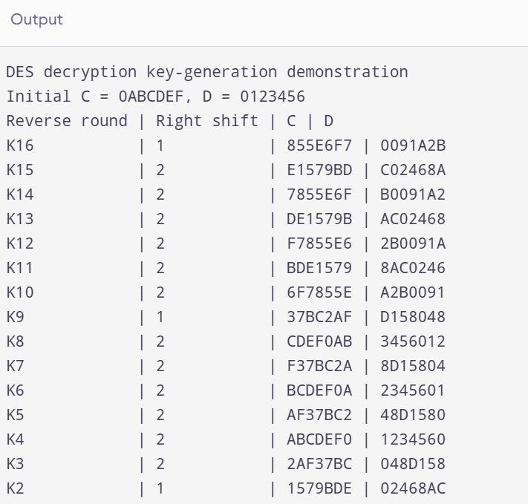

EXPERIMENT 18
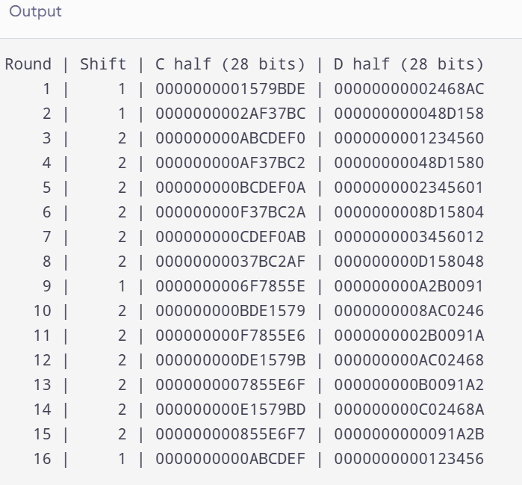

EXPERIMENT 19

EXPERIMENT 20
a.

