**INVOICE MANAGEMENT SYSTEM:**

The invoice Management System developed in JAVA SpringBoot using Intellij IDE. This Project is based on the concept of calculating the total item and generating the invoice of the customer.

**Framework: SpringBoot , Hibernate**

**start.springintializer.io** ([Spring Initializr](https://www.geeksforgeeks.org/spring-initializr/) is a web-based tool using which we can easily generate the structure of the Spring Boot project.

**Databases: Mysql**

**Dependendencies Added in SpringBoot:**

**Spring Web:** Build web, including RESTful, applications using Spring MVC. Uses Apache Tomcat as the default embedded container.

**Lombok :** Java annotation library which helps to reduce boilerplate code.

**Spring Data JPA**Persist data in SQL stores with Java Persistence API using Spring Data and Hibernate.

**MySQL Driver :** MySQL JDBC and R2DBC driver.

**Execution:**

Created a Database “**invoicemanagement_onlinetask”**

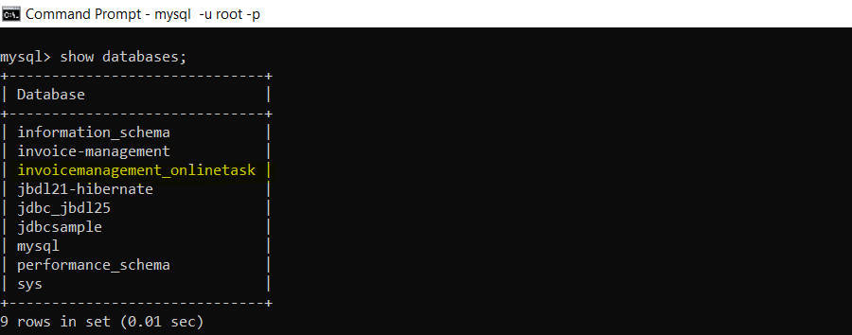

**Created 3 Tables in** “**invoicemanagement_onlinetask”**

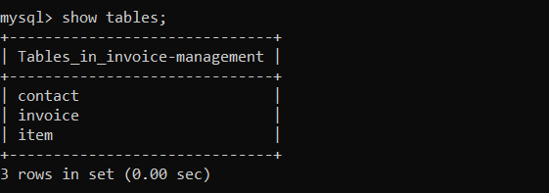

**SCENARIO 1: INVOICE WITH STATUS PAID**

**Item API:**

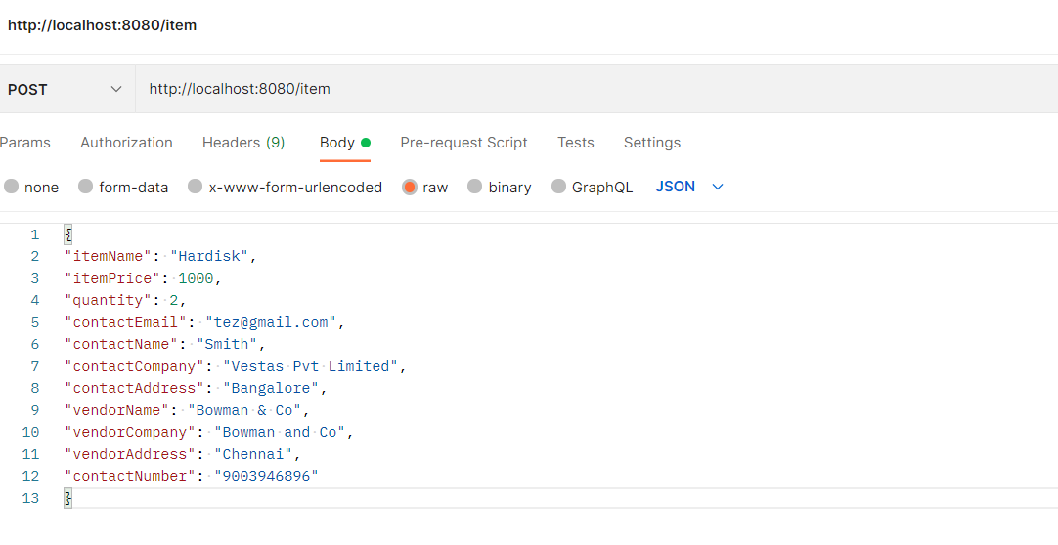

**Item and Contact Table design:**

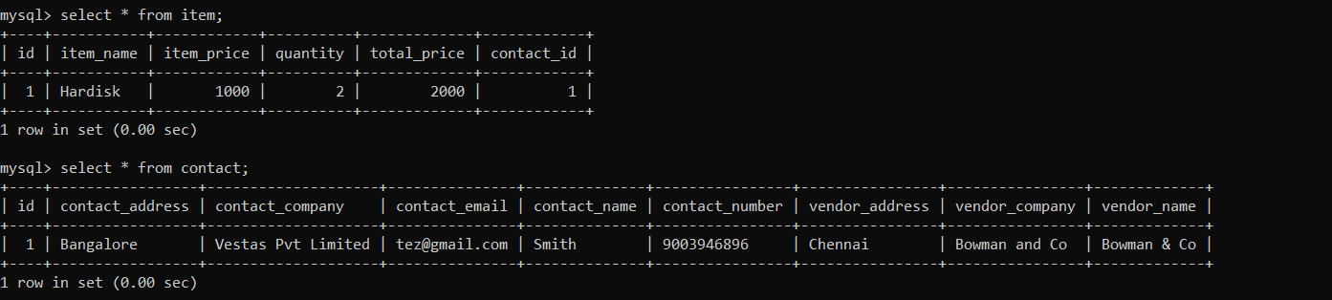

**Invoice API:**

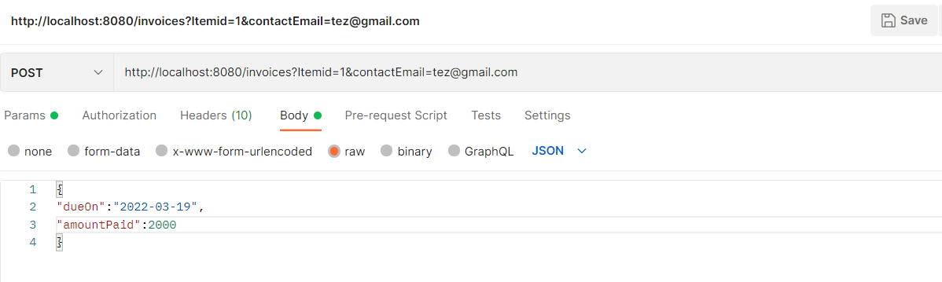

**Invoice Table Design:**

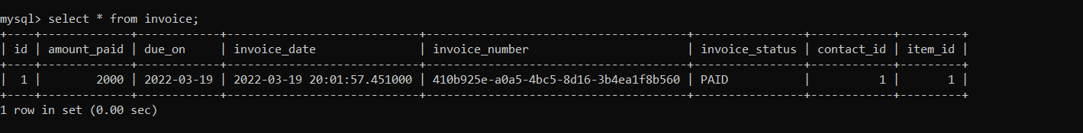

**SCENARIO 2: INVOICE WITH STATUS UNPAID**

**ITEM AND CONTACT TABLE DESIGN:**

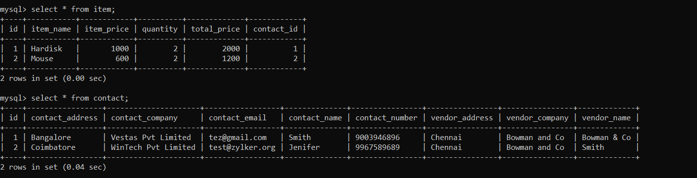

**INVOICE TABLE DESIGN:**

