DAA
DAY 2 LAB EXPERIMENTS
C.PRAVEENA
192324272

4. Write a program that takes an input list of n numbers and creates a new list containing only the unique elements from the original list. What is the space complexity of the algorithm?

Code/Output:
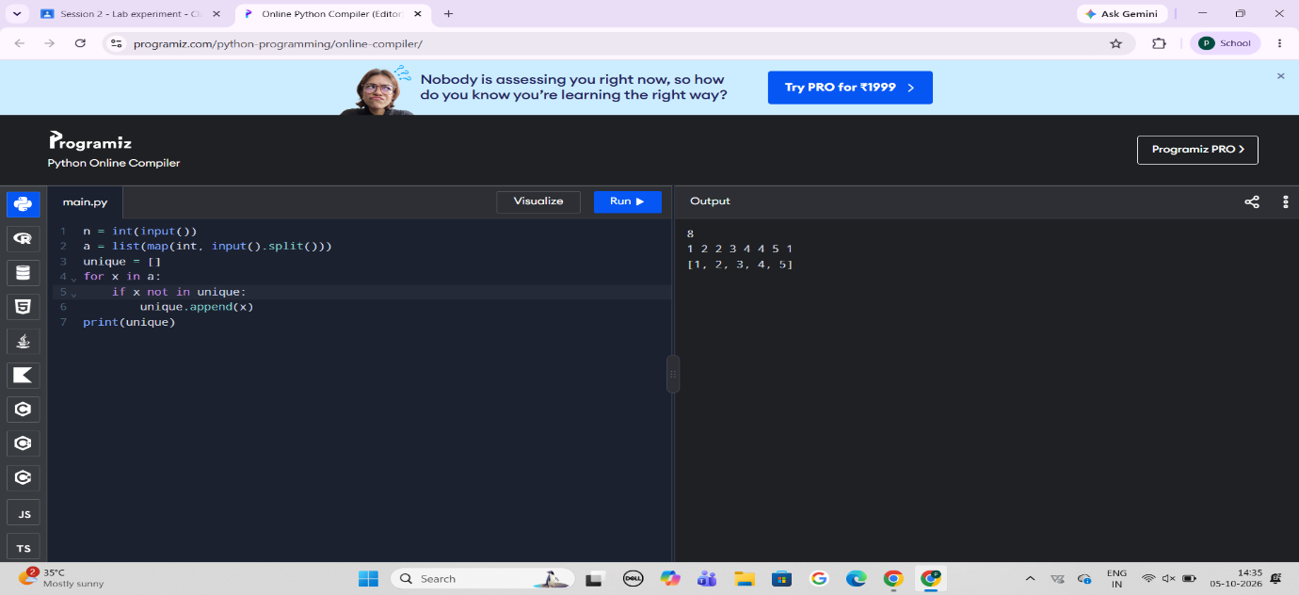
4. Sort an array of integers using the bubble sort technique. Analyze its time complexity using Big-O notation. Write the code
Code/Output:

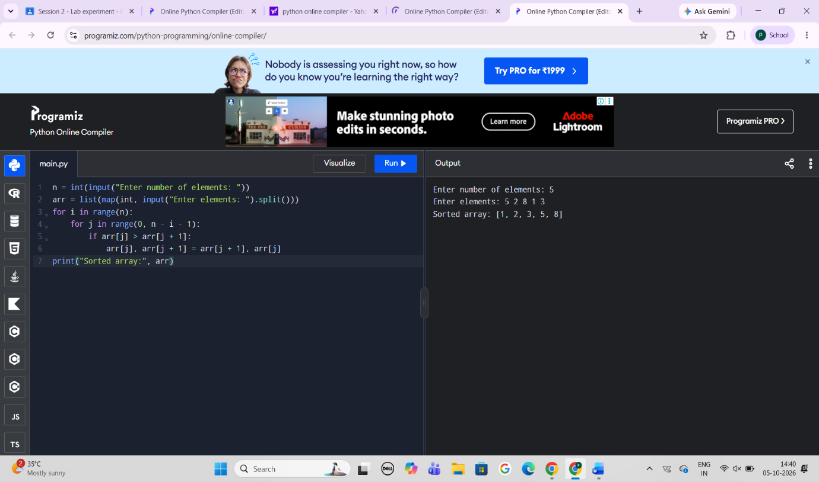
4. Checks if a given number x exists in a sorted array arr using binary search. Analyze its time complexity using Big-O notation.
Code/Output:
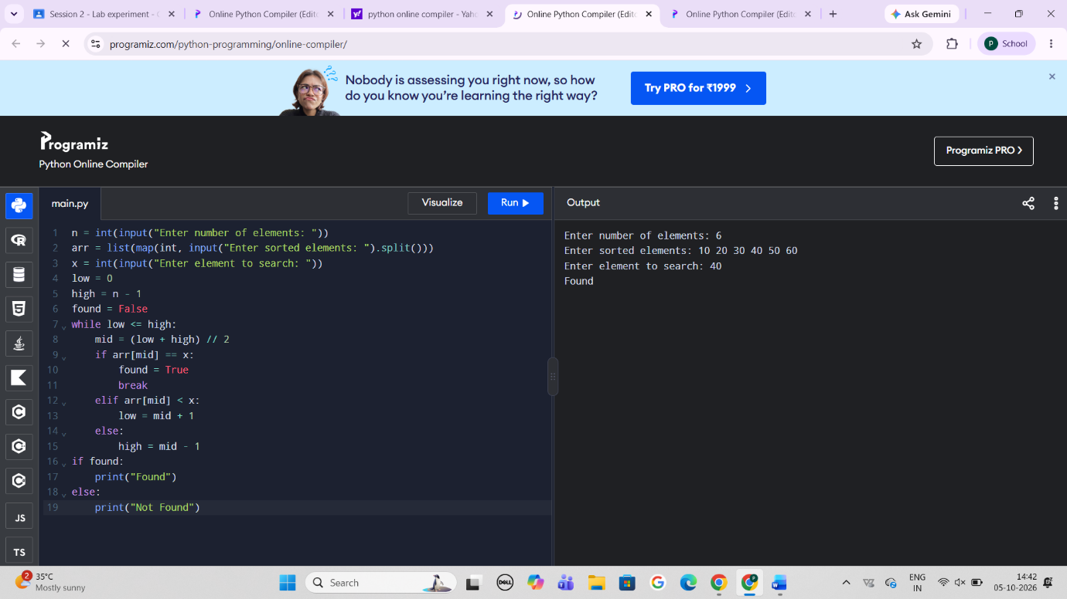
4. Given an array of integers nums, sort the array in ascending order and return it. You must solve the problem without using any built-in functions in O(nlog(n)) time complexity and with the smallest space complexity possible.

Code/Output:
