1. Generate the list of customer has per age and profession and display them according to ascending order of the age.

select * from customer_bank

select age, job from customer_bank order by age;

output:

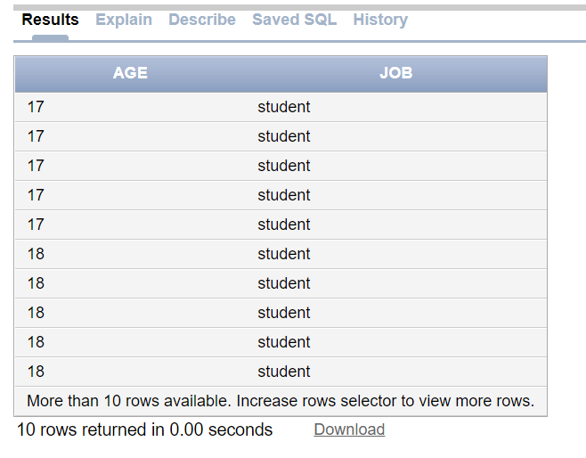

2. 2.● Generate the list of customer who have no housing loan and personal loan.

select customer_id from customer_bank where housing = 'no' and loan = 'no';

output:

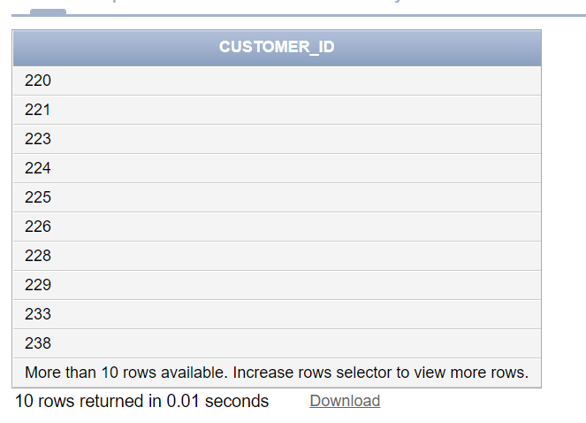

3Generate the list of customer who has credit and has been contacted more than 2 times during the campaign.

select cb.CUSTOMER_ID , cb.DEFAULT1, cp.CAMPAIGN

from CUSTOMER_BANK cb, CAMPAIGN cp

where cb.DEFAULT1 ='yes'and cp.CAMPAIGN > 2

output:

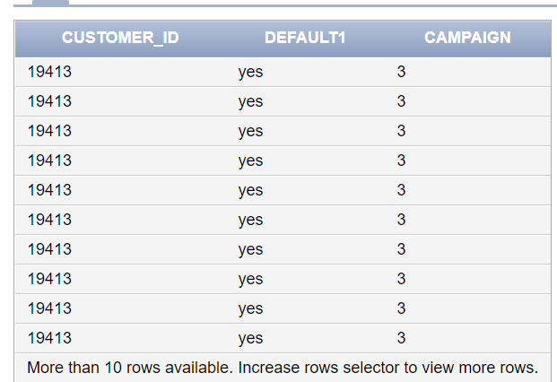

4.Generate the list of customer who has credit and has been contacted more than 2 times during the campaign and

outcome of the campaign is successful.

Query: select cb.CUSTOMER_ID , cb.DEFAULT1, cp.CAMPAIGN , cp.poutcome

from CUSTOMER_BANK cb, CAMPAIGN cp

where cb.DEFAULT1 ='yes'and cp.CAMPAIGN > 2 and cp.poutcome = 'success'

output:

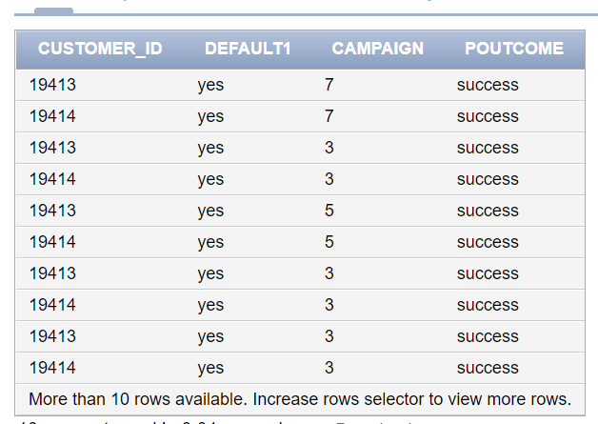

5. Generate the list of customer who has credit and and has been contacted more than 2 times during the campaign and outcome of the campaign is failure and who have been contacted in the month of June and also display the day contacted.

Query:

select cb.CUSTOMER_ID , cb.DEFAULT1, cp.CAMPAIGN , cp.poutcome,cp.month

from CUSTOMER_BANK cb, CAMPAIGN cp

where cb.DEFAULT1 ='yes'and cp.CAMPAIGN > 2

and cp.poutcome = 'failure'and cp.month = 'jun'

output:

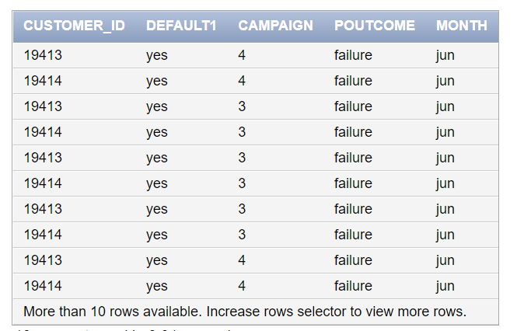

6.Generate report giving state-wise breakup of number of customers

select State_Code, count(CUSTOMER_ID)from customer_bank group by State_Code

output:

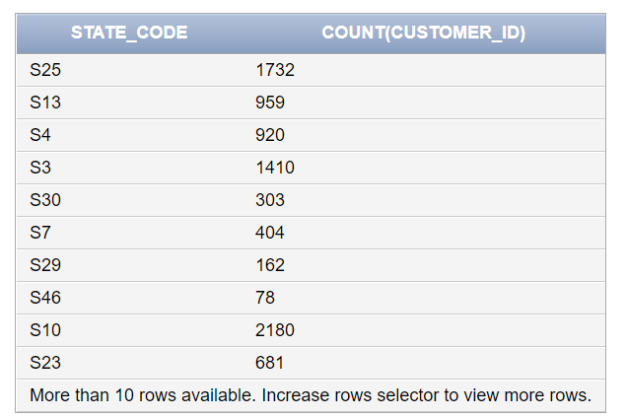

7.