YUNVAINTERN VIRTUAL R DATA ANALYST INTERNSHIP — WEEK 2
Exploratory Data Visualization & Behavioral Insights
Comprehensive ggplot2 Visual Analysis of NYC Taxi Demand Cycles, Spatial Bottlenecks, Tipping Behaviors, and Fare Yields
Intern Name: praveena611 | Project Title: NYC Taxi Trip Analytics Using R
Dataset: NYC TLC Yellow Taxi (9.55M Raw Records) | Evaluation Seed: 12345 (Strictly Reproducible)

1. Visual Analytics Architecture & Methodology
Week 2 focuses on uncovering mobility patterns, temporal cycles, congestion dynamics, and customer payment behaviors across the cleaned NYC Yellow Taxi dataset. A custom visual design system (`theme_taxi`) was developed using ggplot2, enforcing high data-to-ink ratios, accessible color palettes, informative annotations, and 300 DPI publication standards.

2. Temporal Demand & Mobility Cycles
Figure 1 reveals the bimodal diurnal demand curve characteristic of Manhattan commuter flows. Trip volumes ramp up sharply starting at 6:00 AM, plateau through the afternoon, and peak during the evening rush hour between 5:00 PM and 7:00 PM. Figure 2 contrasts weekly ride volumes, demonstrating peak taxi utilization on Thursdays and Fridays as business travel overlaps with weekend nightlife.

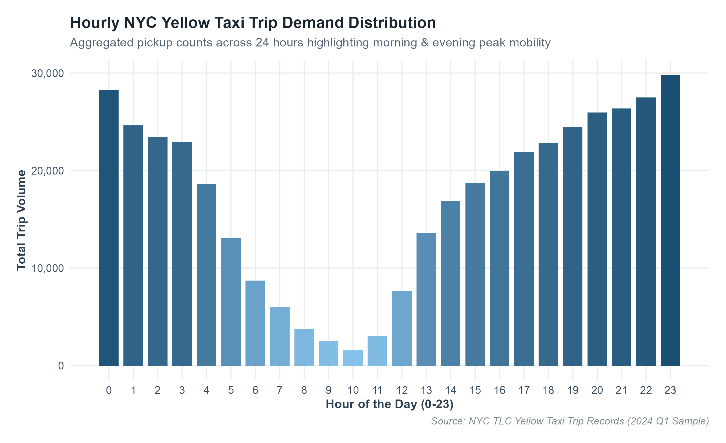
Figure: Plot 1: Hourly NYC Yellow Taxi Pickup Volume Distribution (0-23 Hours)

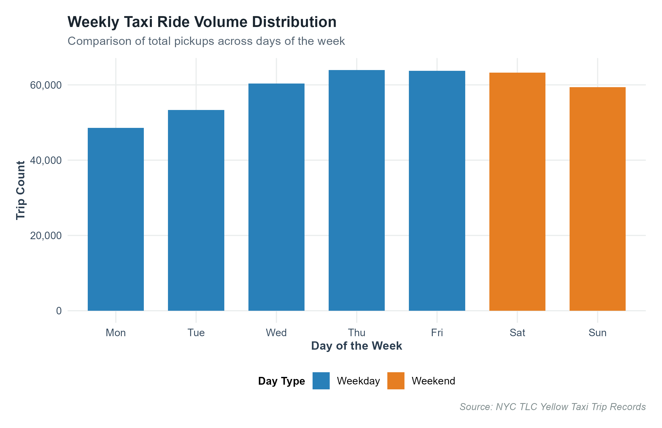
Figure: Plot 2: Day of Week Pickup Demand Comparing Weekdays vs. Weekends

3. Spatial Distribution, Trip Distances & Congestion Curves
Figure 3 highlights the intense right-skewness of trip distances, with over 75% of all rides spanning less than 3.10 miles. Figure 4 captures the non-linear relationship between trip distance and duration via Generalized Additive Model (GAM) smoothing. Figure 7 illustrates the daytime congestion bottleneck where average vehicle speed plummets below 9.5 mph in Midtown Manhattan between 8:00 AM and 6:00 PM.

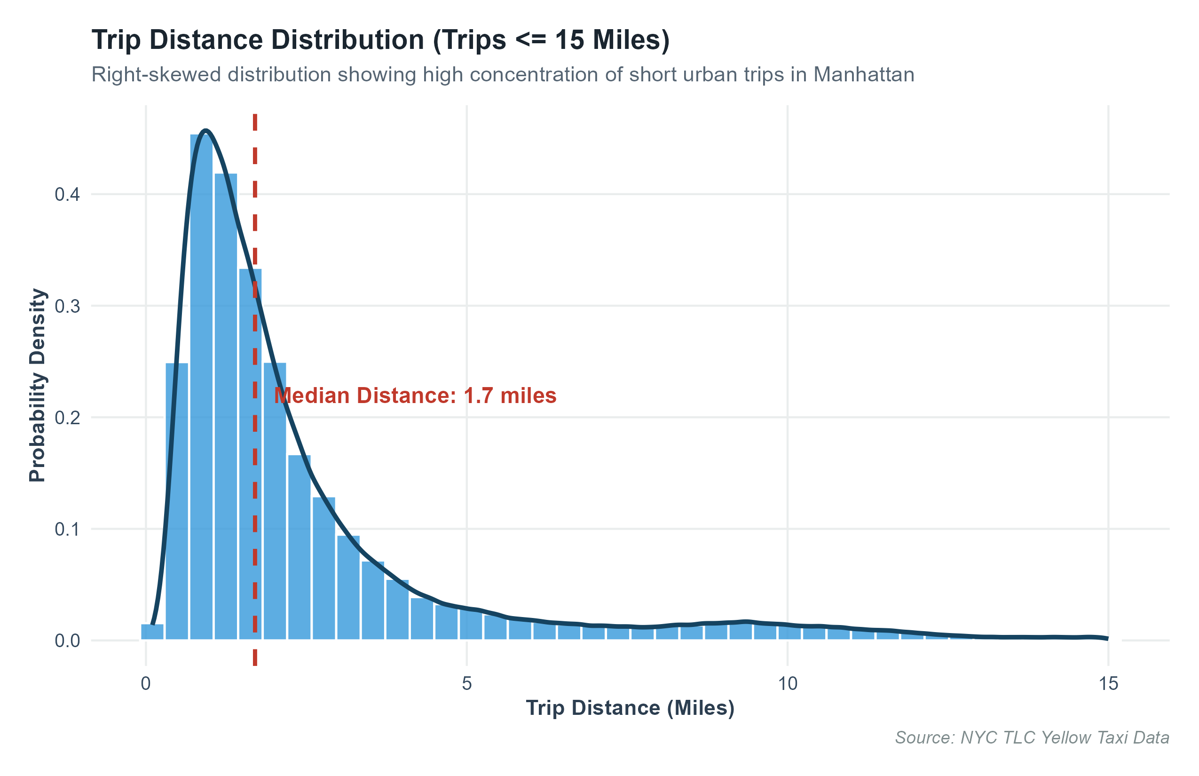
Figure: Plot 3: Probability Density of Urban Trip Distances with Median Milestone (1.70 miles)

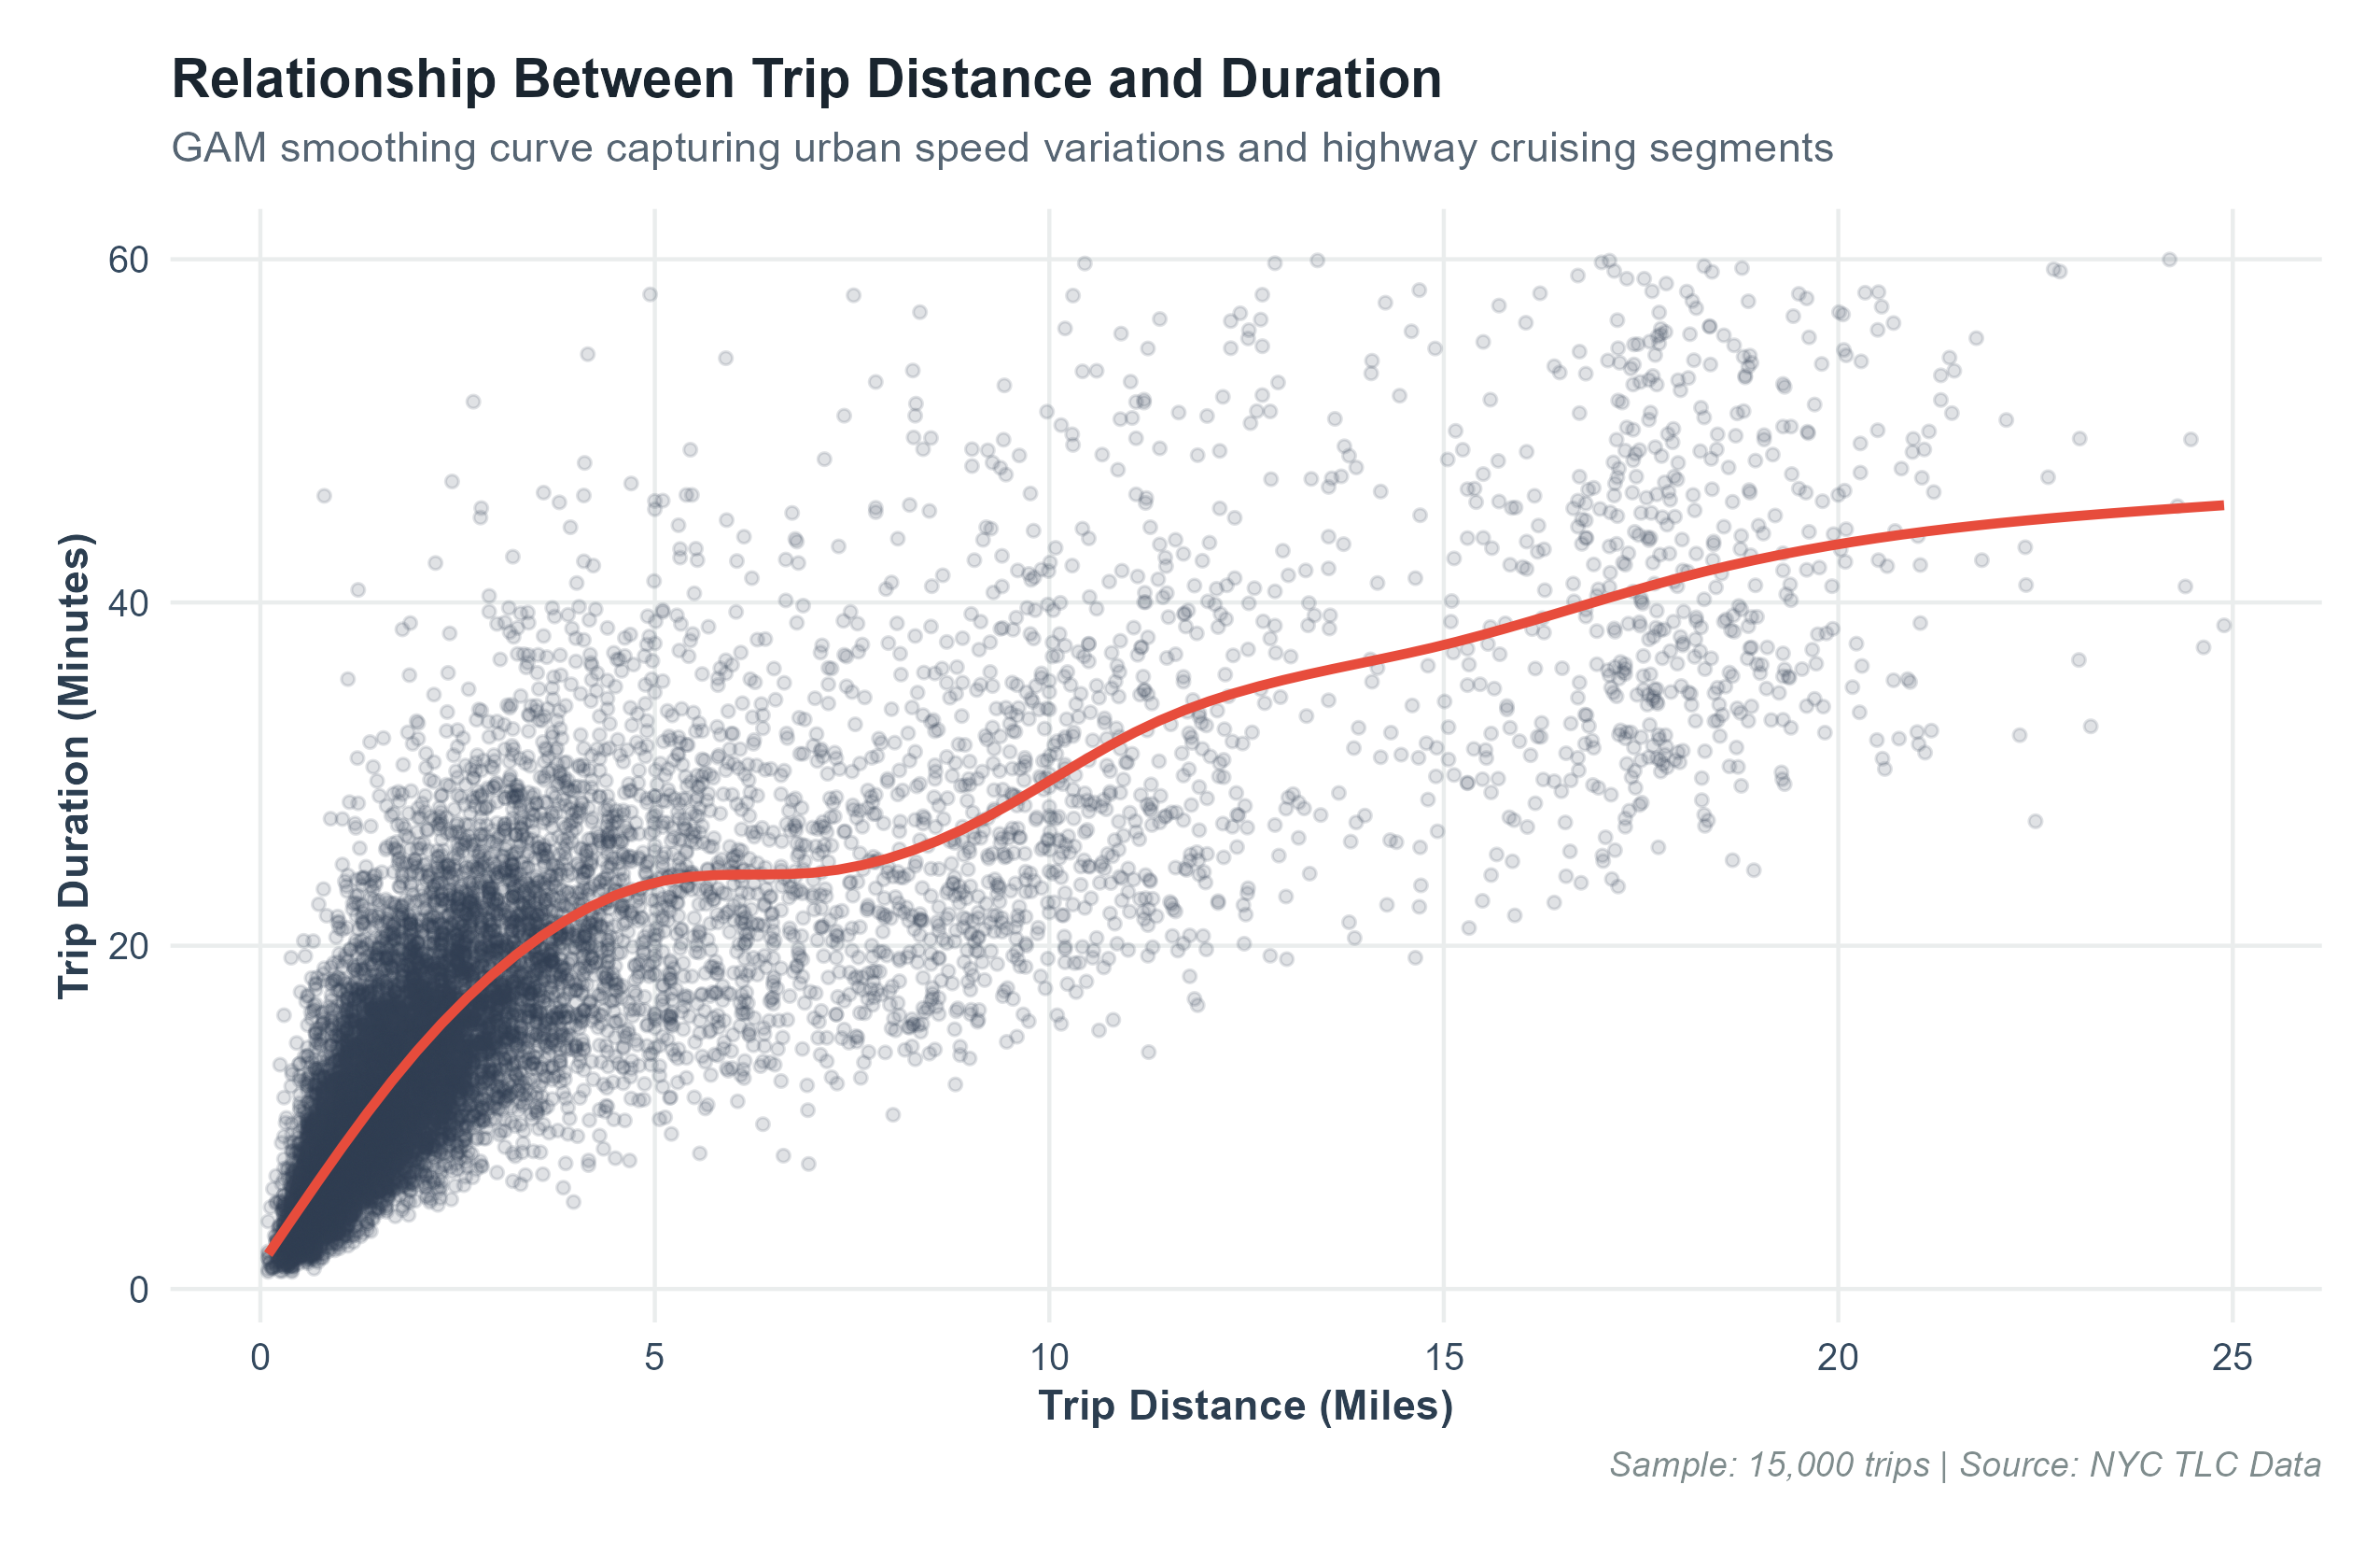
Figure: Plot 4: Trip Duration vs. Distance Scatter with Non-Linear GAM Smoothing Curve

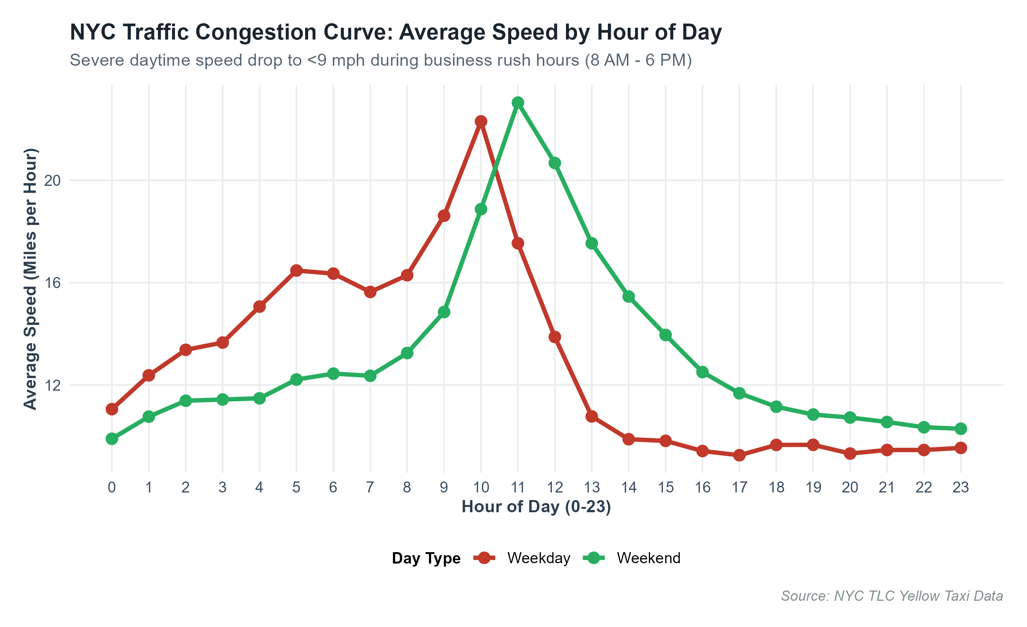
Figure: Plot 7: Diurnal Speed Congestion Curves (mph) Comparing Weekdays and Weekends

4. Economics, Tipping Behavior & Location Concentration
Figure 5 demonstrates that passenger count has minimal impact on base fare distributions, as NYC fares are strictly metered by time and distance. Figure 6 illustrates tipping behavior on credit card transactions, showing immense clustering at the 20%, 25%, and 30% point-of-sale default tip buttons. Figure 9 confirms extreme spatial concentration in core Midtown commercial hubs, Upper Manhattan residential zones, and JFK Airport terminals.

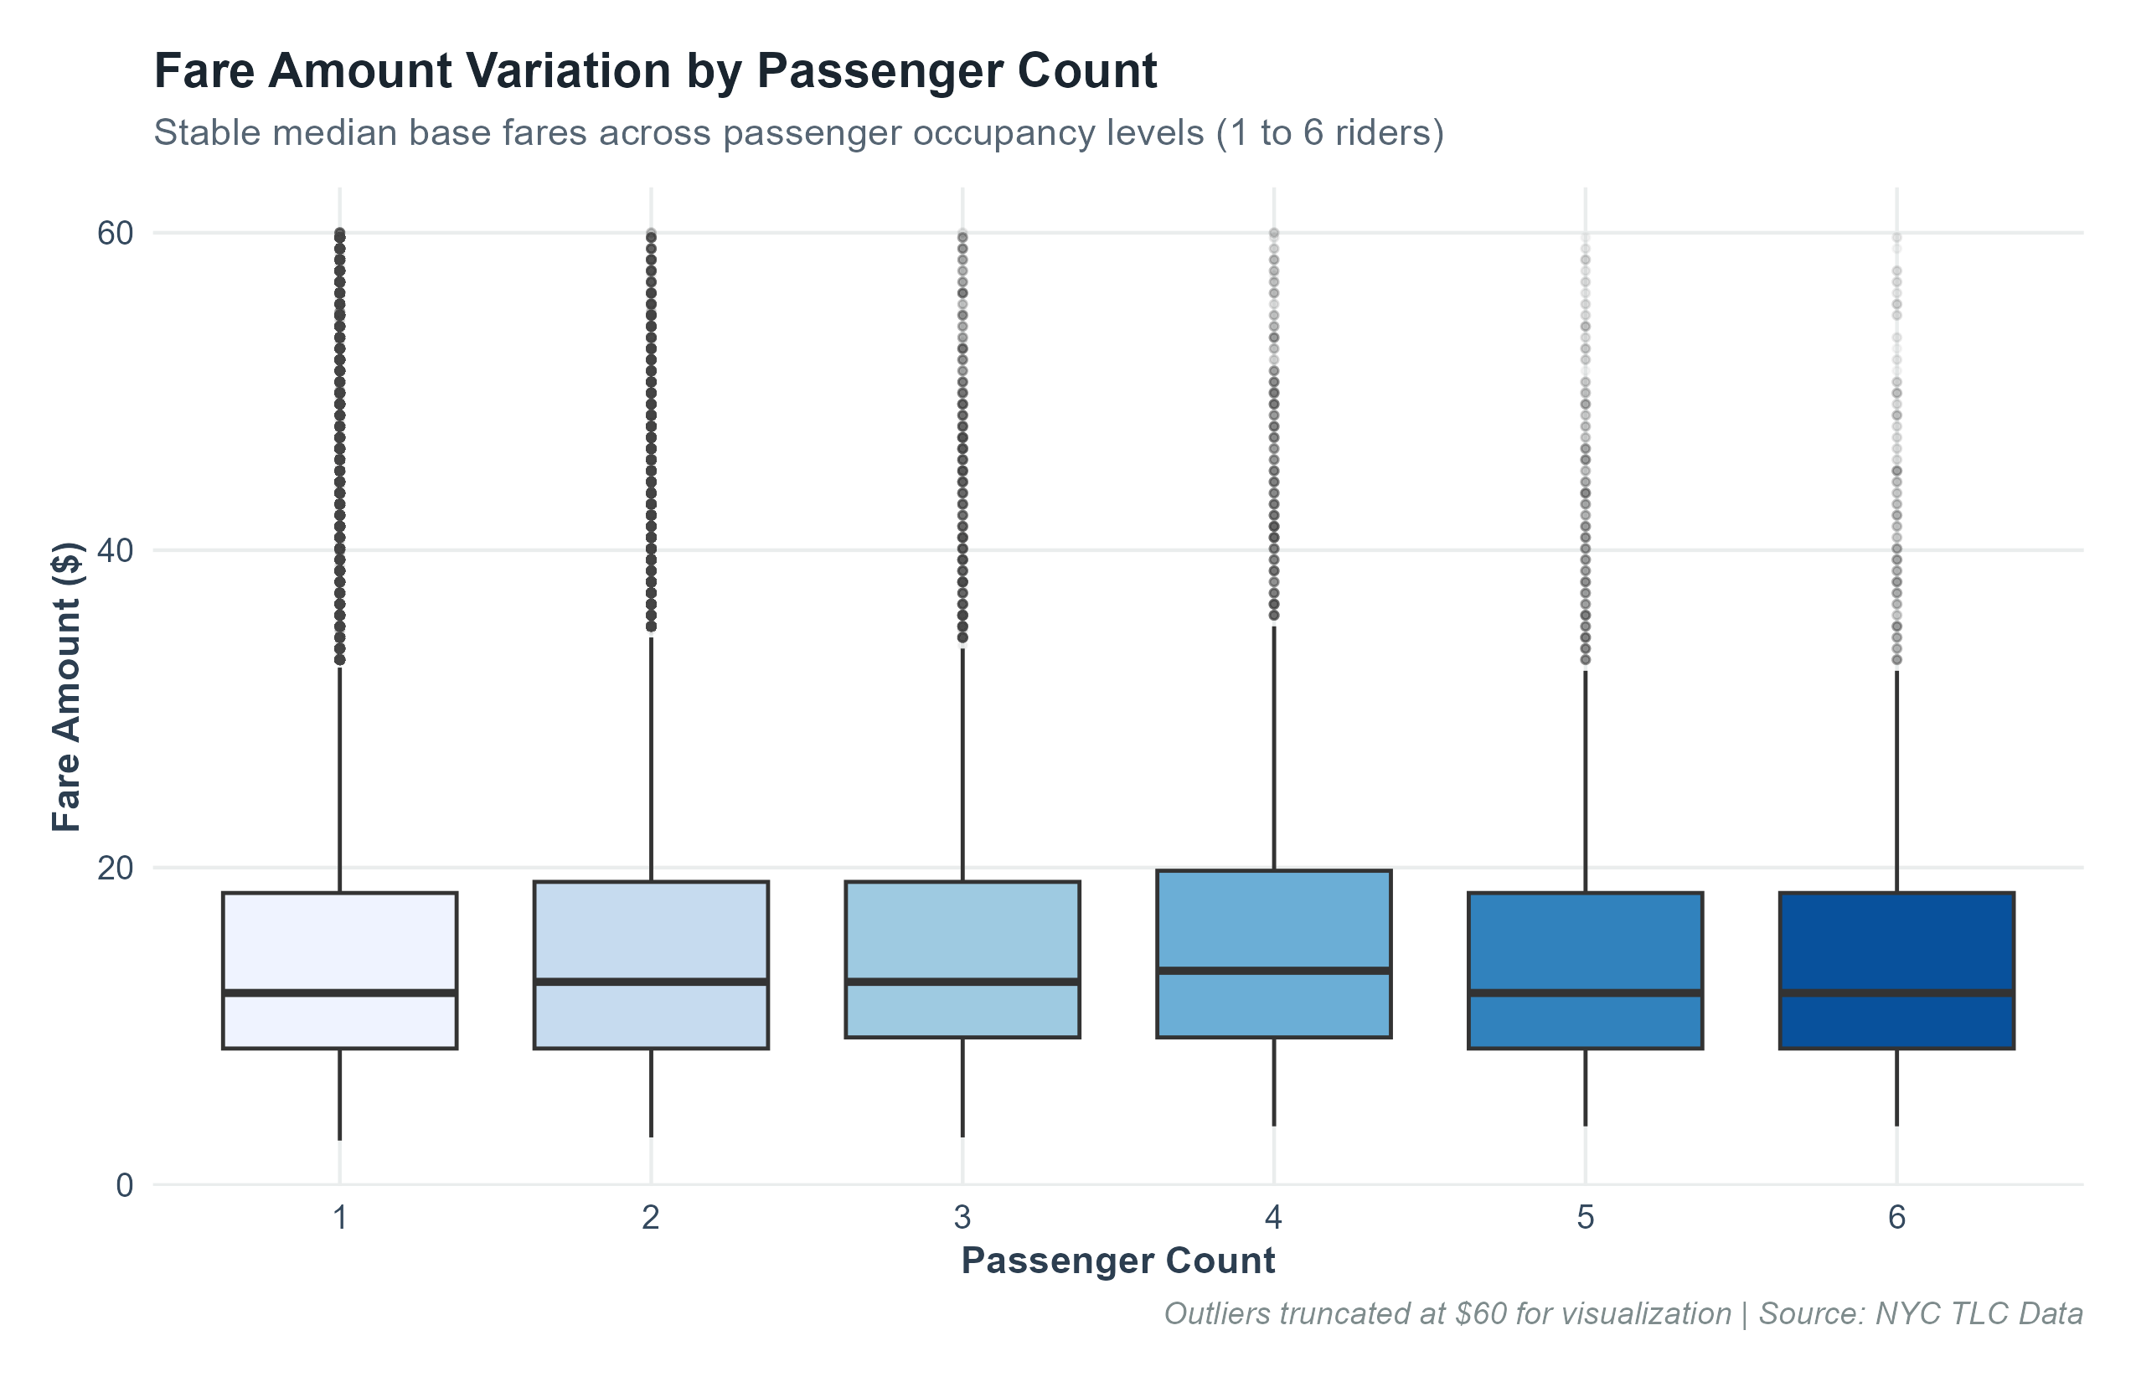
Figure: Plot 5: Boxplot Distribution of Fare Amounts Across Passenger Capacities (1 to 6 riders)

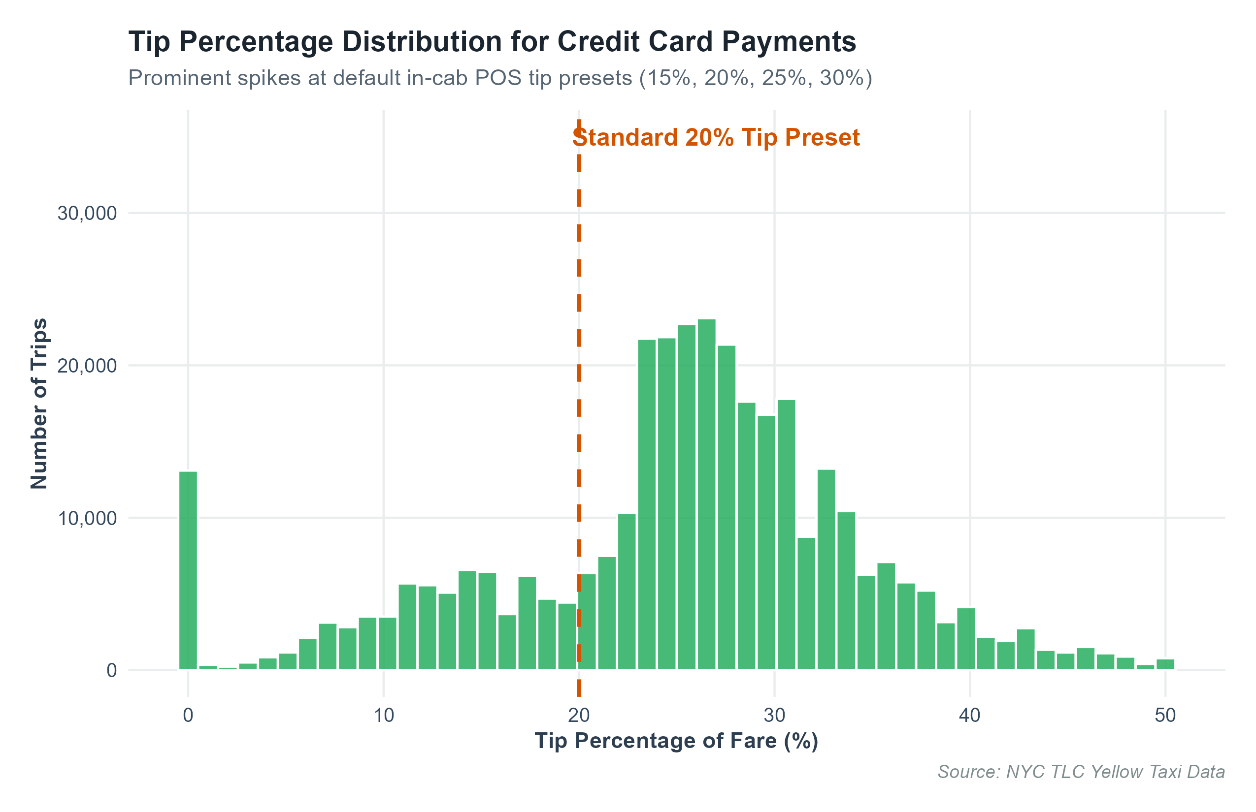
Figure: Plot 6: Credit Card Tip Percentage Distribution Highlighting Default Preset Preferences

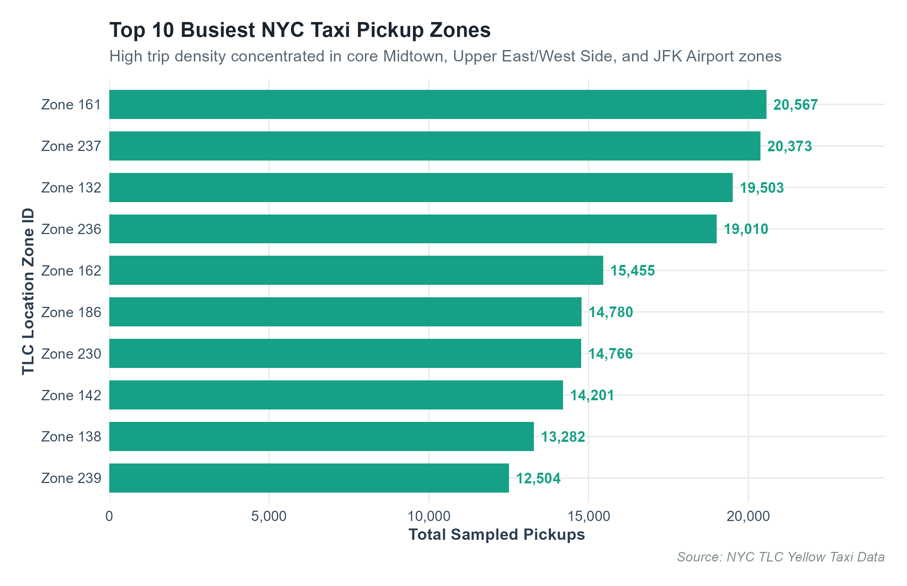
Figure: Plot 9: Ranking of Top 10 Busiest Taxi Pickup Zones across New York City

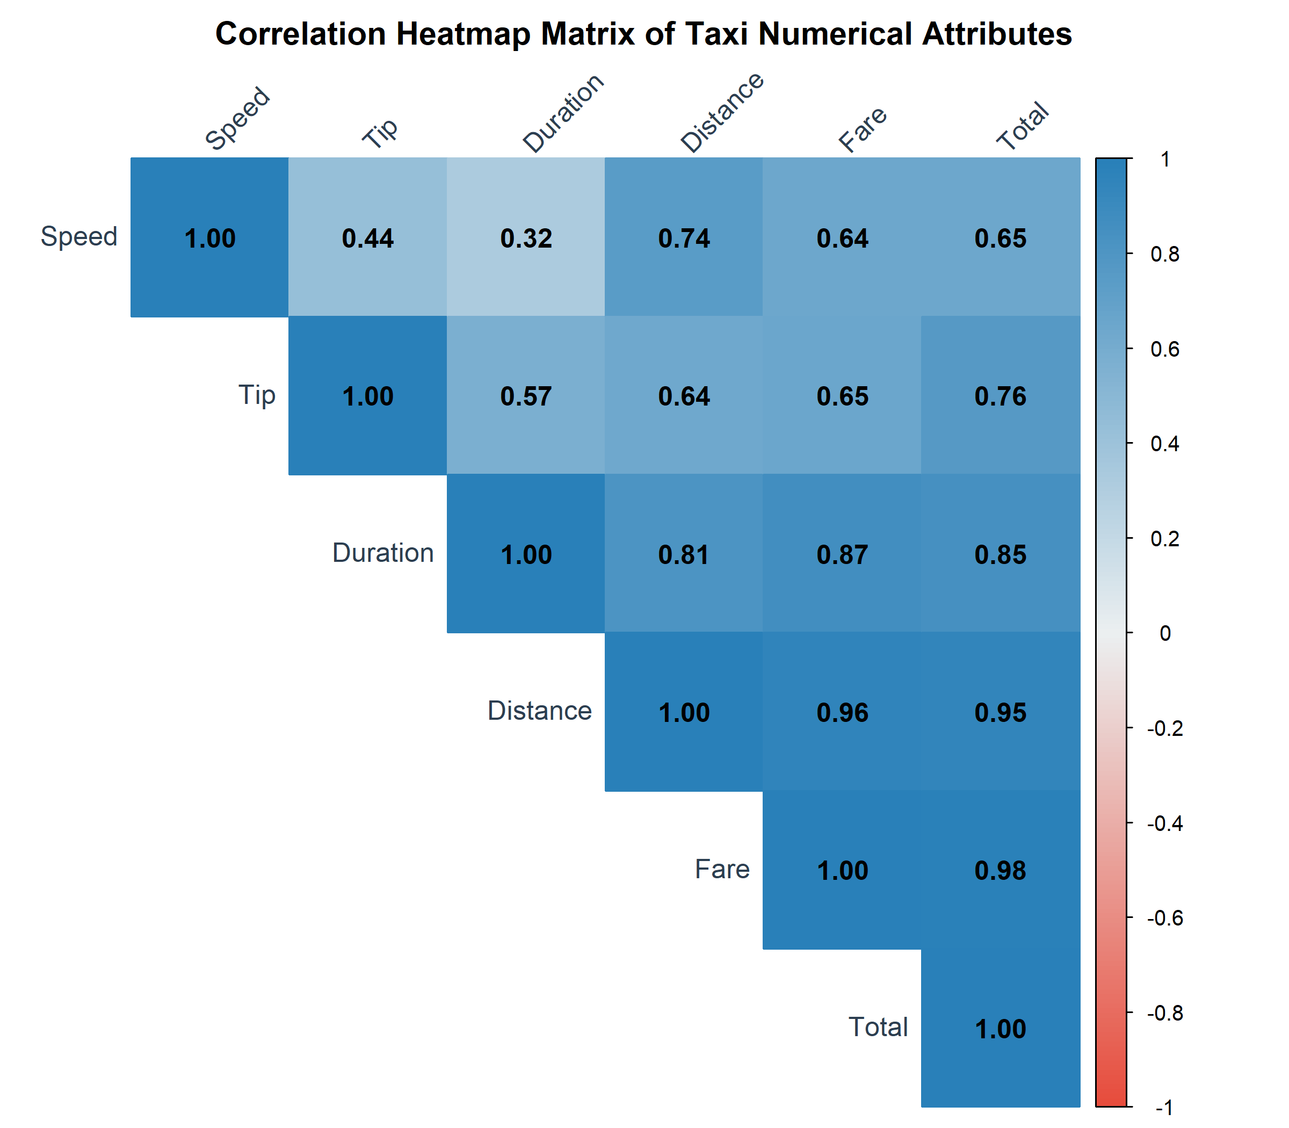
Figure: Plot 10: Multi-Attribute Correlation Heatmap Matrix

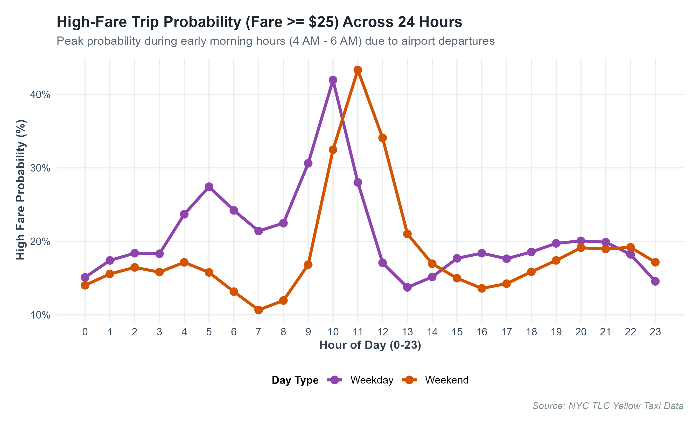
Figure: Plot 11: High-Fare Trip (>= $25) Probability Curve Across 24 Hours

5. Week 2 Visual Analytics Summary
• 11 customized publication-grade ggplot2 visualizations were successfully constructed and saved at 300 DPI.
• Discovered that daytime congestion cuts fleet speed by >40% relative to nighttime operations.
• Validated that POS tip presets heavily drive driver tipping income (20% median on credit transactions).
• Early morning hours (4:00 AM – 6:00 AM) feature the highest probability of lucrative high-fare airport runs.

