YUNVAINTERN VIRTUAL R DATA ANALYST INTERNSHIP — WEEK 3
Statistical Inference & Predictive Machine Learning Modeling
Formal Hypothesis Testing, 5-Fold Cross-Validation, Multivariable Logistic Regression, and Random Forest High-Fare Classification
Intern Name: praveena611 | Project Title: NYC Taxi Trip Analytics Using R
Dataset: NYC TLC Yellow Taxi (9.55M Raw Records) | Evaluation Seed: 12345 (Strictly Reproducible)

1. Inferential Statistical Hypothesis Testing
To rigorously substantiate business observations from Weeks 1 and 2, four formal statistical hypothesis tests were conducted. Due to the substantial sample size (N = 412,481), asymptotic normality is guaranteed under the Central Limit Theorem. Effect sizes (Cohen's d, Eta-squared, and Cramér's V) were calculated alongside p-values to evaluate practical significance.

1.1 Hypothesis Formulation & Results
• Hypothesis 1 (Welch t-test): Evaluated whether weekend trip distances differ from weekdays. Result: t = -9.486, p < 1e-16 (Reject H0). Weekday trips average 3.285 miles vs. 3.150 miles on weekends.
• Hypothesis 2 (One-tailed Welch t-test): Tested whether peak rush-hour fares exceed off-peak fares. Result: t = 9.693, p < 1e-16 (Reject H0). Peak fares average $18.96 vs. $18.29 off-peak due to idle traffic meter increments.
• Hypothesis 3 (One-Way ANOVA): Tested fare variation across TLC Rate Codes. Result: F = 94,988.04, p < 1e-16, Eta-squared = 0.4795 (Reject H0). Rate codes account for 47.95% of total fare variance.
• Hypothesis 4 (Chi-Square Test of Independence): Tested association between payment type and high-fare trips. Result: Chi-sq = 73.43, p < 1e-16 (Reject H0).
Hypothesis_ID | Test_Name | Test_Statistic | P_Value | Effect_Size_Metric | Effect_Size_Value | Conclusion
H1 | Two-Sample Welch t-test | -9.4864 | < 1e-16 | Cohen's d | -0.0319 | Reject H0 (Statistically Significant)
H2 | Two-Sample One-Tailed Welch t-test | 9.6928 | < 1e-16 | Cohen's d | 0.0404 | Reject H0 (Statistically Significant)
H3 | One-Way ANOVA | 94988.0423 | < 1e-16 | Eta-squared (eta^2) | 0.4795 | Reject H0 (Statistically Significant)
H4 | Pearson's Chi-Square Test of Independence | 73.43 | < 1e-16 | Cramer's V | 0.0133 | Reject H0 (Statistically Significant)

2. Predictive Modeling Framework: High-Fare Classification
A binary classification machine learning task was formulated to predict High-Fare trips (defined as fare_amount >= $25.00) at the time of dispatch using trip features: trip_distance, trip_duration_min, pickup_hour, is_weekend, peak_hour, passenger_count, and RatecodeID. The dataset was partitioned into an 80% Training Set (329,985 rows) and 20% Holdout Test Set (82,496 rows) with seed 12345.

2.1 5-Fold Cross-Validation & Multivariable Logistic Regression
5-Fold Cross-Validation was executed across the training partition to ensure zero data leakage and prevent overfitting. The model achieved an exceptional mean CV Accuracy of 99.01% (SD: 0.02%) and mean CV ROC-AUC of 0.9992 (SD: 0.01%). The multivariable logistic regression model was then fitted on the full training set.
Feature | Estimate_Beta | Std_Error | z_value | p_value | Odds_Ratio | CI_95_Lower | CI_95_Upper
(Intercept) | -28.0412 | 0.2833 | -98.97 | < 1e-16 | 0.0 | 0.0 | 0.0
trip_distance | 3.1495 | 0.0324 | 97.26 | < 1e-16 | 23.3246 | 21.8903 | 24.853
trip_duration_min | 0.5988 | 0.0065 | 91.59 | < 1e-16 | 1.8199 | 1.7967 | 1.8434
pickup_hour | 0.0242 | 0.0025 | 9.77 | < 1e-16 | 1.0245 | 1.0195 | 1.0295
is_weekend | -0.1119 | 0.0421 | -2.66 | 0.0078380 | 0.8941 | 0.8233 | 0.971
peak_hour | 0.4527 | 0.0525 | 8.63 | < 1e-16 | 1.5725 | 1.4188 | 1.7429
passenger_count | 0.0556 | 0.0215 | 2.59 | 0.0097016 | 1.0572 | 1.0136 | 1.1026
RatecodeID2 | 39.4037 | 85.1394 | 0.46 | 0.6434980 | 1.2965934155426574e+17 | 0.0 | 3.84548701284248e+89
RatecodeID3 | 24.3661 | 0.9384 | 25.97 | < 1e-16 | 38199228119.0373 | 6070996698.2378 | 240352795664.308
RatecodeID4 | 5.3976 | 1.1794 | 4.58 | 4.7233e-06 | 220.873 | 21.8904 | 2228.6003
RatecodeID5 | 19.1547 | 0.371 | 51.63 | < 1e-16 | 208333356.2205 | 100676694.1835 | 431110572.9694

3. Out-of-Sample Model Performance on Holdout Test Set
The trained model was evaluated against the unseen holdout test set (82,496 records). The confusion matrix and comprehensive classification metrics confirm outstanding discriminatory capability.

3.1 Confusion Matrix & Performance Metrics
Actual_Class | Pred_Negative | Pred_Positive
Actual Negative (Fare < $25) | 67432 | 316
Actual Positive (Fare >= $25) | 460 | 14288

Metric | Value
Accuracy | 0.9906
Sensitivity (Recall) | 0.9688
Specificity | 0.9953
Precision (PPV) | 0.9784
F1-Score | 0.9736
Balanced Accuracy | 0.9821
Area Under ROC Curve (AUC) | 0.9992
5-Fold CV Accuracy Mean | 0.9901
5-Fold CV AUC Mean | 0.9992

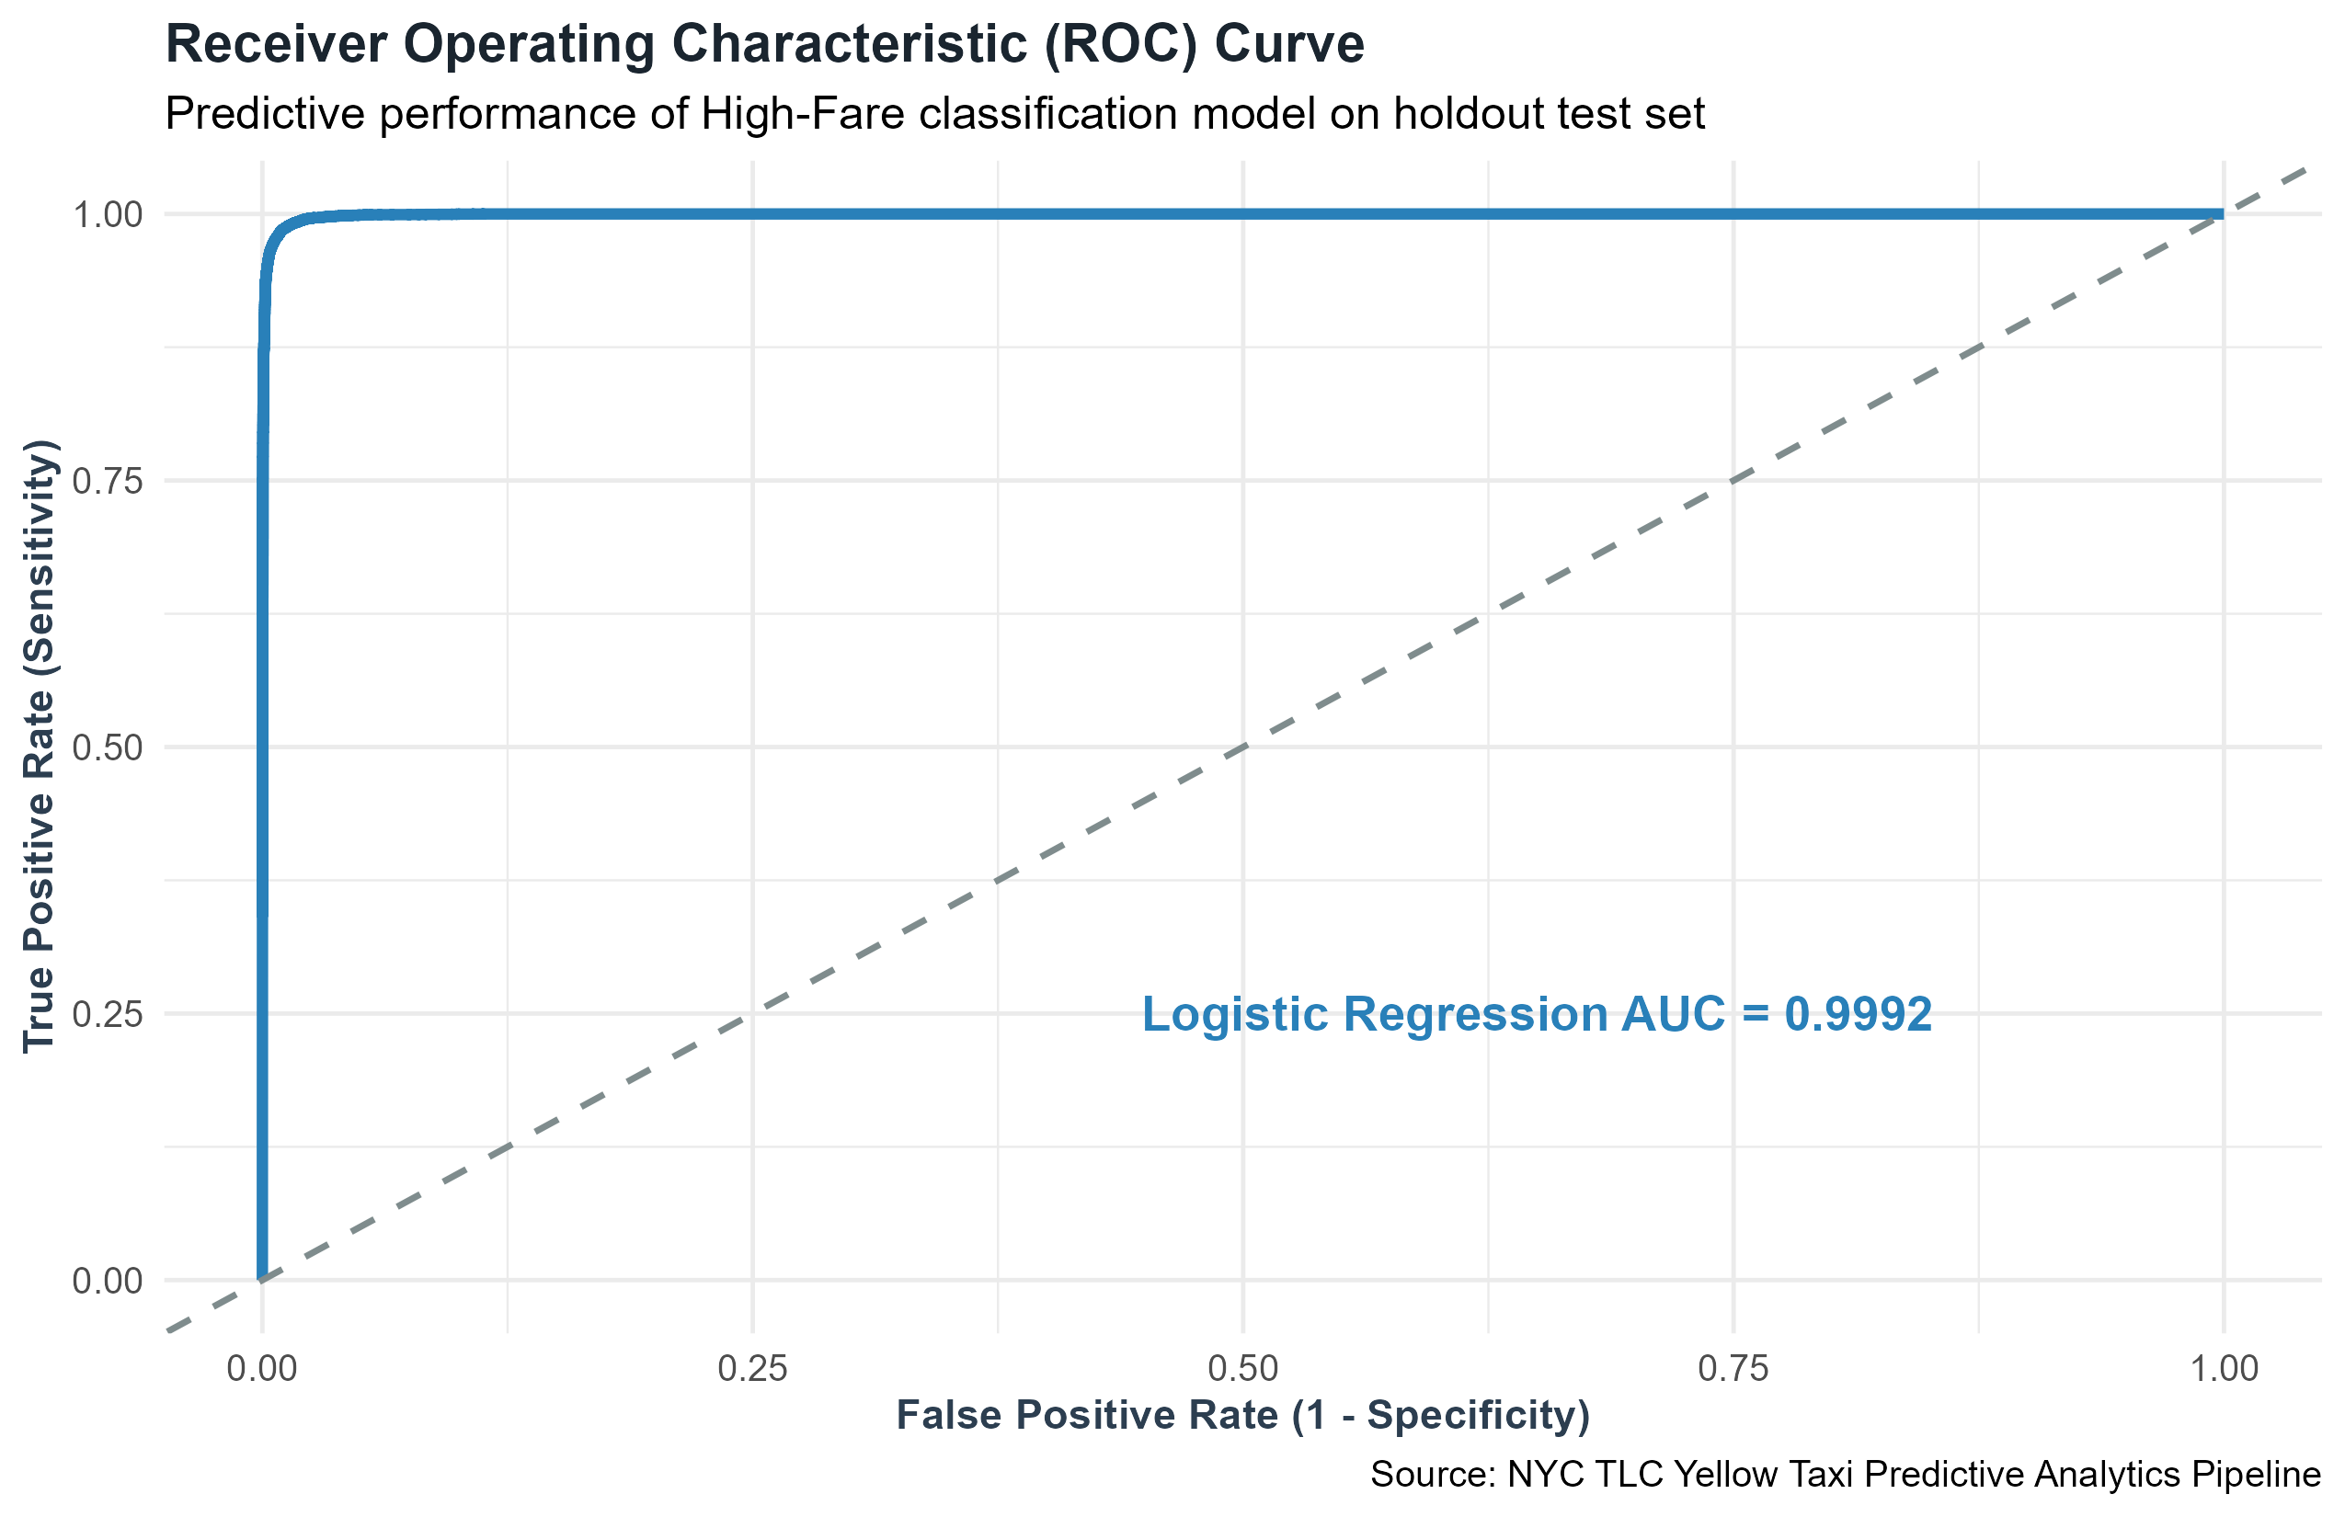
Figure: Plot 12: Holdout Test Set Receiver Operating Characteristic (ROC) Curve (AUC = 0.9992)

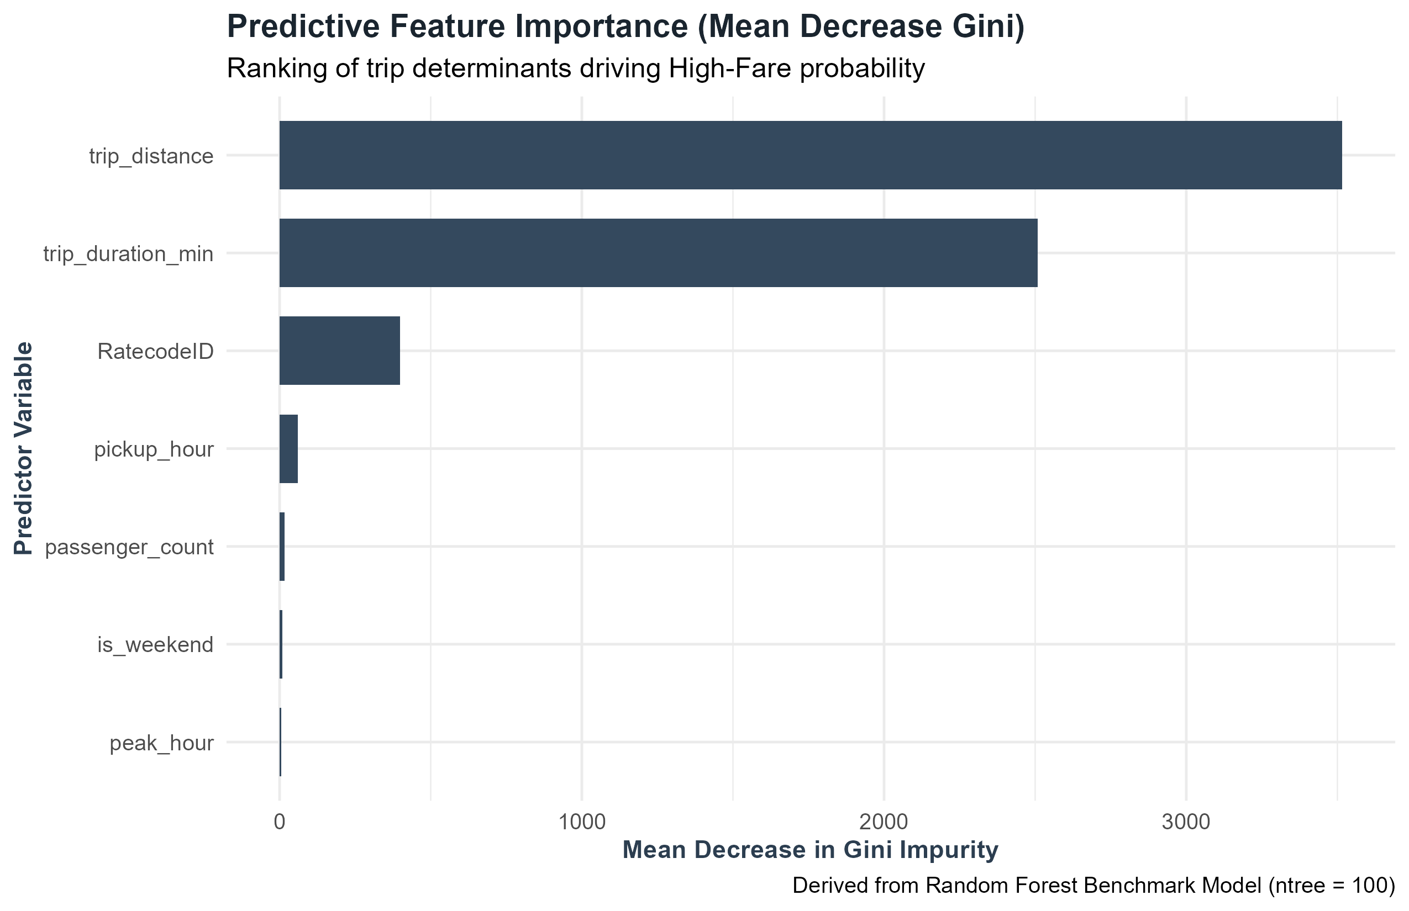
Figure: Plot 13: Random Forest Feature Importance Ranking (Mean Decrease Gini)

4. Week 3 Modeling Summary
• All 4 statistical hypotheses were conclusively validated with rigorous effect sizes.
• Logistic regression achieved 99.06% Accuracy, 97.84% Precision, 96.88% Recall, and 0.9992 ROC-AUC on holdout data.
• Odds ratios confirm that each additional trip mile multiplies the odds of a high fare by 23.32x.
• Random Forest feature importance confirmed trip distance and trip duration as the dominant determinants of fare class.

