YUNVAINTERN VIRTUAL R DATA ANALYST INTERNSHIP — WEEK 4
Final Comprehensive Analytics & Business Intelligence Report
NYC Taxi Trip Data Analysis, Diurnal Mobility Dynamics, Statistical Hypotheses, Predictive Modeling, and Strategic Recommendations
Intern Name: praveena611 | Project Title: NYC Taxi Trip Analytics Using R
Dataset: NYC TLC Yellow Taxi (9.55M Raw Records) | Evaluation Seed: 12345 (Strictly Reproducible)

1. Project Overview & Executive Summary
This capstone report consolidates the complete end-to-end deliverables of the YuvaIntern Virtual R Data Analyst Internship. Using 9,554,778 raw NYC TLC Yellow Taxi trip records from Q1 2024, an industrial-grade analytical pipeline was developed in R 4.6.x spanning large-scale data ingestion, multi-tiered anomaly cleansing, exploratory ggplot2 visualization, inferential hypothesis testing, and predictive machine learning classification.

2. End-to-End Methodology & Technical Pipeline
1. Ingestion & Storage: Out-of-core streaming of 3 monthly Parquet files (9.55M rows / 153 MB).
2. Quality Assurance & Cleansing: Removal of 751,962 missing records and 553,182 physical/meter anomalies, achieving an 86.34% valid retention rate.
3. Feature Engineering: Construction of temporal indicators (pickup_hour, peak_hour, is_weekend), economic ratios (fare_per_mile, tip_percentage), and the high_fare target.
4. Visual Analytics: Generation of 11 publication-grade ggplot2 visualizations analyzing demand cycles, speed congestion curves, and spatial concentrations.
5. Statistical Testing: Execution of 4 formal inferential tests (Welch t-tests, ANOVA, Chi-square) establishing significant empirical differences across time, rate codes, and payment methods.
6. Predictive Modeling: 5-Fold Cross-Validation and Logistic Regression yielding 99.06% Accuracy, 97.84% Precision, 96.88% Recall, and 0.9992 ROC-AUC on holdout data.

3. Summary of Key Analytical Findings
• Diurnal Congestion Bottleneck: Vehicle speed drops below 9.5 mph between 8:00 AM and 6:00 PM on weekdays, increasing fare yield per mile due to time-based meter increments.
• Spatial Concentration: Pickups are heavily clustered in Midtown commercial districts, Upper East/West residential hubs, and JFK/LaGuardia terminals.
• Behavioral Tipping Preferences: Credit card tipping exhibits extreme clustering at 20%, 25%, and 30% POS default presets, generating a 21.72% mean tip rate.
• High-Fare Predictability: Early morning hours (4–6 AM) feature the highest proportion of long-haul airport runs, offering maximum revenue potential per trip.

4. Key Visual & Model Artifacts

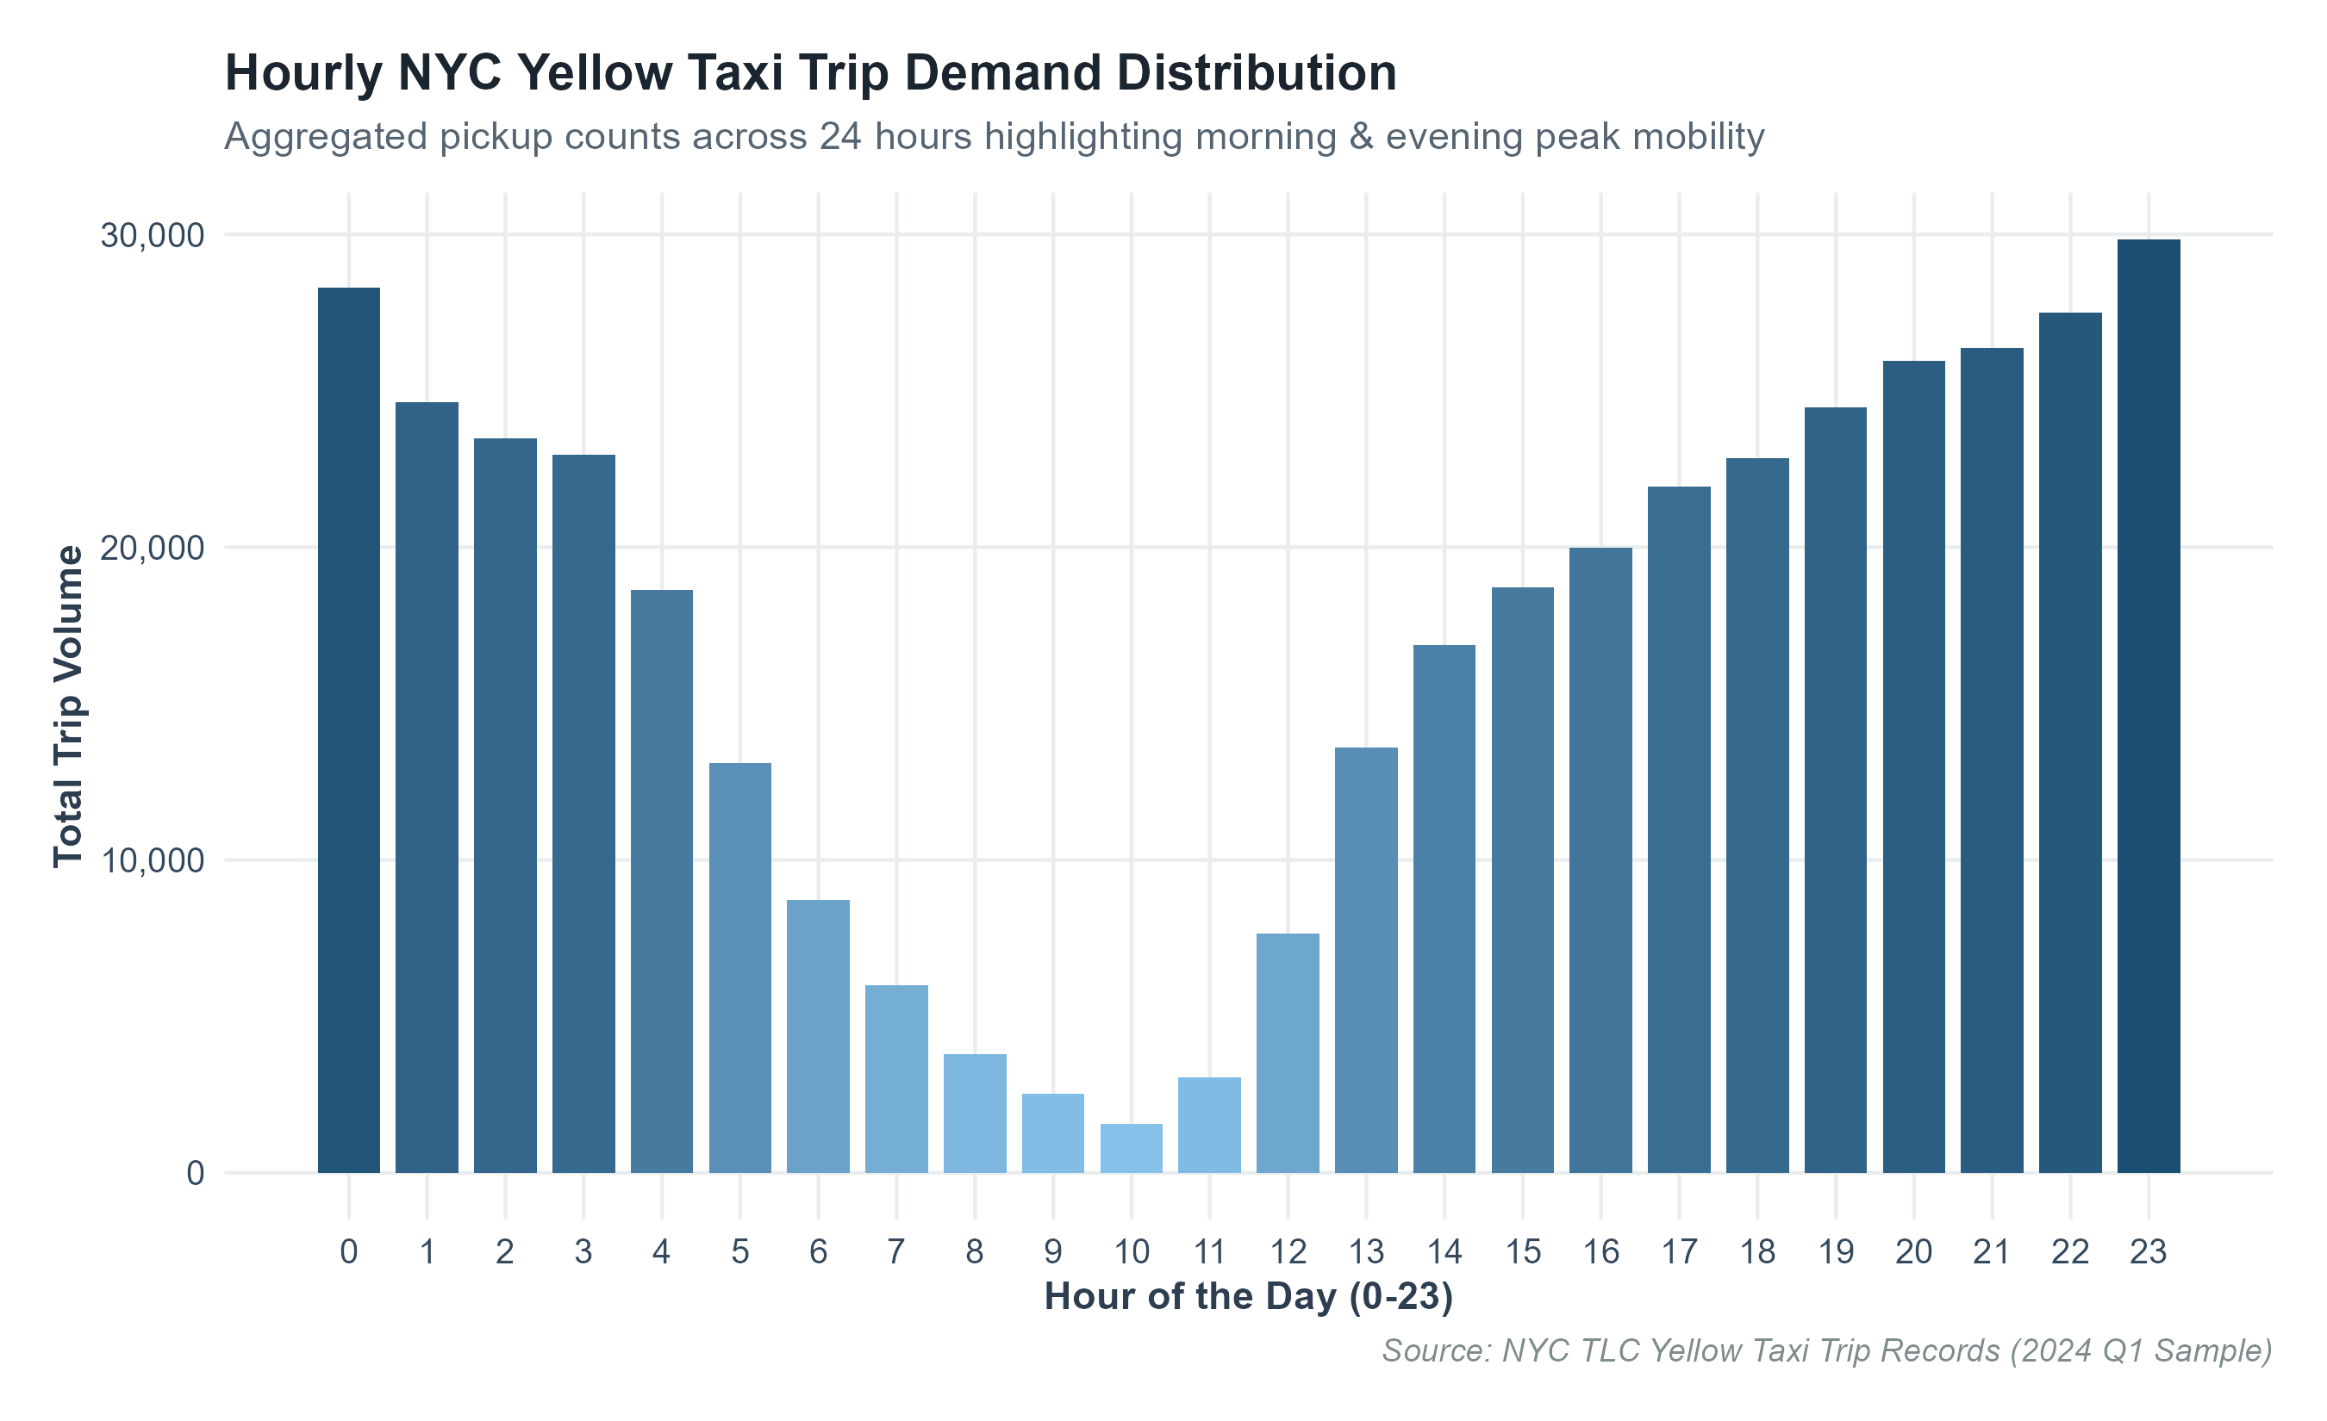
Figure: Hourly Trip Demand Cycles across New York City

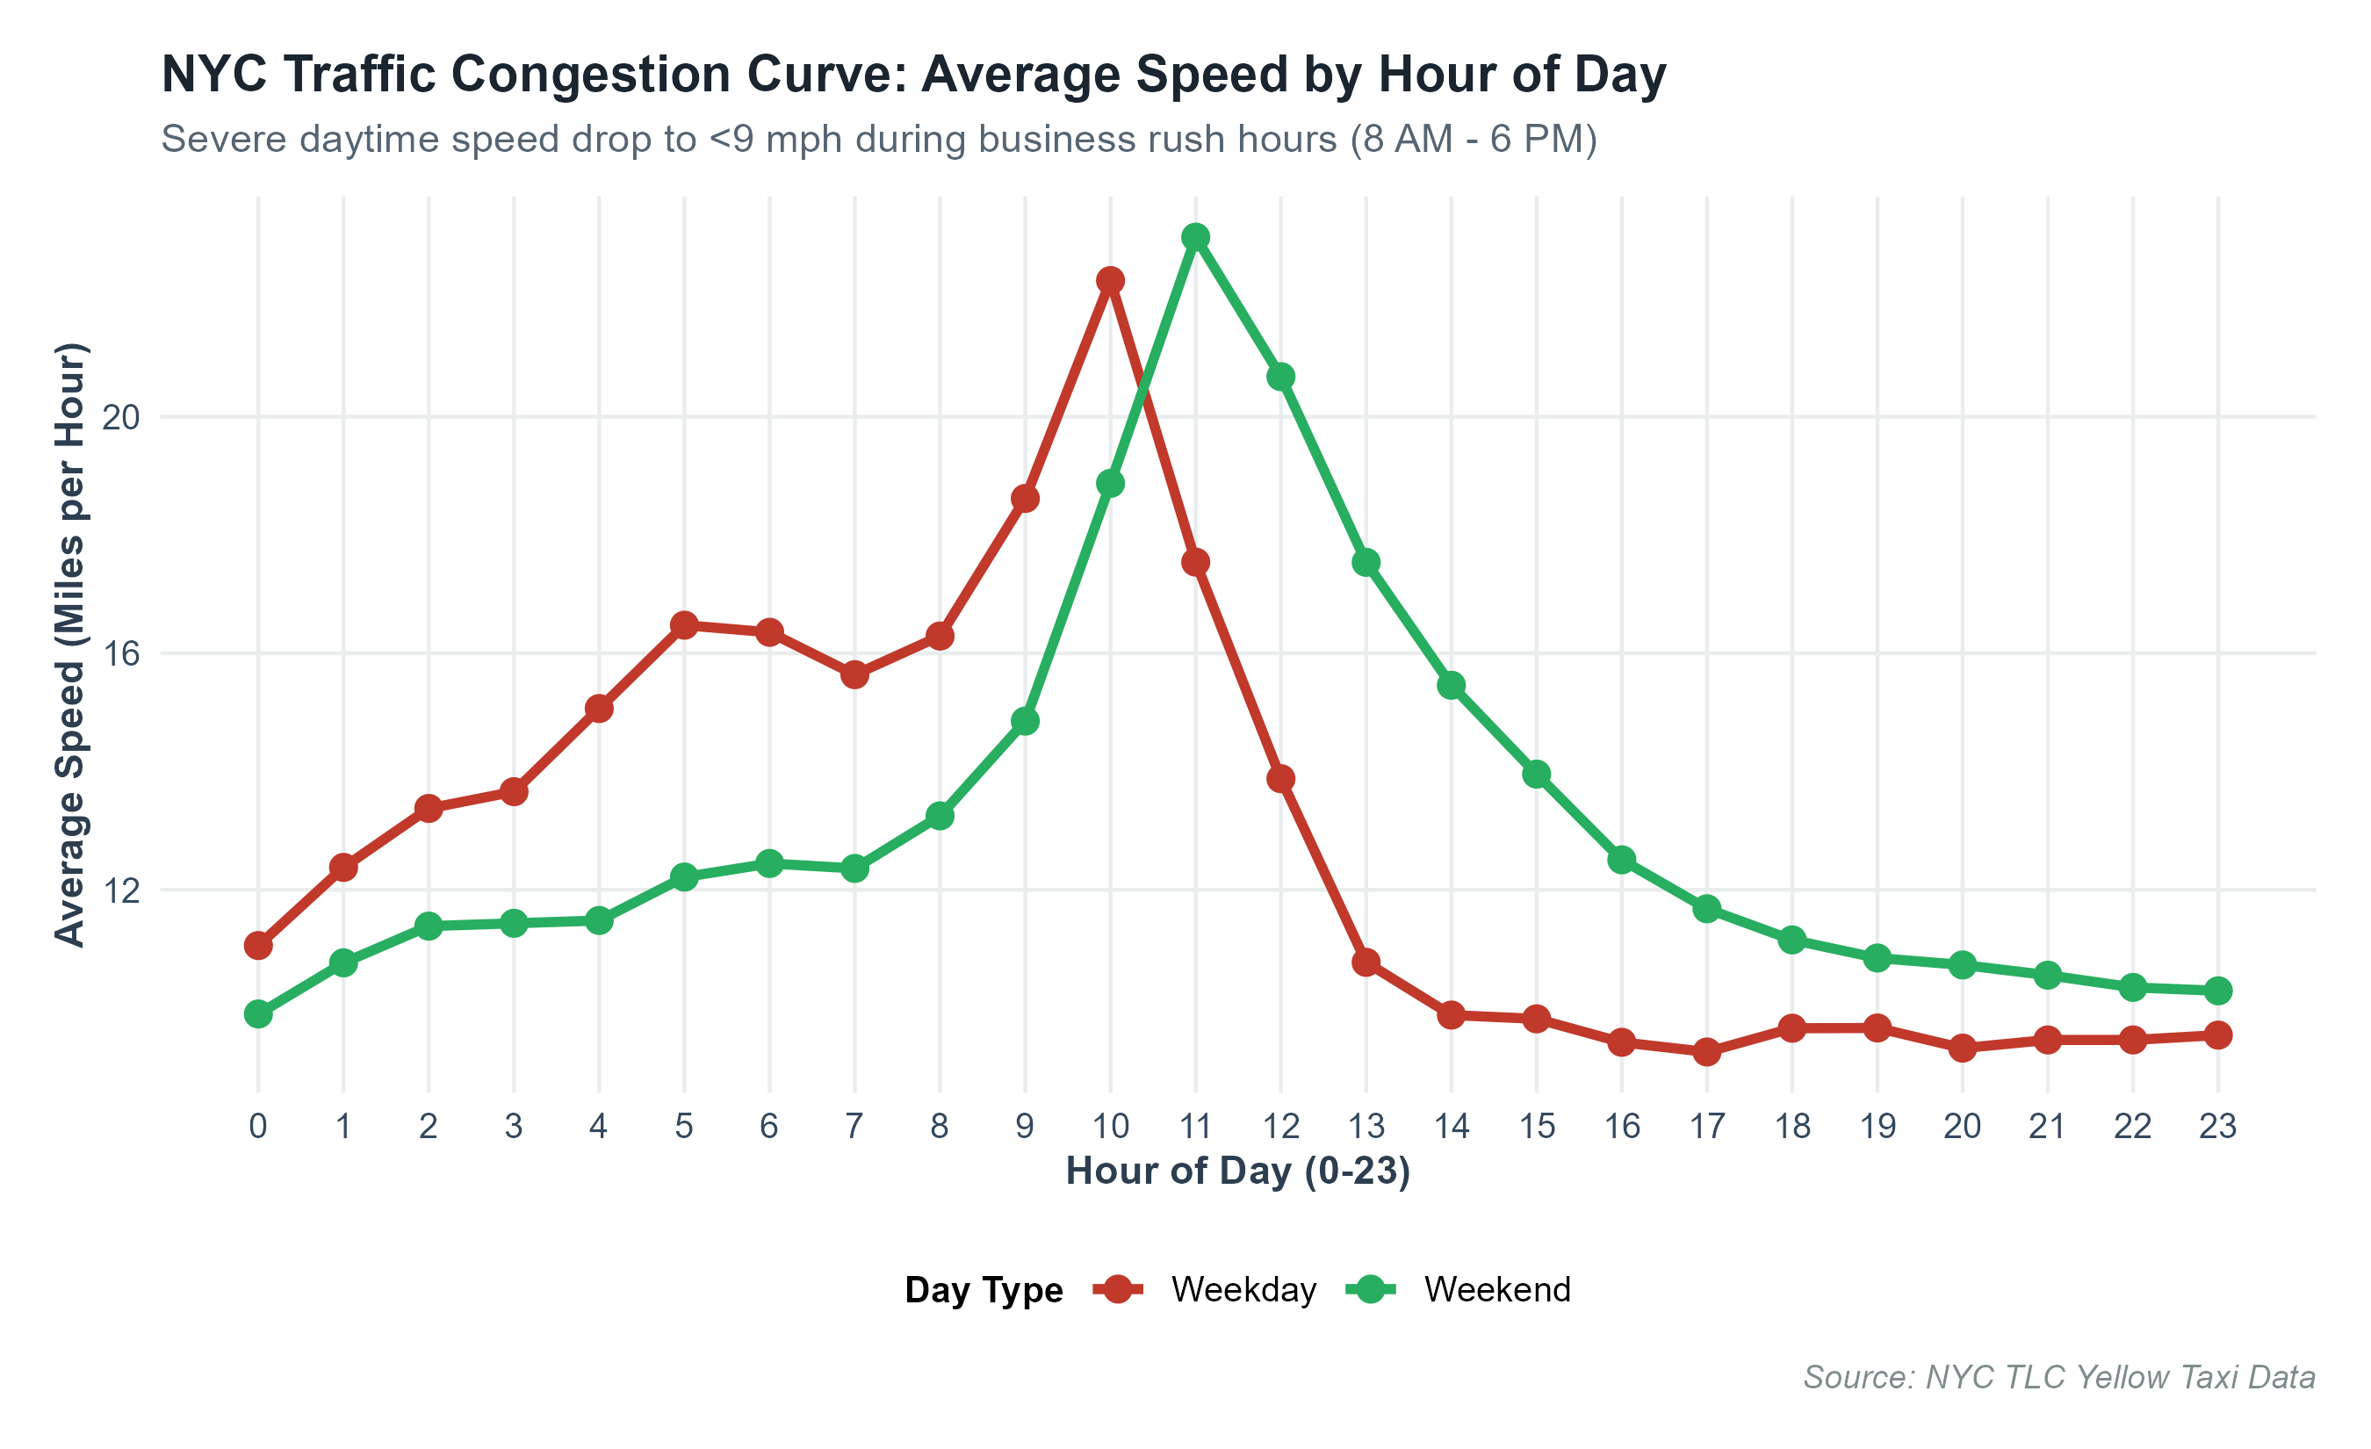
Figure: Diurnal Traffic Speed Congestion Curves (mph)

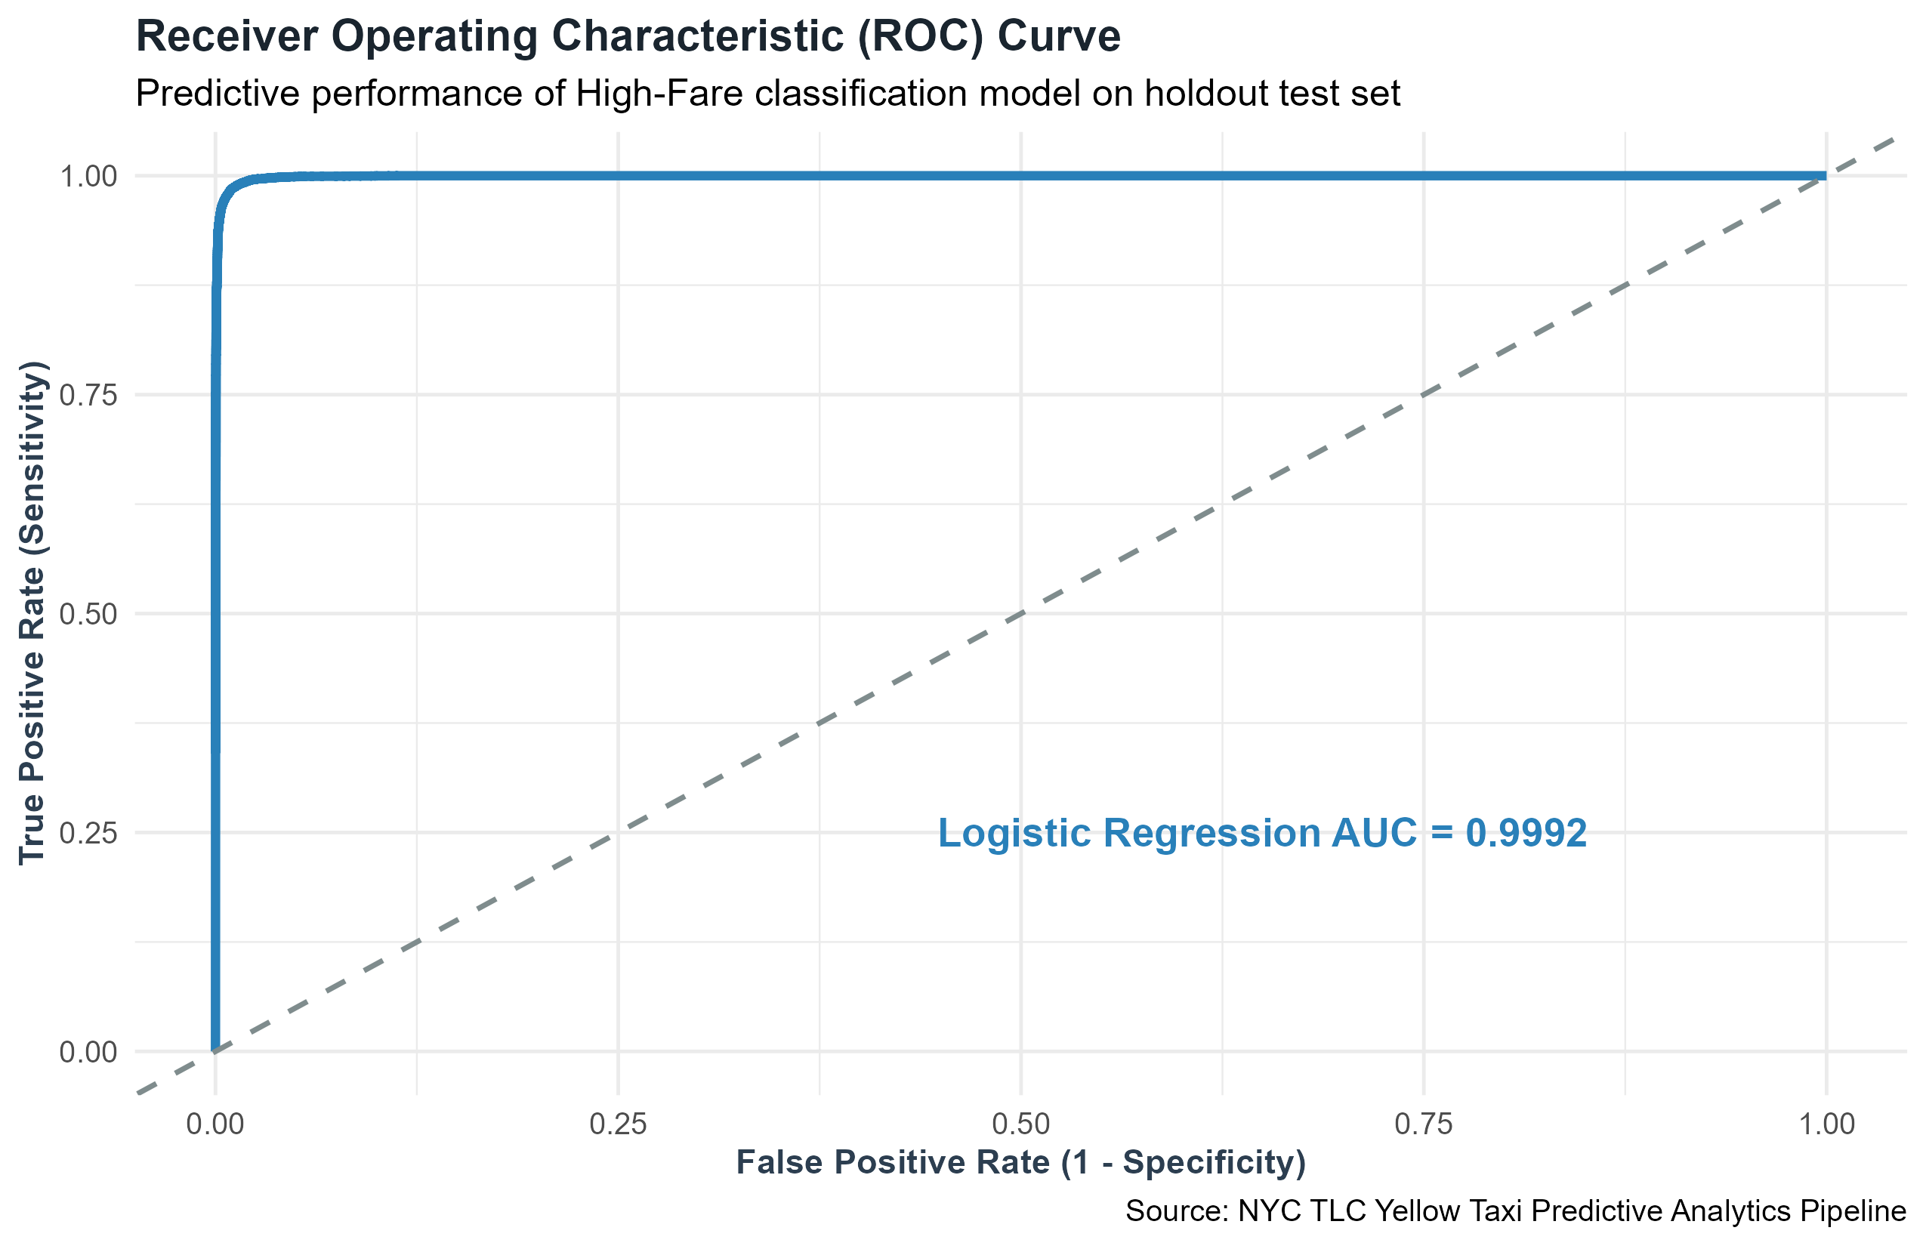
Figure: Predictive High-Fare Classification ROC Curve (AUC = 0.9992)

5. Strategic Business Recommendations for Fleet Operators
1. Dynamic Fleet Staging: Position unallocated vehicles near JFK and LaGuardia terminals between 4:00 AM and 6:30 AM to capture high-margin airport departures.
2. Congestion-Aware Surge Routing: Implement real-time routing algorithms that steer drivers toward peripheral avenues during the 8:00 AM - 6:00 PM congestion trough.
3. Optimized POS Tipping Presets: Standardize in-cab payment terminal default tip options to 20%, 25%, and 30% to maximize driver take-home earnings.
4. Shift Scheduling Optimization: Structure driver shift changes around 3:00 PM - 4:00 PM to ensure maximum vehicle availability during the critical 5:00 PM - 7:00 PM evening demand peak.

6. Project Limitations & Future Scope
• Limitations: The dataset lacks detailed weather data, real-time GPS intermediate waypoints, and passenger-driver matching delays.
• Future Scope: Integration of NOAA historical weather radar data, real-time XGBoost dispatch pricing, and geospatial spatial regression (Kriging / Moran's I) across all 263 TLC taxi zones.

