Create table with the following fields

1. tblcourse-CourseId (P.K, A.I), Coursename, Courseshortname, Coursetype

2. tblbatch-BatchId (P.K, A.I),BatchName

3. tblstudent – Studentid (P.K,A.I),Student_Name,Student_Gender,Student_DOB,Student_Email,Course_Id, Batch_id,Student_mark

1. Select all the details courses

select*from tblcourse;

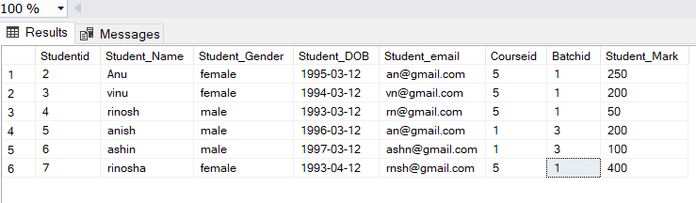

2. Select the name of UG Courses

SELECT Coursename,Courseshortname FROM tblcourse WHERE Coursetype='UG';

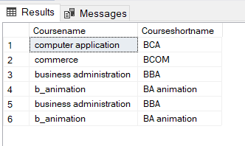

3. Select the name and short name of PG Courses

SELECT Coursename,Courseshortname FROM tblcourse WHERE Coursetype='PG';

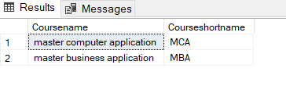

4. Select the details of batches

select*from tblbatch;

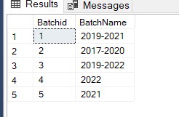

5. Select the details of students

select*from tblstudent;

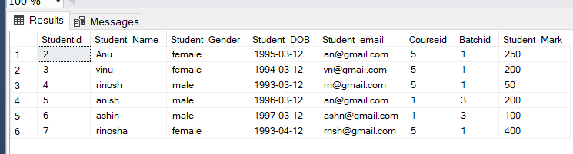

6. Insert 3 students details whose course is MCA or BCA

insert into tblstudent values('Anu','female','1995-03-12','an@gmail.com',5,1,250);

insert into tblstudent [values('vinu','female','1994-03-12','vn@gmail.com',5,1,200](mailto:values('vinu','female','1994-03-12','vn@gmail.com',5,1,200));

insert into tblstudent values('anish','male','1996-03-12','an@gmail.com',1,3,200);

insert into tblstudent [values('ashin','male','1997-03-12','ashn@gmail.com',1,3,100](mailto:values('ashin','male','1997-03-12','ashn@gmail.com',1,3,100));

select*from tblstudent where Courseid in(5,1);



7. Select the count of male and Female Students (use if case Statement)

SELECT COUNT(case when Student_Gender='male' then 1 end) AS

Total_Male,

COUNT(case when Student_Gender='female' then 1 end)As Total_Female from

tblstudent;

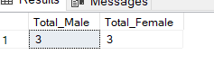

8. Select the details of Female Students

select * from tblstudent where Student_Gender='female';

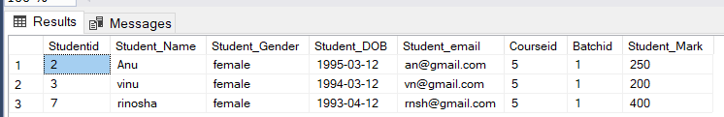

9.Select the details Males students whose course is MCA

select * from tblstudent where Courseid=(select Courseid from

tblcourse where Courseshortname='MCA') and Student_Gender='male';

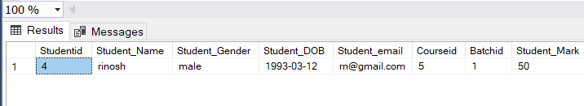

10. Select the details BCA Students

select * from tblstudent where Courseid=(select Courseid from

tblcourse where Courseshortname='BCA') ;

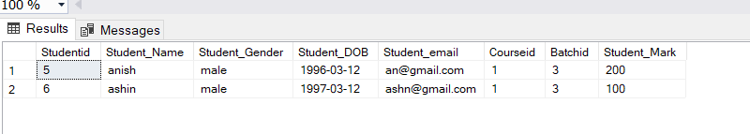

11. Select the details of BCA students whose batch is 2019-2022

select * from tblstudent where Courseid=(select Courseid from

tblcourse where Courseshortname='BCA') and Batchid=(select Batchid

from tblbatch where BatchName='2019-2022');

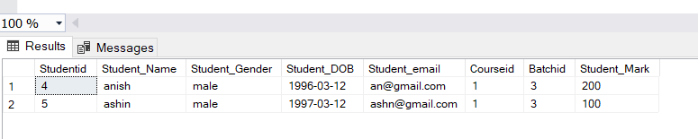

12. Select all the course short name and total number of students

SELECT c.Courseshortname AS Course_name ,COUNT(*) AS Count_students

FROM tblcourse c JOIN tblstudent s

ON s.Courseid = c.Courseid GROUP BY c.Courseshortname;

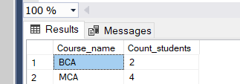

13. Select the details UG Students

select * from tblstudent where Courseid IN(select Courseid from

tblcourse where Coursetype='UG');

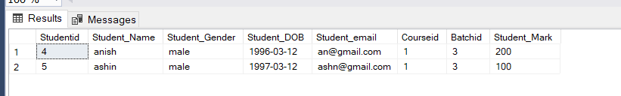

14. Select the details of PG Students

select * from tblstudent where Courseid IN(select Courseid from

tblcourse where Coursetype='PG');

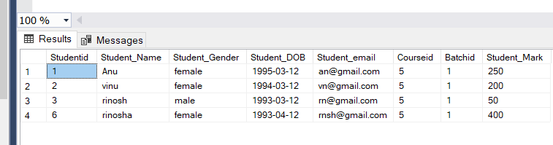

15. Select the details of MCA Students whose batch is 2019-2021

select * from tblstudent where Courseid =(select Courseid from

tblcourse where Courseshortname='MCA') AND Batchid=(select Batchid

from tblbatch where BatchName='2019-2021');

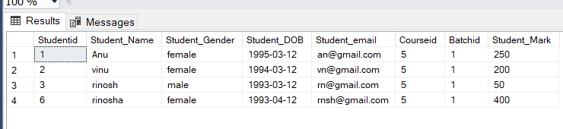

16. Select the email and DOB of BCA Students

select Student_Email,Student_DOB from tblstudent where

Courseid=(select Courseid from tblcourse where

Courseshortname='BCA');

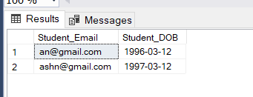

17. Select the students details with their course name and batch name

select s.Student_Name AS Student_Name ,c.Coursename AS

Course_Name,b.BatchName from tblcourse c JOIN tblstudent s ON

s.Courseid=c.Courseid JOIN tblbatch b ON b.Batchid=s.Batchid;

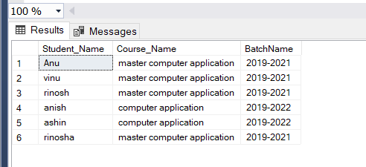

18. Select Batch name and number of students

SELECT b.BatchName AS Batch_Name ,COUNT(*) AS Count_students FROM

tblbatch b JOIN tblstudent s ON s.Batchid = b.Batchid GROUP BY

b.BatchName;

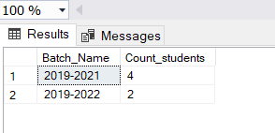

19. Select the students name, course name and students email

select s.Student_Name AS Student_Name ,c.Coursename AS

CourseName,S.Student_email from tblcourse c JOIN tblstudent s ON

s.Courseid=c.Courseid ;

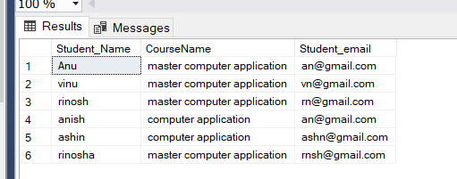

20. Select the Students details and their Batch name also

select s.* ,b.BatchName AS Batch_Name from tblbatch b JOIN

tblstudent s ON s.Batchid=b.Batchid ;

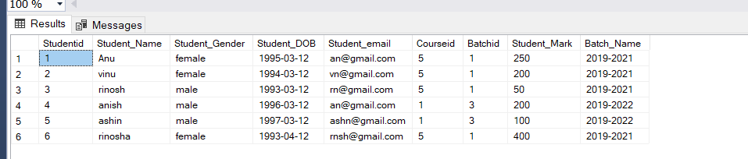

21. Select the count of male and female students in batch wise

SELECT b.BatchName,COUNT(case when Student_Gender='male' then 1 end)

AS Total_Male,

COUNT(case when Student_Gender='female' then 1 end)As Total_Female from

tblstudent s JOIN tblbatch b ON b.Batchid=s.Batchid GROUP BY

b.BatchName;

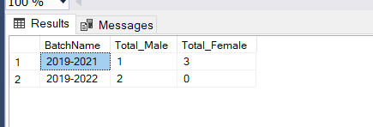

22. Select the name of the BCA Student who have Maximum Mark

SELECT Student_Name FROM tblstudent WHERE Student_Mark=(select

MAX(Student_Mark)from tblstudent where Courseid=(select Courseid

from tblcourse where Courseshortname='BCA'));

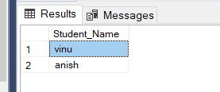

23. Select the Male MCA Student who have Minimum Mark

SELECT Student_Name FROM tblstudent WHERE Student_Mark=(select

MIN(Student_Mark)from tblstudent where Courseid=(select Courseid

from tblcourse where Courseshortname='MCA') and Student_Gender='male');

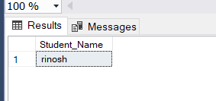

24. Select the students details of UG Students who have greater than the average mark

SELECT * FROM tblstudent WHERE Student_Mark >(select

AVG(Student_Mark)from tblstudent where Courseid IN (select

Courseid from tblcourse where Coursetype='UG'))AND Courseid IN

(select Courseid from tblcourse where Coursetype='UG');

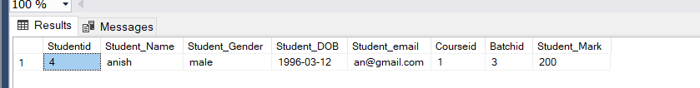

25. Select the BCA student details who have Max Mark

SELECT * FROM tblstudent WHERE Student_Mark=(select

MAX(Student_Mark)from tblstudent where Courseid=(select Courseid

from tblcourse where Courseshortname='BCA'));

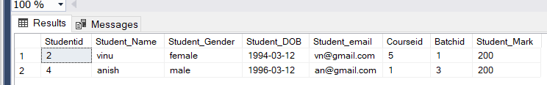

26. Select Name and Email of the students who have second highest mark

SELECT Student_Name,Student_email from tblstudent where

Student_Mark= (select MAX(Student_Mark) FROM tblstudent WHERE

Student_Mark < (SELECT MAX(Student_Mark) FROM tblstudent));

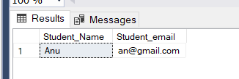

27. Select the Dob and Current Age of All students

Select Student_Name,Student_Dob,datediff(YY,Student_DOB,getdate())

as Age

from tblstudent;

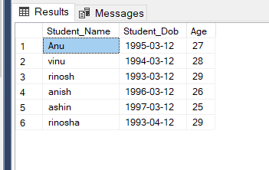

28. Select the Student name , Month name of birth and year of birth for all the students

Select

Student_Name , DATENAME(MONTH,DATEADD(MONTH,MONTH(Student_DOB),-1 ))

AS Birth_Month,YEAR(Student_DOB) AS Year_Of_Birth FROM tblstudent;

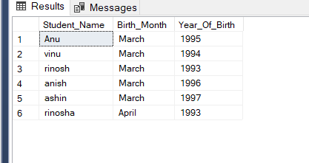

29. Select the Email and Student DOB of MCA Female Students

select Student_Email,Student_DOB from tblstudent where

Courseid=(select Courseid from tblcourse where

Courseshortname='MCA') AND Student_Gender='female';

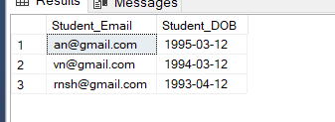

30. Select the name of all the students who have maximum mark in course wise

SELECT c.Courseshortname AS Course, MAX(s.Student_Mark) AS Max_Mark

FROM tblcourse c JOIN tblstudent s

ON s.Courseid = c.Courseid GROUP BY c.Courseshortname;

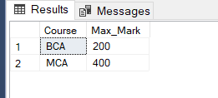

31. Select the Details students whose year of birth less than 1995

Select * from tblstudent where YEAR(Student_DOB)<1995;

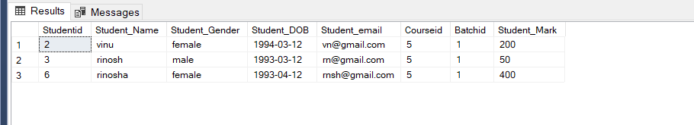

32. Select the Course short name, Batch name , total number of students in batch and Course wise

33. Select details of BCA Students whose year of birth between 1992 and 1996

Select * from tblstudent where Courseid=(select Courseid from

tblcourse where Courseshortname='BCA') AND YEAR(Student_DOB)BETWEEN

1992 AND 1996;

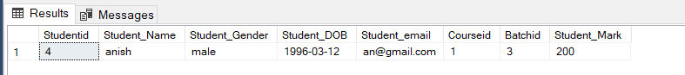

34. Select the details of Male PG Students

SELECT * FROM tblstudent WHERE Student_Gender='male' AND Courseid

in(select Courseid from tblcourse where Coursetype='PG');

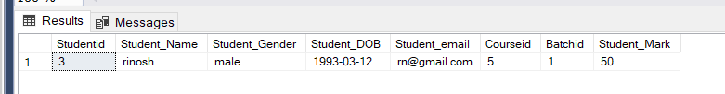

35. Select the details of BCA Students who have greater than average mark

select*FROM tblstudent WHERE Student_Mark >(select AVG(Student_Mark)from

tblstudent where Courseid IN (select Courseid from tblcourse where

Courseshortname='BCA'))AND Courseid IN (select Courseid from

tblcourse where Courseshortname='BCA');

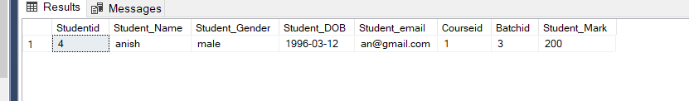

36. Select the details BCA – 2019-2022 Batch Students

SELECT * FROM tblstudent WHERE Courseid=(select Courseid from

tblcourse where Courseshortname='BCA')AND Batchid=(SELECT Batchid

FROM tblbatch WHERE BatchName='2019-2022');

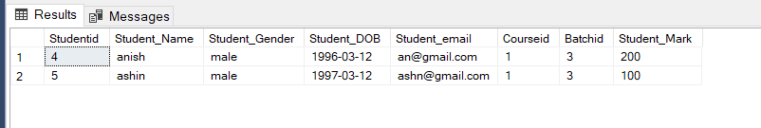

37. Select the name of student having maximum age?

SELECT Student_Name from tblstudent ORDER BY

datediff(YY,Student_DOB,getdate()) DESC OFFSET 0 ROWS FETCH FIRST 1

ROWS ONLY;

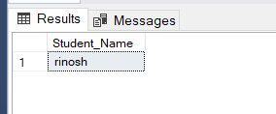

38. Select the name and email of the BCA Students whose have Minimum age

SELECT Student_Name,Student_Email from tblstudent WHERE

Courseid=(select Courseid from tblcourse where

Courseshortname='BCA')

ORDER BY datediff(YY,Student_DOB,getdate()) ASC OFFSET 0 ROWS FETCH

FIRST 1 ROWS ONLY;

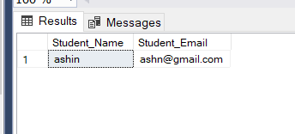

39. Select the details of the students in descending order of their DOB

Select * from tblstudent ORDER BY Student_DOB DESC;

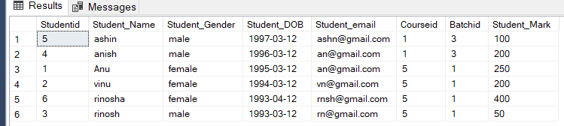

40. Select the details of the students have mark between 49 and 240

SELECT * FROM tblstudent WHERE Student_Mark BETWEEN 49 AND 240;

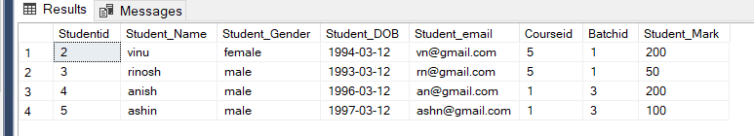

41. Select the details of BCA Students in their mark wise

SELECT * FROM tblstudent WHERE Courseid=(SELECT Courseid from

tblcourse where Courseshortname='BCA') ORDER BY Student_Mark DESC;

