**.NET DESKTOP C# Application Development in Visual Studio**

**Configurations**:

.NET Framework Version 4.7

MS SQL EXRESS SERVER 2012

Microsoft Visual Studio Express 2017 Version 15.9.12

**Create a Class Library for checking Internet Connectivity**

* Install Microsoft Visual Studio Community 2017

<https://visualstudio.microsoft.com/vs/express/>

* Install MS SQL EXPRESS SERVER 2012

<https://www.microsoft.com/en-in/download/details.aspx?id=29062>

* Install Microsoft SQL SERVER MANAGEMENT STUDIO

<https://www.microsoft.com/en-in/download/details.aspx?id=29062>

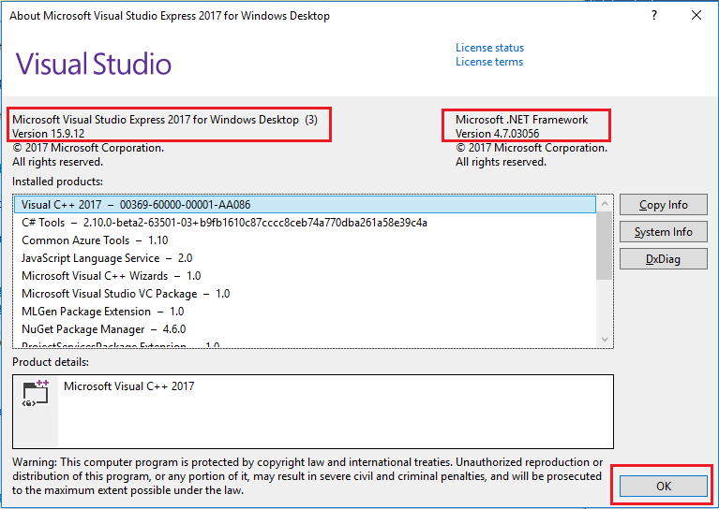

**Step 1:**

After installing Microsoft Visual Studio Express 2017, double click on the icon to open IDE. Create a new Project as shown in screen shot. From the **File** menu, select **New** and then select **Project**.

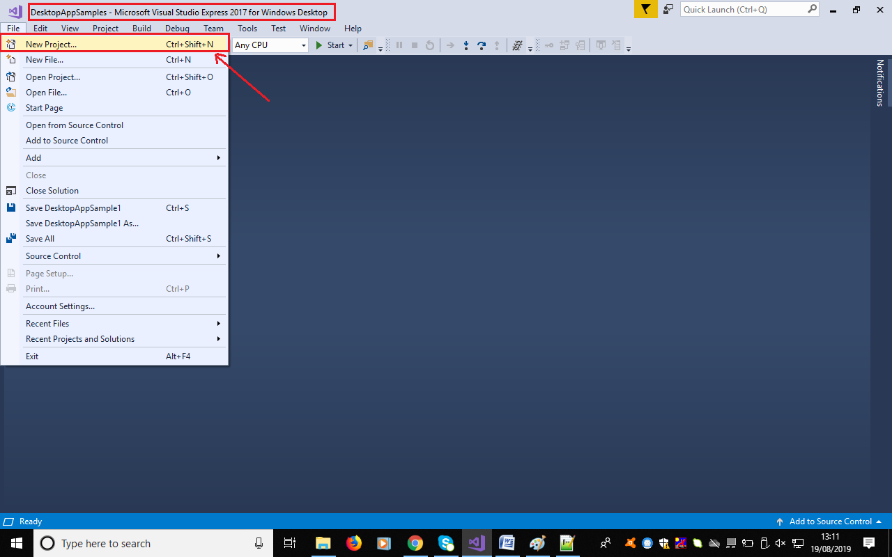

**Step 2:**

Select **Windows Desktop** and choose **Class Library**, then provide the name of the project and solution name. One solution can contain ‘n’ number of projects. Each project can act as a DLL.

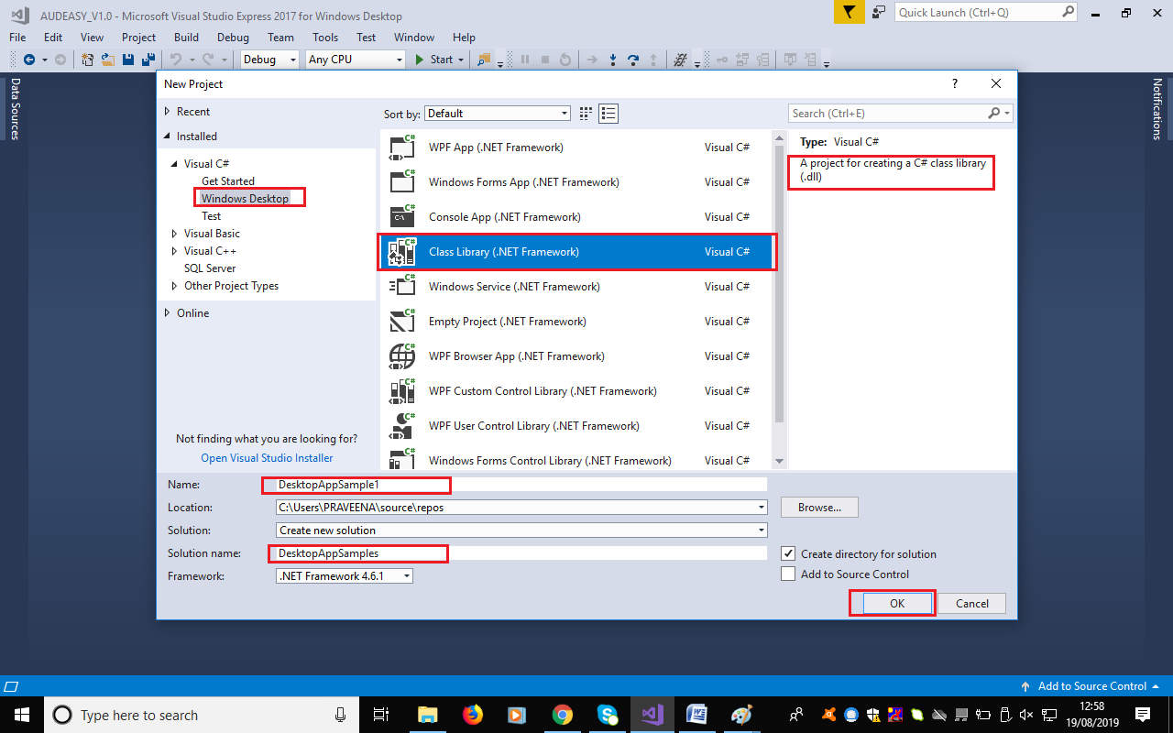

**Step 3:**

Upon clicking on **OK,** project file directory gets created with a default class file named “class1.cs”. Rename the file to “InternetConnectivity.cs”. Place the code and run the application.

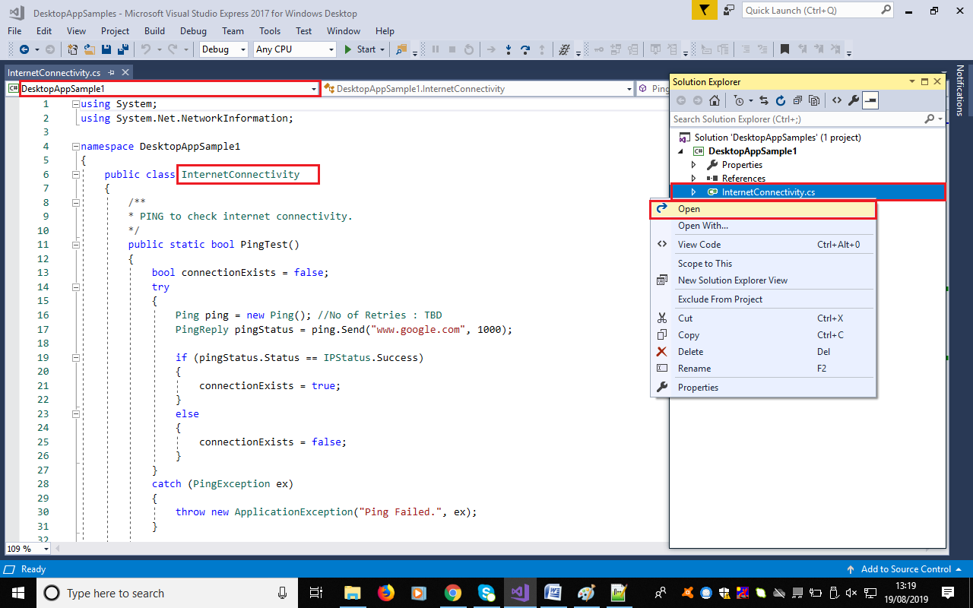

**Step 4:**

Right click on **Project**, and choose **Build**.

After the build is successful, Get to the project source directory,

**source/repos/DesktopAppSamples/DesktopAppSample1/bin/Debug**

Find the DLL file available in this directory, **DesktopAppSample1.dll**

**Step 5:** Building a client application to use the class library is not in the scope of this project. Please refer to other projects in Gitub.