A sequence is a datatype that represents a group of elements. The purpose of any sequence is to store and process group elements. In python, strings, lists, tuples and dictionaries are very important sequence datatypes.

# LIST:

A list is similar to an array that consists of a group of elements or items. Just like an array, a list can store elements. But, there is one major difference between an array and a list. An array can store only one type of elements whereas a list can store different types of elements. Hence lists are more versatile and useful than an array.

## Creating a List:

Creating a list is as simple as putting different comma-separated values between square brackets.

student = [556, “Mothi”, 84, 96, 84, 75, 84 ]

We can create empty list without any elements by simply writing empty square brackets as: student=[ ]

We can create a list by embedding the elements inside a pair of square braces []. The elements in the list should be separated by a comma (,).

## Accessing Values in list:

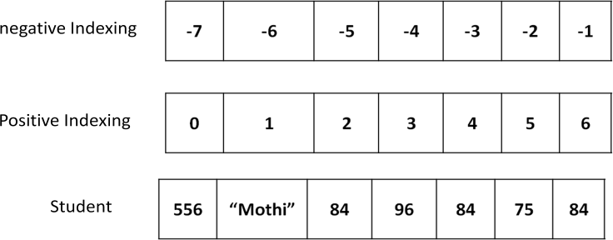To access values in lists, use the square brackets for slicing along with the index or indices to obtain value available at that index. To view the elements of a list as a whole, we can simply pass the list name to print function.

## Ex:

student = [556, “Mothi”, 84, 96, 84, 75, 84 ] print student

print student[0] # Access 0th element

print student[0:2] # Access 0th to 1st elements

print student[2: ] # Access 2nd to end of list elements print student[ :3] # Access starting to 2nd elements print student[ : ] # Access starting to ending elements print student[-1] # Access last index value

print student[-1:-7:-1] # Access elements in reverse order

## Output:

[556, “Mothi”, 84, 96, 84, 75, 84]

Mothi

[556, “Mothi”]

[84, 96, 84, 75, 84]

[556, “Mothi”, 84]

[556, “Mothi”, 84, 96, 84, 75, 84]

84

[84, 75, 84, 96, 84, “Mothi”]

## Creating lists using range() function:

We can use range() function to generate a sequence of integers which can be stored in a list. To store numbers from 0 to 10 in a list as follows.

numbers = list( range(0,11) )

print numbers # [0,1,2,3,4,5,6,7,8,9,10]

To store even numbers from 0 to 10in a list as follows. numbers = list( range(0,11,2) )

print numbers # [0,2,4,6,8,10]

## Looping on lists:

We can also display list by using for loop (or) while loop. The len( ) function useful to know the numbers of elements in the list. while loop retrieves starting from 0th to the last element i.e. n-1

## Ex-1:

numbers = [1,2,3,4,5] for i in numbers:

print i,

## Output:

1 2 3 4 5

## Updating and deleting lists:

Lists are *mutable*. It means we can modify the contents of a list. We can append, update or delete the elements of a list depending upon our requirements.

Appending an element means adding an element at the end of the list. To, append a new element to the list, we should use the append() method.

## Example:

lst=[1,2,4,5,8,6]

print lst # [1,2,4,5,8,6] lst.append(9)

print lst # [1,2,4,5,8,6,9]

Updating an element means changing the value of the element in the list. This can be done by accessing the specific element using indexing or slicing and assigning a new value.

## Example:

lst=[4,7,6,8,9,3]

print lst # [4,7,6,8,9,3]

lst[2]=5 # updates 2nd element in the list print lst # [4,7,5,8,9,3]

lst[2:5]=10,11,12 # update 2nd element to 4th element in the list print lst # [4,7,10,11,12,3]

Deleting an element from the list can be done using *‘del’* statement. The *del* statement takes the position number of the element to be deleted.

## Example:

lst=[5,7,1,8,9,6]

del lst[3] # delete 3rd element from the list i.e., 8 print lst # [5,7,1,9,6]

If we want to delete entire list, we can give statement like *del lst.*

## Concatenation of Two lists:

We can simply use „+‟ operator on two lists to join them. For example, „x‟ and „y‟ are two lists. If we wrte x+y, the list „y‟ is joined at the end of the list „x‟.

## Example:

x=[10,20,32,15,16]

y=[45,18,78,14,86]

print x+y # [10,20,32,15,16,45,18,78,14,86]

## Repetition of Lists:

We can repeat the elements of a list „n‟ number of times using „*‟ operator. x=[10,54,87,96,45]

print x*2 # [10,54,87,96,45,10,54,87,96,45]

## Membership in Lists:

We can check if an element is a member of a list by using „in‟ and „not in‟ operator. If the element is a member of the list, then „in‟ operator returns **True** otherwise returns **False**. If the element is not in the list, then „not in‟ operator returns **True** otherwise returns **False**.

## Example:

x=[10,20,30,45,55,65] a=20

print a in x # True a=25

print a in x # False a=45

print a not in x # False a=40

print a not in x # True

## Aliasing and Cloning Lists:

Giving a new name to an existing list is called *‘aliasing’.* The new name is called

*‘alias name’.* To provide a new name to this list, we can simply use assignment operator (=).

## Example:

x = [10, 20, 30, 40, 50, 60]

y=x # x is aliased as y

print x # [10,20,30,40,50,60]

print y # [10,20,30,40,50,60]

x[1]=90 # modify 1st element in x print x # [10,90,30,40,50,60]

print y # [10,90,30,40,50,60]

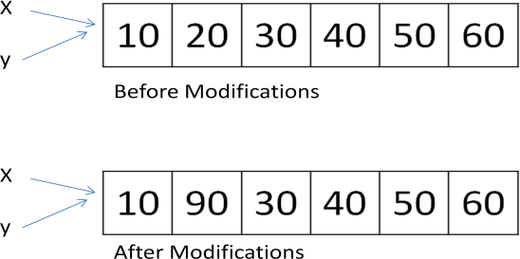

In this case we are having only one list of elements but with two different names „x‟ and „y‟. Here, „x‟ is the original name and „y‟ is the alias name for the same list. Hence, any modifications done to x‟ will also modify „y‟ and vice versa.

Obtaining exact copy of an existing object (or list) is called „*cloning*‟. To Clone a list, we can take help of the slicing operation [:].

## Example:

x = [10, 20, 30, 40, 50, 60]

y=x[:] # x is cloned as y

print x # [10,20,30,40,50,60]

print y # [10,20,30,40,50,60]

x[1]=90 # modify 1st element in x print x # [10,90,30,40,50,60]

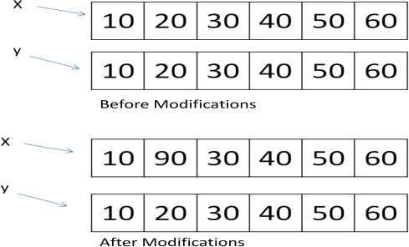print y # [10,20,30,40,50,60]

When we clone a list like this, a separate copy of all the elements is stored into „y‟. The lists „x‟ and „y‟ are independent lists. Hence, any modifications to „x‟ will not affect „y‟ and vice versa.

## Methods in Lists:

|  |  |
| --- | --- |
| **Method** | **Description** |
| *lst.index(x)* | Returns the first occurrence of x in the list. |
| *lst.append(x)* | Appends x at the end of the list. |
| *lst.insert(i,x)* | Inserts x to the list in the position specified by i. |
| *lst.copy()* | Copies all the list elements into a new list and returns it. |
| *lst.extend(lst2)* | Appends lst2 to list. |
| *lst.count(x)* | Returns number of occurrences of x in the list. |
| *lst.remove(x)* | Removes x from the list. |
| *lst.pop()* | Removes the ending element from the list. |
| *lst.sort()* | Sorts the elements of list into ascending order. |
| *lst.reverse()* | Reverses the sequence of elements in the list. |
| *lst.clear()* | Deletes all elements from the list. |
| *max(lst)* | Returns biggest element in the list. |
| *min(lst)* | Returns smallest element in the list. |

**Example:**

lst=[10,25,45,51,45,51,21,65]

lst.insert(1,46)

print lst # [10,46,25,45,51,45,51,21,65]

print lst.count(45) # 2

## Finding Common Elements in Lists:

Sometimes, it is useful to know which elements are repeated in two lists. For example, there is a scholarship for which a group of students enrolled in a college. There is another scholarship for which another group of students got enrolled. Now, we wan to know the names of the students who enrolled for both the scholarships so that we can restrict them to take only one scholarship. That means, we are supposed to find out the common students (or elements) both the lists.

First of all, we should convert the lists into lists into sets, using set( ) function, as: set(list). Then we should find the common elements in the two sets using intersection() method.

## Example:

scholar1=[ „mothi‟, „sudheer‟, „vinay‟, „narendra‟, „ramakoteswararao‟ ] scholar2=[ „vinay‟, „narendra‟, „ramesh‟]

s1=set(scholar1) s2=set(scholar2) s3=s1.intersection(s2) common =list(s3)

print common # display [ „vinay‟, „narendra‟ ]

## Nested Lists:

A list within another list is called a *nested list*. We know that a list contains several elements. When we take a list as an element in another list, then that list is called a nested list.

## Example:

a=[10,20,30]

b=[45,65,a]

print b # display [ 45, 65, [ 10, 20, 30 ] ] print b[1] # display 65

print b[2] # display [ 10, 20, 30 ] print b[2][0] # display 10

print b[2][1] # display 20 print b[2][2] # display 30 for x in b[2]:

print x, # display 10 20 30

## Nested Lists as Matrices:

Suppose we want to create a matrix with 3 rows 3 columns, we should create a list with 3 other lists as:

mat = [ [ 1, 2, 3 ] , [ 4, 5, 6 ] , [ 7, 8, 9 ] ]

Here, „mat‟ is a list that contains 3 lists which are rows of the „mat‟ list. Each row contains again 3 elements as:

[ [ 1, 2, 3] , # first row

[ 4, 5, 6] , # second row

[ 7, 8, 9] ] # third row

## Example:

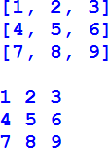

mat=[[1,2,3],[4,5,6],[7,8,9]]

m=len(mat) n=len(mat[0])

print ""

for i in range(0,m): for j in range(0,n):

print mat[i][j], print ""

for r in mat: print r

print ""

One of the main use of nested lists is that they can be used to represent matrices. A matrix represents a group of elements arranged in several rows and columns. In python, matrices are created as 2D arrays or using matrix object in numpy. We can also create a matrix using nested lists.

Q) Write a program to perform addition of two matrices.



a=[[1,2,3],[4,5,6],[7,8,9]]

b=[[4,5,6],[7,8,9],[1,2,3]]

c=[[0,0,0],[0,0,0],[0,0,0]]

m1=len(a) n1=len(a[0]) m2=len(b) n2=len(b[0])

for i in range(0,m1): for j in range(0,n1):

c[i][j]= a[i][j]+b[i][j] for i in range(0,m1):

for j in range(0,n1): print "\t",c[i][j],

print ""

1. Write a program to perform multiplication of two matrices.

a=[[1,2,3],[4,5,6]]

b=[[4,5],[7,8],[1,2]] c=[[0,0],[0,0]]

m1=len(a) n1=len(a[0]) m2=len(b) n2=len(b[0])

for i in range(0,m1): for j in range(0,n2):

print "\t",c[i][j], print ""

for i in range(0,m1): for j in range(0,n2):

for k in range(0,n1): c[i][j] += a[i][k]*b[k][j]

# List Comprehensions:

List comprehensions represent creation of new lists from an iterable object (like a list, set, tuple, dictionary or range) that satisfy a given condition. List comprehensions contain very compact code usually a single statement that performs the task.

We want to create a list with squares of integers from 1 to 100. We can write code as:

squares=[ ]

for i in range(1,11):

squares.append(i**2)

The preceding code will create „squares‟ list with the elements as shown below:

[ 1, 4, 9, 16, 25, 36, 49, 64, 81, 100 ]

The previous code can rewritten in a compact way as:

squares=[x**2 for x in range(1,11)]

This is called list comprehension. From this, we can understand that a list comprehension consists of square braces containing an expression (i.e., x**2). After the expression, a fro loop and then zero or more if statements can be written.

|  |  |  |  |  |  |  |
| --- | --- | --- | --- | --- | --- | --- |
| [ expression | for | item1 | in | iterable | if | statement1 |
|  | for | item1 | in | iterable | if | statement2 |
|  | for | item1 | in | iterable | if | statement3 …..] |

## Example:

Even_squares = [ x**2 for x in range(1,11) if x%2==0 ] It will display the list even squares as list.

[ 4, 16, 36, 64, 100 ]

# TUPLE:

A Tuple is a python sequence which stores a group of elements or items. Tuples are similar to lists but the main difference is tuples are immutable whereas lists are mutable. Once we create a tuple we cannot modify its elements. Hence, we cannot perform operations like append(), extend(), insert(), remove(), pop() and clear() on tuples. Tuples are generally used to store data which should not be modified and retrieve that data on demand.

## Creating Tuples:

We can create a tuple by writing elements separated by commas inside parentheses( ).

The elements can be same datatype or different types.

To create an empty tuple, we can simply write empty parenthesis, as:

tup=( )

To create a tuple with only one element, we can, mention that element in parenthesis and after that a comma is needed. In the absence of comma, python treats the element assign ordinary data type.

|  |  |  |  |
| --- | --- | --- | --- |
| tup = (10) |  | tup = (10,) |  |
| print tup | # display 10 | print tup | # display 10 |
| print type(tup) | # display <type „int‟> | print type(tup) | # display<type „tuple‟> |

To create a tuple with different types of elements:

tup=(10, 20, 31.5, „Gudivada‟)

If we do not mention any brackets and write the elements separating them by comma, then they are taken by default as a tuple.

tup= 10, 20, 34, 47

It is possible to create a tuple from a list. This is done by converting a list into a tuple using tuple function.

Another way to create a tuple by using range( ) function that returns a sequence.

n=[1,2,3,4]

tp=tuple(n)

print tp # display (1,2,3,4)

t=tuple(range(2,11,2))

print t # display (2,4,6,8,10)

## Accessing the tuple elements:

Accessing the elements from a tuple can be done using indexing or slicing. This is same as that of a list. Indexing represents the position number of the element in the tuple. The position starts from 0.

tup=(50,60,70,80,90)

print tup[0] # display 50

print tup[1:4] # display (60,70,80)

print tup[-1] # display 90

print tup[-1:-4:-1] # display (90,80,70) print tup[-4:-1] # display (60,70,80)

## Updating and deleting elements:

Tuples are immutable which means you cannot update, change or delete the values of tuple elements.

## Example-1:

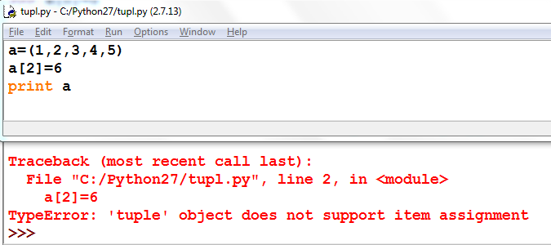

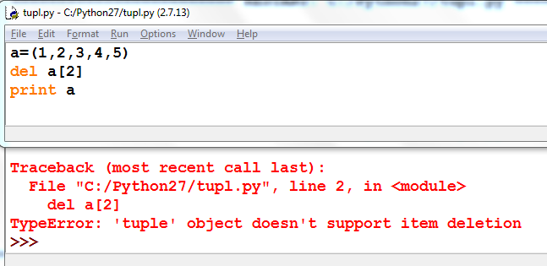**Example-2:**

However, you can always delete the entire tuple by using the statement.

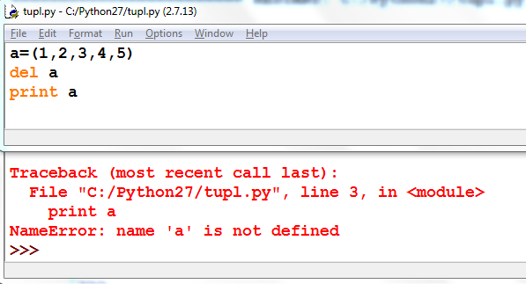

Note that this exception is raised because you are trying print the deleted element.

## Operations on tuple:

|  |  |
| --- | --- |
| **Operation** | **Description** |
| len(t) | Return the length of tuple. |
| tup1+tup2 | Concatenation of two tuples. |
| Tup*n | Repetition of tuple values in n number of times. |
| x in tup | Return True if x is found in tuple otherwise returns False. |
| cmp(tup1,tup2) | Compare elements of both tuples |
| max(tup) | Returns the maximum value in tuple. |
| min(tup) | Returns the minimum value in tuple. |
| tuple(list) | Convert list into tuple. |
| tup.count(x) | Returns how many times the element „x‟ is found in  tuple. |
| tup.index(x) | Returns the first occurrence of the element „x‟ in tuple.  Raises ValueError if „x‟ is not found in the tuple. |
| sorted(tup) | Sorts the elements of tuple into ascending order.  sorted(tup,reverse=True) will sort in reverse order. |

**cmp(tuple1, tuple2)**

The method **cmp()** compares elements of two tuples.

## Syntax

cmp(tuple1, tuple2)

## Parameters

**tuple1** -- This is the first tuple to be compared

**tuple2** -- This is the second tuple to be compared

## Return Value

If elements are of the same type, perform the compare and return the result. If elements are different types, check to see if they are numbers.

* + If numbers, perform numeric coercion if necessary and compare.
  + If either element is a number, then the other element is "larger" (numbers are "smallest").
  + Otherwise, types are sorted alphabetically by name.

If we reached the end of one of the tuples, the longer tuple is "larger." If we exhaust both tuples and share the same data, the result is a tie, meaning that 0 is returned.

## Example:

**Nested Tuples:**

tuple1 = (123, 'xyz')

tuple2 = (456, 'abc')

print cmp(tuple1, tuple2) print cmp(tuple2, tuple1)

#display -1

#display 1

Python allows you to define a tuple inside another tuple. This is called a *nested tuple*.

**Output:** (“RAVI”, “CSE”, 92.00)

students=((“RAVI”, “CSE”, 92.00), (“RAMU”, “ECE”, 93.00), (“RAJA”, “EEE”, 87.00))

for i in students:

print i

(“RAMU”, “ECE”, 93.00)

(“RAJA”, “EEE”, 87.00)

# SET:

Set is another data structure supported by python. Basically, sets are same as lists but

with a difference that sets are lists with no duplicate entries. Technically a set is a mutable and an unordered collection of items. This means that we can easily add or remove items from it.

## Creating a Set:

A set is created by placing all the elements inside curly brackets {}. Separated by comma or by using the built-in function set( ).

## Syntax:

**Example:**

s={1, 2.5, “abc” }

print s

# display set( [ 1, 2.5, “abc” ] )

Set_variable_name={var1, var2, var3, var4, …….}

**Converting a list into set:**

A set can have any number of items and they may be of different data types. *set()*

function is used to converting list into set.

s=set( [ 1, 2.5, “abc” ] )

print s # display set( [ 1, 2.5, “abc” ] )

We can also convert tuple or string into set.

tup= ( 1, 2, 3, 4, 5 )

print set(tup) # set( [ 1, 2, 3, 4, 5 ] ) str= “MOTHILAL”

print str # set( [ 'i', 'h', 'm', 't', 'o' ] )

## Operations on set:

|  |  |  |
| --- | --- | --- |
| **Sno** | **Operation** | **Result** |
| 1 | len(s) | number of elements in set *s* (cardinality) |
| 2 | x in s | test *x* for membership in *s* |
| 3 | x not in s | test *x* for non-membership in *s* |
| 4 | s.issubset(t) (or)  s <= t | test whether every element in *s* is in *t* |
| 5 | s.issuperset(t) (or)  s >= t | test whether every element in *t* is in *s* |
| 6 | s = = t | Returns True if two sets are equivalent and returns False. |
| 7 | s ! = t | Returns True if two sets are not equivalent and returns False. |
| 8 | s.union(t) (or)  s|t | new set with elements from both *s* and *t* |
| 9 | s.intersection(t) (or)  s & t | new set with elements common to *s* and *t* |

|  |  |  |
| --- | --- | --- |
| **Sno** | **Operation** | **Result** |
| 10 | s.difference(t) (or)  s-t | new set with elements in *s* but not in *t* |
| 11 | s.symmetric_difference(t) (or)  s ^ t | new set with elements in either *s* or *t* but not both |
| 12 | s.copy() | new set with a shallow copy of *s* |
| 13 | s.update(t) | return set s with elements added from t |
| 14 | s.intersection_update(t) | return set s keeping only elements also found in t |
| 15 | s.difference_update(t) | return set s after removing elements found in t |
| 16 | s.symmetric_difference_up date(t) | return set s with elements from s or t but not both |
| 17 | s.add(x) | add element x to set s |
| 18 | s.remove(x) | remove x from set s; raises KeyError if not present |
| 19 | s.discard(x) | removes x from set s if present |
| 20 | s.pop() | remove and return an arbitrary element from s; raises KeyError if empty |
| 21 | s.clear() | remove all elements from set s |
| 22 | max(s) | Returns Maximum value in a set |
| 23 | min(s) | Returns Minimum value in a set |
| 24 | sorted(s) | Return a new sorted list from the elements in the set. |

**Note:**

To create an empty set you cannot write s={}, because python will make this as a

directory. Therefore, to create an empty set use *set( )* function.

s=set( )

print type(s) # display <type „set‟>

s={}

print type(s) # display <type „dict‟>

## Updating a set:

Since sets are unordered, indexing has no meaning. Set operations do not allow users to access or change an element using indexing or slicing.

# Dictionary:

A dictionary represents a group of elements arranged in the form of key-value pairs. The first element is considered as „key‟ and the immediate next element is taken as its

„value‟. The key and its value are separated by a colon (:). All the key-value pairs in a dictionary are inserted in curly braces { }.

d= { „Regd.No‟: 556, „Name‟:‟Mothi‟, „Branch‟: „CSE‟ }

Here, the name of dictionary is „dict‟. The first element in the dictionary is a string

„Regd.No‟. So, this is called „key‟. The second element is 556 which is taken as its „value‟.

## Example:

d= { „Regd.No‟: 556, „Name‟:‟Mothi‟, „Branch‟: „CSE‟ } print d[„Regd.No‟] # 556

print d[„Name‟] # Mothi

print d[„Branch‟] # CSE

To access the elements of a dictionary, we should not use indexing or slicing. For example,

dict[0] or dict[1:3] etc. expressions will give error. To access the value associated with a key, we can mention the key name inside the square braces, as: dict[„Name‟].

If we want to know how many key-value pairs are there in a dictionary, we can use the len( ) function, as shown

d= { „Regd.No‟: 556, „Name‟:‟Mothi‟, „Branch‟: „CSE‟ } print len(d) # 3

We can also insert a new key-value pair into an existing dictionary. This is done by mentioning the key and assigning a value to it.

d={'Regd.No':556,'Name':'Mothi','Branch':'CSE'}

print d #{'Branch': 'CSE', 'Name': 'Mothi', 'Regd.No': 556} d['Gender']="Male"

print d # {'Gender': 'Male', 'Branch': 'CSE', 'Name': 'Mothi', 'Regd.No': 556} Suppose, we want to delete a key-value pair from the dictionary, we can use *del* statement as:

del dict[„Regd.No‟] #{'Gender': 'Male', 'Branch': 'CSE', 'Name': 'Mothi'}

To Test whether a „key‟ is available in a dictionary or not, we can use „in‟ and „not in‟ operators. These operators return either True or False.

„Name‟ in d # check if „Name‟ is a key in d and returns True / False

We can use any datatypes for value. For example, a value can be a number, string, list, tuple or another dictionary. But keys should obey the rules:

* + Keys should be unique. It means, duplicate keys are not allowd. If we enter same key again, the old key will be overwritten and only the new key will be available.

emp={'nag':10,'vishnu':20,'nag':20} print emp # {'nag': 20, 'vishnu': 20}

* + Keys should be immutable type. For example, we can use a number, string or tuples as keys since they are immutable. We cannot use lists or dictionaries as keys. If they are used as keys, we will get „TypeError‟.

emp={['nag']:10,'vishnu':20,'nag':20} Traceback (most recent call last):

File "<pyshell#2>", line 1, in <module> emp={['nag']:10,'vishnu':20,'nag':20}

TypeError: unhashable type: 'list'

## Dictionary Methods:

|  |  |
| --- | --- |
| **Method** | **Description** |
| d.clear() | Removes all key-value pairs from dictionary„d‟. |
| d2=d.copy() | Copies all elements from„d‟ into a new dictionary d2. |
| d.fromkeys(s [,v] ) | Create a new dictionary with keys from sequence„s‟ and  values all set to „v‟. |
| d.get(k [,v] ) | Returns the value associated with key „k‟. If key is not  found, it returns „v‟. |
| d.items() | Returns an object that contains key-value pairs of„d‟. The  pairs are stored as tuples in the object. |
| d.keys() | Returns a sequence of keys from the dictionary„d‟. |
| d.values() | Returns a sequence of values from the dictionary„d‟. |
| d.update(x) | Adds all elements from dictionary „x‟ to„d‟. |
| d.pop(k [,v] ) | Removes the key „k‟ and its value from„d‟ and returns the value. If key is not found, then the value „v‟ is returned. If key is not found and „v‟ is not mentioned then „KeyError‟  is raised. |
| d.setdefault(k [,v] ) | If key „k‟ is found, its value is returned. If key is not  found, then the k, v pair is stored into the dictionary„d‟. |

**Using for loop with Dictionaries:**

*for* loop is very convenient to retrieve the elements of a dictionary. Let‟s take a simple dictionary that contains color code and its name as:

colors = { 'r':"RED", 'g':"GREEN", 'b':"BLUE", 'w':"WHITE" }

Here, „r‟, „g‟, „b‟ represents keys and „RED‟, „GREEN‟, „BLUE‟ and „WHITE‟ indicate values.

colors = { 'r':"RED", 'g':"GREEN", 'b':"BLUE", 'w':"WHITE" }

for k in colors:

print k # displays only keys for k in colors:

print colors[k] # keys to to dictionary and display the values

## Converting Lists into Dictionary:

When we have two lists, it is possible to convert them into a dictionary. For example, we have two lists containing names of countries and names of their capital cities.

There are two steps involved to convert the lists into a dictionary. The first step is to create a „zip‟ class object by passing the two lists to zip( ) function. The zip( ) function is useful to convert the sequences into a zip class object. The second step is to convert the zip object into a dictionary by using dict( ) function.

## Example:

countries = [ 'USA', 'INDIA', 'GERMANY', 'FRANCE' ]

cities = [ 'Washington', 'New Delhi', 'Berlin', 'Paris' ] z=zip(countries, cities)

d=dict(z) print d

**Output:**

{'GERMANY': 'Berlin', 'INDIA': 'New Delhi', 'USA': 'Washington', 'FRANCE': 'Paris'}

## Converting Strings into Dictionary:

When a string is given with key and value pairs separated by some delimiter like a comma ( , ) we can convert the string into a dictionary and use it as dictionary.

s="Vijay=23,Ganesh=20,Lakshmi=19,Nikhil=22" s1=s.split(',')

s2=[]

d={}

for i in s1: s2.append(i.split('='))

print d

{'Ganesh': '20', 'Lakshmi': '19', 'Nikhil': '22', 'Vijay': '23'}

## Q) A Python program to create a dictionary and find the sum of values.

d={'m1':85,'m3':84,'eng':86,'c':91}

sum=0

for i in d.values():

sum+=i

print sum # 346

**Q) A Python program to create a dictionary with cricket player’s names and scores in a match. Also we are retrieving runs by entering the player’s name.**

Enter How many players? 3 Enter Player name: "Sachin" Enter score: 98

n=input("Enter How many players? ") d={}

for i in range(0,n): k=input("Enter Player name: ") v=input("Enter score: ") d[k]=v

print d

name=input("Enter name of player for score: ") print "The Score is",d[name]

Enter Player name: "Sehwag" Enter score: 91

Enter Player name: "Dhoni" Enter score: 95

{'Sehwag': 91, 'Sachin': 98, 'Dhoni': 95} Enter name of player for score: "Sehwag" The Score is 91