Praveen Apuri 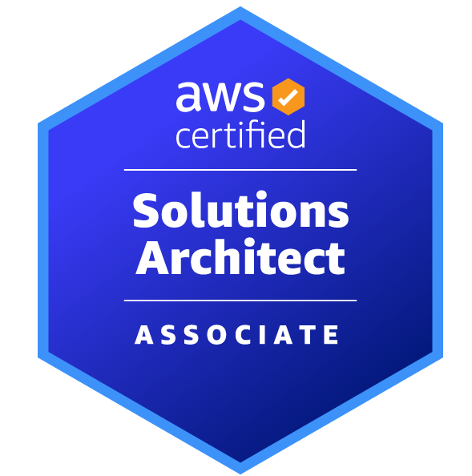 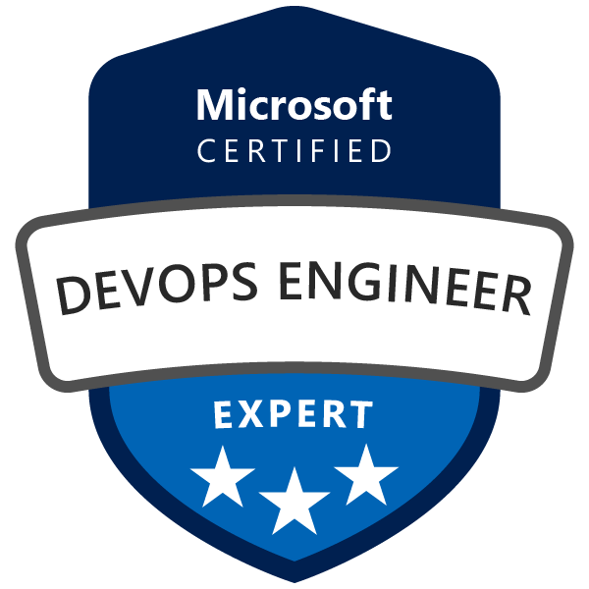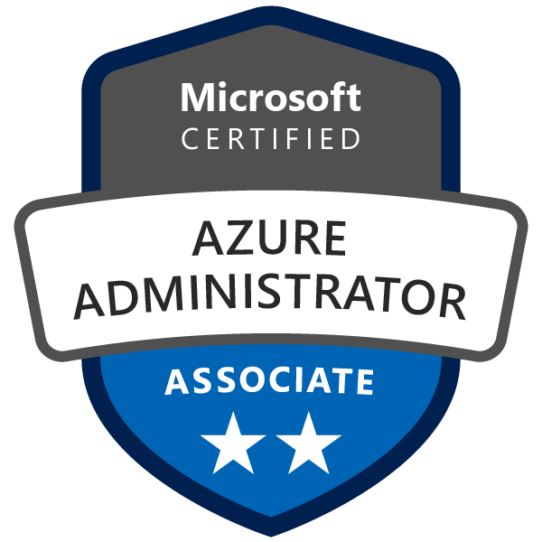

Senior - DevSecOps and Cloud Engineer
: 571-578-7171 : Praveen.Apuri@gmail.com

Citizenship: USA

----------------------------------------------------------------------------------------------------------------------------------------------
SUMMARY

- Experienced DevSecOps and Cloud Engineer with a strong background in DevSecOps, CICD, application Security, IaC, Automation, AWS, Azure DevOps, and Configuration management solutions.
- Adopted DevSecOps culture and Software Development Life Cycle (SDLC), implementing, and thought leadership for all the latest, best, and skewed practices of the IT Industry.
- Microsoft Certified DevOps Engineer Expert and Azure Administrator.
- AWS certified solution architect – associate
- Expertise working with Terraform features such as Infrastructure as Code, Execution plans, Resource graphs, etc
- Experience in building Liquibase pipelines for Database change deployment.
- An application security expert with rich experience architecting, implementing, and automating various application security tools in CICD pipelines.
- Expertise in performing QA automation and integration with CICD pipelines.
- Critical thinking DevOps Engineer with extensive understanding of high availability architecture and concepts. Purpose-driven professional with the capacity to be a strong team player and work effectively independently.
- Software development experience spanning Solution Architecture, DevOps, Security, Agile project management, Site Reliability, web development, and hands-on application troubleshooting in enterprise and Azure PaaS and IaaS for multiple production workloads.

CERTIFICATIONS

AZ-400: Microsoft Certified DevOps Engineer Expert
AZ-104: Microsoft Certified Azure Administrator
SAA-CO3: AWS Certified Solution Architect - Associate

TECHNICAL SKILLS

Core Skills | CICD, Azure, Azure DevOps, AWS DevOps, Docker, Kubernetes, Terraform, Python
Collaboration | JIRA, Rally, Azure Boards, Confluence
Version Control Software | GitHub, BitBucket, MKS, ClearCase, UCM, SVN, Azure Repo
Scripting | Bash, Power Shell, Groovy, XML
Build | Maven, Docker, MSBuild, Gradle
IaC | Terraform, Ansible, AWS Cloud Formation
CICD | Jenkins, Azure DevOps, AWS CodePipeline, GitHub Actions, XLR, UDeploy, AWS DevOps.
application security | SonarQube, CheckmarxOne, Prisma Cloud, Nessus, Trivy, Burp Suite, Claire, AWS Inspector, Synopsis, Snyk, etc
Cloud security | Nessus, Azure Security Center, Prisma Cloud, AWS Security Hub
Testing Frameworks | Playwright, Selenium, Karate, Pa11y, e2e, lint
Artifactory | JFrog Artifactory, Azure Container Registry, Nexus, DTR, ECR
Deployment | Kubernetes, Docker, OpenShift Container platform, Terraform, Ansible, UDeploy
Monitoring | Splunk, DataDog, Cloud Watch, Dynatrace
Cloud | Azure, AWS
Other Technical | WebSphere, Weblogic, JBOSS, Apache, My SQL, SQL Server 2005, Oracle 10i

EDUCATION

Bachelor of Technology (B.Tech) in Chemical Engineering From J N T University 2002, India

EXPERIENCE

TCS
Client: Cigna
Duration: 10/2022 to Present.

DevSecOps/ AWS Cloud Engineer

- Provisioning of AWS resources (EC2, PVC, SG, ASG, EKS, ECS, S3, Route 53) using CloudFormation and Terraform.
- Implemented serverless architecture using API Gateway, Lambda, and Dynamo DB also deployed Lambda code from S3 Buckets.
- Deployed RDS instances and provided endpoint details to database teams and managed database snapshot methods.
- Work with the Application development teams and resolve all Application security vulnerabilities.
- Configure and administer CheckmarxOne access management using SAML and Azure AD groups.
- Strategize, design, and implement CICD pipelines for applications migrating to AWS.
- Implemented serverless architecture using APIGateway, Lambda and Dynamo DB also deployed Lambda code from S3 Buckets.
- Strategize, design, and implementation of CICD pipelines for applications migrating to AWS.
- Build and document Liquibase pipelines for DB change deployments.
- Collaborate with the QA team and build QA Automation jobs. Also, integrate QA automation with application CICD pipelines. Used Playwright for webapps and Karate for API testing.
- Build Docker Images for applications that are getting refactored and containerized.
- Design and build CICD pipelines using AWS Code Build, Code Pipeline, Jenkins, and Udeploy.
- Provisioning of AWS resources (EC2, PVC, SG, ASG, EKS, ECS, S3, Route 53) using CloudFormation and Terraform.
- Implemented serverless architecture using APIGateway, Lambda and Dynamo DB also deployed Lambda code from S3 Buckets.

Creative Systems and Consulting Inc \ ICF inc, McLean VA
Duration: 4/2021 – 9/2022
Client: USDA
Lead DevSecOps Engineer

- Architected and implemented DevSecOps solutions to USDA Forest Service applications.
- Containerization of Forest Service application using docker.
- Built DevSecOps pipelines for Forest Service to deploy to on-premises and AWS environments.
- Implemented container scanning tools and automated with Jenkins pipelines.
- Provisioned VMs and deployed configurations using Terraform, and Ansible.
- Wrote Jenkins Pipeline code and automated Build and Deployments to Kubernetes using Helm.
- Analyzed Jenkins Shared Libraries and integrated Shared Libraries in Jenkins Pipeline for Application Deployments.
- Prepared, built, and deployed to non-prod environments, and released notes to the service delivery team for production deployments.
- Troubleshooted build issues and coordinated with Dev teams to fix issues.
- Configure and manage Nessus for Cloud infrastructure security scan.
- Configure and manage Azure Security Center for Advanced Threat Protection and security management.

Tech Trend Inc, Fairfax VA
Duration: 3/2020 – 3/2021
Client: USDA
Sr. DevSecOps Engineer

- Built and maintained FedRAMP-certified complete Dev Sec Ops (DSO) CI/CD pipeline using Jenkins and GitHub.
- Worked on Hybrid environment both Azure cloud and on-premises environment.
- Implemented GitHub Actions, created workflows, integrated with SonarQube to perform scan, build and deployed docker containers.
- Worked on Security scanning tools white source, SonarQube, SonarLint.
- Implemented JIRA with the DSO pipeline and integrated with GitHub and Jenkins.
- Integrated Selenium testing tool with the DSO pipeline.
- Designed and built DSO Portal application using Python and Angular.js. Built Python APIs to fetch data from different tools.

TD Bank, Mount Laurel, NJ
Duration: 05/09/2011 – 2/28/2020

IT Solutions Design Specialist \ Sr. DevOps Engineer

- Worked on the creation of custom Docker container images, tagging, and pushing the images.
- Setup V2 Docker registry for local image storage / management. Used Docker Registry API to interact with the registry.
- Worked on Docker container snapshots, attaching to a running container, removing images, managing director structures, and managing containers.
- Created and maintained fully automated CI/CD enterprise delivery pipeline using various DevOps tools like Jenkins, XLR, XLD, Salt, Docker, Nexus, BitBucket, etc.
- Groovy scripting for Jenkins jobs; Python scripting for SaltStack; Maven for REST APIs.
- Automated Code coverage, code scan using SonaType, VeraCode, SonarQube.
- Define source code management process using BitBukcket; branching, versioning, merging, managing pull requests, etc.
- Managing JIRA dash boards, release defects, workflows.
- Built and deployed Docker containers to break up monolithic app into microservices, improving developer workflow, increasing scalability, and optimizing speed.
- Conducting daily stand-up calls with Development and QA teams.
- Troubleshoot and debug environment and infrastructure problems found in the production and non-production environments.

Employer: Hance Inc.
Duration: 04/05/2010 – 05/06/2011

Build & Release Consultant
TD Banknorth Inc., Portland, ME

- Defining and Implementing Build/Release infrastructure, incorporating best practices
- Managing source code configuration using MKS, Provenir. Responsible for Code management, Release management, and Environment stability.
- As a release engineer responsible for communication between the Development team, Test team, and Business line.
- Responsible for all production issues resolved, tested, and deployed to production.
- Define and implement the SCM process so that the software promotion process from development environments through test environments into production environments is accurate and consistent.
- Automated complete build and deployment process using scripting and CruiseControl.

Other experience details will be provided on request.

