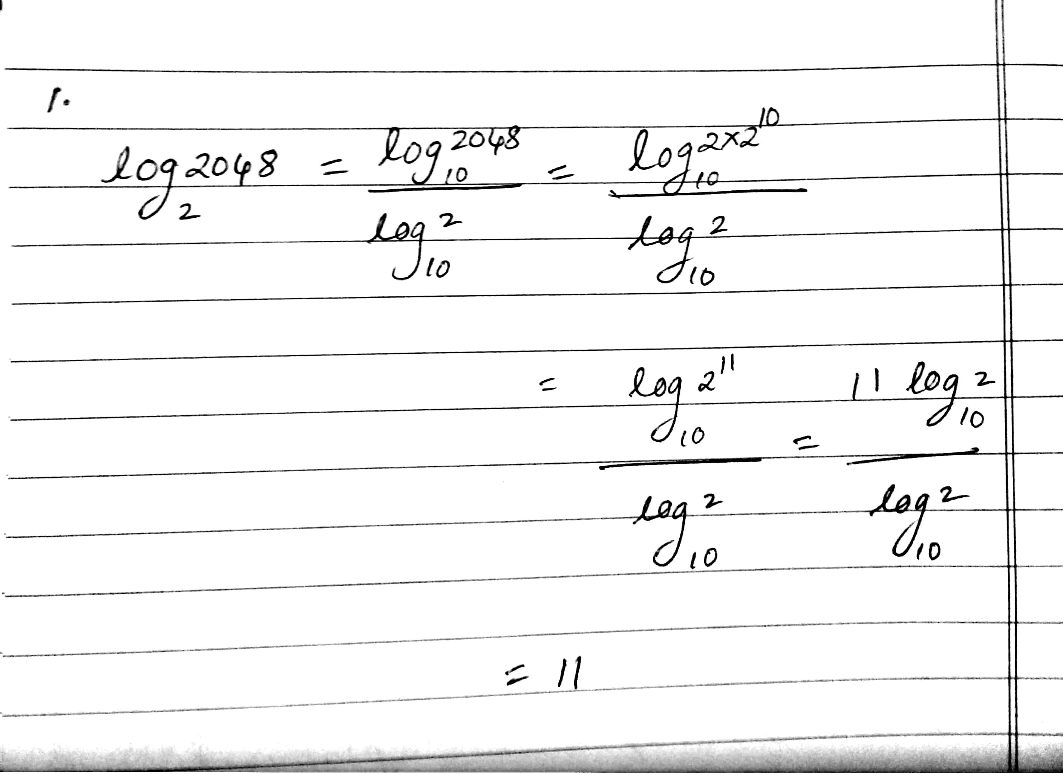

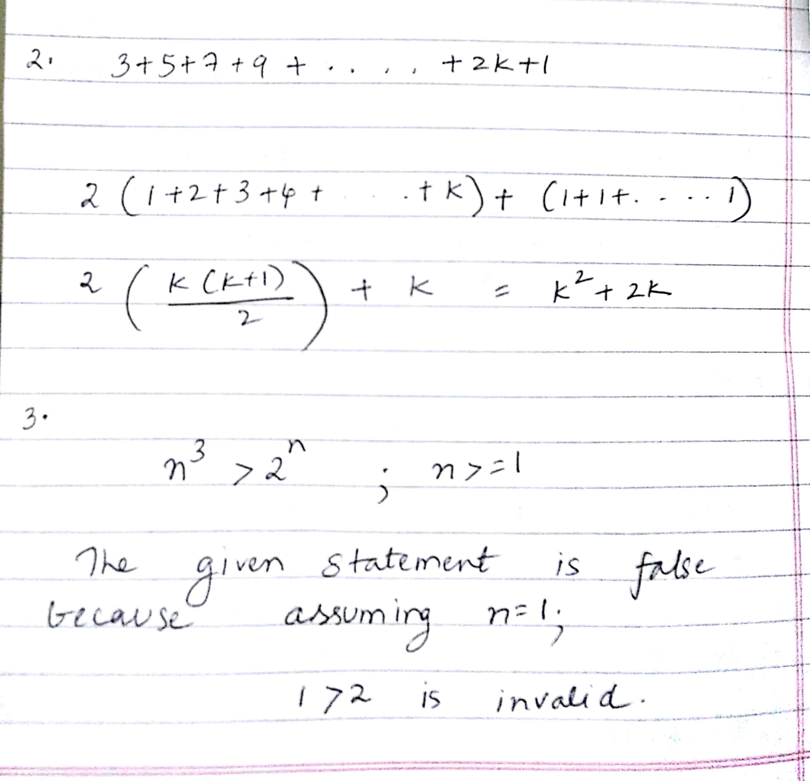

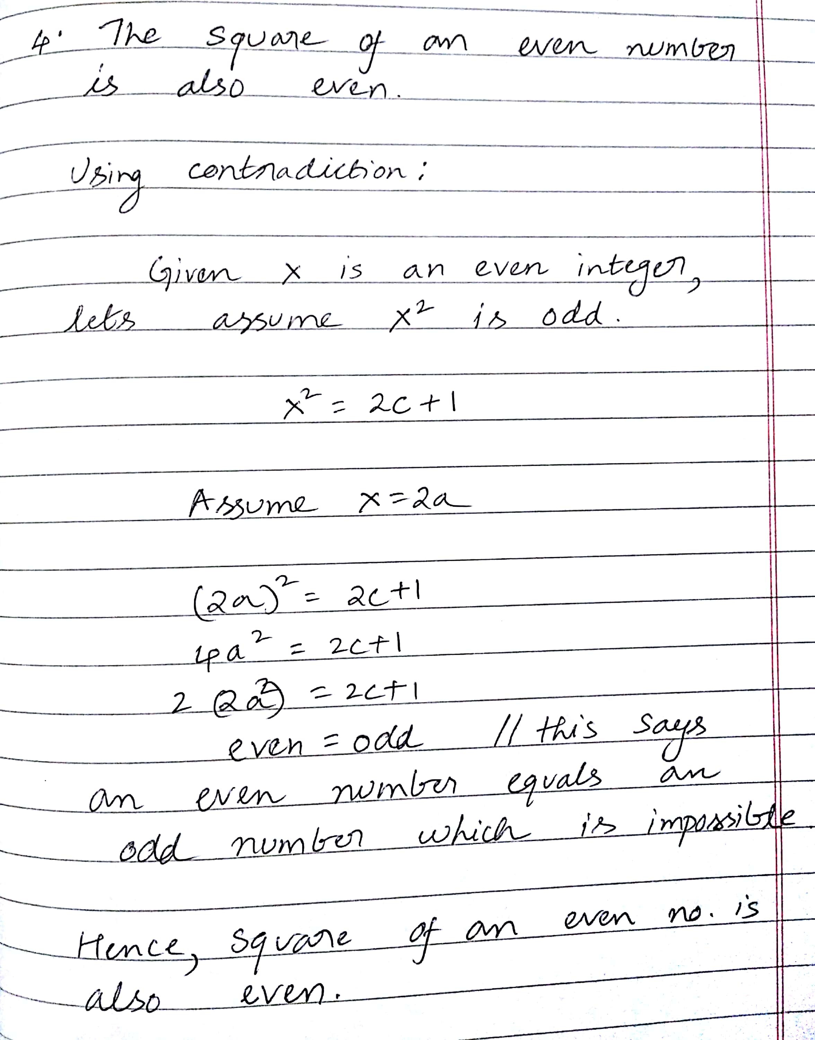

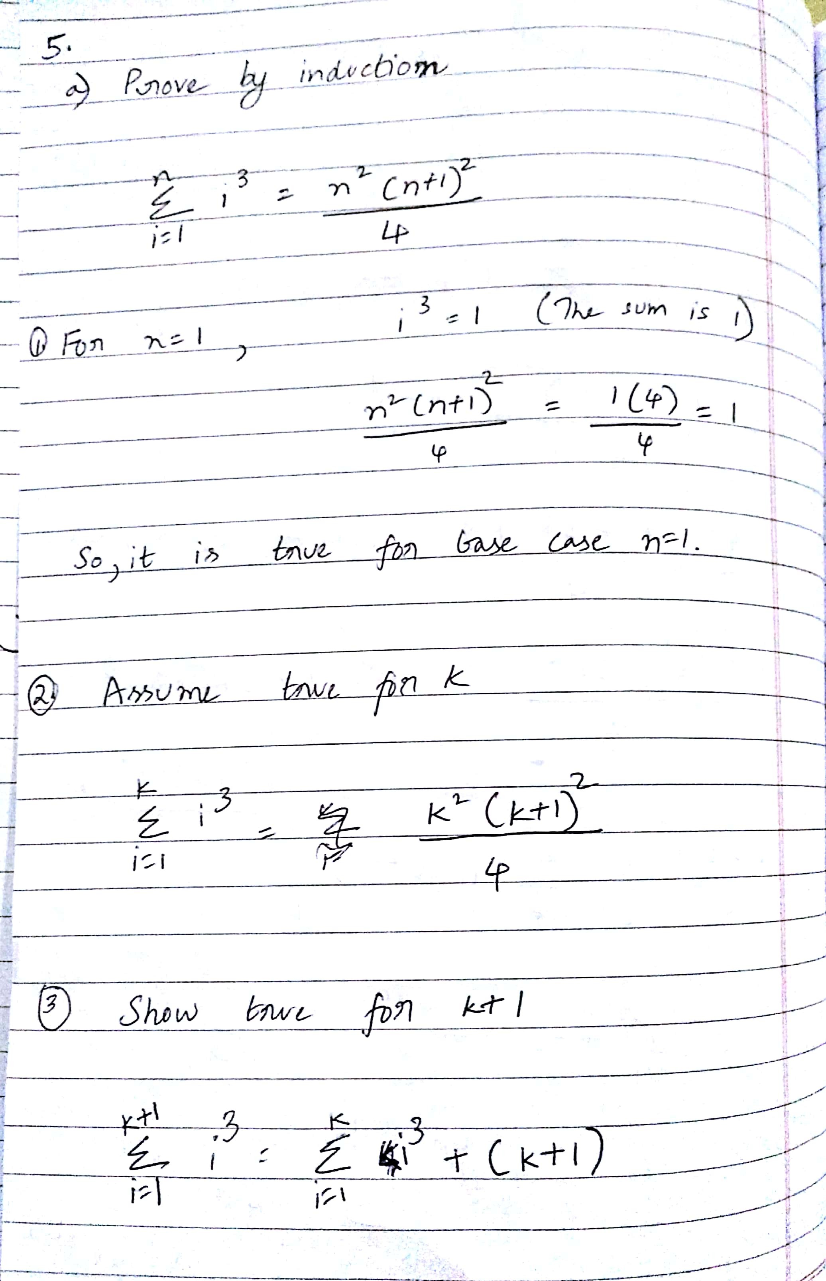

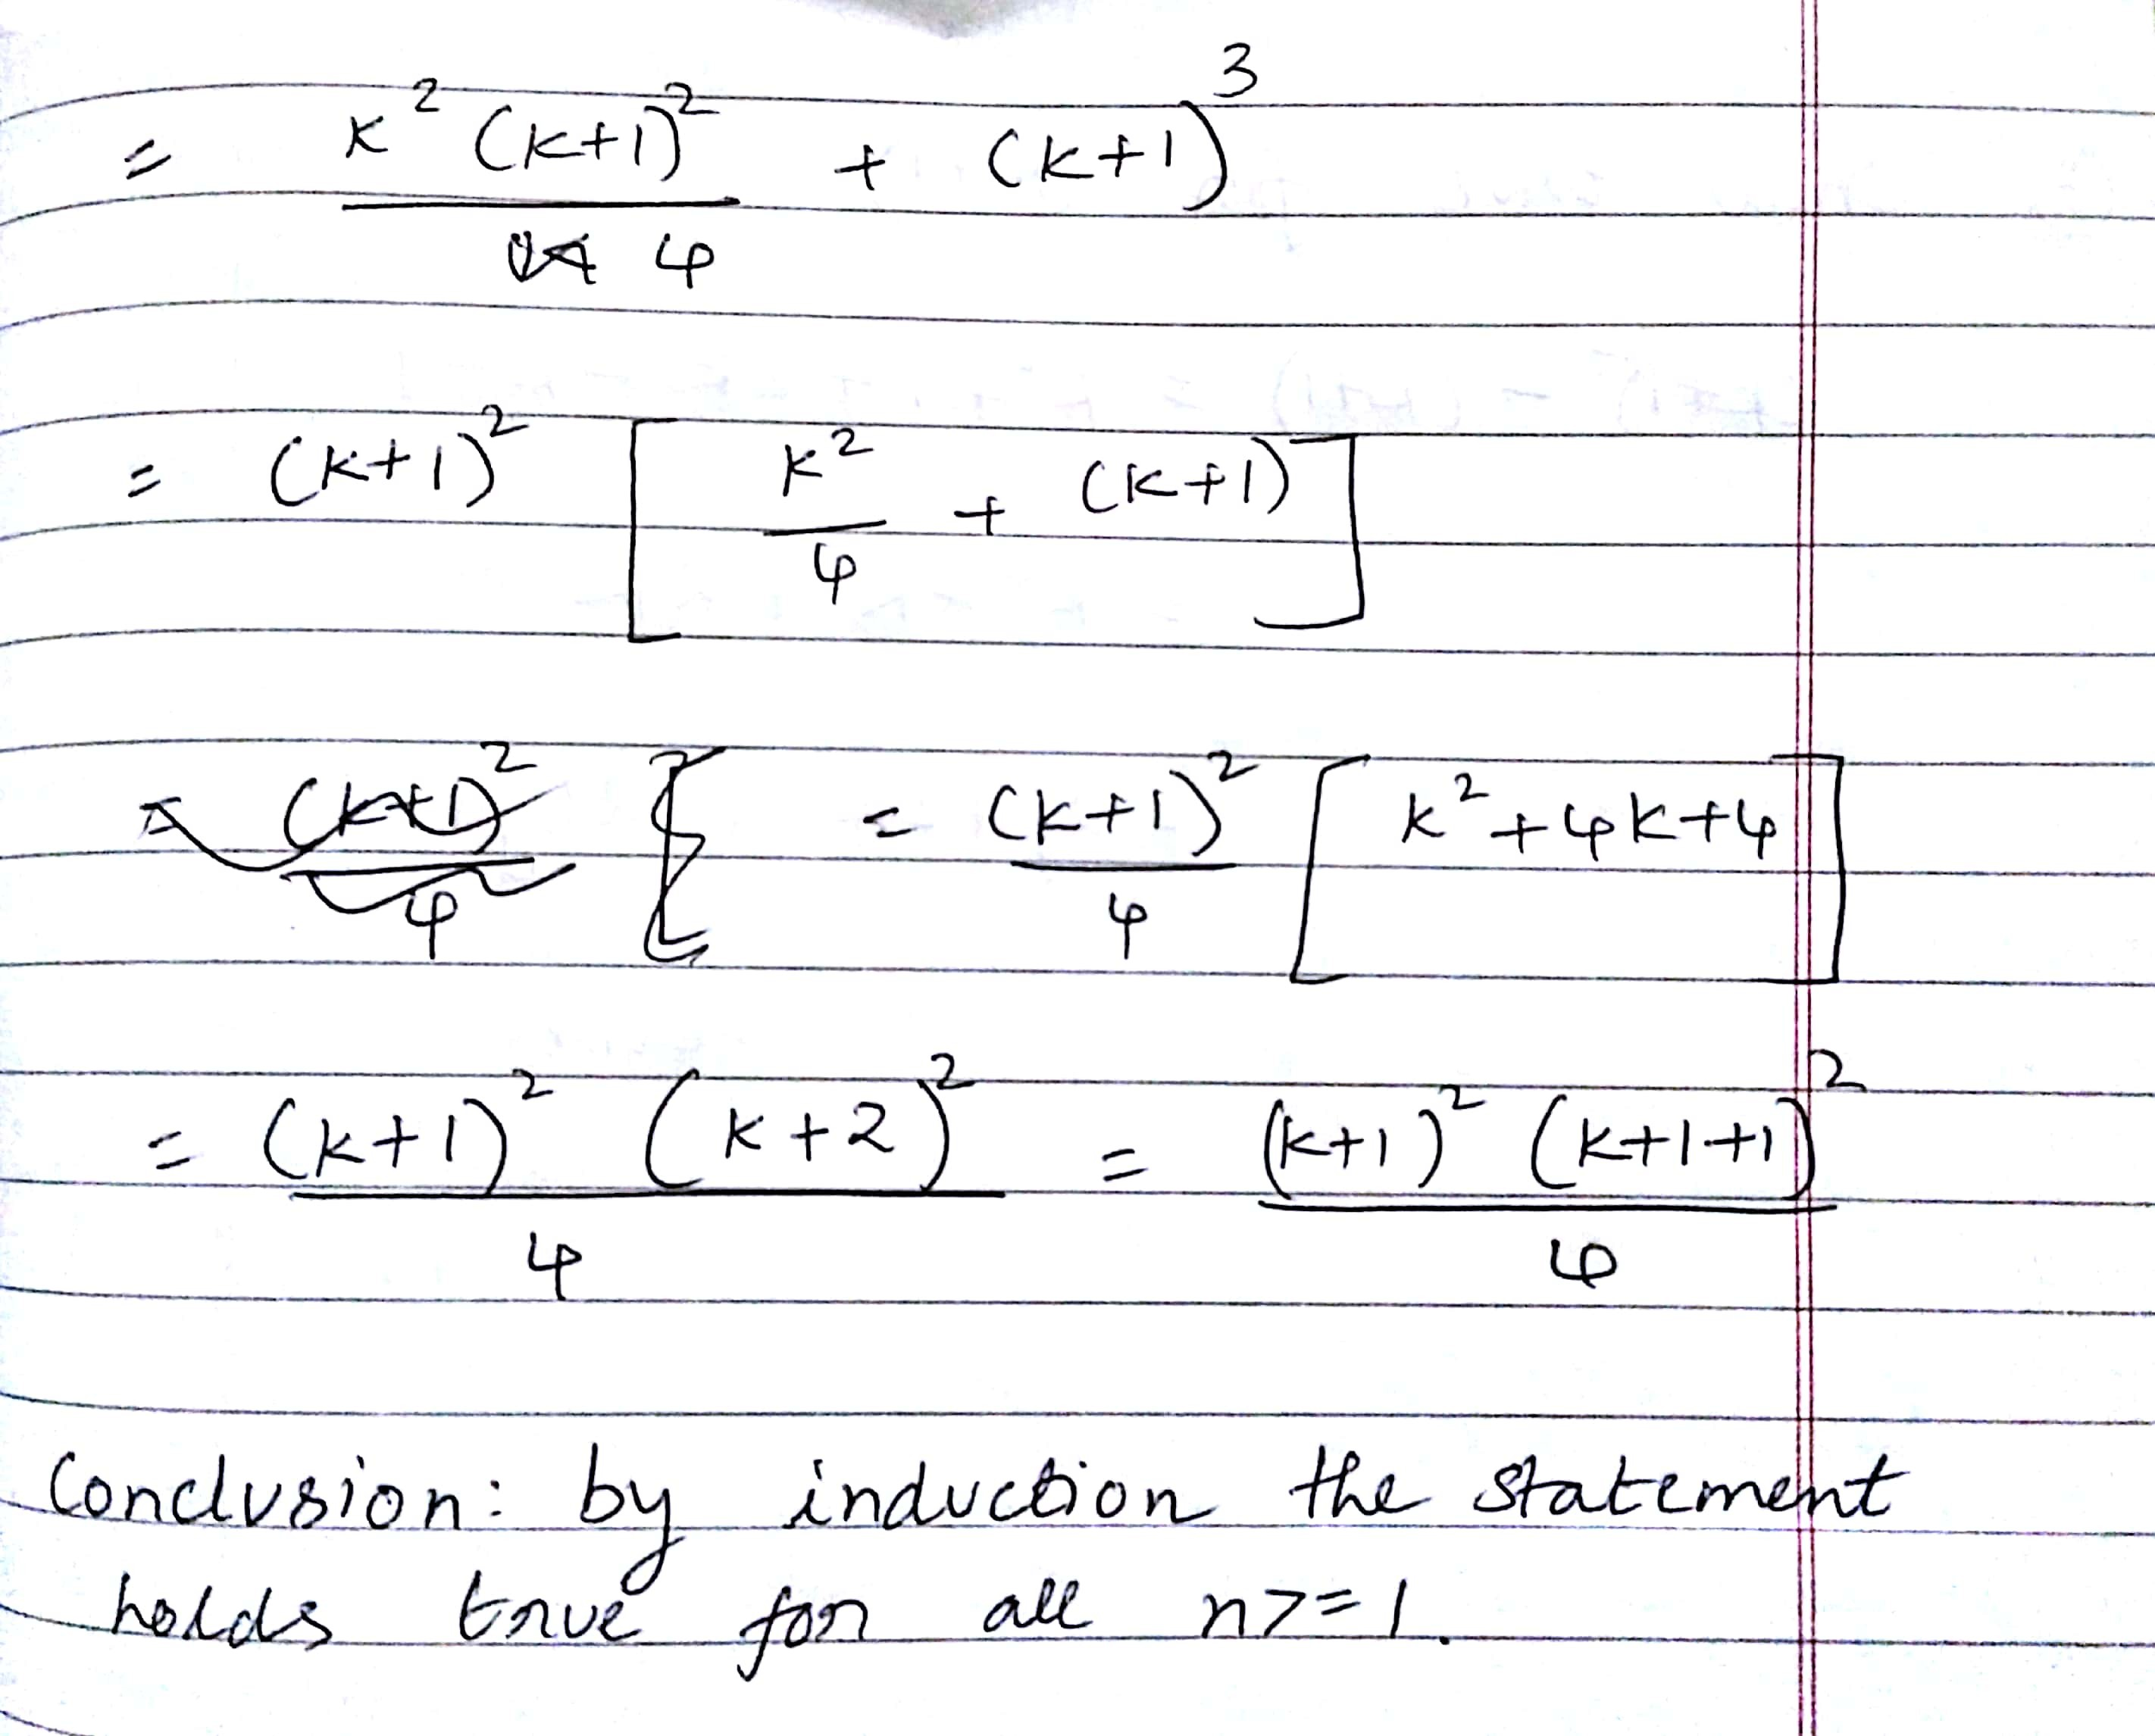

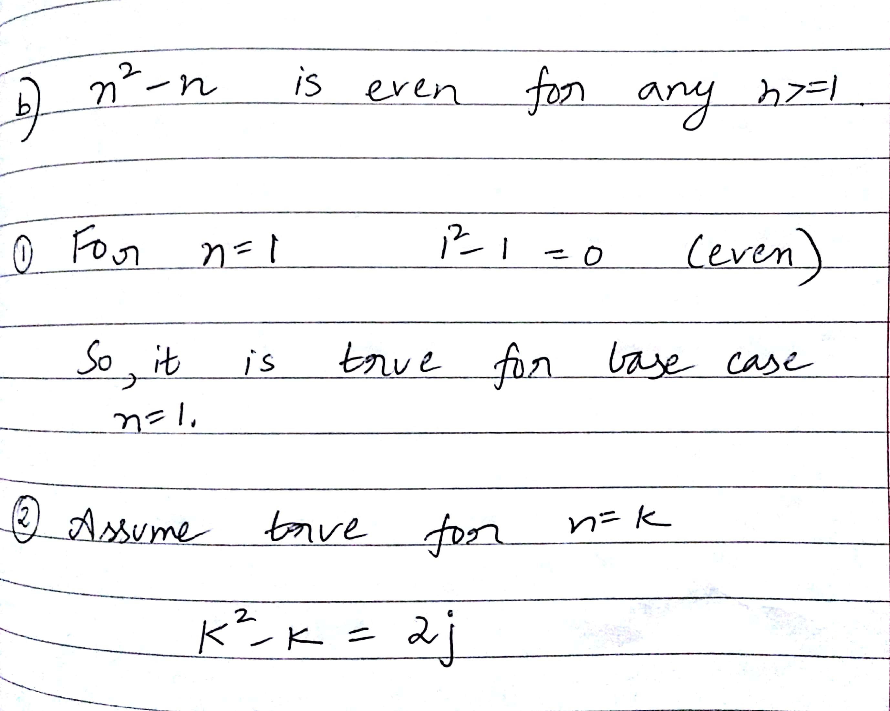

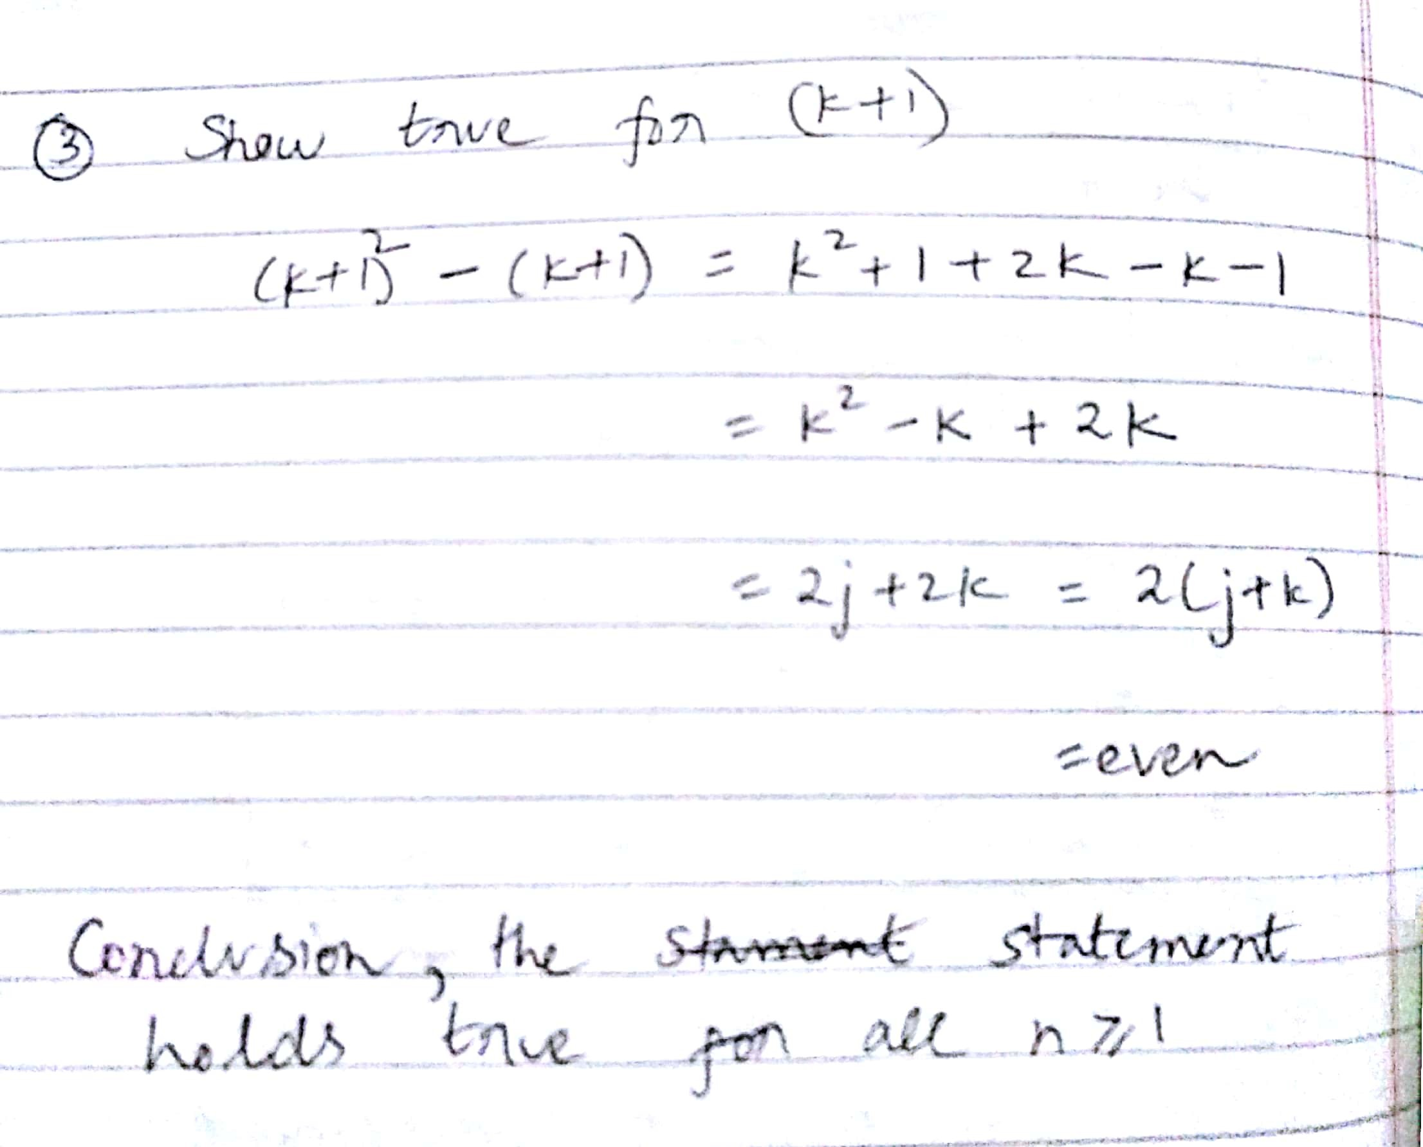

6.

a)

package javaapplication1;

import java.util.\*;

public class JavaApplication1 {

public static void main(String[] args) {

// TODO code application logic here

int n;

n=0;

Scanner in=new Scanner(System.in);

System.out.println("Enter n");

n=in.nextInt();

comp(n);

}

public static void comp(int n){

System.out.print(n+" ");

if(n==0)

{ return; }

comp(n-1);

System.out.print(n+" ");

}

}

b)

package javaapplication1;

import java.util.\*;

public class Sub {

public static int i=0;

public static void main(String[] args)

{

int n;

Scanner in=new Scanner(System.in);

System.out.println("Enter n");

n=in.nextInt();

int[] a=new int[n];

for(int i=0;i<n;i++)

{

System.out.println("Enter "+i);

a[i]=in.nextInt();

}

int k=sec(a,0);

System.out.println("Total odd numbers are:"+k);

}

public static int sec(int[] a,int pos)

{

// i=0;

// System.out.println("length"+a.length);

if(pos==a.length)

{

// System.out.println("value of i "+i);

return i;}

if(a[pos]%2!=0)

{

sec(a,pos+1);

System.out.println("pos"+pos);

++i;

return i;

}

sec(a,pos+1);

return i;

}

}

7.

package javaapplication1;

public class Pair<T> {

private T str1,str2;

public T getContent1()

{ return str1; }

public T getContent2()

{ return str2; }

public void setContent1(T str1 )

{ this.str1 = str1;

}

public void setContent2(T str2)

{ this.str2=str2; }

}

Class with main method to print output:

package javaapplication1;

public class TestPair {

public static void main(String[] args) {

Pair<String> p = new Pair<String>();

p.setContent1("This is string one");

String str1 = p.getContent1();

p.setContent2("This is string two");

String str2 = p.getContent2();

System.out.println(str1);

System.out.println(str2);

}

}