Movie Data Analysis Dashboard Using Power BI

1. Project Overview
This project focuses on analyzing movie metadata using Microsoft Excel and Power BI to identify trends, performance patterns, and key insights in the film industry. The objective of this project is to analyze movie performance based on gross revenue, budget, and profit, identify trends across genres, languages, and years, and build an interactive dashboard for business insights and decision-making.

2. Tools Used
• Microsoft Excel – Data Cleaning and Preprocessing
• Microsoft Power BI – Data Modeling, DAX Calculations, and Visualization

3. Dataset Description
Source: Sample movie metadata dataset
The dataset contains approximately 4900 movie records with the following key columns:
• Movie Title
• Title Year
• Genre
• Director Name
• Language
• Country
• Budget
• Gross Revenue
• IMDb Rating
• Duration
• Content Rating

4. Steps Followed

Step 1: Data Cleaning in Excel
• Removed blank and duplicate records
• Standardized column names
• Extracted year from date field
• Converted duration into numeric format (minutes)
• Formatted gross and budget columns to currency
• Verified data consistency

Step 2: Data Import to Power BI
• Imported cleaned Excel dataset into Power BI
• Checked data types and column formatting

Step 3: Data Modeling
Created Calculated column:
Profit = Gross – Budget
Calculated Column: Profit Status
A calculated column named Profit Status was created to classify movies as “Hit” or “Flop” based on profitability.
Created measures for:
• Total Movies
• Total Gross
• Average IMDb Rating
• Average Duration
• Total Profit

Step 4: Dashboard Creation
• KPI Cards – Total Movies, Total Gross, Average IMDb Rating, Average Duration
• Bar Chart – Total Movies by Genre
• Donut Chart – Movies by Profit Status
• Line Charts – Gross by Year and Profit by Year
• Scatter Plot – Budget vs Gross vs IMDb Rating
• Column Chart – Gross by Movie Title
• Pie Chart – Movies by Language
• Slicers – Genre, Country, Director, Content Rating, Year
• Buttons - Genre

5. Key Insights
• Total Movies analyzed: 4900
• Total Gross Revenue: 214 Billion
• Average IMDb Rating: 6.44
• Average Movie Duration: 107 minutes
• Drama and Comedy genres have the highest number of movies
• Gross revenue significantly increased after the year 2000
• Higher budget movies tend to generate higher gross revenue
• English language movies dominate the dataset

6. Screenshots
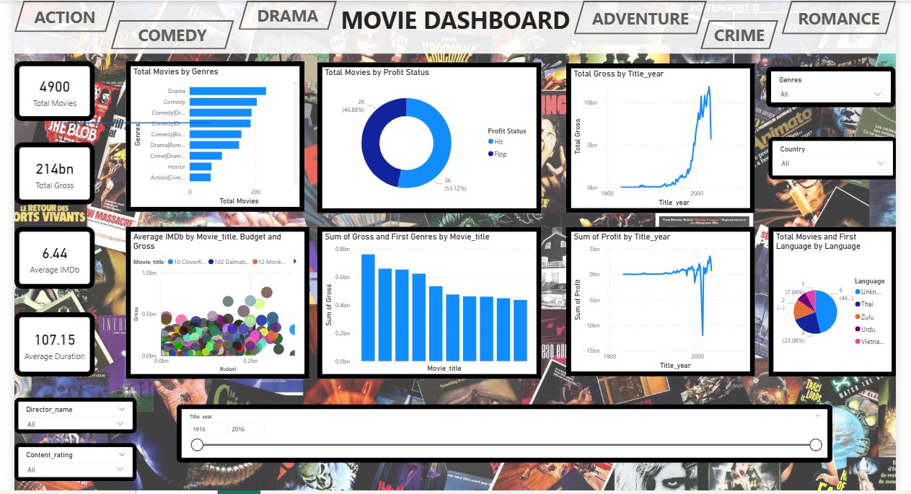

7. Files Included
• Mini_Project_Praveena_Cleaned.xlsx – Cleaned dataset
• Visualization Mini Project.pbix – Power BI dashboard
• Project Documentation.docx – Documentation file

8. How to Use
• Open the Excel file to view cleaned dataset
• Open the Power BI (.pbix) file in Power BI Desktop
• Use slicers to filter data by genre, year, country, or director
• Interact with visuals to explore insights

