DHANEKULA INSTITUTE OF ENGINEERING AND TECHNOLOGY
A project report submitted in partial fulfillment of the requirements for the award of the Degree of
BACHELOR OF TECHNOLOGY
in
COMPUTER SCIENCE AND ENGINEERING (DATA SCIENCE)
Smart Barcode Attendance System
A Web-Based Barcode Attendance Management System
Submitted by:
[Student Name] | ROLL NO: [Roll No]
Under the esteemed Guidance of:
[Guide Name]
Professor, Department of CSE (DS)

DEPARTMENT OF COMPUTER SCIENCE AND ENGINEERING (DATA SCIENCE)
DHANEKULA INSTITUTE OF ENGINEERING AND TECHNOLOGY

DECLARATION
I hereby declare that the project report entitled “Smart Barcode Attendance System” submitted to the Department of Computer Science and Engineering (Data Science), Dhanekula Institute of Engineering and Technology, Vijayawada, is a record of original work done by me under the supervision of Ms. [Guide Name], Professor, Dept. of CSE (DS).
I further declare that the work reported in this project has not been submitted and will not be submitted, either in part or in full, for the award of any other degree or diploma in this institute or any other institute or university.

[Student Name]
Roll No: [Roll No]

ACKNOWLEDGEMENT
The satisfaction that accompanies the successful completion of any task would be incomplete without mentioning the people who made it possible, whose constant guidance and encouragement crowned my efforts with success.
I express my deep sense of gratitude to my esteemed guide, Ms. [Guide Name], Professor, Department of Computer Science and Engineering (Data Science), for her continuous support, encouragement, and invaluable guidance throughout the course of this project work.
I am highly obliged to the Head of the Department, CSE (Data Science), for providing necessary facilities and creating an environment conducive to learning and research.

[Student Name]
([Roll No])

ABSTRACT
Smart Barcode Attendance System is a web-based platform developed to make attendance marking in colleges fast, accurate and paperless. Every student is identified by a Code-128 barcode generated from the Roll Number, which can be printed on an ID card. The system provides essential attendance management modules including student registration, barcode and ID card generation, attendance scanning, dashboard analytics, daily attendance sheets, and attendance summary with graphical and table views.
A teacher selects the batch, subject and date and scans each student’s barcode with a USB barcode scanner or the camera of a phone or laptop. The system instantly validates the barcode, blocks duplicate and wrong-batch entries, and records the time of attendance. The recorded data is analysed to calculate each student’s attendance percentage and to highlight students whose attendance is below a configurable limit, helping faculty to take timely action. Reports can be exported as CSV files, and the complete data can be backed up and restored.
The system is designed with a simple, user-friendly interface that works on desktop and mobile browsers. It is developed using HTML5, CSS3 and JavaScript with the JsBarcode and html5-qrcode libraries, and uses the browser’s local storage for data. By bringing student registration, barcode generation, attendance marking and attendance analysis together in one platform, the proposed system reduces the time spent on roll calls, removes manual calculation errors, and provides a structured approach to attendance management.

INTRODUCTION

1.1 Background
Regular attendance is closely linked to academic performance, and most institutions require students to maintain a minimum attendance percentage to be eligible for examinations. Despite this importance, attendance is still recorded manually in many classrooms. Calling out names or passing a register consumes teaching time in every period, makes proxy attendance easy, and leaves the faculty with the task of totalling attendance by hand at the end of the month.
With the growth of web technologies, there is an opportunity to automate this routine. A barcode printed on a student ID card can be read in a fraction of a second by a low-cost USB scanner or by the camera of any smartphone. A web-based system can store the scanned records, remove duplicates, calculate attendance percentages and present reports and graphs instantly. Such a system can make attendance marking faster, more accurate and easier to analyse.

1.2 Introduction to Smart Barcode Attendance System
Smart Barcode Attendance System is a comprehensive, web-based attendance management platform developed to record and analyse student attendance through barcode scanning. The system provides several interconnected modules, including Student Management, Barcode and ID Card Generation, Attendance Scanning, Dashboard, Daily Sheet Report, Attendance Summary, and Data Management (backup, restore and export).
The portal allows a teacher to choose a batch, subject and date and then scan student barcodes to mark attendance. The system analyses the stored records to calculate attendance percentages, display them as graphs or tables, and identify students with shortage of attendance. The data management module allows the user to export reports as CSV files and to back up or restore all data.
The system is developed using HTML5, CSS3 and JavaScript for the application, the JsBarcode library for barcode generation, the html5-qrcode library for camera scanning, and the browser’s local storage for data storage. The platform provides a simple and user-friendly interface that helps faculty save classroom time, improve accuracy and monitor attendance effectively.

1.3 Problem Statement
Despite the availability of attendance software and biometric devices, many classrooms still depend on manual roll calls and paper registers. Roll calls waste lecture time, registers can be lost or altered, and proxy attendance is difficult to detect. Attendance percentages must be calculated manually, so students with shortage of attendance are often identified too late.
Another major challenge is the lack of a simple, low-cost tool that can be used inside any classroom without special hardware or installation. Biometric and RFID systems are costly and fixed to one location, while ERP attendance modules need logins, network access and training.
The Smart Barcode Attendance System addresses these challenges by providing a unified platform that combines student registration, barcode ID card generation, scanner and camera based attendance marking, graphical attendance analysis and low-attendance identification. It requires only a browser and either a USB scanner or a phone camera.

1.4 Scope and Organization
The scope of this project encompasses the design, development and implementation of the Smart Barcode Attendance System as a web-based application for classroom attendance. The system is intended to give faculty a quick way to mark attendance and an organized view of attendance data for each batch and subject.
The project includes student registration, barcode and ID card generation, attendance scanning, dashboard analytics, daily sheet reports, attendance summary with graph and table views, low-attendance identification, CSV export, and backup and restore. The system can be further enhanced in the future with a central database, faculty login, automatic alerts to students and parents, and integration with college ERP systems.
The report is organized into several chapters describing the complete project development process. Chapter 1 introduces the project and presents the background and problem statement. Chapter 2 lists the objectives. Chapter 3 describes the existing system and its limitations. Chapter 4 presents the proposed system and its modules. Chapter 5 explains the system design, including architecture, use cases, data flow diagrams and the ER diagram. Chapter 6 describes the methodology, technologies and algorithms. Chapter 7 presents the code implementation. Chapter 8 shows the output screens. Chapter 9 analyses the results. Chapter 10 lists the core features, and Chapter 11 gives the conclusion and future scope.

OBJECTIVE
The development of the Smart Barcode Attendance System is guided by a specific set of primary and secondary objectives aimed at creating an organized, user-friendly and effective platform for attendance management.

2.1 Primary Objectives
- Develop a Centralized Attendance Platform: To provide a single web-based platform for student registration, barcode ID card generation and attendance marking by batch, subject and date.
- Analyze Attendance Data: To calculate attendance percentages and identify students whose attendance is below the required limit so that action can be taken early.
- Provide Reports and Data Management: To provide daily sheets, graphical summaries, CSV export, and backup and restore of all attendance data.

2.2 Technical Objectives
- To utilize HTML5, CSS3 and JavaScript for developing a single-page web application that manages the different pages, forms and events.
- To generate Code-128 barcodes using the JsBarcode library and to read barcodes from the camera using the html5-qrcode library.
- To implement structured data storage in the browser’s local storage for efficiently saving student profiles and attendance records.

2.3 User-Centric Objectives
- To provide an easy-to-use platform where a teacher can mark attendance in one second per student, using a USB scanner, camera or typed code.
- To provide clear feedback for every scan (success, already marked, unknown barcode or wrong batch) with colours and a beep.
- To help faculty monitor attendance through graphs, top-attendance and at-risk lists, and department-wise summaries.

2.4 System Performance Objectives
- To provide fast system response so that attendance is recorded and reports are displayed without unnecessary delays.
- To design a responsive web interface, with light and dark themes, that works smoothly across desktops, laptops, tablets and mobile devices.

EXISTING SYSTEM

3.1 Overview
In most institutions today, attendance is taken through one of the following methods: a paper attendance register where the faculty calls out names, spreadsheets updated after the class, biometric or RFID devices installed at fixed locations, and the attendance module of a college ERP system.

3.2 Limitations of the Existing System
- Roll call consumes valuable teaching time in every period.
- Paper registers are easily lost, damaged or altered, and proxy attendance is hard to detect.
- Percentages must be calculated manually, so students with shortage of attendance are identified late.
- Biometric and RFID devices are costly and are usually fixed at one location, not in every classroom.
- ERP attendance modules often need network access, logins and training, and are slow to use inside the classroom.
- Producing reports for a specific batch, subject or date range requires extra manual work.

PROPOSED SYSTEM

4.1 System Overview
The Smart Barcode Attendance System is a web-based application designed to manage the complete attendance cycle through a single, organized platform. The system addresses the difficulties faced with manual roll calls and paper registers by identifying every student through a barcode and recording attendance automatically.
The proposed system is developed using HTML5, CSS3 and JavaScript for the application and user interface, the JsBarcode and html5-qrcode libraries for barcode generation and scanning, and the browser’s local storage for data storage. It provides student management, barcode ID card generation, attendance scanning, dashboard analytics, daily sheet reports, attendance summary, and data management. By integrating these modules into one platform, the system helps faculty mark attendance quickly, analyse the results and identify students who need attention.

4.2 Key Modules of the Proposed System

4.2.1 Student Management Module
The Student Management module allows the teacher to add students with Roll No, name, department and year/batch. Students can be added one at a time, in bulk from text lines, or from a built-in demo dataset of 40 students. The list can be searched, and a student can be deleted together with his or her attendance records. Roll numbers are unique.

4.2.2 Barcode and ID Card Module
This module generates a Code-128 barcode from each student’s Roll Number and displays it on a card with the name, department and batch. Each card can be saved as a PNG image for printing on a student ID card.

4.2.3 Attendance Scanning Module
The Scan module marks attendance for the selected batch, subject and date. Barcodes can be read by a USB scanner (which types the code and presses Enter), typed manually, or captured by the camera of a phone or webcam. The module blocks unknown barcodes, students of another batch and duplicate entries, shows the live present list, and allows a wrong entry to be removed. A Simulate Scan button helps in testing without a scanner.

4.2.4 Dashboard Module
The Dashboard shows the number of students, students present today, sessions today and today’s attendance rate. It also shows a 14-day check-in trend, an overall attendance summary graph, top-attendance and at-risk lists, and department-wise attendance bars.

4.2.5 Reports Module
The Reports module provides a Daily Sheet that lists present and absent students for a chosen date, batch and subject, and an Attendance Summary that calculates the attendance percentage of every student for a date range, batch and subject. The summary is available as a graph (donut chart and per-student column chart with a limit line) or as a table, and both reports can be exported as CSV.

4.2.6 Low Attendance Identification Module
Using a configurable limit (default 75%), the system flags students whose attendance is below the limit as Low. These students are shown in red in the graph and table and in the at-risk list on the dashboard, helping faculty to counsel them in time.

4.2.7 Data Management Module
The Data Management module allows the user to download a JSON backup of all students and records, restore a backup file after validation, and clear all data after a two-click confirmation.

4.2.8 AI Insights Module (Optional)
When an AI service is available in the hosting environment, this module generates a short written summary of the attendance statistics with suggested actions for the teacher.

4.3 System Workflow
The workflow of the system is shown in Figure 4.1. The user registers the students, generates the barcode ID cards, selects the batch, subject and date, and scans the barcodes. Every scan is validated; valid scans are recorded, and invalid scans show a warning. The recorded data is then used for reports, graphs and low-attendance identification, and can be exported or backed up.
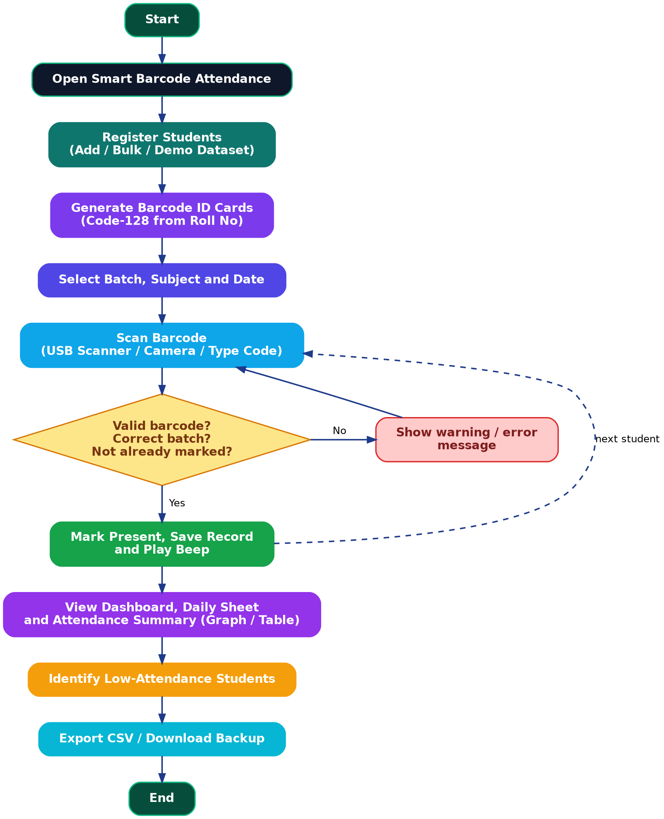
Figure 4.1: System Workflow of Smart Barcode Attendance System

SYSTEM DESIGN

5.1 System Architecture
The Smart Barcode Attendance System follows a three-tier architecture that separates the user interface, application logic and data storage. This structure makes the system organized, easy to maintain and suitable for future improvements.
- Tier 1 – Presentation Layer: The user interface is developed using HTML5 and CSS3. It consists of the Dashboard, Scan, Students, Barcodes and Reports pages with forms, tables, graphs and messages.
- Tier 2 – Application Layer: The application logic is developed in JavaScript. It validates students, marks attendance, checks batch and duplicate entries, calculates attendance percentages, renders graphs, exports CSV files and handles backup and restore. The JsBarcode and html5-qrcode libraries are used for barcode generation and scanning.
- Tier 3 – Data Layer: The browser’s local storage is used to store the student list and the attendance records as JSON under the key “sba”. The data layer maintains and retrieves the information required by the application.
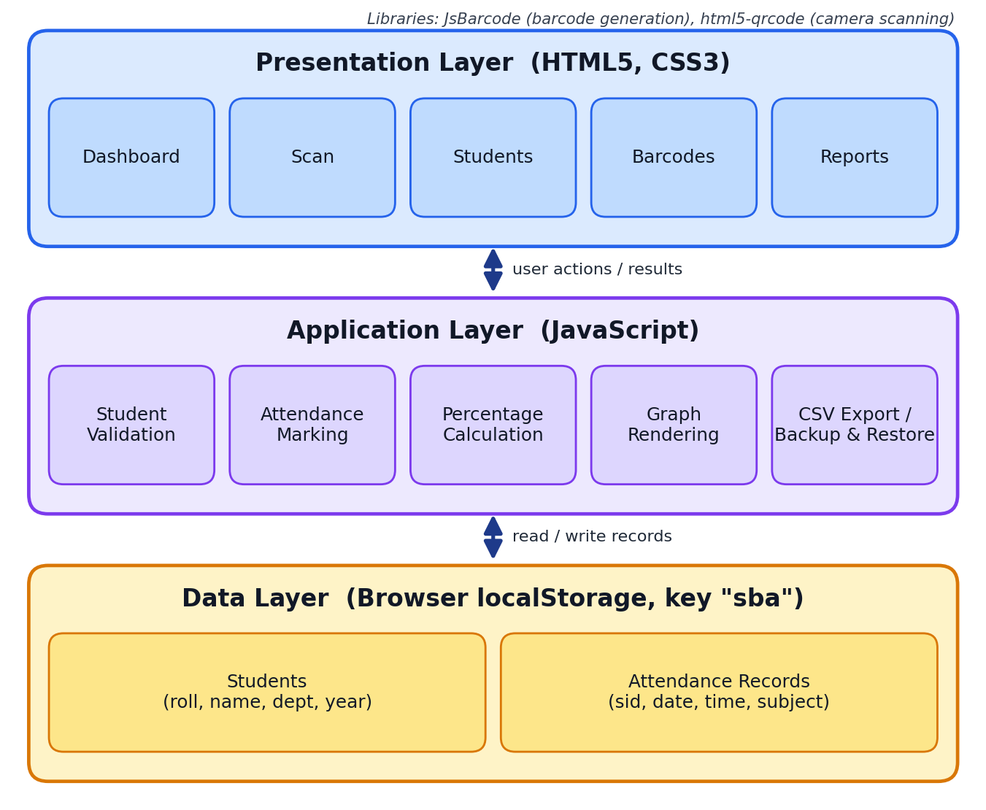
Figure 5.1: Three-Tier Architecture

5.2 Use Case Description
The primary actor of the Smart Barcode Attendance System is the Faculty (Teacher), who can register students, generate barcode ID cards, select the batch, subject and date, scan barcodes to mark attendance, view reports and graphs, export CSV files, and back up or restore data. The secondary actor is the Student, who presents the barcode ID card to be scanned; the student’s Roll Number is the identity used by the system. The administrator role (managing the student list and data) is performed by the same user in the current version.

5.3 Data Flow Diagram (DFD)
At Level 0 (Figure 5.2), the Smart Barcode Attendance System is represented as a single process that interacts with the Faculty and the Student. The Faculty provides student details, the batch, subject and date, and report requests, and receives confirmation messages, reports, graphs and files. The Student’s barcode is scanned by the system, and the system produces the student’s barcode ID card.
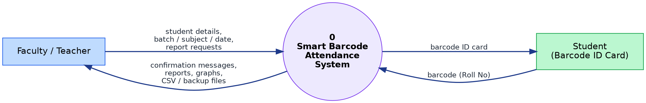
Figure 5.2: DFD Level 0 (Context Diagram)
At Level 1 (Figure 5.3), the system is divided into the following processes:
- Manage Students: Accepts student details and stores them in the Students data store.
- Generate Barcode ID Cards: Reads student data and produces Code-128 barcodes and ID card images.
- Mark Attendance: Reads the scanned barcode, verifies the student, checks batch and duplicates, and stores the attendance record.
- Reports and Analytics: Reads students and attendance records and produces the daily sheet, attendance summary, graphs and CSV files.
- Backup and Restore: Exports or imports the Students and Attendance data stores.
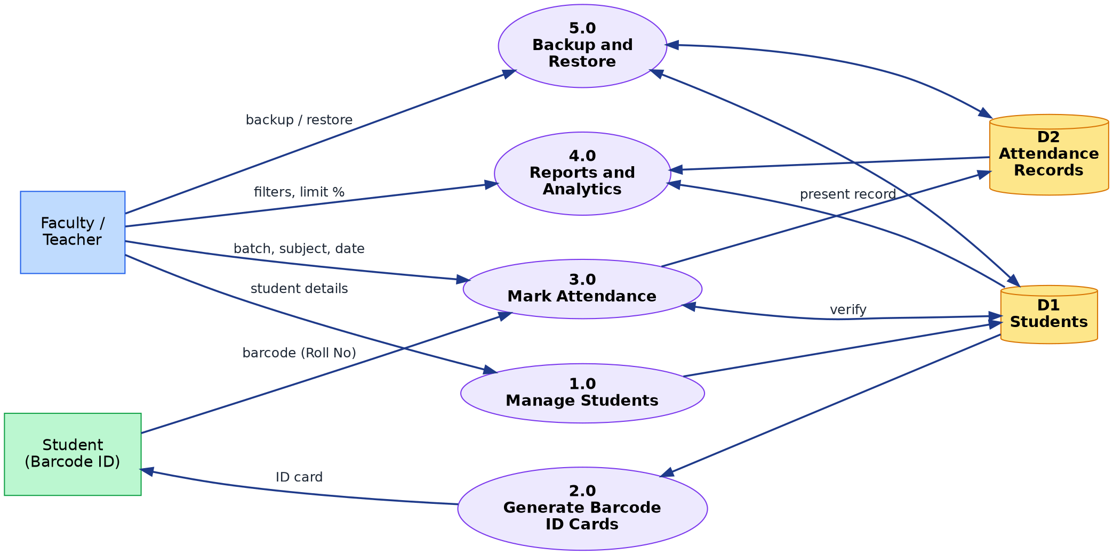
Figure 5.3: DFD Level 1

5.4 Entity Relationship (ER) Diagram Description
The database design includes two entities, Student and Attendance Record. Student details are maintained in the Student entity, where the Roll Number (roll) is the primary key and is also the value encoded in the barcode; it also stores the name, department and year (batch). The Attendance Record entity stores the Roll Number of the student (sid), the date (d), the time of scan (t) and the subject or session (sub). One student can have many attendance records, and each record belongs to exactly one student. A session is identified by the combination of date and subject and is derived from the attendance records.
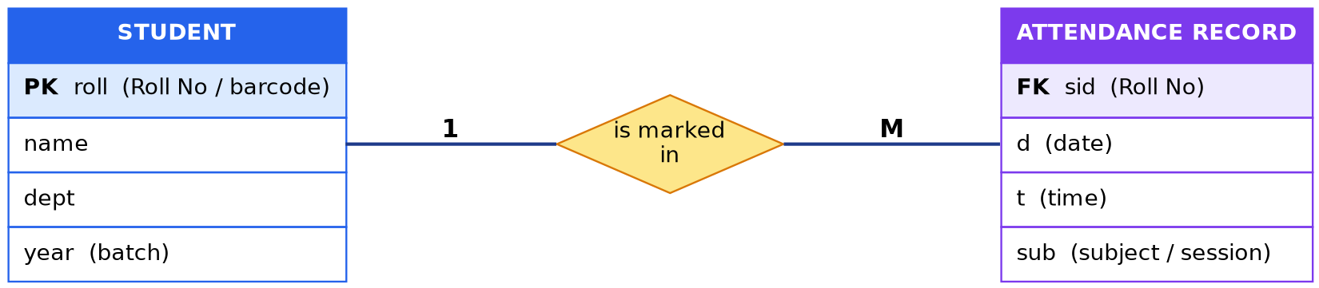
Figure 5.4: ER Diagram

METHODOLOGY AND ALGORITHM

6.1 Software Development Methodology
The development of the Smart Barcode Attendance System follows a systematic software development approach. The project is divided into different stages, including requirement analysis, system design, implementation, testing and deployment. This approach helps develop the application in an organized manner and ensures that all required modules work properly.
- Phase 1: Requirement Analysis: Identify the requirements for student registration, barcode generation, attendance scanning, reports, graphs, low-attendance identification and data management.
- Phase 2: System Design: Design the application architecture, user interface, data structure and workflow for the different modules.
- Phase 3: Implementation: Develop the interface using HTML5 and CSS3, implement the logic in JavaScript, integrate the JsBarcode and html5-qrcode libraries, and use local storage to save the data.
- Phase 4: Testing and Deployment: Test student management, barcode generation, scanning, duplicate prevention, reports, graphs and backup. Fix errors and run the application in the browser.

6.2 Technology Stack
- Application Language: JavaScript (ES6)
- Frontend: HTML5, CSS3 (flexbox, grid, CSS variables, conic-gradient)
- Barcode Generation: JsBarcode 3.11.6 (Code-128)
- Barcode Scanning: html5-qrcode 2.3.8 (camera) and USB barcode scanner
- Data Storage: Browser localStorage (JSON)
- Browser APIs: Canvas, Web Audio, Blob and FileReader
- Development Tool: Visual Studio Code
- Web Browser: Google Chrome or any modern browser
- Application Type: Web-Based Application

6.3 Algorithm 1: Marking Attendance by Barcode
- Read the scanned or typed code and remove surrounding spaces; ignore it if empty.
- Search the student list for a Roll No equal to the code, ignoring upper and lower case.
- If no student is found, show “Unknown barcode” in red and stop.
- If a particular batch is selected and the student’s batch is different, show a warning and stop.
- If a record with the same student, date and subject already exists, show an “already marked” warning and stop.
- Otherwise add the record {student, date, time, subject} to the list and save it to local storage.
- Play a beep, show a green “marked PRESENT” message and refresh the present list.

6.4 Algorithm 2: Attendance Percentage and Low-Attendance Flag
- Select the students of the chosen batch and the attendance records within the chosen date range and subject.
- Count the sessions held as the number of distinct date-and-subject combinations in those records.
- For every student, count the records belonging to that student.
- Calculate percentage = (present count ÷ sessions) × 100, rounded to one decimal place; use 0 when no session has been held.
- Mark the student as Low if the percentage is below the limit (default 75%), otherwise OK.
- Sort the students from lowest to highest percentage and display them as a graph or a table.

CODE IMPLEMENTATION

7.1 Code Implementation:
The complete application is implemented in a single HTML file containing the styles, markup and scripts. The key parts of the implementation are given below.

Application Data Store
let S = { students: [], records: [] };
try { S = Object.assign(S, JSON.parse(localStorage.getItem('sba') || '{}')); } catch (e) {}
const store = () => {
try { localStorage.setItem('sba', JSON.stringify(S)); } catch (e) {}
};
const today = () => new Date().toLocaleDateString('en-CA');
const tnow = () => new Date().toTimeString().slice(0, 8);

Student Management Module
function addStu(roll, name, dept, yr) {
roll = (roll || '').trim(); name = (name || '').trim();
if (!roll || !name) return false;
if (S.students.some(s => s.roll.toLowerCase() === roll.toLowerCase()))
return false; // Roll No must be unique
S.students.push({ roll, name, dept: (dept || '').trim(),
year: (yr || '').trim() });
return true;
}

Attendance Marking Module
function mark(code) {
code = code.trim(); if (!code) return;
const st = S.students.find(s => s.roll.toLowerCase() === code.toLowerCase());
const sub = $('#subj').value.trim() || 'General';
const d = $('#sdate').value || today();
if (!st) return msg('Unknown barcode: ' + code, 'bad');
const bt = $('#batch').value || 'All';
if (bt !== 'All' && st.year !== bt)
return msg(st.name + ' belongs to batch ' + st.year + ', not ' + bt, 'wa');
if (S.records.some(r => r.sid === st.roll && r.d === d && r.sub === sub))
return msg(st.name + ' is already marked for ' + sub, 'wa');
S.records.push({ sid: st.roll, d, t: tnow(), sub });
store(); beep();
msg(st.name + ' (' + st.roll + ') marked PRESENT', 'ok');
rSl(); // refresh the present list
}

Camera Scanning
cam = new Html5Qrcode('reader');
await cam.start(
{ facingMode: 'environment' },
{ fps: 10, qrbox: { width: 280, height: 120 } },
c => {
const n = Date.now();
if (c === last.c && n - last.t < 3000) return; // ignore repeat reads
last = { c, t: n };
mark(c);
},
() => {});

Barcode ID Card Generation
function cardBlob(s) {
return new Promise(res => {
const b = document.createElement('canvas');
JsBarcode(b, s.roll, { height: 60, fontSize: 16, margin: 10 });
const c = document.createElement('canvas');
c.width = Math.max(b.width, 360); c.height = b.height + 64;
const x = c.getContext('2d');
x.fillStyle = '#fff'; x.fillRect(0, 0, c.width, c.height);
x.fillStyle = '#111'; x.textAlign = 'center';
x.font = 'bold 18px sans-serif'; x.fillText(s.name, c.width / 2, 26);
x.font = '13px sans-serif';
x.fillText([s.dept, s.year].filter(Boolean).join(' • '), c.width / 2, 46);
x.drawImage(b, (c.width - b.width) / 2, 56);
c.toBlob(res, 'image/png');
});
}

Performance Analysis Module (Attendance Percentage)
const stu = S.students.filter(inBatch(bt));
const ids = new Set(stu.map(s => s.roll));
const rs = S.records.filter(r => ids.has(r.sid)
&& (!f || r.d >= f) && (!t || r.d <= t)
&& (sub === 'All' || r.sub === sub));
const tot = new Set(rs.map(r => r.d + '|' + r.sub)).size; // sessions held
const L = stu.map(s => {
const p = rs.filter(r => r.sid === s.roll).length;
return { s, p, pct: tot ? Math.round(p / tot * 1000) / 10 : 0 };
}).sort((a, b) => a.pct - b.pct);
// status: x.pct < lim ? 'Low' : 'OK'

CSV Export, Backup and Restore
const csv = rows => rows.map(r =>
r.map(v => '"' + String(v).replace(/"/g, '""') + '"').join(',')
).join('\n');

$('#bkp').onclick = () => dl('attendance-backup.json',
new Blob([JSON.stringify(S)], { type: 'application/json' }));

// restore: validate before replacing the data
const o = JSON.parse(reader.result);
if (!Array.isArray(o.students) || !Array.isArray(o.records)) throw 0;
S = { students: o.students, records: o.records };
store();

OUTPUT
This chapter presents the detailed descriptions of the major user interface screens of the Smart Barcode Attendance System. The application consists of several pages designed to provide an organized and user-friendly attendance experience. Screenshots and descriptions of the application output are provided below. (Load the demo dataset first so that every screen shows data.)

Home Page Dashboard
The Dashboard is the first screen displayed when the teacher opens the application. It shows the number of students, students present today, sessions today and today’s rate, a 14-day check-in trend, and options for backup and loading the demo dataset. Navigation buttons give access to Scan, Students, Barcodes and Reports.
[ Insert screenshot of the Dashboard here ]
Figure 8.1: Home Page Dashboard

Dashboard Analytics
Below the trend chart, the dashboard shows the overall attendance summary graph, the top-attendance and at-risk lists, and department-wise attendance bars, giving the faculty a quick view of attendance without opening the reports.
[ Insert screenshot of the Dashboard graphs and lists here ]
Figure 8.2: Dashboard Analytics

Attendance Scanning Interface
The Scan page lets the teacher select the batch, subject and date and then scan with a USB scanner, type a code, or start the camera. A coloured message confirms success, a duplicate, a wrong batch or an unknown barcode, and the present list updates immediately.
[ Insert screenshot of the Scan page after marking attendance here ]
Figure 8.3: Attendance Scanning Interface

Student Management Interface
The Students page allows students to be added individually, in bulk or from the demo dataset. A search box filters the list by Roll No, name or department, and each student can be deleted.
[ Insert screenshot of the Students page here ]
Figure 8.4: Student Management Interface

Barcodes and ID Cards
The Barcodes page shows a card for every student with the Code-128 barcode of the Roll No, the name, department and batch. The Save ID card button downloads the card as a PNG image for printing.
[ Insert screenshot of the Barcodes page here ]
Figure 8.5: Barcodes and ID Cards

Daily Sheet Report
For the selected date, batch and subject, the Daily Sheet lists present students with the scan time and absent students separately. It can be exported as a CSV file.
[ Insert screenshot of the Daily Sheet report here ]
Figure 8.6: Daily Sheet Report

Attendance Summary: Graph View
A donut chart shows the share of students above the limit, tiles show the average attendance and the counts above and below the limit, and a column chart shows every student’s percentage with a dashed limit line. Red columns are below the limit.
[ Insert screenshot of the Attendance Summary graph view here ]
Figure 8.7: Attendance Summary (Graph View)

Attendance Summary: Table View and Weak Attendance Identification
The same data is available as a table with present count, sessions, an attendance bar and an OK/Low status for every student, sorted from lowest to highest attendance, which helps in identifying students with shortage of attendance.
[ Insert screenshot of the Attendance Summary table view here ]
Figure 8.8: Attendance Summary (Table View)

RESULT ANALYSIS

9.1 System Performance Evaluation
The Smart Barcode Attendance System is evaluated based on its main functional modules and usability. The evaluation focuses on student management, barcode generation, attendance scanning, duplicate prevention, daily reports, attendance summary graphs, low-attendance identification, and data management. Functional testing can be used to verify whether each module works as expected and provides the intended results. The following table presents the key performance evaluation criteria for the proposed system.

Performance Evaluation Metrics
Metric | Evaluation Criteria | Status
Page Loading | Pages load and display correctly | ✓ Met
Student Management | Students can be added, searched and deleted | ✓ Met
Barcode Generation | Code-128 barcode and ID card are generated for every student | ✓ Met
Attendance Scanning | Valid barcodes are marked present with time and beep | ✓ Met
Duplicate and Batch Check | Duplicate and wrong-batch scans show a warning and are not saved | ✓ Met
Daily Sheet | Present and absent lists are displayed correctly | ✓ Met
Attendance Summary | Percentages are shown in graph and table views | ✓ Met
Low Attendance Identification | Students below the limit are flagged | ✓ Met
Backup and Export | CSV export, JSON backup and restore work | ✓ Met

9.2 Functional Testing Analysis
The main modules of the Smart Barcode Attendance System are designed to support the different stages of attendance management. Functional testing helps verify navigation between pages, generation of barcodes, handling of valid and invalid scans, duplicate prevention and the calculation of attendance percentages. Each module should be tested with suitable inputs to check whether it behaves according to the project requirements.
A valid Roll No is marked present with a green message, a repeated scan for the same date and subject shows an “already marked” warning, an unregistered code shows an “Unknown barcode” error, and a student of another batch is rejected when a batch is selected. For attendance calculation, a student present in 8 of 10 sessions shows 80% (OK), while one present in 7 of 10 sessions shows 70% (Low) against the default 75% limit.

9.3 Result Analysis
The system provides a centralized environment for attendance management by combining multiple modules in one application. Its main benefit is that attendance can be marked in about a second per student without calling out names, and reports are produced instantly without manual calculation. The graphical summary and at-risk lists help faculty to identify students with shortage of attendance early. Camera scanning depends on lighting and print quality, so a USB scanner is recommended for large classes, and data should be backed up regularly because it is stored in the browser.

CORE FEATURES
The Smart Barcode Attendance System is designed with several core features to provide a complete and organized attendance management experience:
- Student Management: Allows the teacher to add students individually, in bulk or from a 40-student demo dataset, search the list and delete students.
- Barcode Identification: Generates a unique Code-128 barcode for every student from the Roll Number.
- ID Card Generation: Creates a downloadable PNG ID card with the name, department, batch and barcode.
- Multiple Scan Methods: Supports USB scanners, typed codes and phone or webcam cameras.
- Batch and Subject Sessions: Records attendance for the selected batch, subject and date.
- Duplicate and Wrong-Batch Protection: Shows a warning instead of marking a student twice or marking a student of another batch.
- Dashboard Analytics: Shows metrics, a 14-day trend, top attendance, at-risk list and department-wise attendance.
- Graphical Attendance Summary: Displays a donut chart, a per-student column chart with a limit line, and a table view.
- Daily Sheet and CSV Export: Provides present and absent lists for any date, batch and subject, and exports reports to CSV.
- Backup and Restore: Provides JSON backup, validated restore and a two-click clear option.
- User-Friendly Interface: Provides a simple, responsive interface with light and dark themes that works on desktop and mobile.
- Zero-Setup Deployment: Runs from a single HTML file in any modern browser.

CONCLUSION
The Smart Barcode Attendance System shows how a low-cost, browser-based tool can replace manual roll calls. By combining student registration, Code-128 ID cards, scanner and camera based marking, batch and subject sessions, daily sheets and graphical attendance summaries in a single responsive application, the project saves classroom time, reduces errors and proxy entries, and helps faculty identify students with low attendance early.

Limitations
- Data is stored only in the browser of one device; there is no central database or multi-user synchronisation.
- There is no login or role separation between faculty and administrators.
- The barcode is the Roll Number itself, so a card can be copied or shared; the system does not verify the person holding it.
- Camera scanning accuracy depends on lighting and print quality.
- There are no automatic notifications to students or parents about low attendance.

Future Scope
- Add a secure backend with a central database, faculty and admin login, and synchronisation across classrooms.
- Use dynamic QR codes or face recognition along with the barcode to prevent proxy attendance.
- Send SMS, email or WhatsApp alerts to students and parents when attendance falls below the limit.
- Integrate with the college ERP or learning management system.
- Provide a dedicated mobile app with offline scanning and automatic sync.
- Add timetable-based sessions, leave management and monthly report generation in PDF.

REFERENCES
- Mozilla Developer Network (MDN), HTML: HyperText Markup Language. Available: https://developer.mozilla.org/en-US/docs/Web/HTML
- Mozilla Developer Network (MDN), CSS: Cascading Style Sheets. Available: https://developer.mozilla.org/en-US/docs/Web/CSS
- Mozilla Developer Network (MDN), JavaScript Documentation. Available: https://developer.mozilla.org/en-US/docs/Web/JavaScript
- Mozilla Developer Network (MDN), Window.localStorage. Available: https://developer.mozilla.org/en-US/docs/Web/API/Window/localStorage
- Mozilla Developer Network (MDN), Canvas API. Available: https://developer.mozilla.org/en-US/docs/Web/API/Canvas_API
- Mozilla Developer Network (MDN), Web Audio API. Available: https://developer.mozilla.org/en-US/docs/Web/API/Web_Audio_API
- JsBarcode, Barcode generation library for JavaScript. Available: https://github.com/lindell/JsBarcode
- html5-qrcode, Cross-platform QR code and barcode scanner library. Available: https://github.com/mebjas/html5-qrcode
- ISO/IEC 15417, Information technology: Automatic identification and data capture techniques: Code 128 bar code symbology specification.
- W3Schools, JavaScript Tutorial. Available: https://www.w3schools.com/js/
- TutorialsPoint, Software Engineering – Software Development Life Cycle. Available: https://www.tutorialspoint.com/software_engineering/software_development_life_cycle.htm

