PROJECT 4: DEPLOY A JAVA SPRING BOOT APPLICATION TO AKS USING MAVEN, DOCKER, ACR, SONAR TRIVY VIA JENKINS PIPELINE
Project Objective
The primary objective of this project is to design, implement, and automate a secure, enterprise-grade Continuous Integration and Continuous Delivery (CI/CD) pipeline for a microservices-based Java Spring Boot application using Jenkins, Maven, SonarQube, Trivy, Docker, Azure Container Registry (ACR), and Azure Kubernetes Service (AKS).
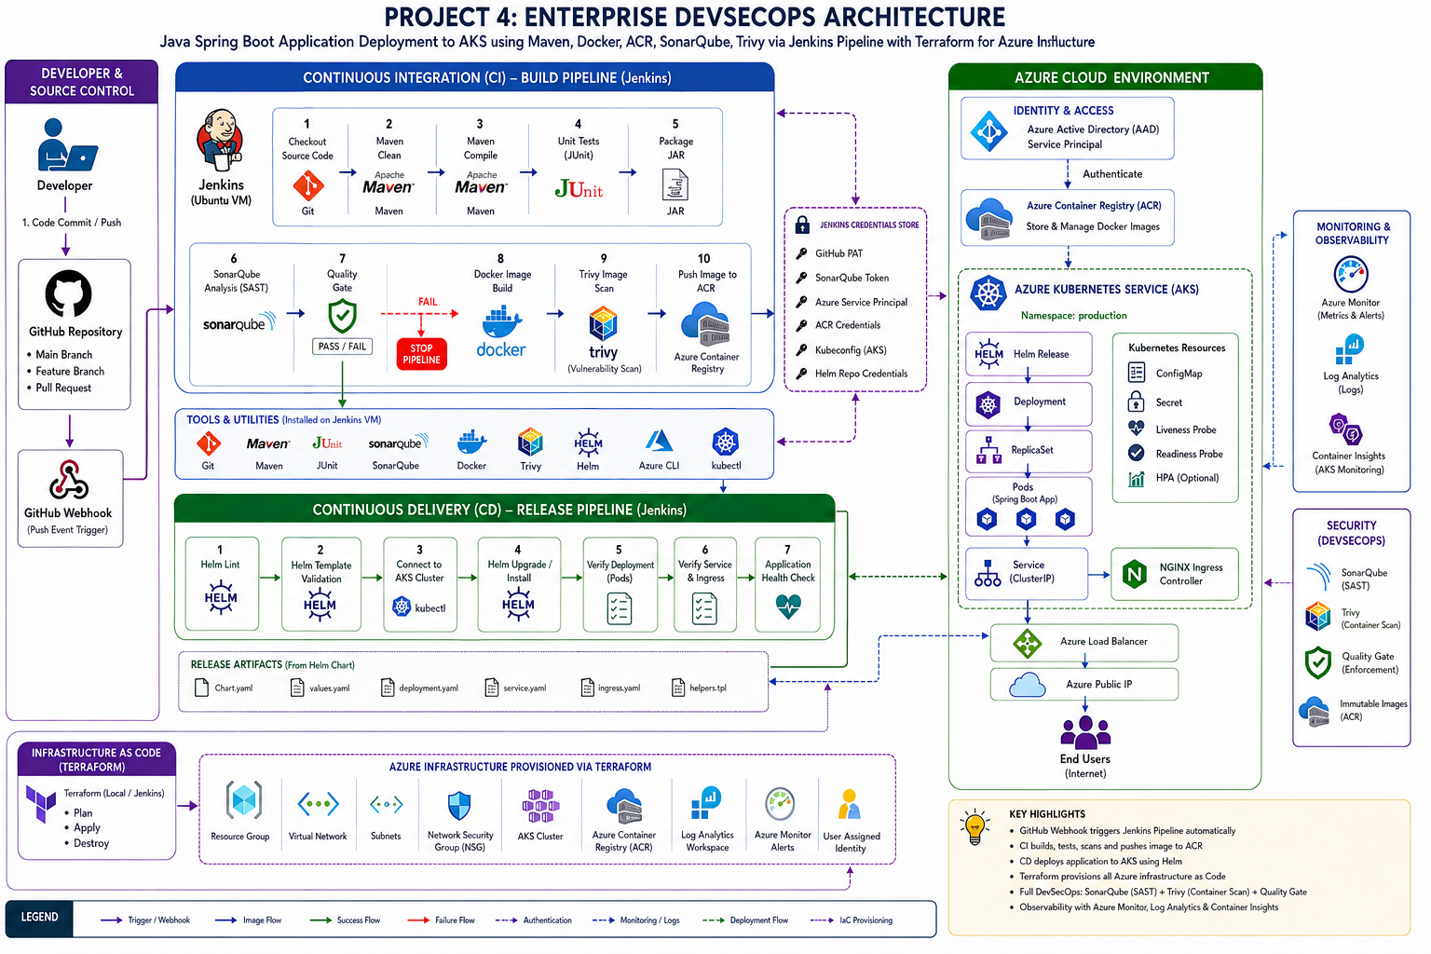

Cloned the Repository from Public GitHub Repo onto Local machine
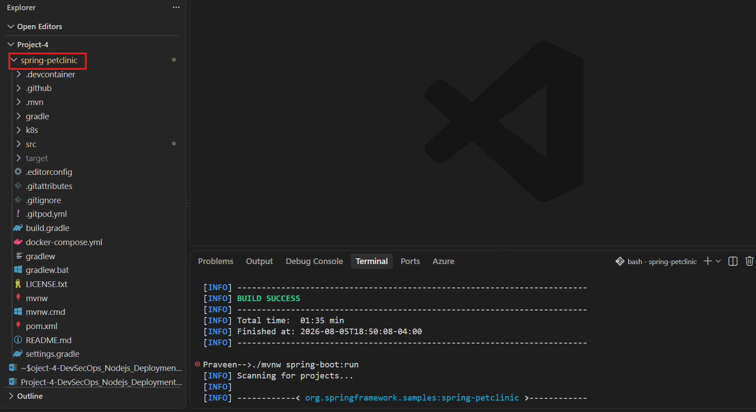
Successfully tested the Application on Local Machine
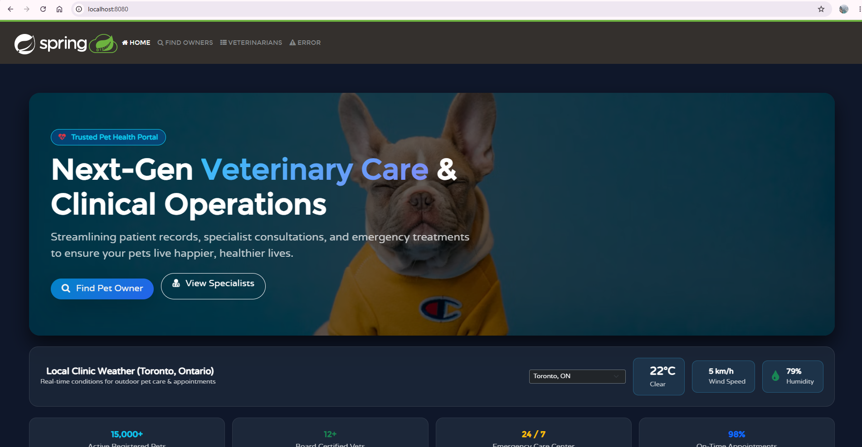

Pushed the Code to my Remote GitHub repository
