RETINAMASK

1)Retinamask is a combination of both Retinanet and Mask Rcnn

how Retinanet works?

2)
i)Retinanet is a single stage architecture which consists of a back bone network and two sub networks.
ii) The back bone network is Resnet + FPN
iii) The sub networks are i) for classification – classifies which class it belongs to
ii) for Regression – Gives bounding box values

how mask rcnn works?

3)In general Mask Rcnn also consists of a back bone network and three sub networks.
i)The back bone network is Resnet+RPN
ii)The sub networks are i)for classification-classifies which class it belongs to
ii)for Regression-Gives bounding box values
iii)for mask-masks the regions predicted.

Idea behind Retina Mask?

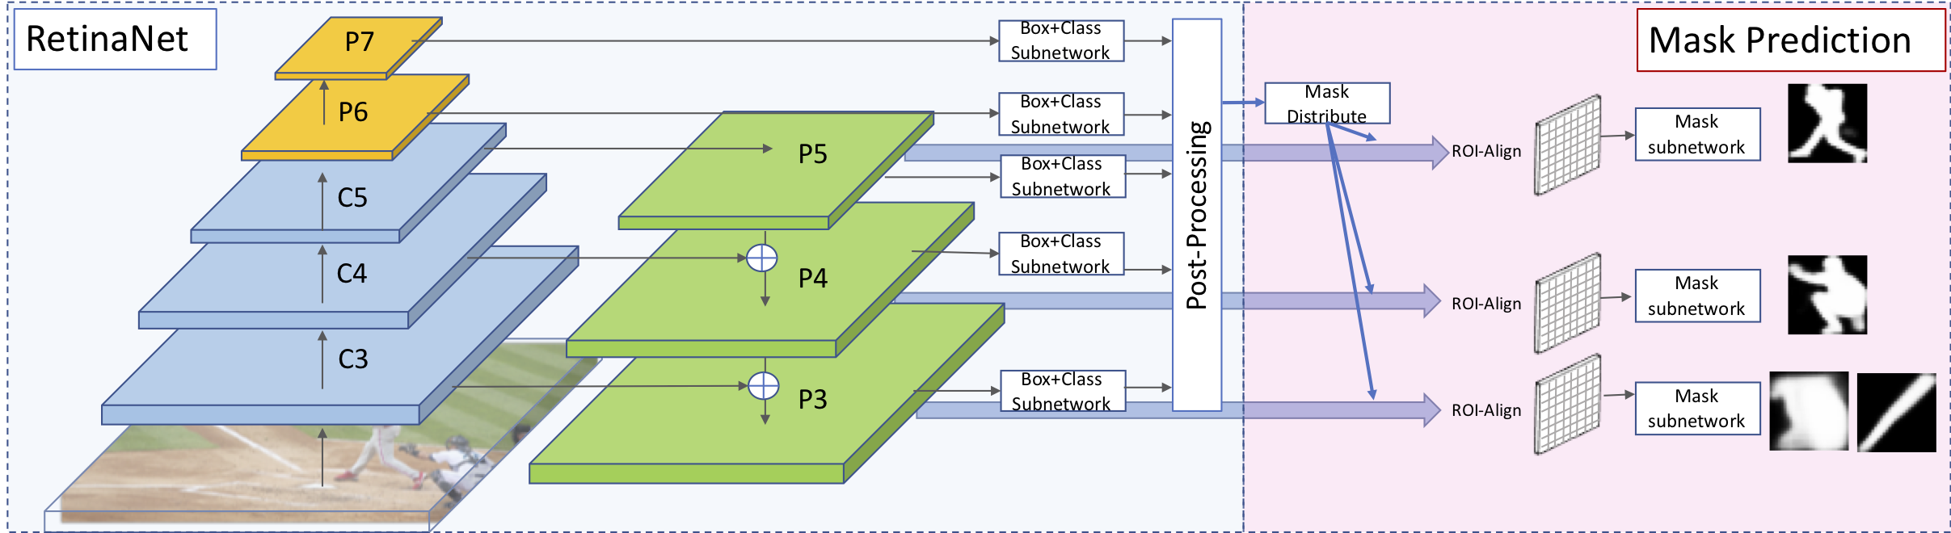

4)
i)In general Mask Rcnn takes ROI-Region of interests from RPN and then classifies it and masks it.

ii)So what we are doing in Retinamask is we are taking Region of interests from FPN.

iii)Retinanet takes ROI from FPN and classify it and draw a bounding box.

iv)mask rcnn takes ROI from FPN and masks the output prediction.

CODE:Inputs
i)A csv file containing image path ,bounding box values,label,mask path.
ii)Here mask path denotes we need to create ground truth images using label me and give that path.
Iii) A csv file containing classes
iv)PRETRAINED-WEIGHTS:we use resnet50_coco_v0.2.0.h5 file

