**GCP (Google Cloud Platform) CLI**

**How to create instance using gcloud command using Google Cloud Shell?**

Create instance using cloud shell.



By Clicking above Google Cloud Shell you can establish the connection to your Google Cloud Shell... Please find the below screenshot.

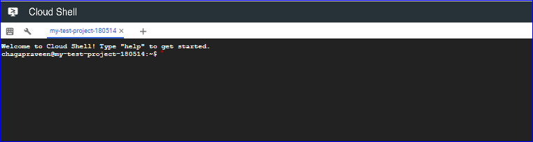

By using below G-Cloud command, we can create the Instance.

***gcloud compute instances create “Instance-Name” –zone “Zone name”***

***Example: gcloud compute instances create instance-1 –zone us-centrall-a***

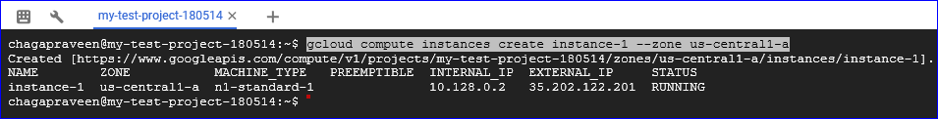

**How to set a default zone for the project?**

Set the default Zone for the project. All new instances will placed in the specified zone if you did not mention any zone while creating the new instance.

***gcloud compute instances create instance2***

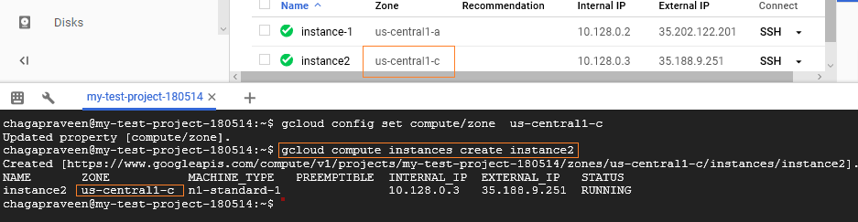

**How to stop the instance?**

**Example: *gcloud compute instances stop instance2***

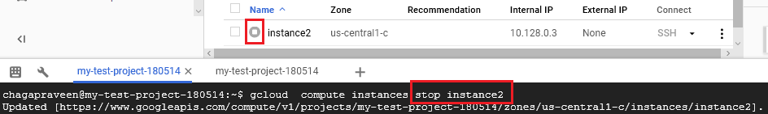

**How to start the instance?**

***Gcloud compute instances start instance2***

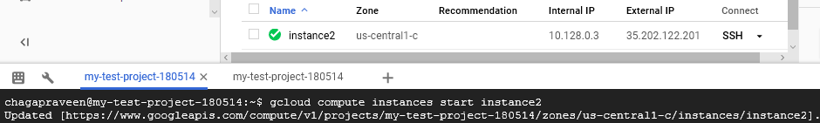

**How to delete the instance?**

***Gcloud compute instances delete instance2***

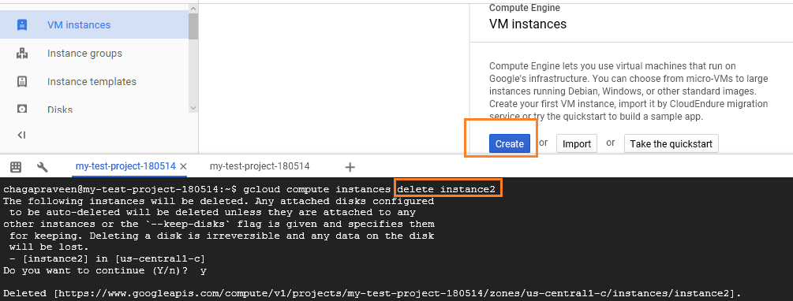

**How to create multiple servers?**

***gcloud compute instances create server1 server 2***

“This will create the 2 servers in us-central1-c because we are not mentioning any –zone flag and default zone already configured as us-central1-c”

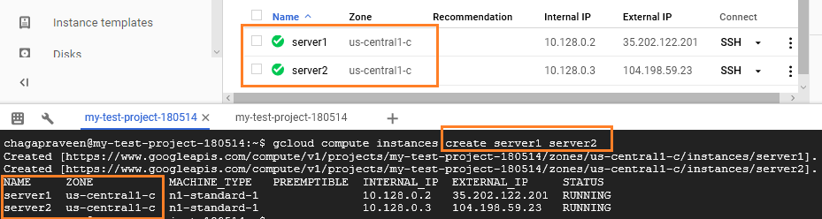

**How to delete the multiple instances?**

***gcloud compute instances delete server1 server2***

