**Cloud software- jelastic**

**Why Jelastic cloud computing?**

Jelastic is the next-generation, auto-scaling cloud hosting platform. Early generation cloud computing platforms required developers to manage virtual machines or purpose-build applications to work in the cloud. Jelastic is different.

About Jelastic

|  |  |
| --- | --- |
| Jelastic | |
| **Industry** | Cloud Computing |
| **Founded** | 2010 |
| **Founders** | Ruslan Synytskyy (CEO) Constantin Alexandrov Alexey Skutin |
| **Headquarters** | Palo Alto, California |
| **Products** | Web Hosting, Cloud Hosting, Platform-as-Infrastructure, Paas, IaaS |
| **Website** | http://jelastic.com/ |
|  |  |

Acronym of jelastic is **JAVA ELASTIC.**

1. Here in jelastic we get free trial.

2. I have logged in for jelastic free trail by my login id- [thlavanyagowda@gmail.com](mailto:thlavanyagowda@gmail.com)

3. Password will be mailed to your mail id.

4. My password is **DzCgDYqmE3.**

5. I have logged into free trail and i have runned the hello world program.

6. This free trail wil be available only upto 2 to 3 weeks.

**FEATURES OF JELASTIC**

Why we have to go for jelastic.

1. Its easy to do.

2. Better and easier scalability than VM Ware.

3. Easier management.

4. Better security than other paas.

5. Better density and multitenancy than VM.

## Supported development platforms

* [Java](http://en.wikipedia.org/wiki/Java_(programming_language))
* [PHP](http://en.wikipedia.org/wiki/Php)
* [Ruby](http://en.wikipedia.org/wiki/Ruby_(programming_language))
* [Python](http://en.wikipedia.org/wiki/Python_(programming_language))
* [Node.js](http://en.wikipedia.org/wiki/Node.js)
* [OpenShift](http://en.wikipedia.org/wiki/OpenShift)
* [Docker_(software)](http://en.wikipedia.org/wiki/Docker_(software))

HOW TO INSTALL JELASTIC

* 1. Log into the

Jelastic Manager

* 1. Click **Create environment** to set up a new environment in Jelastic.

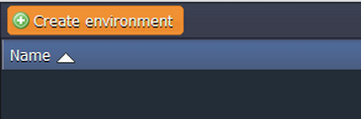

* 1. In the **Environment topology** dialog pick **GlassFish** as your application server, **MySQL** as the database you want to use and type your environment name, for example, *webroller*.Then click **Create**.

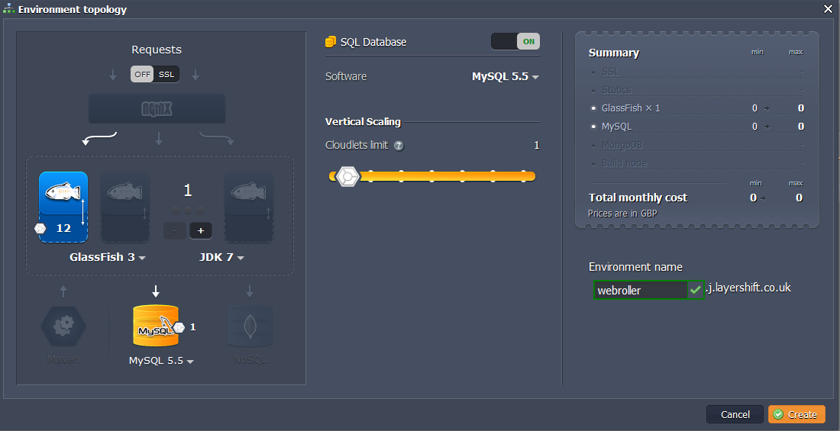

Wait just a minute for your environment to be created.

1. **Upload Java package**

* 1. Go to [Apache Roller website](http://roller.apache.org/) and download **roller-weblogger-5.0.0-for-javaee.zip** file.

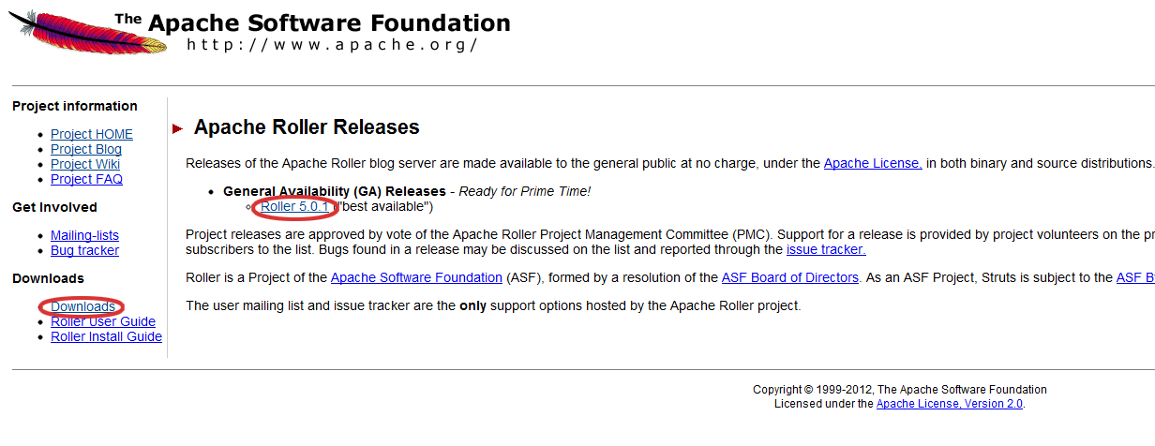  
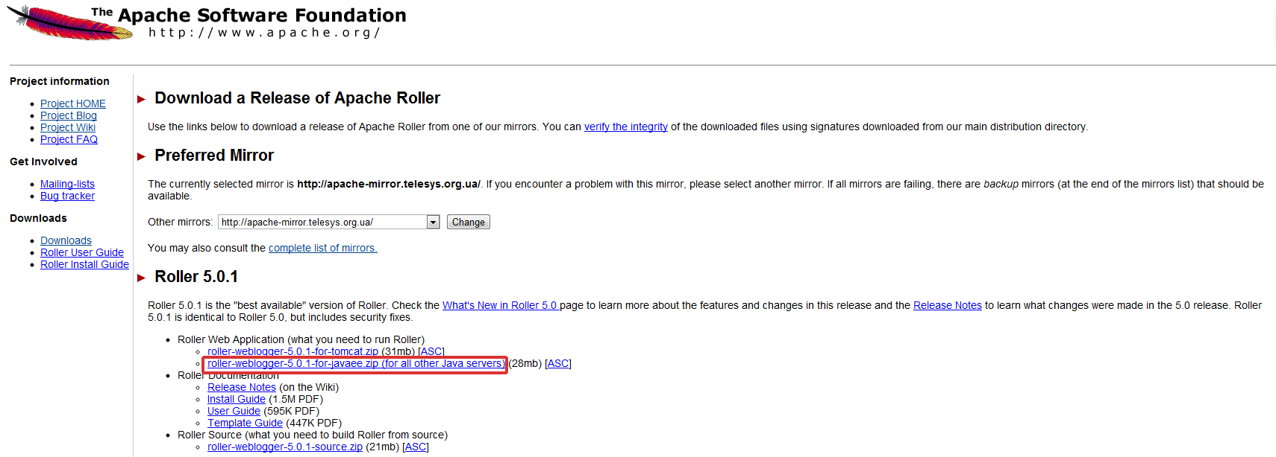

* 1. Extract the files from the package you have just downloaded.

* 1. Switch back to Jelastic dashboard and upload **roller-5.0.0-javaee.war** package (*roller-weblogger-5.0.0-for-javaee/webapp/roller-5.0.0-javaee.war*) to the **Deployment manager**.

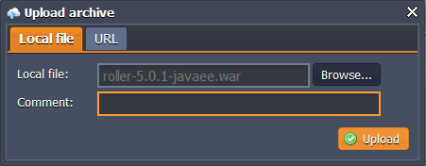

1. **Configure database**

* 1. Click **Open in browser** button for **MySQL**.

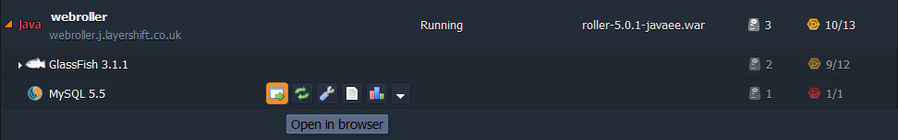

* 1. While you were creating the environment, Jelastic sent you the email with credentials to the database. Create an account and the database with the application using these credentials.

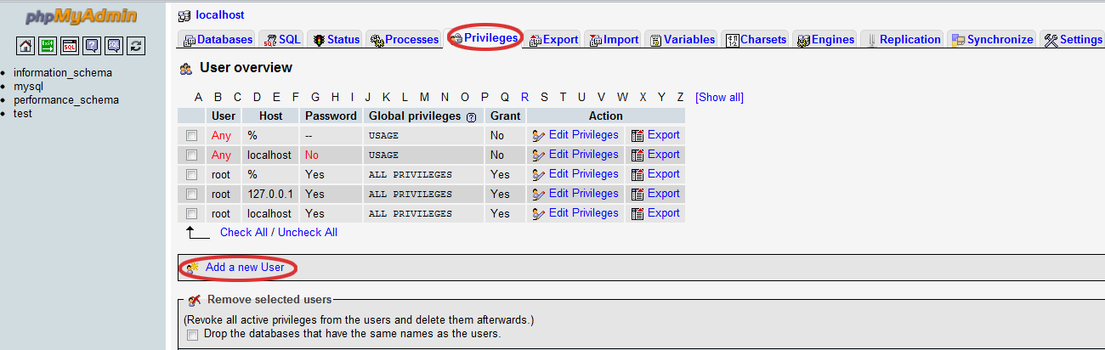  
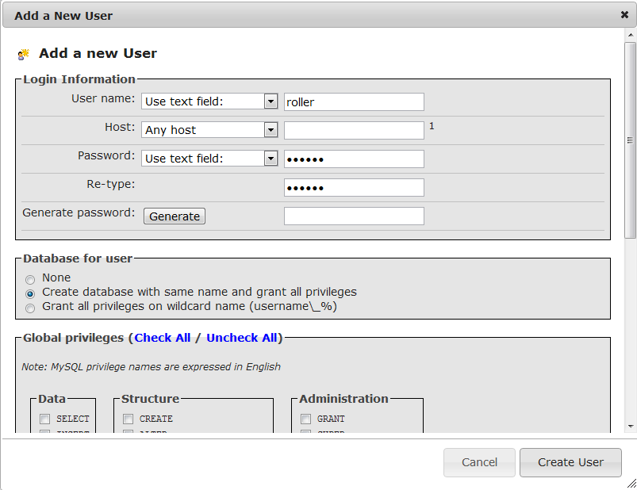

1. **Configure Apache Roller**

* 1. Click the **Config** button for GlassFish and upload **MySQL connector** to the **lib** folder.

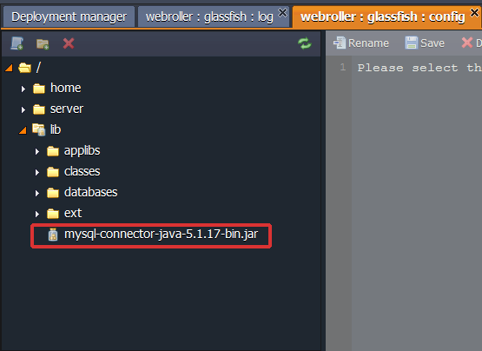

* 1. Create a file named **roller-custom.properties** with the following content:

*installation.type=auto   
mediafiles.storage.dir=/home/rollerdata/mediafiles   
search.index.dir=/home/rollerdata/searchindex   
log4j.appender.roller.File=/home/rollerdata/roller.log*

* 1. Upload the **roller-custom.properties** file to **classes** directory (*lib/classes*).   
     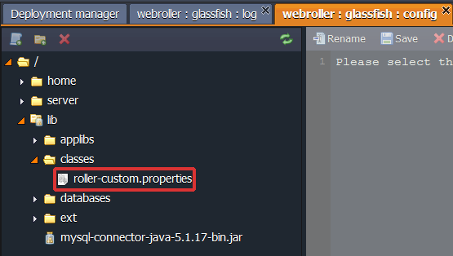
  2. Create **rollerdata** directory in the **home** folder. Then select the rollerdata directory and create **mediafiles**and **searchindex** directories in there.

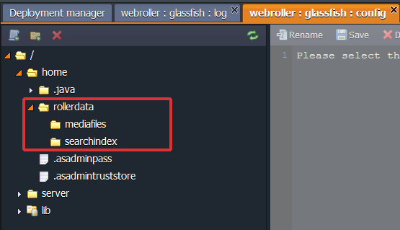

* 1. While you were creating the environment, Jelastic sent you the email with credentials to your **GlassFish DAS node**. Go to **GlassFish admin panel** and log in using these credentials.

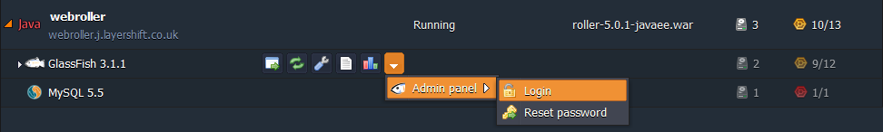  
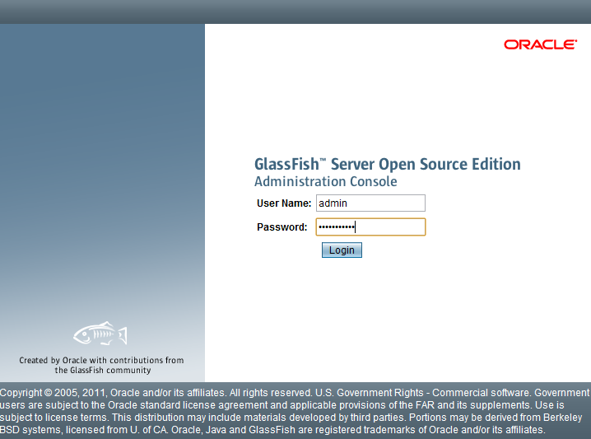

* 1. Create **connection pool** with the name *WebRollerPool*. Choose *java.sql.Driver* as the resource type and MySQL as the database driver vendor. Click **Next**.

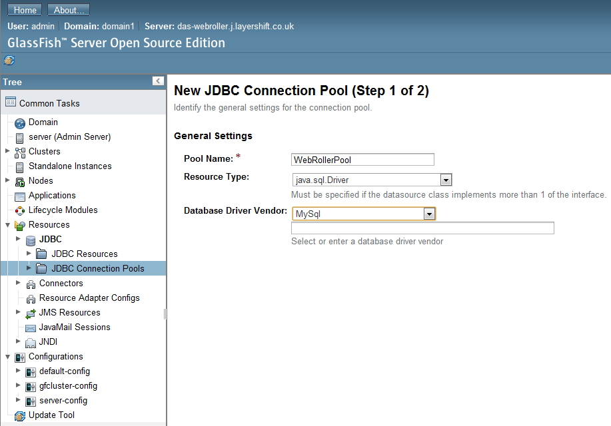

Navigate to **additional properties** and enter your database URL, username and password.

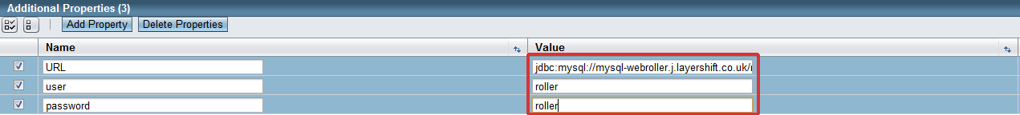

* 1. Create **JDBC resource** named *jdbc/rollerdb* and select the created **WebRollerPool** as the pool to be used by this resource.

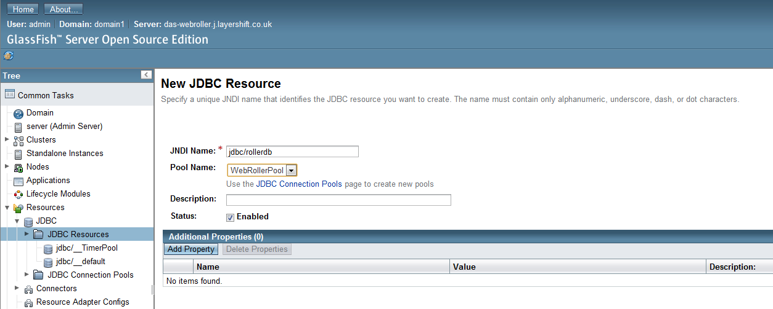

* 1. Create a **mail session** with the name *mail/Sessions* (we use Gmail as an example).

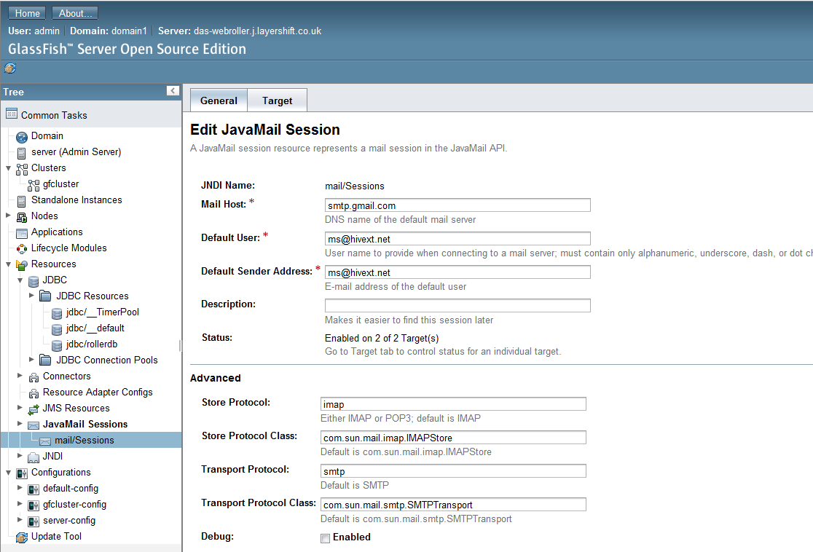

* 1. Go back to Jelastic dashboard and deploy your Java package to the environment you have created earlier.

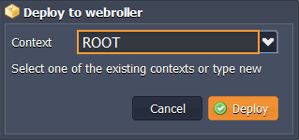

Now open you can open **Apache Roller** in a web browser, complete the installation process and start using it.

