Force.com

* Force.com, the #1 Platform-as-a-Service, helps developers create and deploy next-generation cloud apps, using rock-solid APIs and frameworks.
* Force.com delivers an on-demand cloud database with easy tools for building data driven applications and APIs for integrating with other apps.
* Force.com is the fastest way to create enterprise cloud apps.

**How to install force.com**

**Step 1: Register for a developer edition “Org”**

If you haven't already done so, start by registering for a free Force.com Developer Edition instance of Salesforce ("DE org" for short). Use an email address that you can access immediately, submit the form, and wait for an activation email. Once you receive the activation email, open it, click the login link, and set your password.

Now you’re in the Force.com's browser-based application development environment and ready to begin building an app.

**Step 2: Create an App**

Creating the foundation of a basic cloud app with Force.com requires just a few mouse clicks. In this tutorial, you use the App Quick Start wizard to create an app that can help you manage merchandise records in a warehouse.

From the Force.com Home page, click the big Add App button in the Getting Started section. (If you're starting from somewhere else, click <your_name> | Setup to return to the Force.com Home page).

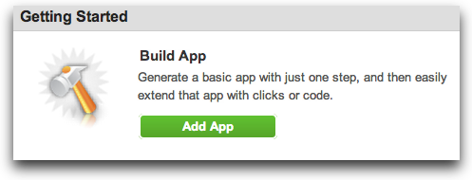

Next, fill in the form as follows to match this screen, then click **Create**:

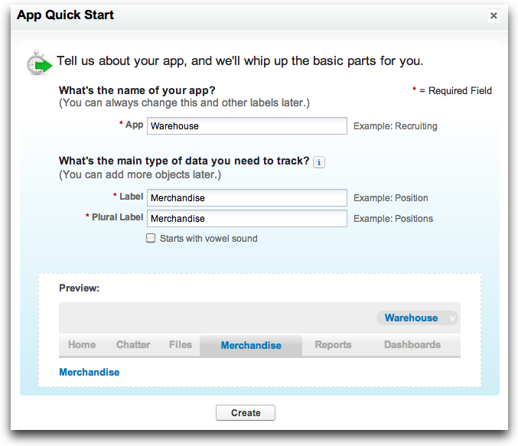

Once the wizard finishes, click **Go To My App**, **Start Tour**, and follow along for a quick overview of your app's user interface.

Step 3: Try an app

To try out your new app, just click **New** to create a new record of Merchandise.

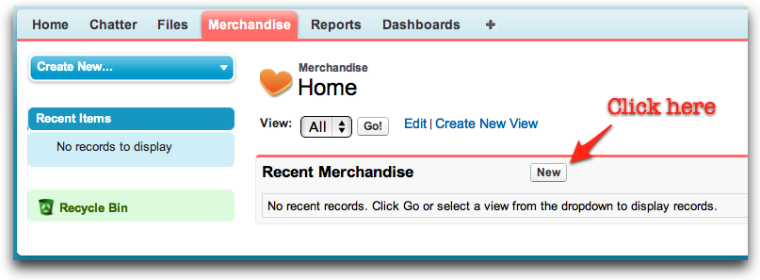

Then add a new merchandise record for "Laptop" computers.

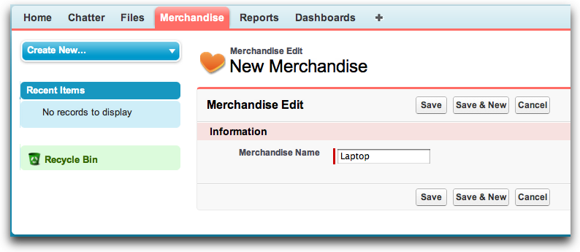

# Advantages of Developing on Force.com

1. Faster, more nimble development.

2. Easier to get started

3. Simpler and cheaper to maintain

4. Conceived with the future of the web in mind

5. Built for change

6. Don’t fret over security

7. Seamlessly integrate with other technologies