OPENNEBULA

**Introduction**

**OpenNebula** is a [cloud computing](http://en.wikipedia.org/wiki/Cloud_computing) platform.

* It manages heterogeneous distributed [data center](http://en.wikipedia.org/wiki/Data_center) infrastructures.

The OpenNebula platform manages a data center's virtual infrastructure to build private, public and hybrid implementations of [infrastructure as a service](http://en.wikipedia.org/wiki/Infrastructure_as_a_service).

* OpenNebula is [free and open-source software](http://en.wikipedia.org/wiki/Free_and_open-source_software).
* OpenNebula is sponsored by [OpenNebula Systems](http://en.wikipedia.org/wiki/OpenNebula_Systems" \o "OpenNebula Systems).
* OpenNebula is used by hosting providers, telecom operators.
* IT services providers supercomputing centers, research labs, and international research projects.
* OpenNebula is sponsored by [OpenNebula Systems](http://en.wikipedia.org/wiki/OpenNebula_Systems" \o "OpenNebula Systems).

OpenNebula is used by hosting providers, telecom operators, IT services providers, supercomputing centers, research labs, and international research projects. Some other cloud solutions use OpenNebula as the cloud engine or kernel service.

**BENIFITES OF OPENNEBLLA**

* For the Infrastructure Manager
* Centralized management of VM workload and distributed infrastructures
* Support for VM placement policies: balance of workload, server consolidation
* Dynamic resizing of the infrastructure
* Dynamic partition and isolation of clusters
* Dynamic scaling of private infrastructure to meet fluctuating demands
* Lower infrastructure expenses combining local and remote Cloud resources
* For the Infrastructure User
* Faster delivery and scalability of services
* Support for heterogeneous execution environments
* Full control of the lifecycle of virtualized services management

**OpenNebula Offer to Cloud Operators**

OpenNebula is composed of the following subsystems:

• Users and Groups: OpenNebula features advanced multi-tenancy with powerful users and groups management, fine-grained ACLs for resource allocation, and resource quota management to track and limit computing, storage and networking utilization.

• Virtualization: Various hypervisors are supported in the virtualization manager, with the ability to control the complete lifecycle of Virtual Machines and multiple hypervisors in the same cloud infrastructure.

• Hosts: The host manager provides complete functionality for the management of the physical hosts in the cloud.

• Monitoring: Virtual resources as well as hosts are periodically monitored for key performance indicators. The information can then used by a powerful and flexible scheduler for the definition of workload and resource-aware allocation policies. You can also gain insight application status and performance.

• Accounting: A Configurable accounting system to visualize and report resource usage data, to allow their integration with chargeback and billing platforms, or to guarantee fair share of resources among users.

• Networking: An easily adaptable and customizable network subsystem is present in OpenNebula in order to better integrate with the specific network requirements of existing data centers and to allow full isolation between virtual machines that composes a virtualised service.

• Storage: The support for multiple datastores in the storage subsystem provides extreme flexibility in planning the storage backend and important performance benefits.

• Security: This feature is spread across several subsystems: authentication and authorization mechanisms allowing for various possible mechanisms to identify a authorize users, a powerful Access Control List mechanism allowing different role management with fine grain permission granting over any resource managed by Open-Nebula, support for isolation at different levels...

• High Availability: Support for HA architectures and configurable behavior in the event of host or VM failure to provide easy to use and cost-effective failover solutions.

• Clusters: Clusters are pools of hosts that share datastores and virtual networks. Clusters are used for load balancing, high availability, and high performance computing.

Multiple Zones: The OpenNebula Zones component (oZones) allows for the centralized management of multiple instances of OpenNebula, called Zones, for scalability, isolation and multiple-site support.

• VDCs. An OpenNebula instance (or Zone) can be further compartmentalized in Virtual Data Centers (VDCs),which offer a fully-isolated virtual infrastructure environments where a group of users, under the control of the VDC administrator, can create and manage compute, storage and networking capacity.

• Cloud Bursting: OpenNebula gives support to build a hybrid cloud, an extension of a private cloud to combine local resources with resources from remote cloud providers. A whole public cloud provider can be encapsulated as a local resource to be able to use extra computational capacity to satisfy peak demands.

• App Market: OpenNebula allows the deployment of a private centralized catalog of cloud applications to share and distribute virtual appliances across OpenNebula instances.

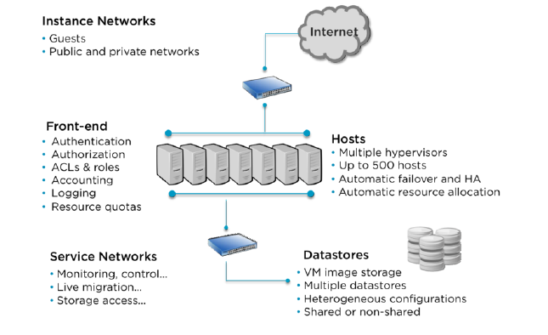

**OpenNebula Offer to Cloud Builders**

OpenNebula offers broad support for commodity and enterprise-grade hypervisor, monitoring, storage, networking and user management services:

* User Management: OpenNebula can validate users using its own internal user database based on passwords, or external mechanisms, like ssh, x509, ldap or Active Directory
* Virtualization: Several hypervisor technologies are fully supported, like Xen, KVM and VMware.
* Monitoring: OpenNebula provides its own customizable and highly scalable monitoring system and also can be integrated with external data center monitoring tools.
* Networking: Virtual networks can be backed up by 802.1Q VLANs, ebtables, Open vSwitch or VMware networking.
* Storage: Multiple backends are supported like the regular (shared or not) filesystem datastore supporting popular distributed file systems like NFS, Lustre, GlusterFS, ZFS, GPFS, MooseFS...; the VMware datastore (both regular filesystem or VMFS based) specialized for the VMware hypervisor that handle the vmdk format; the LVM datastore to store disk images in a block device form; and Ceph for distributed block device.
* Databases: Aside from the original sqlite backend, mysql is also supported.
* Cloud Bursting: Out of the box connectors are shipped to support Amazon EC2 cloudbursting.

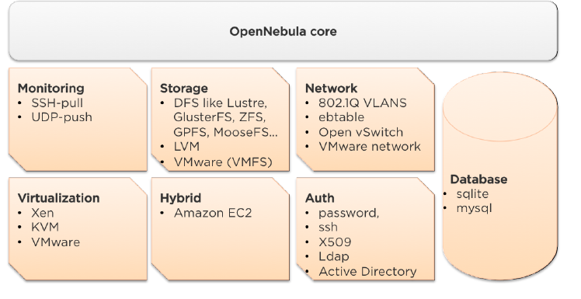

**Interfaces Provided by OpenNebula**

OpenNebula provides many different interfaces that can be used to interact with the functionality offered to manage physical and virtual resources.

There are four main different perspectives to interact with OpenNebula:

• Cloud interfaces for Cloud Consumers, like the OCCI and EC2 Query and EBS interfaces, and a simple Sunstone cloud user view that can be used as a self-service portal.

• Administration interfaces for Cloud Advanced Users and Operators, like a Unix-like command line interface and the powerful Sunstone GUI.

• Extensible low-level APIs for Cloud Integrators in Ruby, JAVA and XMLRPC API

• A Marketplace for Appliance Builders with a catalog of virtual appliances ready to run in OpenNebula environments.

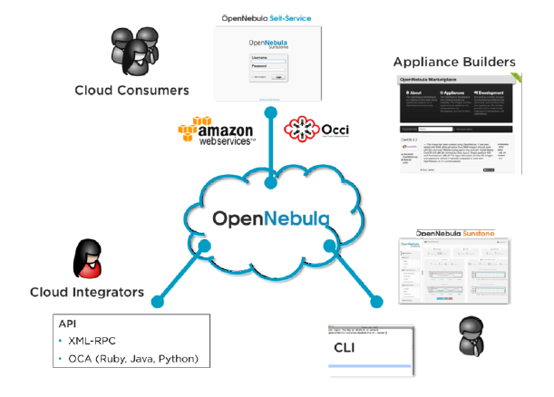

**INSTLATION STEP ON UBUNTU**

First, from a terminal on the Front-end enter:

sudo apt-get install opennebula

On each computer Node install:

sudo apt-get install opennebula-node

In order to copy SSH keys, the one admin user will need to have a password. On each machine execute:

sudo passwd oneadmin

Next, copy the oneadmin user’s SSH key to the compute Nodes, and to the Front-end’s authorized_keys file:

sudo scp/var/lib/one/.ssh/id_rsa.pub [oneadmin@node01:/var/lib/one/.ssh/authorized_keys](mailto:oneadmin@node01:/var/lib/one/.ssh/authorized_keys)

sudo scp/var/lib/one/.ssh/id_rsa.pub [oneadmin@node02:/var/lib/one/.ssh/authorized_keys](mailto:oneadmin@node02:/var/lib/one/.ssh/authorized_keys)

sudo sh –c “cat /var/lib/one/.ssh/id_rsa.pub>>/var/lib/one/.ssh/authorized_keys”

The SSH key for the compute Nodes needs to be added to the /etc/ssh/ssh_known_hosts file on the front_end host. To accomplish this SSH to each compute node as a user other than oneadmin. Then exit from the SSH session, and execute the following to copy the SSH key from ~/.ssh/known_hosts to /etc/ssh/ssh_known_hosts:

sudo sh –c “ssh-keygen –f .ssh/known_hosts_F node01 1>>/etc/ssh/ssh_known_hosts”

sudo sh –c “ssh-keygen –f .ssh/known_hosts_F node02 1>>/etc/ssh/ssh_known_hosts”

On the Front-end create a directory to store the VM images, giving the oneadmin user access to the directory:

sudo mkdir /var/lib/one/images

sudo chown oneadmin /var/lib/one/images

Configuration:

From a terminal prompt enter:

one host create node 01 im_kvm vmm_kvm tm_ssh

one host create node 02 im_kvm vmm_kvm tm_ssh

Next, create a virtual network template file named vnet 01.template:

NAME=”LAN”

TYPE: RANGED

BRIDGE= br0

NETWORK_SIZE=C

NETWORK_ADDRESS=192.168.0.0

Using the onevnet utility,add the virtual network to opennebula:

Onevnet create vnet01.template

Start the virtual machine using onevm:

Onevm submit vm01.template

**Architectural Overview**

OpenNebula assumes that your physical infrastructure adopts a classical cluster-like architecture with a front-end, and a set of hosts where Virtual Machines (VM) will be executed. There is at least one physical network joining all the hosts with the front-end.

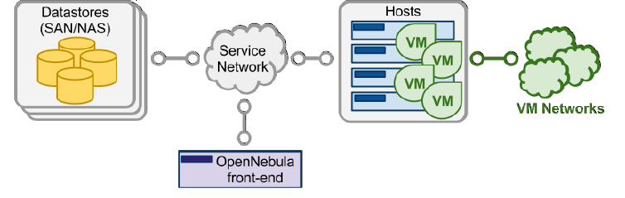

The basic components of an OpenNebula system are:

• Front-end that executes the OpenNebula services.

• Hypervisor-enabled hosts that provide the resources needed by the VMs.

• Datastores that hold the base images of the VMs.

• Physical networks used to support basic services such as interconnection of the storage servers and OpenNebula control operations, and VLANs for the VMs.

OpenNebula presents a highly modular architecture that offers broad support for commodity and enterprise-grade hypervisor, monitoring, storage, networking and user management services. This guide briefly describes the different choices that you can make for the management of the different subsystems. If your specific services are not supported we recommend to check the drivers available in the Add-on Catalog. We also provide information and support about how to develop new drivers.

