**Requirements To Install Hadoop**

**Installation of hadoop:**

1. Download Apache HADOOP tar file

2. Extract it and copy to /usr/local/hadoop

3. Update $HOME/.bashrc file

4. Configuration: Set the environment variables in env.sh

5. Change the configuration file core-site.xml

6. Format the HDFS filesystem using NAMENODE

7. /usr/local/hadoop/bin/hadoop namenode -format

8. Start the single node cluster:

/usr/local/hadoop/bin/start-all.sh

9. Check Hadoop process status using jps command

10.Stopping single node cluster:

/usr/local/hadoop/bin/stop-all.sh

11. Run Matrix Multiplication using MAP-REDUCE and also word count programmes

12. Restart HADOOP cluster

13. Run the map-reduce program again

14. The output can be view using web browsers with URL: http://localhost:50070

15. Following is the output

**The output screen for matrix multiplication with hadoop:**

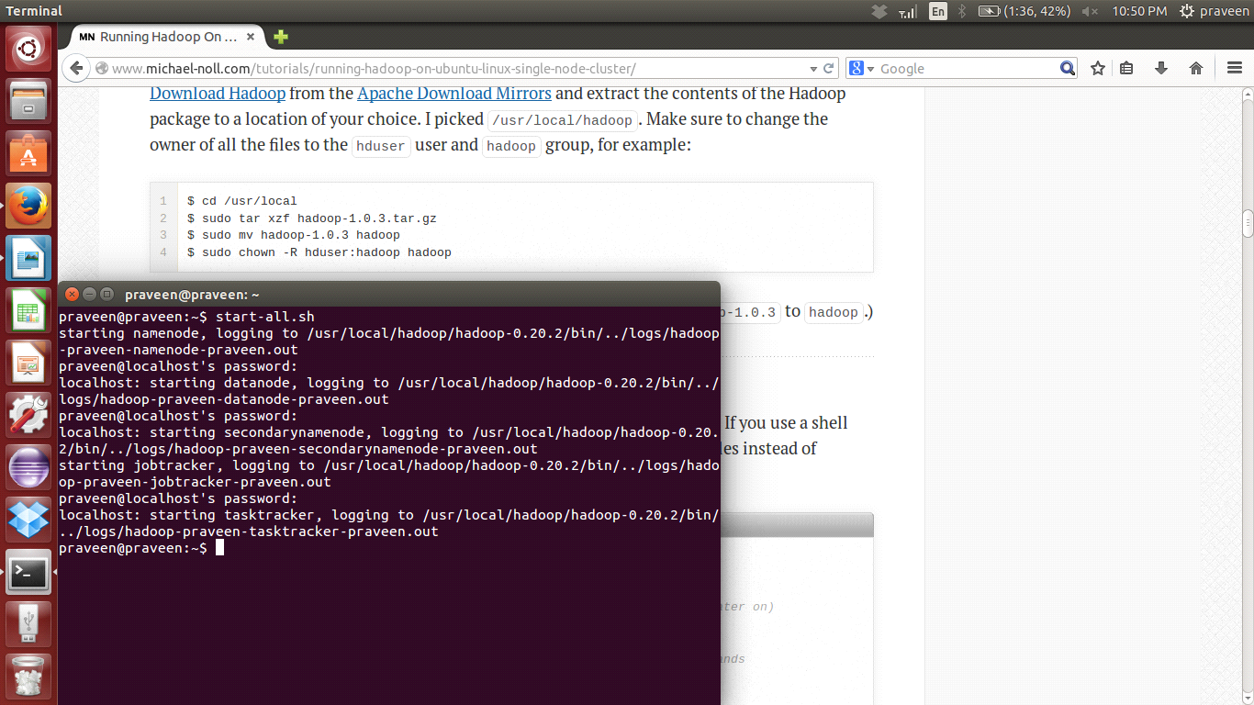

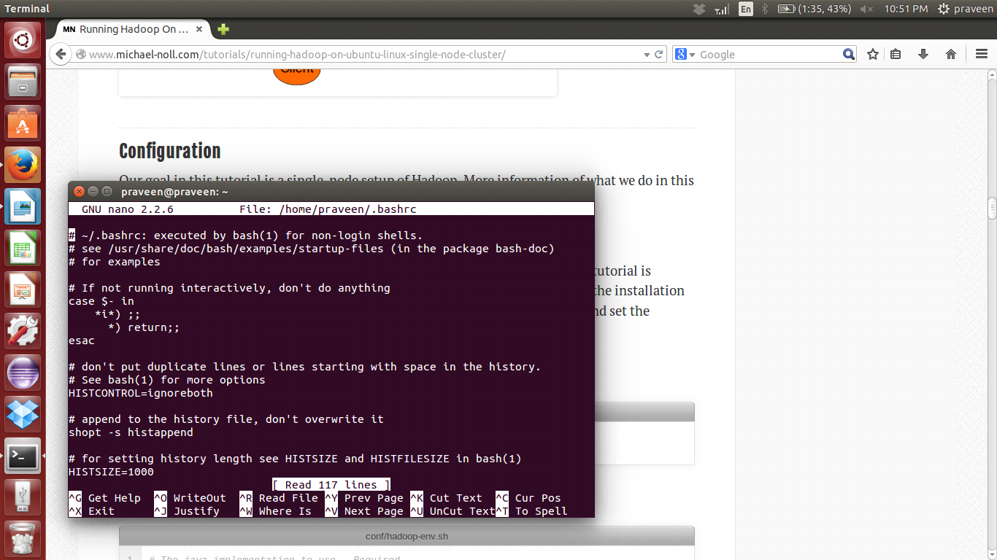

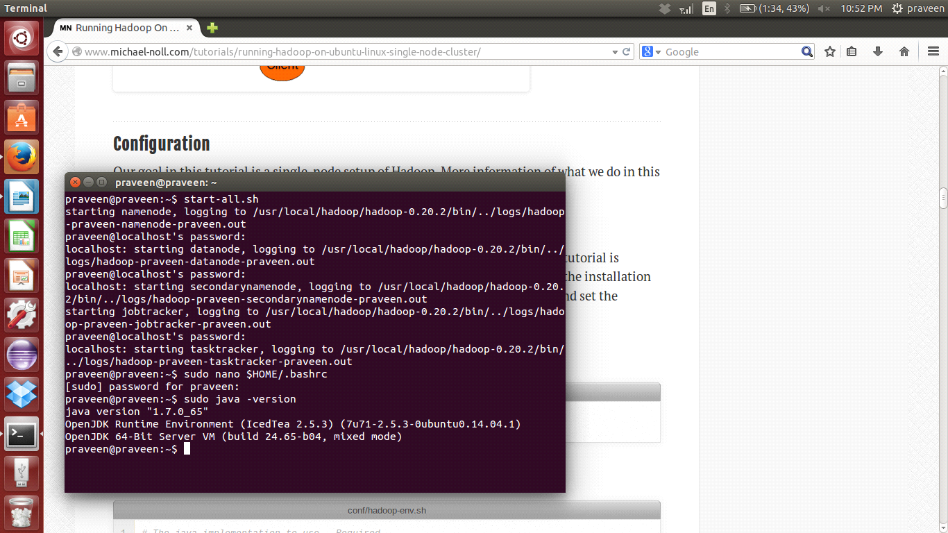

before running ,we need to convert matrxmul.java file into .jar files:

Here is that procedure:

