**HOW TO RUN WEB APPLICATION ON VIRTUAL MACHINE**

Step 1: First we have updated the packages by using

**sudo apt-get update**

step 2: we installed apache2 using

**sudo apt-get install apache2**

step3: we typed the program using nano editor

**sudo nano ll.html**

step4: run in web-browser **localhost/ll.html**

step5: we pinged the result in host machine by giving the IP address <http://192.168.239.141/ll.html>

fig 1:simple program to run web application

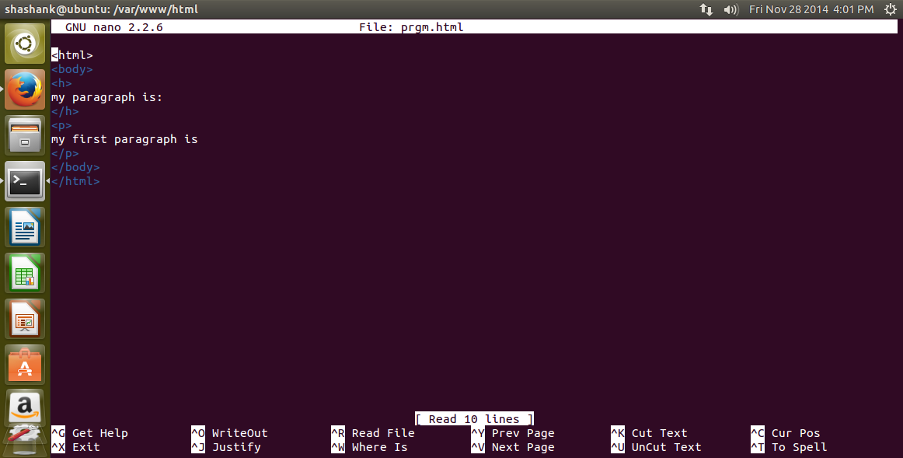

Fig 2:output window in ubuntu

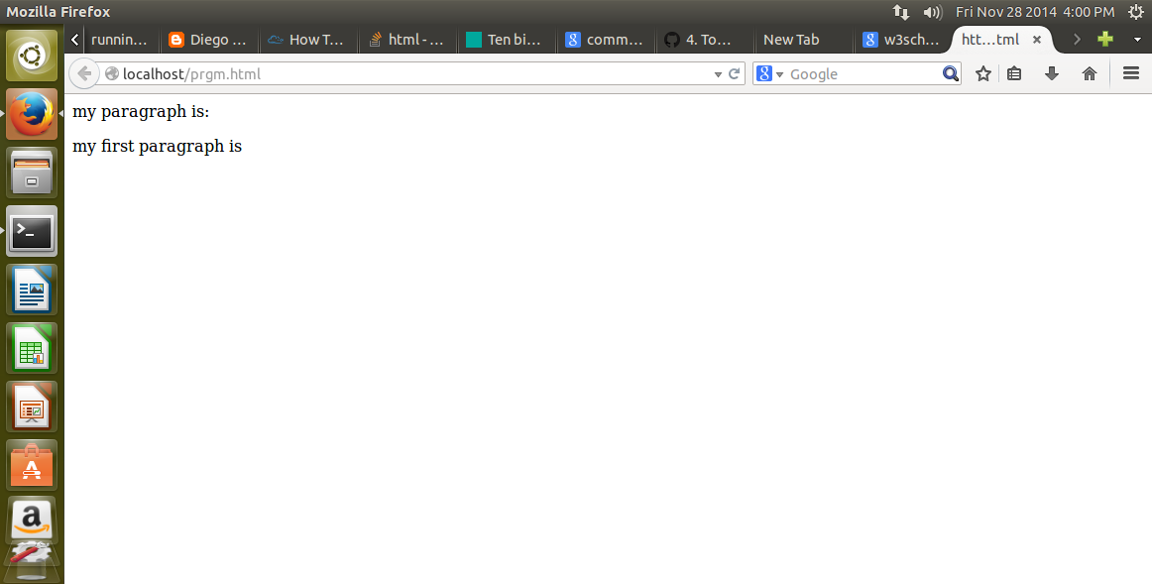

Fig 3:output accessed from ubuntu to host me chain

