**HOW TO RUN WEB APPLICATION ON VIRTUAL MACHINE**

Step 1: First we have to update packages by using

**sudo apt-get update**

step2: install apache2 using

**sudo apt-get install apache2**

step3: type example program using nano editor with html extension.

**sudo nano filename.html**

step4: run in web-browser **localhost/filename.html**we get the output in web browser.

step5: ping the result in host machine by giving the IP address <http://192.168.239.141/ll.html>

**Simple program to run web application**

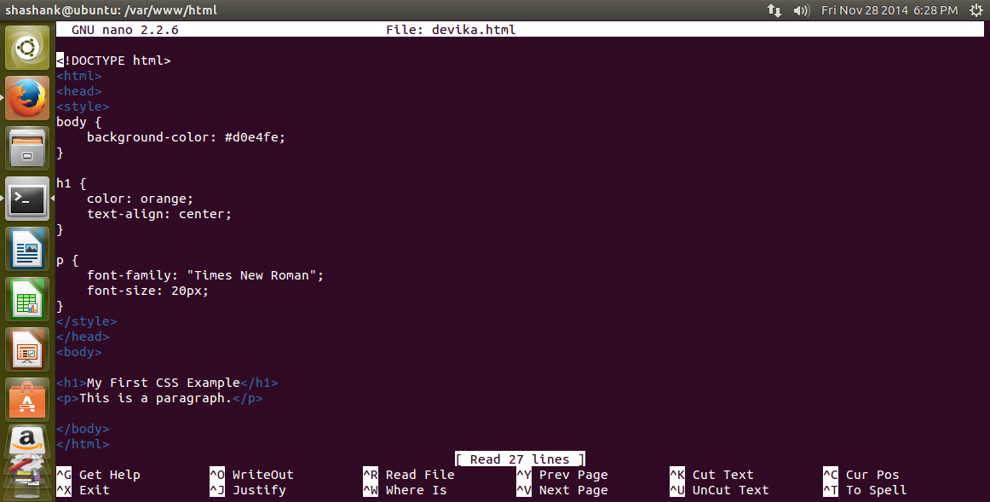

Output:

