SKYBOOK
An Airline Reservation Platform
Engineering Case Study
Eight Spring Boot microservices · Apache Kafka · PostgreSQL · React
Nineteen delivery increments over thirty-five days
Praveen Somireddy
3 August 2026
github.com/praveencloudlab/skybook

Contents
1. Executive Summary
2. Problem and Context
3. Requirements
4. Architecture
5. Event Choreography
6. The Booking Saga
7. Money: Payment, Pricing and Refunds
8. Check-in and Boarding
9. Platform Engineering
10. Deployment
11. Delivery History
12. Testing
13. Defects and Lessons
14. Known Gaps and Contradictions
15. Data Model
16. Conclusion
Fourteen figures appear on landscape pages throughout.

1. Executive Summary
SkyBook is a passenger reservation platform for an airline, built as eight Spring Boot microservices behind a single API gateway, with PostgreSQL for persistence, Apache Kafka for event choreography, and a React single-page application for the passenger journey. It covers the complete customer lifecycle: searching for flights without an account, pricing a trip, selecting seats, paying, checking in, and downloading a boarding pass.
The platform was delivered over thirty-five days in nineteen increments, all reconstructible from git history. It runs today on a single cloud virtual machine behind an automatically provisioned TLS certificate, seeded with a full year of bookable flights.
This document is a case study rather than a brochure. It records what was built, why each significant decision was taken, what the decisions cost, and — deliberately — what does not work, what is not tested, and where the documentation and the code disagree. Several sections exist only to record a mistake and its correction, because those are the parts of a project that are usually edited out and are usually the most instructive.
How to read this document
Sections 9 and 10 record defects, contradictions and gaps rather than achievements. They are the point of the study, not an appendix to it. Every figure in this document was generated from the repository, and every count was measured rather than estimated.

2. Problem and Context
An airline reservation system solves a deceptively simple-sounding problem: let a traveller find a flight, buy a seat on it, and board it. The difficulty is that almost every step involves scarce inventory, irreversible money movement, and state that must remain consistent across independently failing components.
Two seats cannot be sold to two passengers. A payment that succeeds must never leave a booking unconfirmed, and a booking that fails must never leave money captured. A passenger who cancels must be refunded according to the fare they actually bought, at the price they actually paid, not at whatever the fare table says today. Check-in must open and close against the departure airport's local clock. None of these are difficult in isolation; all of them are difficult at once, across a distributed system, where any component can fail between any two steps.
SkyBook exists to work through that problem end to end. Its stated purpose in the requirements specification is explicit about its second motive: it is a portfolio system built to demonstrate senior-level engineering, not a system commissioned by a named airline. That framing matters for honest reading — there is no commercial business case, no market analysis, and no revenue model in any project document, and this study does not invent one.

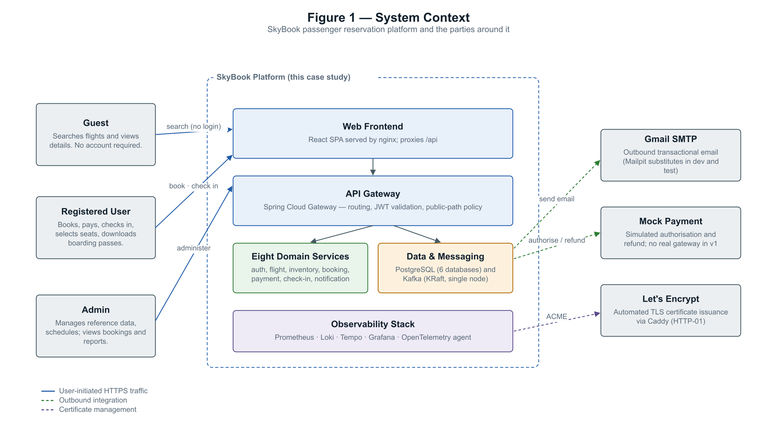
Figure 1 — System context: the actors around the platform and its external dependencies.

2.1 Scope

In scope for version 1
- Guest flight search without an account
- User registration and authentication
- One-way, round-trip and multi-city booking
- Multi-passenger bookings on a single PNR
- Seat selection with attribute-based pricing
- Payment authorisation, capture and refund
- Online check-in and boarding-pass issue
- Event-driven email notification
- Admin flight and reference-data management
- Baggage allowance and excess calculation

Explicitly out of scope
- A real payment gateway integration
- Real airline or GDS API integration
- Flight delay and irregular-operations management
- Loyalty points and frequent-flyer programmes
- Hotel and car-rental ancillaries
- A native mobile application
- Refresh tokens and token revocation
- Load, performance and capacity testing

3. Requirements
The requirements specification is a prose document organised into seven sections. It contains no requirement identifiers — no FR-1, no NFR-1, no tags of any kind. This is worth stating plainly at the outset, because case studies routinely invent such identifiers retrospectively to look rigorous. The tables below therefore group the specification's own unlabelled statements by domain rather than citing identifiers that do not exist.

3.1 Functional requirements by domain
Area | Requirement
Search | Guests may search flights without logging in. A search takes five inputs: origin, destination, journey date, passenger count and cabin class. Only active, scheduled, future flights are returned.
Registration | Email addresses are unique. Passwords are hashed with BCrypt. The default role on registration is USER; administrators cannot self-register and are granted only by a bootstrap property at service start.
Booking | Only authenticated users may book. One booking may carry multiple passengers and must generate a unique PNR. A booking begins as PENDING and becomes CONFIRMED once payment succeeds.
Passengers | The passenger is not necessarily the account holder — one user may book for family members. Passenger details are stored separately from the user account. Adult, child and infant types are supported.
Payment | Version 1 uses a simulated payment gateway. Booking and payment state must remain consistent. A real gateway is explicitly out of scope.
Check-in | Only confirmed bookings may check in. Check-in opens 24 hours before departure and closes 45 minutes before. A passenger may check in only once per flight. The booking reaches CHECKED_IN only when every passenger has checked in.
Seat selection | One seat can never be assigned to two passengers, and seat assignment must be transactional. The original specification placed seat choice at check-in; the implemented system moved it to booking time with paid selection, which is recorded as a deviation in this study.
Boarding pass | Generated only after a successful check-in, carrying passenger, flight, seat, gate, boarding time and a scannable code, and downloadable as a PDF.
Notification | The system publishes domain events and sends transactional email automatically. Consumers must be idempotent. Kafka is for asynchronous processing, never for search.
Administration | Administrators manage airports, airlines, aircraft and flight schedules, create flight instances, and view bookings and reports.

3.2 Non-functional requirements
The specification's non-functional section is entirely qualitative. It requires that "flight search should respond quickly", that "proper indexes must be added", and that consumers be idempotent — but it contains no latency target, no throughput figure, no availability percentage, no concurrency goal and no recovery objectives.
This is a genuine gap rather than an omission from this study, and it has a consequence worth naming: the platform measures p95 latency on its Grafana dashboard but has no p95 target to measure against. Where numeric limits do exist in the running system — a 100 request-per-minute rate limit, a 15-minute seat-hold TTL, a 124-day calendar cap, 2-second connect and 5-second read timeouts — they were set during implementation as reasoned defaults, and none of them derives from a stated requirement or from measurement under load.

3.3 Business rules with concrete values
These are the numeric rules the running system actually enforces. Where a value was set during implementation rather than specified, that is noted in section 3.2.
Rule | Value
Check-in window opens | 24 hours before departure
Check-in window closes | 45 minutes before departure
Boarding opens | 45 minutes before departure
Gate closes | 20 minutes before departure
Seat hold time-to-live | 15 minutes, swept every 60 seconds
Booking cutoff | departures less than 60 minutes away are not bookable
Route calendar cap | 124 days per query
Refund — FLEXI fare | 100%, no cancellation fee
Refund — PREMIUM fare | 100%, no cancellation fee
Refund — SAVER fare | 70%, a 30% cancellation fee
Cabin base fares | Economy 100, Premium Economy 180, Business 350, First 700
Fare-type multipliers | Saver 0.85, Flexi 1.00, Premium 1.25
Protected connection layover | 45 minutes minimum (self-transfer requires 60)
PNR format | SB plus four characters from a 31-character unambiguous alphabet

3.4 Actors
Actor | Capabilities
Guest | Search flights, view details, price a trip, register, sign in
Registered user | Everything a guest can do, plus book, pay, manage bookings, cancel, check in, select seats and download boarding passes — scoped to their own bookings
Administrator | Reference data, flight schedules, flight lifecycle, all bookings, back-office and gate operations including boarding
System | Publishes domain events, generates PNRs, tickets and boarding passes, sweeps expired holds and drafts, marks no-shows

4. Architecture
SkyBook is organised around business capabilities, with strict database-per-service isolation: no service reads or writes another service's tables, and no foreign key crosses a database boundary. Cross-service references are plain identifiers. Where one service needs another's data, it either calls it over HTTP through an anti-corruption DTO or receives it on a Kafka event.
Communication is split by intent rather than by fashion. Synchronous REST is used when the caller cannot proceed without an answer — validating that a flight exists before booking it, or holding a seat. Kafka is used when something has happened and other services need to react without blocking the caller — a booking was created, a payment succeeded, a passenger checked in.

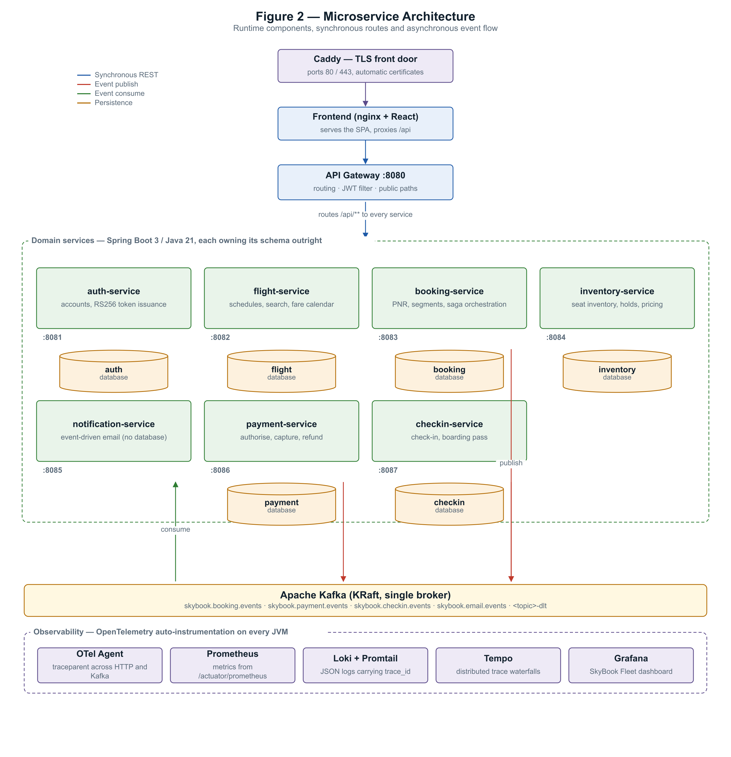
Figure 2 — Runtime architecture: edge, services, per-service databases, the event bus and the telemetry stack.

4.1 Service inventory
Service | Port | Database | Responsibility
api-gateway | 8080 | — | Single public entry point: routing, JWT validation, CORS, rate limiting, request logging
auth-service | 8081 | skybook_auth | Registration, BCrypt passwords, RS256 token issuance, password reset, saved travellers
flight-service | 8082 | skybook_flight | Flights, recurring schedules, search, itineraries, route calendar, flight lifecycle
booking-service | 8083 | skybook_booking | Booking lifecycle, PNR, segments, tickets and coupons, cancellation, fare quote
inventory-service | 8084 | skybook_inventory | Aircraft and seat maps, per-flight seat counts, seat holds, reservations, seat pricing
notification-service | 8085 | none | Pure Kafka consumer; renders and sends transactional email. Not routed by the gateway
payment-service | 8086 | skybook_payment | Payment lifecycle, refunds, invoices
checkin-service | 8087 | skybook_checkin | Check-in, boarding passes, baggage, flight manifests
frontend | 3000 | none | React SPA served by nginx, proxying /api to the gateway on one origin

4.2 Layering
Layering is deliberately not uniform. flight-service uses three layers — controller, service, repository — because it is essentially CRUD over reference data. booking-service, inventory-service, payment-service and checkin-service use five, inserting a facade above the service layer.
The facade earns its place by owning one rule: it is the only layer that knows other services exist, and it is never annotated @Transactional. That combination is what keeps external I/O — a Feign call to inventory, a payment gateway round trip — outside any database transaction. Holding a database connection open across a network call is the failure mode this structure exists to prevent, and it also means that by the time a facade publishes a Kafka event, the transaction has already committed.
The rule that shapes every service
The facade is the only layer that knows other services exist, and it is never transactional. External I/O therefore never happens inside a database transaction, and any event published after a service call is published after that transaction has already committed.

4.3 The customer journey

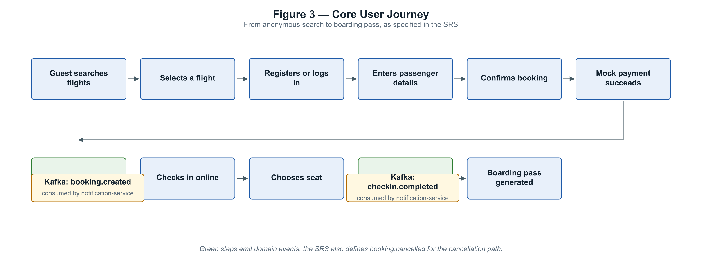
Figure 3 — The core journey as specified: anonymous search through to boarding pass.

5. Event Choreography
Five topics carry the platform's domain events, one per producing service, each with a type discriminator in the payload. This is a deliberate departure from the architecture document, which specified one topic per event type; that scheme was never built.

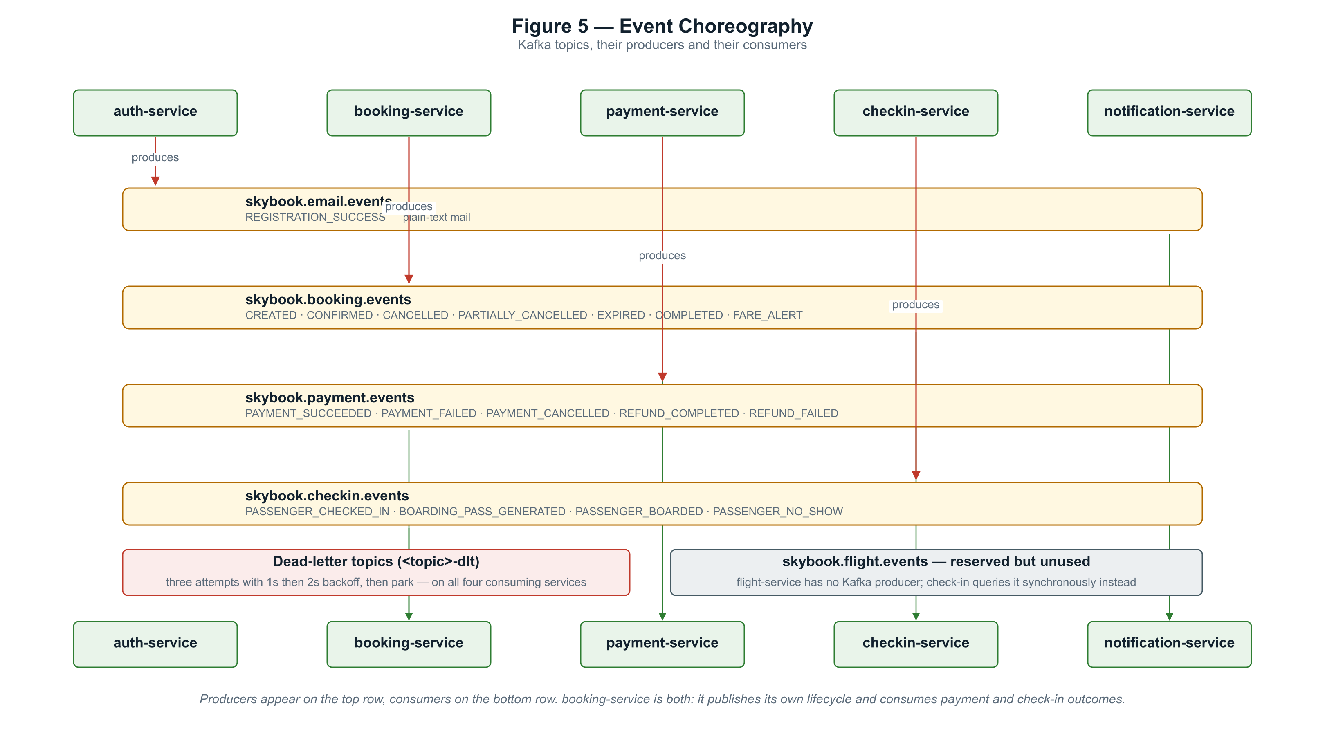
Figure 5 — Topics, producers and consumers. booking-service is both a producer and a consumer.

Two properties of this design are load-bearing. Consumers are idempotent by natural key rather than by bookkeeping — payment-service keys on booking identifier, checkin-service on booking-passenger identifier, both backed by unique constraints — so a redelivered event finds existing state and does nothing. And event evolution is additive only: new fields arrive nullable, consumers running older builds ignore what they do not recognise, and consumers that encounter genuinely pre-enrichment events skip them loudly rather than throwing.
Every consuming service retries three times with one- and two-second backoff before parking a message on a dead-letter topic. This replaced the framework default of roughly ten immediate retries followed by silently committing past the record — which loses the business event permanently. Deserialization is wrapped so a malformed message fails into the error handler instead of wedging the consumer forever, a failure that had already occurred once in development.

6. The Booking Saga
Creating a booking is the platform's most involved operation, and its shape changed materially during the seat-selection work. The original implementation assigned seats inside the booking transaction, before passenger rows had been saved — so it had no identifiers to give inventory, could return only a seat number as a string, and had nowhere to put a network call.
The replacement is a three-stage saga: draft, hold, finalize. The draft commits first, producing real booking and passenger identifiers with the seat column still null and no payment row at all. Holds are then taken against inventory, outside any booking transaction. Finally a single transaction writes every seat, every fare, the booking total and the payment row, and moves the booking from DRAFT to CREATED.
The DRAFT status is the point of the exercise. CONFIRMED is reachable only from CREATED, so a crash between the draft and the finalize can leave a draft booking but can never leave a confirmable booking with no seat and no payment. That window closes structurally rather than by convention. A sweep job cancels stale drafts after fifteen minutes, matching the seat-hold TTL.
Compensation spans the whole journey. On a round trip, a failure on the return leg releases the holds already taken on the outbound leg as well, cancels the draft, and rethrows the original exception so the caller sees the real cause rather than a compensation artefact.

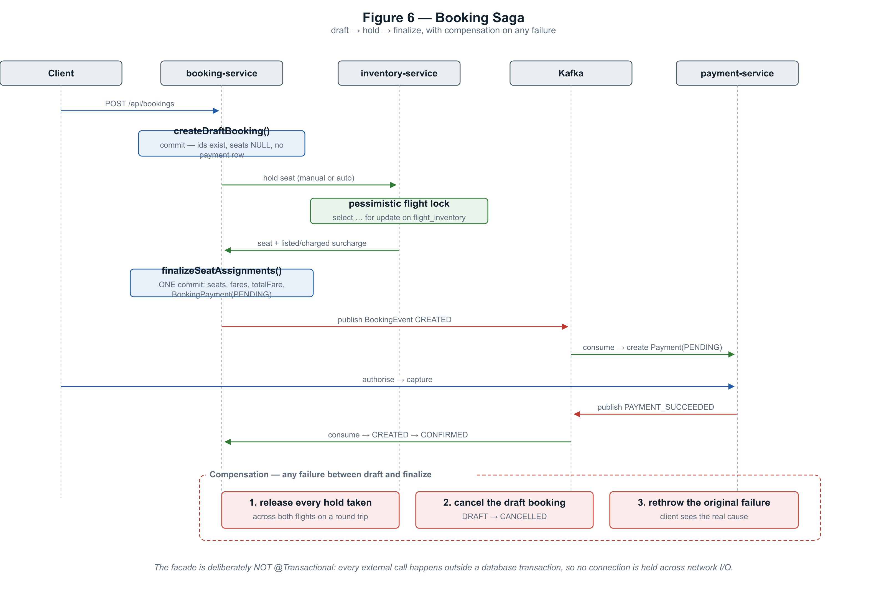
Figure 6 — Booking as a three-stage saga with compensation spanning every flight involved.

6.1 Booking lifecycle

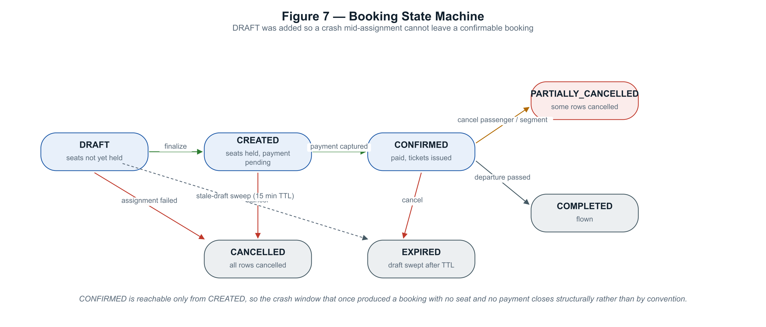
Figure 7 — Booking states. CONFIRMED is reachable only from CREATED.

6.2 Concurrency and the double-sell problem
Selling the same seat twice is the canonical failure of a reservation system, and SkyBook defends against it in layers rather than trusting any single mechanism.
The authoritative defence is a pessimistic flight-level lock in inventory-service. Every operation that mutates the available, held, reserved or blocked counters takes SELECT … FOR UPDATE on the flight inventory row, so manual and automatic seat selection serialise against each other rather than racing. Optimistic @Version locking remains as a second line. Automatic assignment goes further: seat selection and the hold happen atomically inside inventory-service, so there is no window between choosing a seat and taking it.
The invariant those operations maintain is stated once and enforced in one place: available + held + reserved + blocked always equals total.
Underneath both sits the argument the project returns to repeatedly — that a database-enforced rule survives buggy code while a code-enforced rule does not. This was demonstrated live rather than asserted: in a double-capture race in payment-service, the losing thread was stopped by the unique constraint on invoices.payment_id, exactly as the design had predicted. The corresponding concurrency test accepts either a constraint violation or an optimistic-lock failure, because either outcome is correct.

7. Money: Payment, Pricing and Refunds
Payment splits failure into two states rather than one, because the two are not equivalent: an authorisation failure leaves nothing behind, while a capture failure leaves a live authorisation that can still be retried or voided. Collapsing them would have made the legal next steps ambiguous.

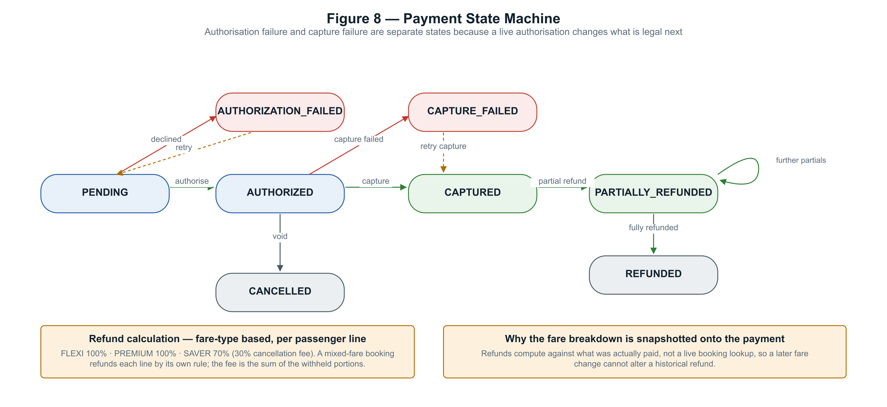
Figure 8 — Payment states, including the partial-refund self-loop.

7.1 Refunds compute against what was paid
The fare breakdown is snapshotted onto the payment when it is created from the booking event, and refunds are computed from that snapshot rather than from a live lookup against booking-service. A mixed-fare booking therefore refunds each passenger line by its own rule, and a later change to the fare table cannot alter a historical refund. Cumulative refunds can never exceed the captured amount — enforced by a validator, re-checked by a service invariant, and serialised under optimistic locking.

7.2 Seat pricing
Seat surcharges are derived from seat attributes at read time and never stored on the seat row, so re-pricing is a configuration change rather than a data migration. The distinction that makes the model work is between what a seat is worth and what a passenger actually paid: an automatically assigned window seat carries a listed surcharge but is charged nothing.

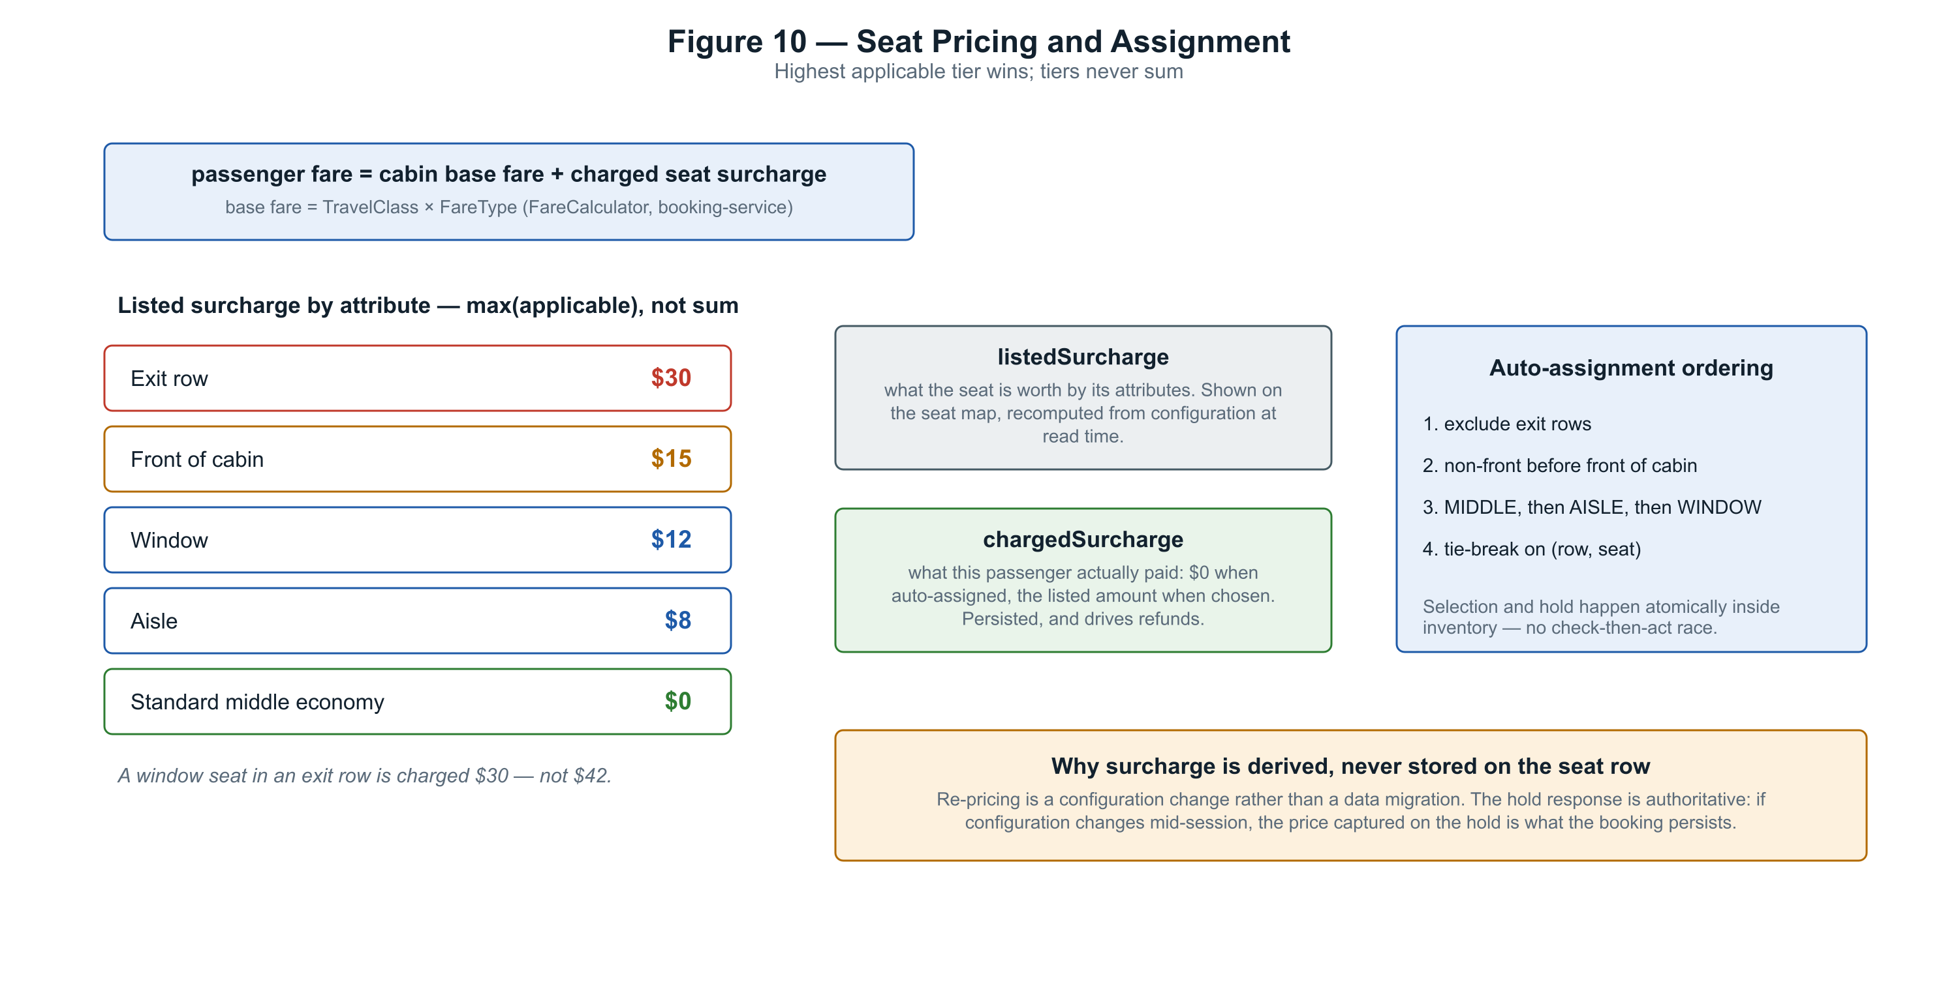
Figure 10 — Attribute-based seat pricing. Tiers take the highest applicable value; they never sum.

8. Check-in and Boarding
One check-in record exists per passenger per segment, created when a booking is confirmed. That granularity is what makes per-direction check-in on a round trip work without any schema change: the record is keyed on the booking-passenger row, and on a round trip that row is already per segment.

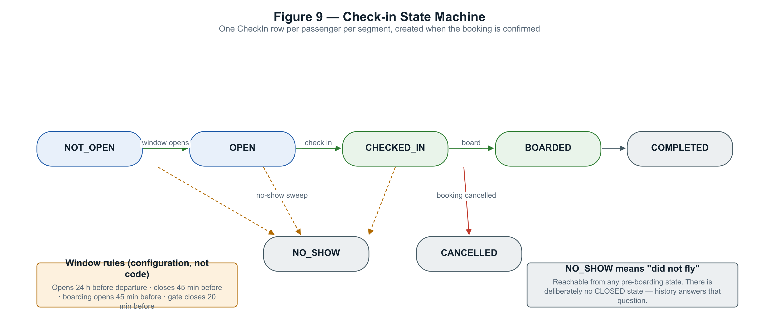
Figure 9 — Check-in states. NO_SHOW deliberately means "did not fly" and is reachable from any pre-boarding state.

A boarding pass is not an endpoint but a side effect of a successful check-in, and it is deliberately denormalised so it remains a self-contained printable document even if the underlying record changes. A seat change revokes the existing pass and issues a new one rather than mutating it, which preserves the append-only history the rest of the platform uses.
Each pass carries a token: a compact payload with an HMAC-SHA256 signature, verified by recomputing the signature and then confirming that the pass is still active and the passenger has not already boarded. The token signer is described in its own design document as the riskiest new code in that module, and its tests cover tampered signatures, tampered payloads, malformed tokens and wrong-key rejection.
A boundary the platform enforces deliberately
A passenger may check in but may never board themselves — boarding is a gate operation and returns 403 to a passenger token. The user interface does not offer the action at all, and the certification suite asserts the refusal explicitly.

9. Platform Engineering

9.1 Security
Authentication is RS256 asymmetric. auth-service alone holds the private key; the gateway and every service hold only the public key, so no component other than the issuer can mint a token. An earlier design used a shared symmetric secret and was rejected in review precisely because any holder could forge an administrator or service token.

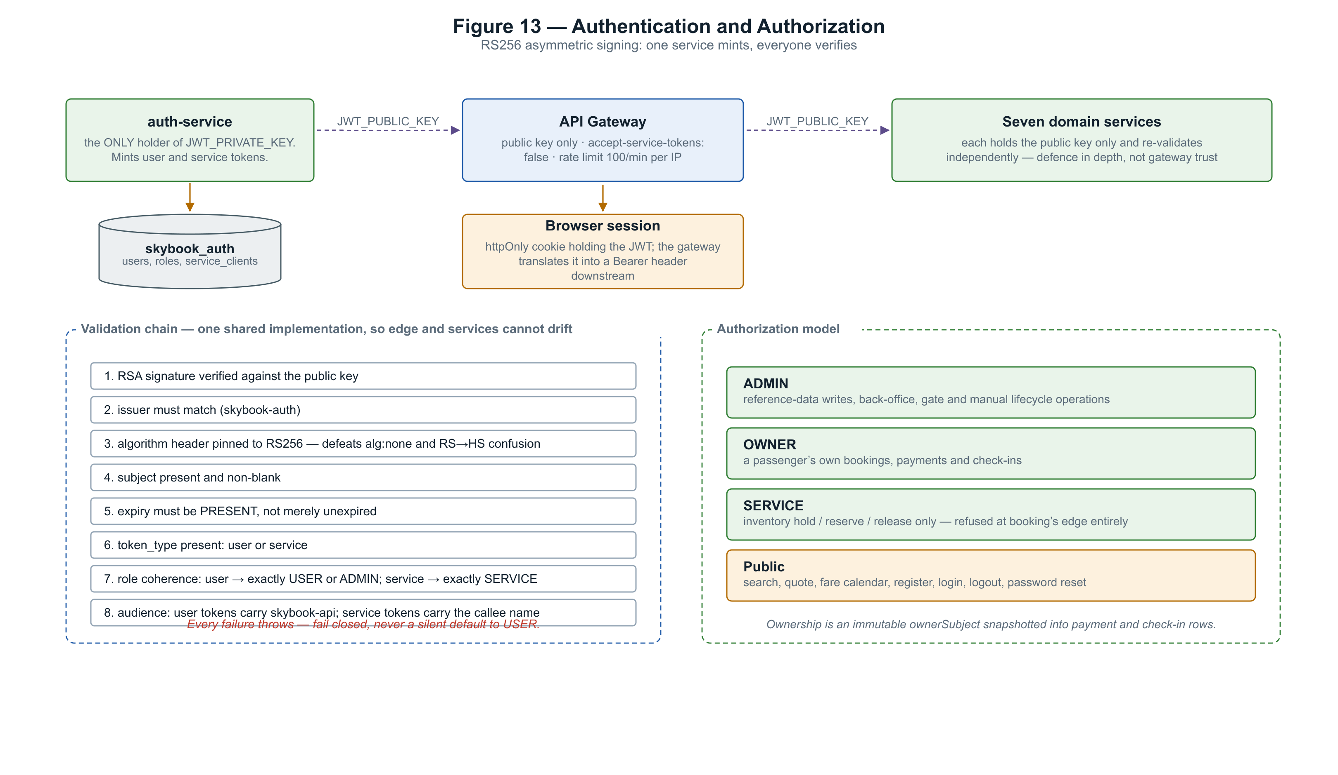
Figure 13 — Token issuance, the shared validation chain, and the authorisation model.

The gateway is no longer the only enforcement point, which was the entire purpose of the security work. Every service re-validates independently using the same shared implementation, so the edge and the services cannot drift. Ownership is enforced from an immutable owner subject captured at booking time and snapshotted into payment and check-in rows, so each service answers ownership questions from its own data without a cross-service lookup.

9.2 Resilience
Circuit breakers, retries, bulkheads and timeouts are applied to all five synchronous cross-service paths. The structure matters as much as the values: the annotations sit on an inner bean so the breaker observes raw transport exceptions rather than already-translated domain exceptions, and an open circuit fails fast before the outer wrapper's error handling would have run.
Control | Setting | Rationale
Connect / read timeout | 2 s / 5 s | Replaced framework defaults of 10 s and 60 s, which were configured nowhere
Circuit breaker | 50% failure rate over 10 calls, 10 s open | Only 5xx, timeouts and connect failures count; a 404 proves the downstream is working
Retry | 3 attempts, 200 ms doubling | Reads only — a retried seat hold risks a double side effect
Bulkhead | 10 concurrent calls | Without a ceiling, 200 Tomcat threads all block on one hanging dependency
Kafka retry | 3 attempts, then dead-letter | The framework default silently commits past the record after retrying

There are deliberately no fallbacks. For a reservation platform, the correct response to "the flight service cannot be reached" is an immediate, clear failure — not a cached flight that may no longer exist. This was verified live: with flight-service stopped, the first request failed in 4.7 seconds, and once the breaker opened, subsequent requests failed in 78 milliseconds. The unrelated dependency's breaker stayed closed throughout, confirming isolation.

9.3 Observability
Metrics, logs and traces each travel one pipe: Prometheus scrapes the management port, log lines are collected from container stdout, and an OpenTelemetry agent exports traces. The agent was chosen over hand-written instrumentation because it propagates trace context across Kafka as well as HTTP, which manual approaches achieve only with per-service code, and because attaching it required no change to any Dockerfile.
The honest limit is recorded in the design document itself: a full cross-service trace across the Kafka hop was never observed during that increment, because the development database had no flights to complete a booking against. The claim rested on mechanism until the certification suite later asserted it directly.

9.4 Delivery pipeline
Three workflows exist. The backend pipeline compiles, runs the full suite in a single Maven invocation, uploads reports whether or not the run passed, scans dependencies, then builds all eight images in parallel and scans each one before any push. The ordering is the security property: a vulnerable image is never published, because the scan step fails before the push step runs. A pull request builds and scans everything and pushes nothing.
Vulnerability scanning earned its place immediately, surfacing three fixable advisories in transitive dependencies on its first run. Static analysis blocked a merge over a type-comparison defect. The certification suite runs nightly rather than per-pull-request, which is a deliberate trade-off and means a merge can land without those thirty-two assertions ever having run.

10. Deployment
The platform runs on a single cloud virtual machine as eighteen containers. Exactly one process is reachable from the internet: a reverse proxy that terminates TLS on ports 80 and 443 and obtains its certificate automatically. Everything else — the gateway, the dashboards, the metrics stores, the mail sink — is bound to the loopback interface and reachable only through an SSH tunnel.

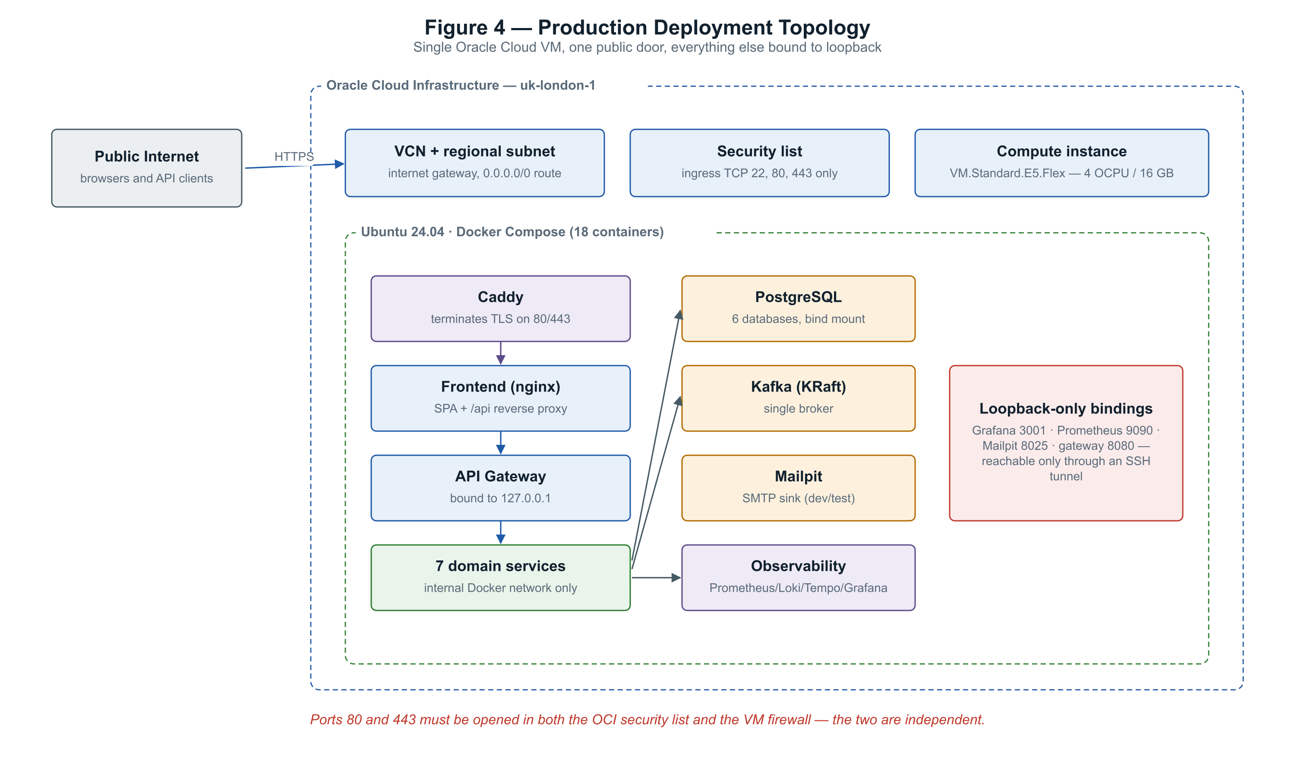
Figure 4 — Production topology. One public door; everything else is loopback-bound.

A deployment trap worth recording
Ports must be opened in two independent places: the cloud provider's security list and the virtual machine's own firewall. Opening only one produces a service that is running, healthy and completely unreachable, with no error anywhere to explain why.
A second trap sits in the data directories. On a clean machine the container runtime creates bind-mount directories owned by root, while the metrics and log containers run as unprivileged users — so they crash on first start with a permission error, and everything that depends on them fails behind it.

11. Delivery History
Nineteen increments were delivered over thirty-five calendar days, with 358 commits across nineteen branches. Every date, branch name and commit count below is derived from git history rather than from a plan.

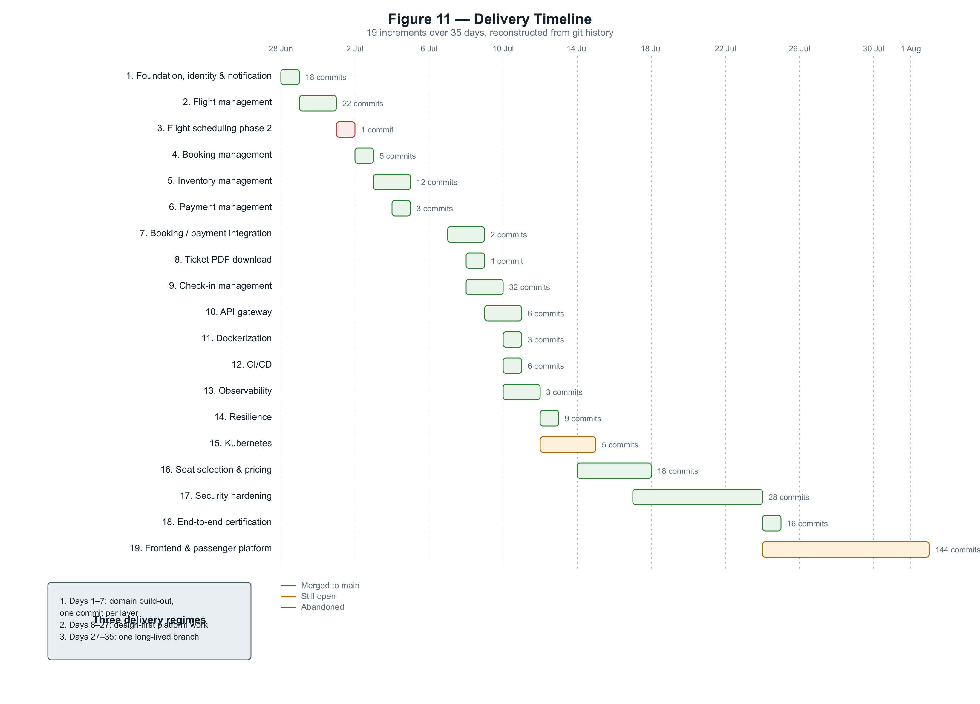
Figure 11 — Delivery timeline. Green increments merged; amber remain open; red was abandoned.

11.1 Increments
# | Increment | Dates | Commits | Status
1 | Foundation, identity & notification | 28–29 Jun | 18 | Merged
2 | Flight management | 29–30 Jun | 22 | Merged
3 | Flight scheduling phase 2 | 1 Jul | 1 | Abandoned
4 | Booking management | 2 Jul | 5 | Merged
5 | Inventory management | 3–4 Jul | 12 | Merged
6 | Payment management | 4 Jul | 3 | Merged
7 | Booking / payment integration | 7–8 Jul | 2 | Merged
8 | Ticket PDF download | 8 Jul | 1 | Merged
9 | Check-in management | 8–9 Jul | 32 | Merged
10 | API gateway | 9–10 Jul | 6 | Merged
11 | Dockerization | 10 Jul | 3 | Merged
12 | CI/CD | 10 Jul | 6 | Merged
13 | Observability | 10–11 Jul | 3 | Merged
14 | Resilience | 12 Jul | 9 | Merged
15 | Kubernetes | 12–14 Jul | 5 | Open
16 | Seat selection & pricing | 14–17 Jul | 18 | Merged
17 | Security hardening | 17–23 Jul | 28 | Merged
18 | End-to-end certification | 24 Jul | 16 | Merged
19 | Frontend & passenger platform | 24 Jul – 1 Aug | 144 | Open

11.2 What the history shows about process
Three regimes are visible. The first week is domain build-out at very fine granularity — one commit per layer, with visibly loose commit hygiene that tightens within days. The middle three weeks are design-first platform engineering: each increment opens with a committed design document, freezes it after between one and seven review rounds, executes a numbered build order whose steps are cited in commit messages, and closes with an implementation-notes commit. The final week is a single long-lived branch that absorbed what would previously have been six separate increments.
Roughly 52% of commits are features, 15% fixes, 15% documentation and 9% tests — so documentation and tests together account for about 28% of all commits. Thirteen commits carry the word "freeze". Several exist only to correct an earlier claim, which is the habit this study tries to continue.
Delivery risk visible in the data
Two designed and reviewed increments are stranded unmerged, and the final pull request has been open carrying 40% of the project's commit history. Long-lived branches were the practice that degraded most as the project accelerated.

12. Testing
Testing is structured as a five-layer pyramid whose layers are separated mechanically rather than by convention. Surefire runs unit and slice tests; Failsafe runs integration tests matching a distinct filename pattern; JaCoCo binds twice so unit and integration coverage never collide in one exec file. The end-to-end module deliberately breaks the naming convention and disables Surefire outright, because a plain build once ran the entire certification suite against a fleet that was not running.
The counts below are from the full reactor run of 4 August 2026: 1,586 tests executed with zero failures - 1,562 through Surefire and 24 integration tests through Failsafe, with one deliberately skipped. Eleven days earlier the same measurement gave roughly 808. The difference is the coverage lift described in section 12.5, and the per-service table shows exactly where it landed: the four worst-covered modules absorbed nearly all of it.

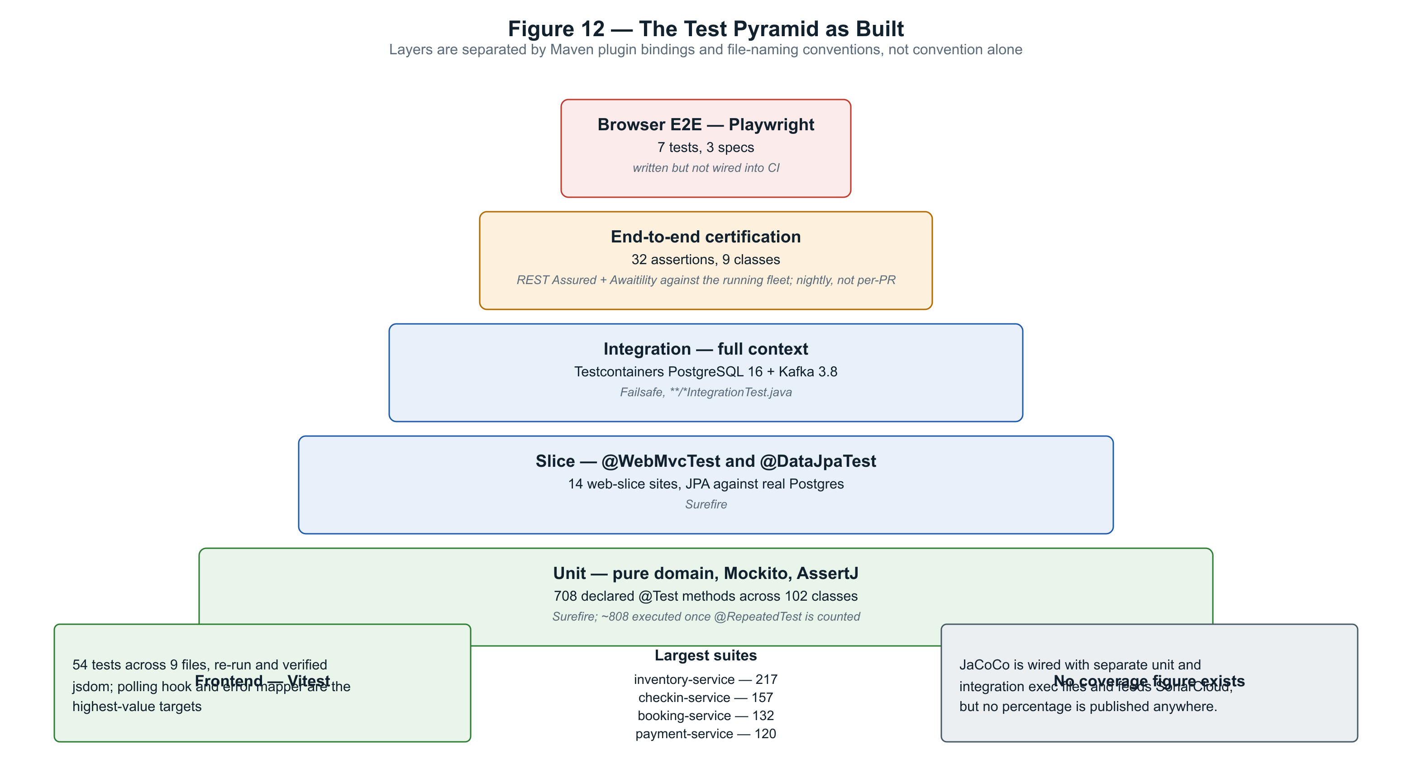
Figure 12 — The pyramid as built, with measured counts.

12.1 Suite inventory
Module | Classes | Tests | Notes
booking-service | 23 | 469 | Now the largest suite: cancellation money-paths, the event producer, schedulers, controller and advice
flight-service | 9 | 220 | Was a single smoke test; now covers itineraries, calendar, schedules and zone-correct generation
inventory-service | 26 | 217 | Includes five seat-hold concurrency tests
skybook-common | 8 | 188 | Was zero across 16 classes; the time library alone carries 41, DST boundaries included
checkin-service | 25 | 157 | Boarding-pass token signing and two concurrency tests
auth-service | 12 | 138 | Was 22: now account enumeration, reset-token hashing, session cookie shape, the security chain
payment-service | 19 | 120 | Includes double-capture and concurrent-refund races
notification-service | 10 | 115 | Was 7: every email and PDF template asserted down to escaping and the mail sink
skybook-security | 8 | 70 | Shared RS256 validation library, filter and access rules
api-gateway | 5 | 21 | Routing, JWT enforcement, public-path identity, CORS and rate limiting

12.2 End-to-end certification
The certification suite drives the platform through the gateway only, exactly as a real client would. Because every service port, PostgreSQL and Kafka are unpublished after the security work, the suite is physically forced through the correct trust boundary.
It distinguishes three kinds of assertion. Synchronous contracts are asserted directly. Asynchronous effects — a payment row appearing after a booking event, a booking confirming after a capture — are polled with a timeout and never with a sleep. Cross-cutting evidence is gathered afterwards, such as querying the trace backend to prove one trace spans the gateway, booking-service and payment-service across the Kafka hop.
Nine classes carry thirty-two assertions covering the happy path, the check-in journey, a failure matrix, graceful degradation with a service stopped, a genuine double-sell race, real email delivery into a capture sink, and the distributed trace.

12.3 What the suite deliberately does not certify
The certification environment overrides four production settings. Each override is recorded in the compose file itself alongside its consequence, because an override that is not written down becomes a false claim of coverage.
Override | Consequence
Check-in and boarding windows | Widened to 8760 hours and 525600 minutes. Check-in requires the flight to be more than 45 minutes away and boarding requires it to be less, so no single wall-clock moment permits both on one flight. The enforcement is real and observable, but the suite does not certify it.
Gateway rate limit | Raised from 100 to 10000 requests per minute, because the suite's own legitimate polling tripped it and produced 429s that looked exactly like product failures. The limiter is covered only by three unit tests.
Seat-hold TTL | Reduced from 15 minutes to 1 so expiry can be observed. The sweep logic is byte-identical; only the clock differs. The production TTL value itself is untested.
Email transport | A local capture sink replaces the real SMTP provider, which upgrades the claim from "an event was published" to "an email actually arrived" without sending mail to real people.

12.4 Techniques worth noting
- Concurrency tests use a barrier so threads genuinely collide rather than running in sequence, and are deliberately non-transactional so each racer commits independently.
- The simulated payment gateway fails deterministically on specific amount endings, so failure paths are exercised through the real product path rather than through test-only hooks.
- Idempotency is tested at four levels: the database constraint, the service, the controller and the end-to-end suite — triggered by a real product header, not a backdoor.
- Asynchronous effects are always polled with a timeout. There is no sleep anywhere in the certification suite.
- Email delivery is asserted against a capture sink, which upgrades the claim from "an event was published" to "a message actually arrived".

12.5 Static analysis and the quality gate
SonarCloud analyses every push to main. The figures below were read from its API on 4 August 2026, and the movement column matters more than the closing number: eleven days earlier the gate was failing on three conditions.
Metric | Now | Was
Quality gate | PASSED — all six conditions | FAILED on reliability, security and coverage
Reliability rating | A, zero open bugs | C, 11 open bugs
Security rating | A, zero vulnerabilities | D, 8 open — the CSRF findings
Overall coverage | 91.2% | 67.1%
New-code coverage | 90.6% against the 80% threshold | 51.9%
Security hotspots reviewed | 100% | —
Lines of code analysed | 19,098 | 15,705

Two things about how the gate was turned are worth recording, because they are the difference between a green badge and a quality exercise. The eight CSRF findings were closed with written justifications, not waved through: the investigation established that the browser cookie is consumed at the API gateway and translated into a bearer header, making the gateway the CSRF boundary, and then audited all 48 GET endpoints to confirm the one hole SameSite leaves — a state-changing GET — does not exist. And the final open bug, a duration computed between zone-naive timestamps, unravelled into a genuine data defect: arrival times stored on the origin's clock, displaying hours wrong at every cross-timezone destination. Fixing it touched flight generation, the email template, search results and 414,679 stored rows.
The dashboard is public: https://sonarcloud.io/project/overview?id=praveencloudlab_skybook

13. Defects and Lessons
Each of the following cost real debugging time. They are recorded because they are the parts of a project that are normally edited out, and because each one generalises well beyond this system.

13.1 A single-broker Kafka silently swallowed every offset commit
Left at Kafka's default replication factor of three, a one-broker cluster can never create its internal offsets topic. Consumer groups therefore committed nothing, forever — while the broker reported healthy and application logs printed a perfectly normal "Subscribed to topic(s)". The first verification pass accepted that log line as proof. The fix is three configuration lines; the lesson is that a health check proving a component answers requests proves nothing about whether it works.

13.2 A test that only passes once is worse than no test
The double-sell certification test passed alone and failed in the full suite, because it consumed a seat and always chose the first flight in a window. It now searches for a completely unsold flight. A test whose outcome depends on execution order is not evidence.

13.3 The most valuable CI result was its first failure
Three context-load tests had always passed locally because the development machine ran a native PostgreSQL service that satisfied a hidden localhost dependency. They failed on the first clean CI runner. The dependency had existed for weeks and was invisible precisely because the local environment was too generous.

13.4 Commenting out a secret does not hide it
A real credential was committed inside a commented-out configuration line and remained readable in the history of a public repository long after the active line was removed. Deleting a line in a later commit does not remove it from git. Secret scanning cannot reliably catch a sixteen-character lowercase string with no distinctive prefix, so the control that would have caught it is a keyword-based scanner, not a pattern-based one.

13.5 The framework default was not what the design assumed
The design specified dead-letter topics with a .DLT suffix; the actual framework default in this version is -dlt. This was found empirically after an integration test watched the wrong topic for thirty seconds. Separately, a retry policy specified as "three attempts" would have retried without any bound at all, because the backoff class chosen sets an interval and a multiplier but no attempt limit.

13.6 A repository method did not do what its name implied
A derived query named findDistinctFlightIdBy… produced a full-entity SELECT DISTINCT rather than a scalar projection. It passed startup validation and failed only at result binding, only against a real PostgreSQL. No amount of mock-based service testing could have caught it.

14. Known Gaps and Contradictions

14.1 Where the documentation and the code disagree
These are stated rather than reconciled. In every case the code is what runs; the document is what was intended at some earlier point.
Subject | The disagreement
Seat selection timing | The specification locks seat choice to check-in and defers paid selection to a later version. The implemented system takes the seat at booking with attribute-based pricing. The requirement was superseded, not met.
Booking status vocabulary | The specification names PENDING, CONFIRMED and CHECKED_IN. The implementation uses DRAFT, CREATED, CONFIRMED, PARTIALLY_CANCELLED, CANCELLED and COMPLETED. PENDING does not exist in code.
Anonymous search | The specification requires search without login, and the running gateway does treat it as public — but a worked example in the seed-data document calls the same endpoint with a bearer token.
Notification persistence | The architecture document reserves a database for notification-service. The service has none, keeps no send log, and cannot report what it has delivered.
Kafka topic scheme | The architecture document lists eight topics named per event type. None exist. The implementation uses one topic per producing service with a type discriminator in the payload.
A published test report | One service's test report describes twelve classes, six of which have never existed in the repository at any commit. The other two service reports reconcile cleanly as point-in-time snapshots.

14.2 Deferred work, with reasons
Item | Status and reason
Transactional outbox | Events are published after the transaction commits rather than from an outbox table. A crash between commit and publish loses the event. Deferred consistently in every service, and named as such in each.
Refresh tokens and revocation | Access tokens last sixty minutes and cannot be revoked. Logout expires the browser cookie but does not invalidate the token. This is the stated reason the browser credential is an httpOnly cookie rather than readable storage.
Kubernetes | A complete manifest tree of 58 objects exists on an unmerged branch and renders cleanly, but has never been applied to a running cluster. The application-side groundwork — separate liveness and readiness endpoints — is merged and live.
Contract testing | No consumer-driven contract tests exist. A breaking change to a shared event DTO would pass every module's own build and fail only in the nightly certification run.
Flyway across the fleet | Four services own their schema through migrations; the rest still rely on Hibernate schema generation, with manual SQL documented for constraint changes.
Load and performance testing | No load testing has been performed. Every threshold in the system is a reasoned default rather than a measured one.

14.3 Testing gaps
- flight-service has one test — a context-load smoke test — despite owning search, scheduling and the seeded dataset the entire front end depends on.
- skybook-common has no tests at all, although it now contains the airport time-zone logic governing booking cutoffs, cancellation tiers, check-in windows and both sweep jobs.
- notification-service has seven tests, all covering document rendering. Nothing covers its consumers, template selection or the send path — in a service whose characteristic failure is silence.
- booking-service has no controller or mapper tests; its HTTP contract is asserted only end to end.
- No coverage percentage is published anywhere, so coverage cannot be cited as evidence in either direction.
- The browser test suite is written and configured but is not invoked by any pipeline.

15. Data Model
Each service owns its schema outright. The booking aggregate is the most elaborate, and it changed shape when round trips arrived: the passenger row became per passenger per segment, which is what allowed per-direction check-in and per-segment coupons without altering the check-in service at all.

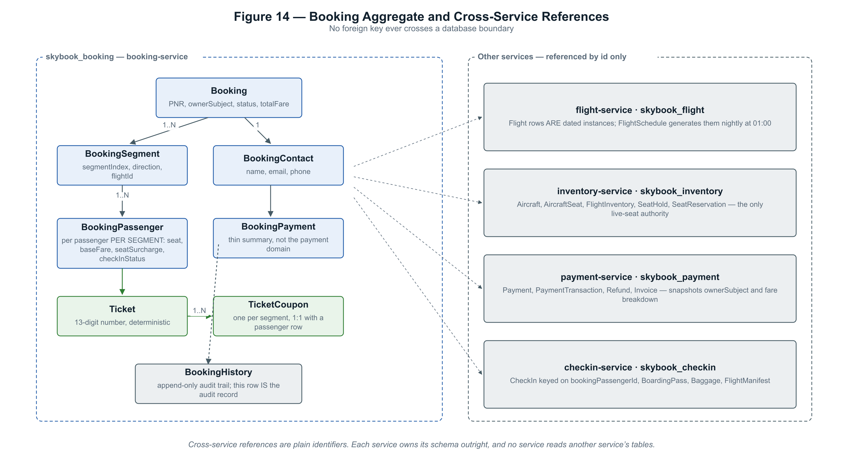
Figure 14 — The booking aggregate and its identifier-only references to other services.

Two conventions run through every schema. Business entities carry audit columns and an optimistic-lock version, while history rows carry neither — a history row is itself the audit record and is never updated. And every enumerated column is persisted by name rather than by ordinal, a rule adopted after an early defect in which reordering an enum silently changed the meaning of stored data.

16. Conclusion
SkyBook works. A passenger can search without an account, price a trip against a real fare calendar, choose a seat from a real seat map, pay, receive a confirmation email, check in inside the correct window, and download a boarding pass carrying a signed, verifiable token. Two passengers cannot take the same seat. A cancellation refunds according to the fare that was actually purchased at the price that was actually paid. All of this runs on one small virtual machine behind an automatically renewed certificate.
The engineering practices are visible in the record rather than asserted. Nine increments opened with a design document that was frozen after between one and seven review rounds before implementation began, and implementation commits cite numbered steps from that frozen document. Roughly 28% of all commits are documentation or tests. Static analysis and vulnerability scanning both blocked merges. Several commits exist only to correct an earlier claim.
The gaps stated in the first edition of this document were real, and most of them have since been closed the measurable way: flight-service, which had one smoke test, now carries 220; the shared time library, which had none, is at full line coverage; notification delivery, whose failure mode is silence, is pinned by 115 tests down to the rendered HTML. SonarCloud publishes the figure - 91.2 per cent, behind a passing quality gate. What genuinely remains: no consumer-driven contract testing, no load testing, and no revocation of issued tokens.
The most useful thing this project demonstrates is not the architecture, which is conventional, but the discipline of writing down what went wrong. A single-broker Kafka that silently committed nothing while reporting healthy, a test that passed alone and failed in company, a credential that survived in git history long after it was deleted from the working tree, a repository method that lied about what it queried — each cost real time, and each is preserved here because a case study that reports only successes teaches nothing that could not have been guessed.
The single most transferable lesson
Health checks that prove a component answers requests prove nothing about whether it works. A Kafka broker reported healthy while silently discarding every offset commit; a service reported healthy while its mail transport was misconfigured; a smoke test passed for weeks because the developer's machine happened to satisfy a hidden dependency. In each case the signal was green and the system was broken. Verification has to assert the effect, not the liveness.

