SkyBook
An airline reservations platform, built end to end
Recruiter edition — the 12-page summary of a 68-page engineering case study

At a glance
Item | Detail
What | A working airline: anonymous search, real seat maps, payment, confirmation email, check-in, scannable boarding pass, cancellations with fare-rule refunds, an admin console
Shape | Eight Spring Boot applications (one API gateway, seven domain services), React 19 web client, PostgreSQL, Kafka, full observability
Built | 35 calendar days of designed increments, then a measured quality and release-engineering revision
Quality | SonarCloud gate PASSING: 91.2% coverage, 0 bugs, 0 vulnerabilities, security and reliability rating A
Tests | 1,722 backend executions + 55 frontend + a 24-test end-to-end certification that races real buyers for one seat - zero failures at the evidence commit
Environments | A real promotion ladder: LOCAL > DEV > SIT > QA > PERF > UAT > STAGING > PROD, plus a weekly disaster-recovery drill that restores and verifies row counts
Deployment | One cloud VM, 18 containers, automatic TLS - promoted by image digest, never rebuilt on the way to production
Role | Solo: requirements, architecture, backend, frontend, testing, CI/CD, cloud, documentation. Built using AI-assisted development tooling, with every decision and merge owned by the author

Repository: github.com/praveencloudlab/skybook
Quality dashboard: sonarcloud.io/project/overview?id=praveencloudlab_skybook

Disclaimer: SkyBook is a personal portfolio project - not a real airline, affiliated with no carrier. Airline-style codes in seed data are illustration only; payments are simulated server-side and no cardholder data exists; all passenger records are synthetic.

The system
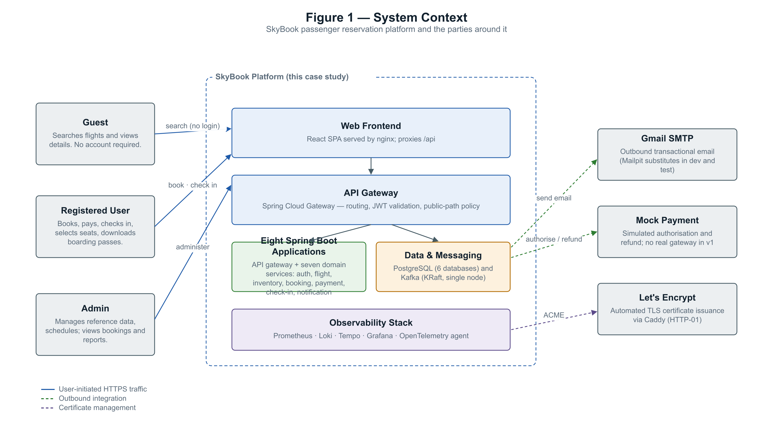
The context: a public shopping surface, an authenticated booking core, and operations behind an admin role.
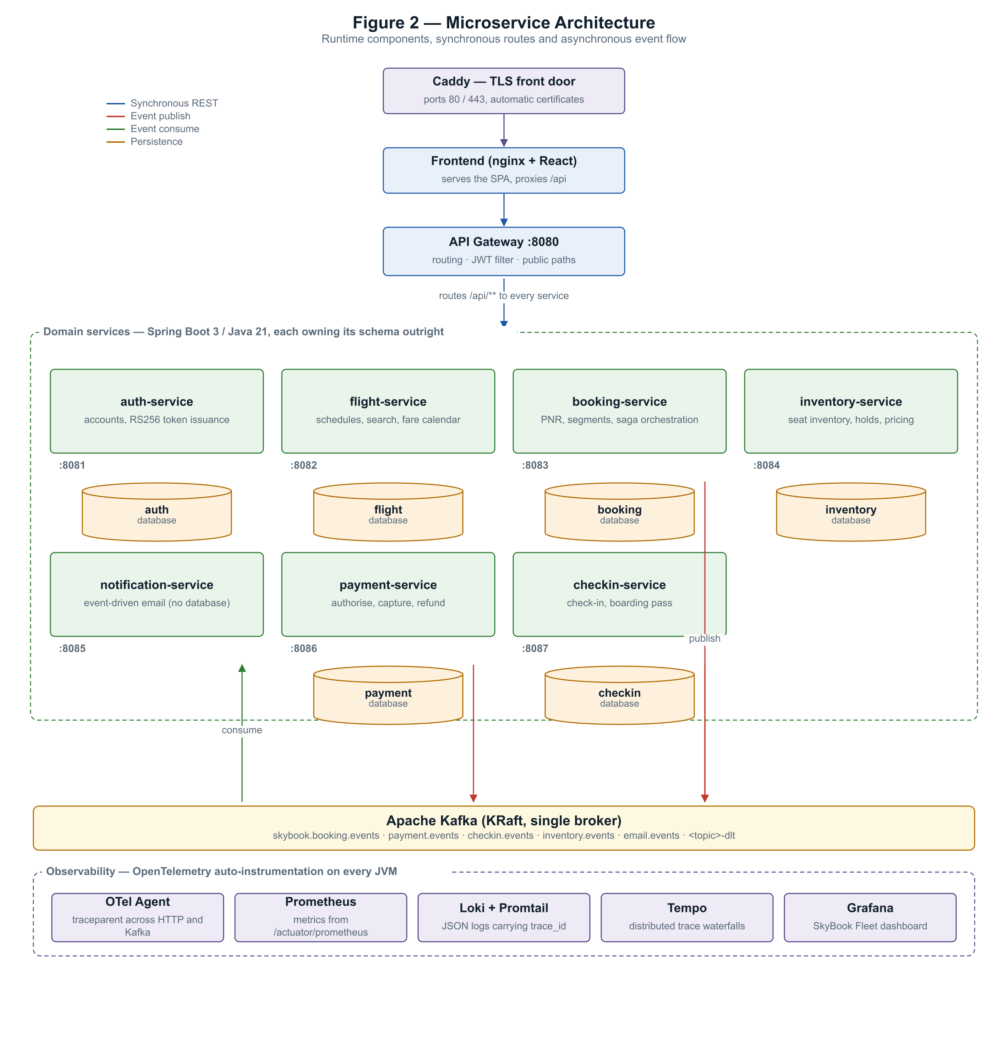
Eight applications over one database instance (six schemas) and one event bus. Every service owns its data; nothing reaches another service's tables.

The hard part: money moves asynchronously
A booking is not confirmed when the payment call returns - it is confirmed when payment-service says so over Kafka and booking-service reacts. The saga below is the platform's spine, and the double-sell race (two real buyers, one seat, concurrent checkout) is certified end to end every night and on every promotion.
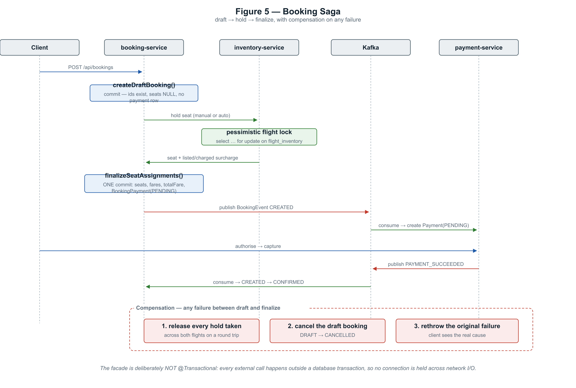
The booking saga: draft, hold, pay, confirm - with compensations, not distributed locks.

Security, stated honestly
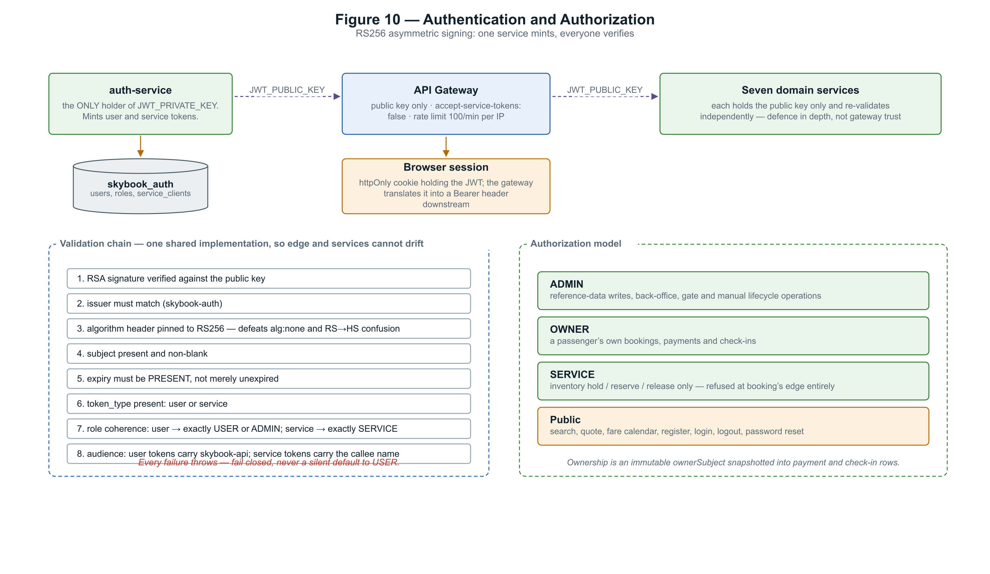
RS256 sessions, per-service credentials, an httpOnly cookie the gateway exchanges for a Bearer header - and the gaps stated next to the controls.
The eight CSRF findings SonarCloud raised were closed with written justifications in code - the cookie is consumed at the gateway, SameSite=Lax covers the SPA, and all 48 GET endpoints were audited as read-only. A leaked mail credential early in the project was revoked, purged from history, and is recorded in the study as an incident, not hidden.

Evidence, not adjectives
Claim | Proof
1,722 tests, zero failures | mvn clean verify at commit 96e24b2, 4 Aug 2026 - per-module table in the full study sums to exactly this
91.2% coverage, gate passing | Public SonarCloud dashboard, measured on every push
The journey certifies | 24 e2e tests through the gateway only: booking, payment, check-in, boarding pass, double-sell race, email into a real sink, one trace across the Kafka hop
Fast enough under load | k6: 3,405/3,405 checks, p95 search 60 ms, quote 26 ms, 0.00% errors - thresholds gate every promotion
Backups actually restore | Weekly drill: back up, destroy the database volume, restore, verify 1,336,748 rows against the manifest - drilled live on 4 Aug
Same artifact everywhere | Images built once per commit, scanned, published as multi-arch digests; every environment from DEV to PROD runs those exact bytes

The product
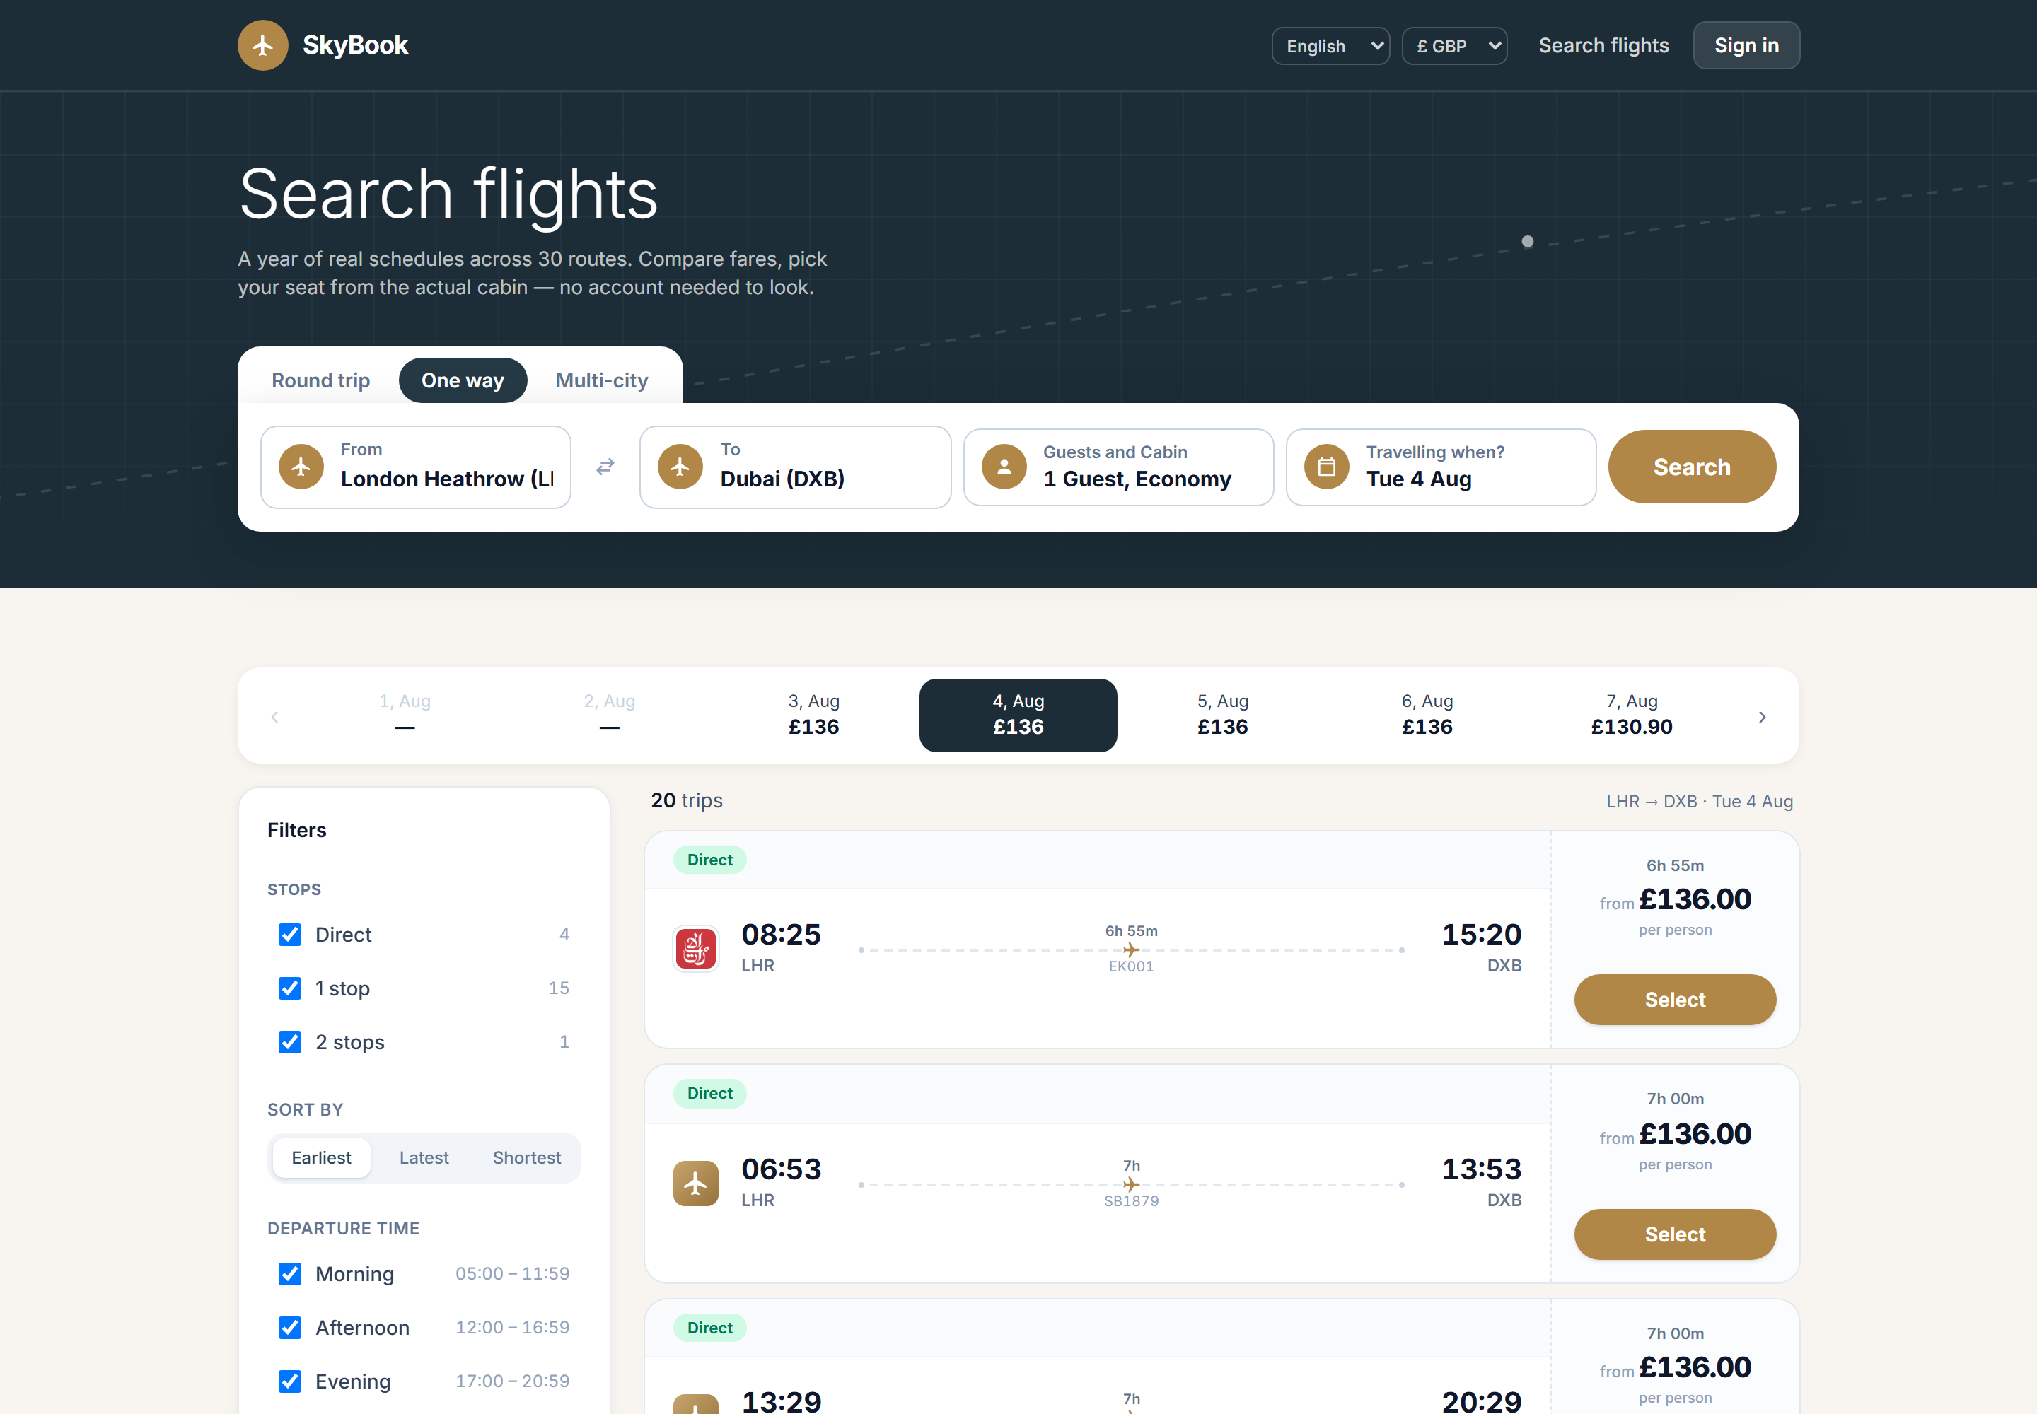
Search: a seven-day price strip and one card per itinerary - priced by the same endpoint checkout will use.
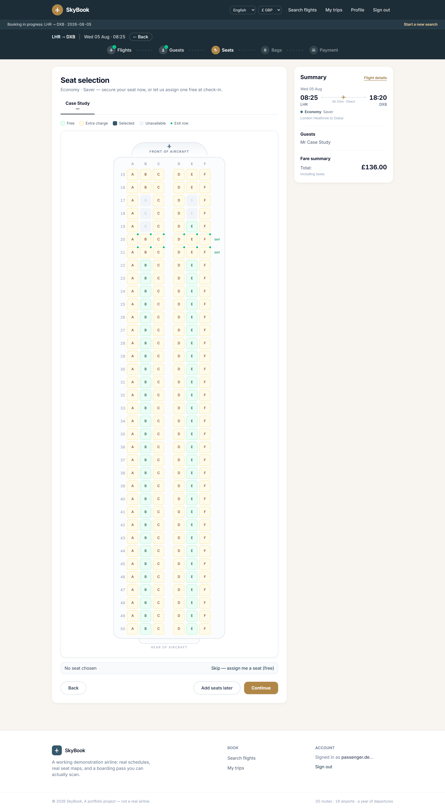
Seat selection from the real cabin: paid rows priced per seat, held seats disabled, free auto-assign.

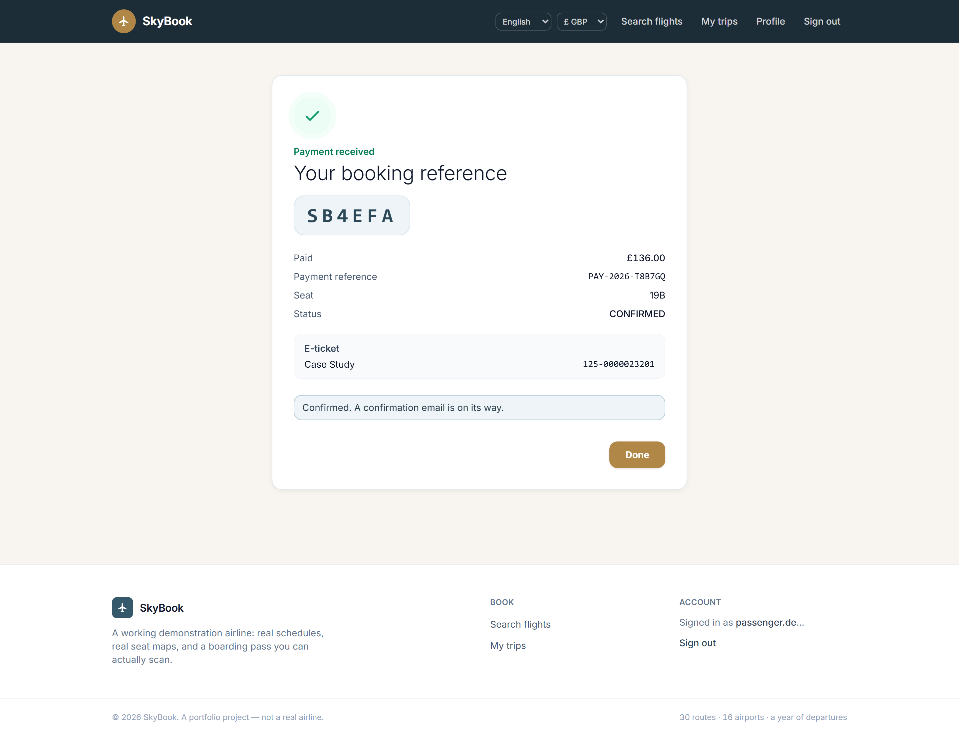
The moment three services agree: record locator, paid amount, trip saved.
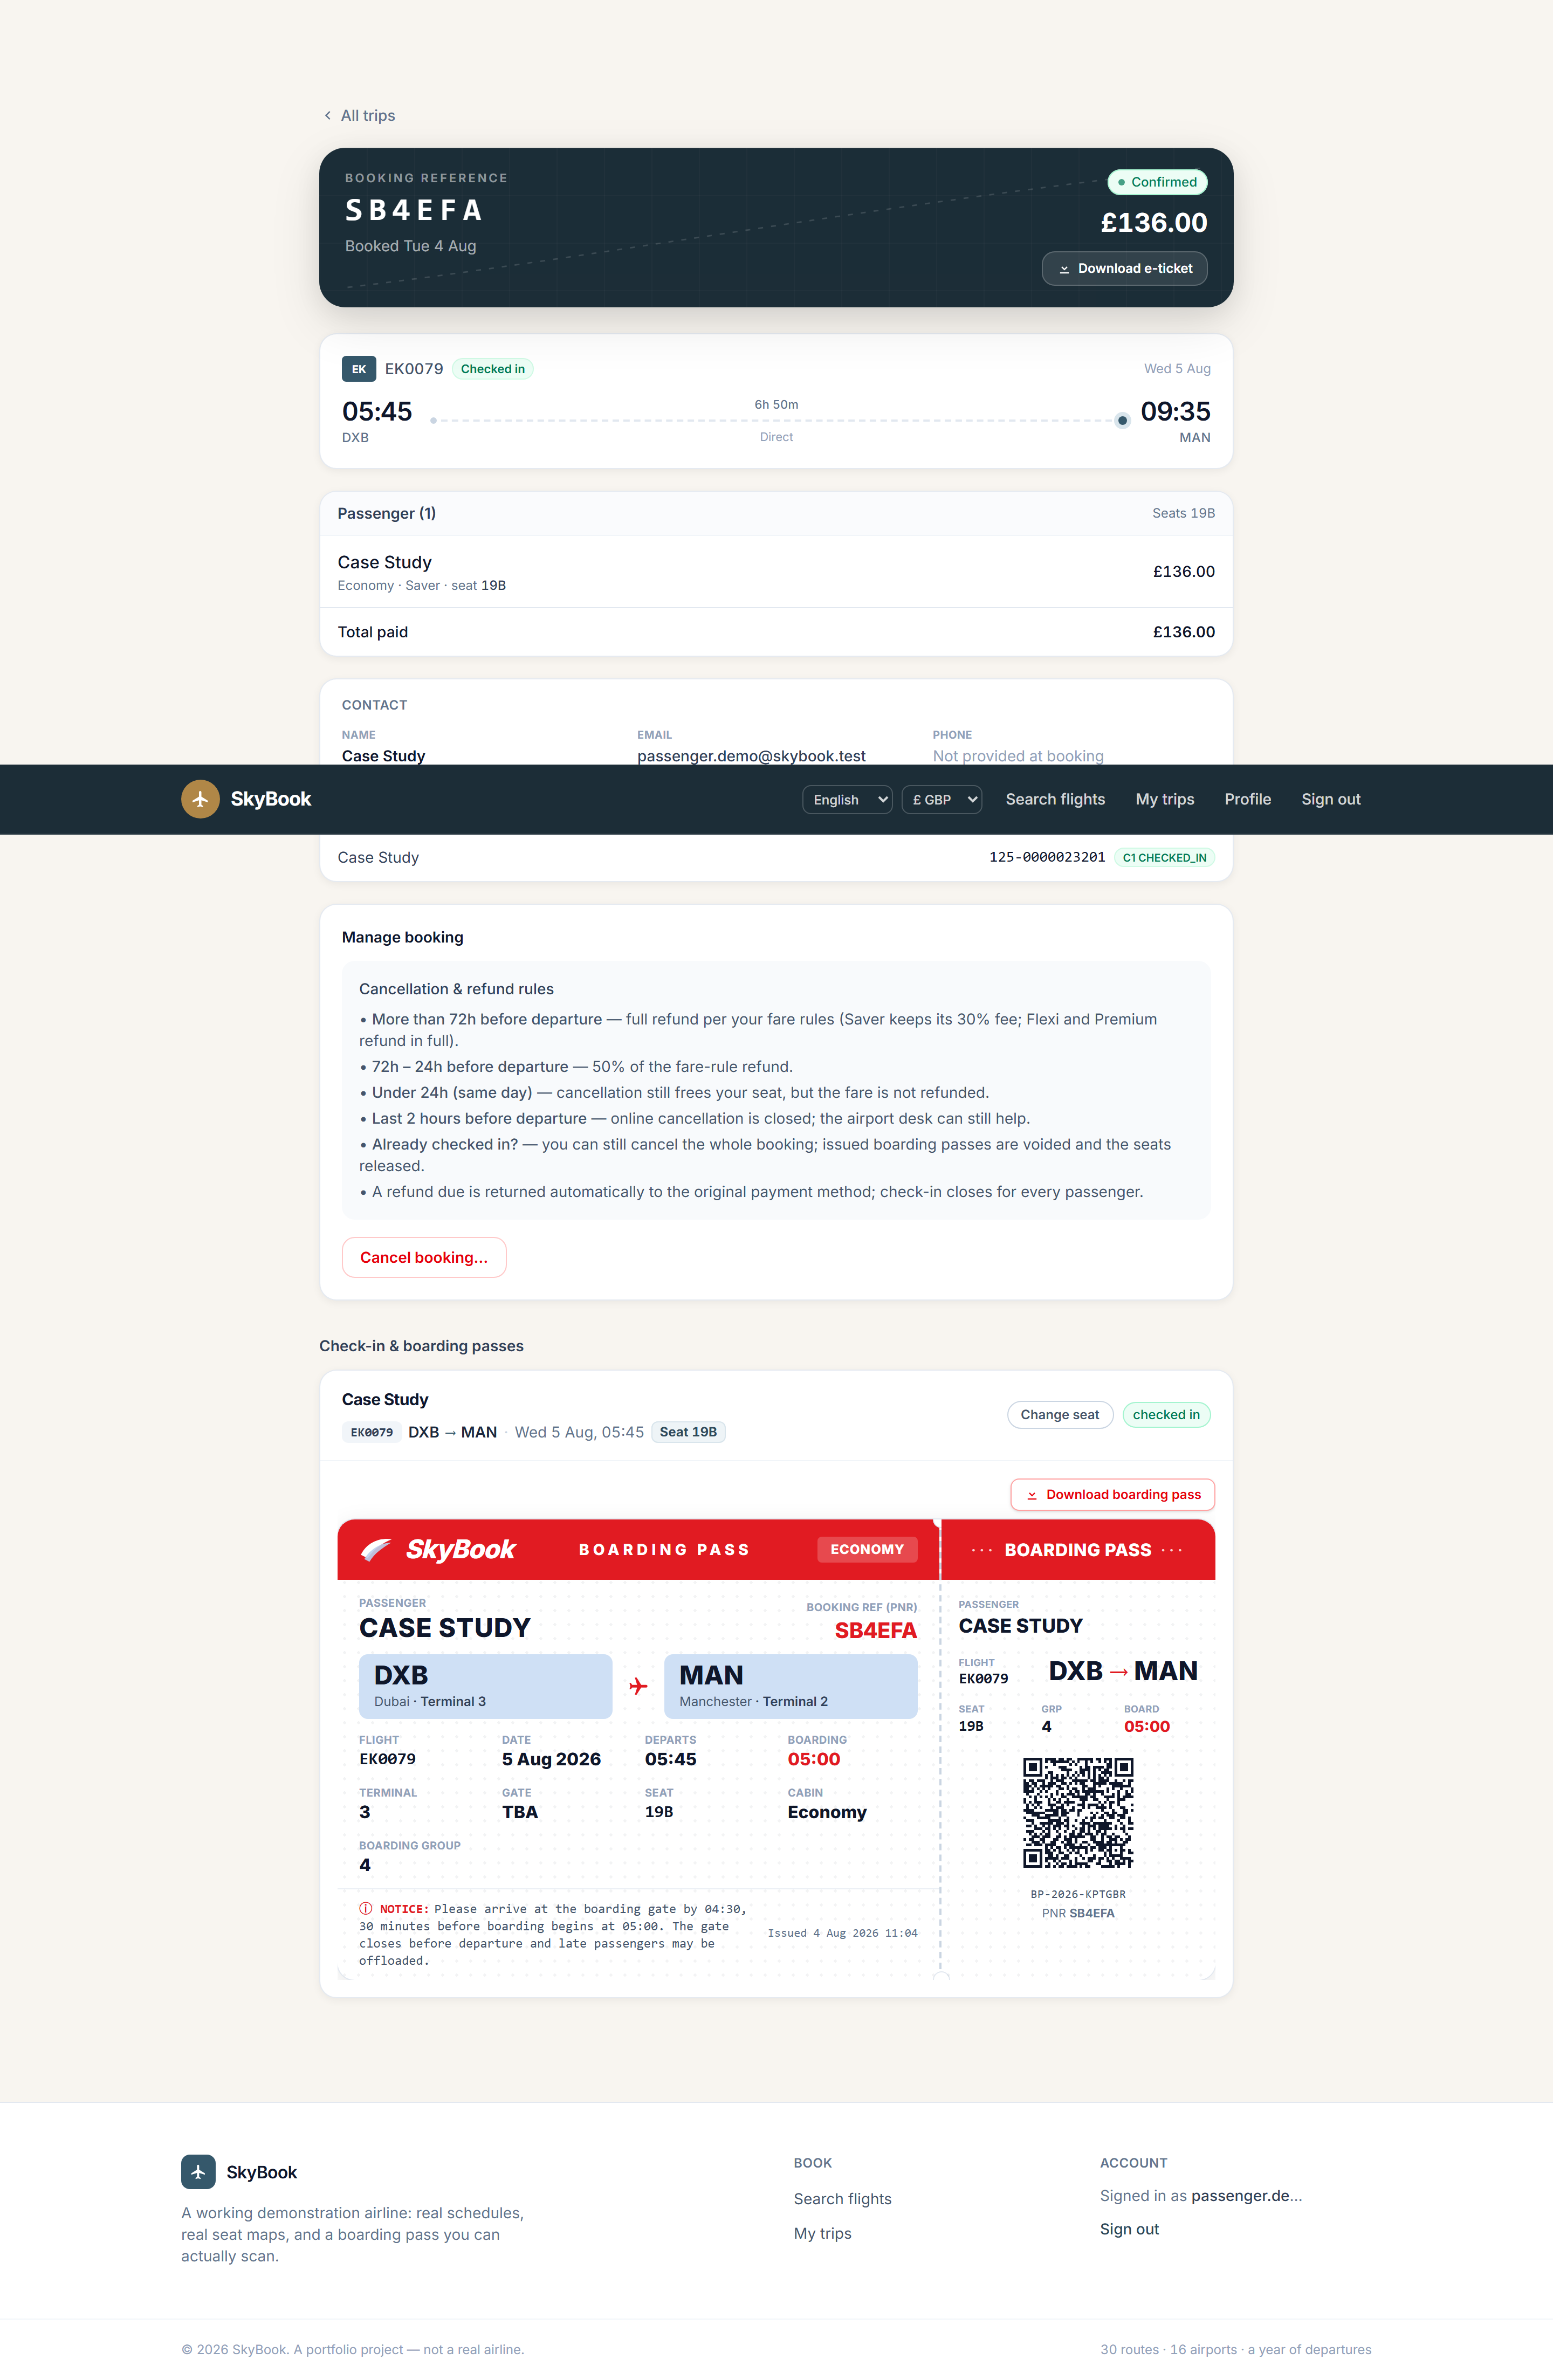
The boarding pass - the QR is real and the gate-operations console verifies it.

Five things that went wrong, on purpose in print
Incident | Lesson
A transactional method silently ran with no transaction (Spring self-invocation) | Proxies do not apply to internal calls; the nightly schedule generator ran unprotected until static analysis flagged it
Every cross-timezone arrival displayed hours wrong - durations looked right by accident | Two wall clocks in different zones subtract to nonsense; fixing it touched generation, email, search, 414,679 rows and the screenshots
A round-trip cancellation could refund partially and leave the booking looking live | The expansion set and the remaining set were computed from different keys; pinned by tests that fail on the old code
The environment ladder's first ever run refused a bad promotion, then caught its own seeding bug | Gates that only pass are decoration; these blocked, and the fixes are commits
A test demanded zero collisions from a generator whose own name promised "rare" | The birthday paradox made CI red one run in twenty-two; assert what the code promises, not more

Current limits, stated: no transactional outbox (a post-commit publish failure loses the event - top of the roadmap), no sustained capacity test (the k6 gate catches regressions, not limits), single-VM deployment with RPO 24h / RTO ~30min, and a browser UI suite not yet wired into CI. The full study gives every gap its reasons.

The full 68-page engineering edition covers the architecture, the saga, pricing and refunds, check-in, the delivery history commit by commit, testing, defects and lessons, the data model, and six appendices - traceability, API contracts, security operations, screens, roadmap, glossary.

