Software Engineering
Software Requirements Specification
(SRS) Document
of Software based Calculator

Praveen Deshpande
05/06/2023

Contents

1. Introduction 3
2. General Description 3
3. Functional Requirements 4
4. Interface Requirements 5
4.1 User Interfaces 5
4.2 Hardware Interfaces 5
4.3 Communications Interfaces 5
4.4 Software Interfaces 5
5. Performance Requirements 5
6. Other non-functional attributes 6
6.1 Security 6
6.2 Binary Compatibility 6
6.3 Reliability 6
6.4 Maintainability 6
6.5 Portability 6
6.6 Extensibility 6
6.7 Reusability 6
6.8 Application Affinity/Compatibility 7
6.9 Resource Utilization 7
6.10 Serviceability 7
7. Operational Scenarios 7
8. Preliminary Use Case Models and Sequence Diagrams 8
8.1 Use Case Model 8
8.2 Sequence Diagrams 9
9. Updated Schedule 10
10. Updated Budget 10
11. Appendices 10
11.1 Definitions, Acronyms, Abbreviations 10

1. Introduction
  - Introduction
The purpose of this document is to define and describe the requirements of the project and to spell out the system’s functionality and its constraints.

  - Scope of this Document
The customer and the user for the system are the employees of the Ignitarium, including developers of the system.

  - Overview
The product is an software based calculator which performs arithmetic operations
viz., addition, subtraction, multiplication and division. It takes two input numbers for
performing operations and an operator as input for type of operation

  - Business Context
To demonstrate the C programming language features and understand the concepts
and apply it to create an application as per the requirement

2. General Description
2.1 Product Functions
The product performs the arithmetic operation based on user input and provide
the result to the user. It also checks the result for any overflow or underflow
and displays it to the user.

2.2 Similar System Information
There are calclualtors which are based on C++ or Java based language. But this
project aims at implementing the application using C language features.

2.3 User Characteristics
The users include everybody who knows C language and understands the
fundamental operations in mathematics.

2.4 User Problem Statement
it is a project for learning C language along with data structures and linux
application programming

2.5 User Objectives
The result of the arithmetic operation is displayed for the numbers input and
given operator by the user.

2.6 General Constraints
only four basic operations are provided with this application as of now.

3. Functional Requirements
- The users input the numbers and the operator so that the program will display the
result after performing the calculation of the input numbers.

- The numbers inputted by user are stored as floating point numbers so the result also
will be calculated as floating point number

4. Interface Requirements
4.1 User Interfaces
- 4.1.1 GUI
The user interface for this program is the interface provided by Microsoft Access 2007. Access includes forms and reports for the users to query and organize data to suit their needs. Forms and reports both have builders that let the user specify which fields they want to use and which constraints they want to define.
- 4.1.2 CLI
There is no command line interface
- 4.1.3 API
There is no API for the product
- 4.1.4 Diagnostics or ROM
There is a troubleshooting and help section provided by Microsoft
4.2 Hardware Interfaces
The program (Access) uses the hard disk. Access to the hard drive and other hardware is managed by the operating system and Access.
4.3 Communications Interfaces
If we decide to implement an Ad Hoc network for a shared database, the operating system will handle those connections.
4.4 Software Interfaces
The Access system may be used to import and export data with Microsoft Excel. This functionality is built in to the user interface.

5. Performance Requirements
The database is designed to be operated through Microsoft Access 2007, thus no additional system requirements exist beyond those required to run Microsoft Office 2007, except for a negligible amount of hard drive space to store the database.

Microsoft lists the requirements for Access 2007 as follows:
500 MHz processor or higher
256MB RAM or higher
1.5GB Available Hard Drive Space
Windows XP SP2 or later operating system.
Windows Office Professional 2007 (Windows Access)
There is also Access Available for Mac OS X, the clients have not stated a need thus far.

6. Other non-functional attributes
.

6.1 Security

The system shall be designed with a level of security appropriate for the sensitivity of information enclosed in the database. More interaction is needed with client about the volatility of the information. Since there is no obvious information that is of a high security level such as credit card information, the only requirements that could be implemented are encrypting the database and/or making the database password-protected, by user’s request.

6.2 Binary Compatibility

This system will be compatible with any computer that has Microsoft Office Professional 2007 or later installed (whether PC or Mac), and will be designed with more than one computer in mind.

6.3 Reliability

Reliability is one of the key attributes of the system. Back-ups will be made regularly so that restoration with minimal data loss is possible in the event of unforeseen events. The system will also be thoroughly tested by all team members to ensure reliability.

6.4 Maintainability

The system shall be maintained by Sheila Roop, of the IDA, or delegated to another employee.

6.5 Portability

The system shall be designed in a way that shall allow it to be run on multiple computers with Microsoft Office Professional 2007 or later installed.

6.6 Extensibility

The system shall be designed and documented in such a way that anybody with an understanding of Microsoft Access shall be able to extend the system to fit their needs with the team’s basic instructions.

6.7 Reusability

The system should be designed in a way that allows the database to be re-used regularly for the various silent auctions that the organization shall hold.

6.8 Application Affinity/Compatibility

This system requires the Microsoft Office Professional 2007 suite or later, as it operates primarily through Microsoft Access, in conjunction with Microsoft Excel.

6.9 Resource Utilization

The resources used in the creation of this system include: Dr. Lewis, the client (Sheila Roop), the computers in Davis Hall, and the internet.

6.10 Serviceability

The maintenance of the system should be able to be sufficiently performed by any person with a basic understanding of Microsoft Access.

7. Operational Scenarios
Scenario A: Initial Item Definitions
The user shall enter the information about the items into the database for its initial construction and evolution. The fields will be completed via a form that will manipulate the data.

Scenario B: Customer Check-out
The user shall be able to enter information about the customer purchasing a particular item, and record their bid and other information. They will also enter the winning bid

Scenario C: Database Maintenance
The user may want to alter/delete information after the auction is over, In this case they will need to be able to remove the data that has been entered.

8. Preliminary Use Case Models and Sequence Diagrams
This section presents a list of the fundamental sequence diagrams and use cases that satisfy the system’s requirements. The purpose is to provide an alternative, "structural" view of the requirements stated above and how they might be satisfied in the system.
8.1 Use Case Model
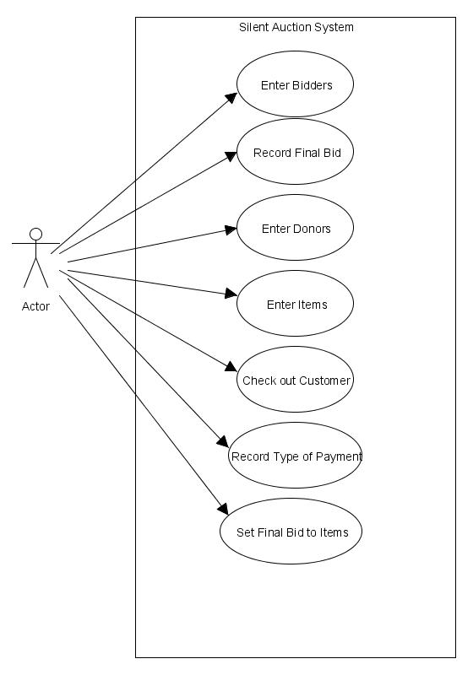

8.2 Sequence Diagrams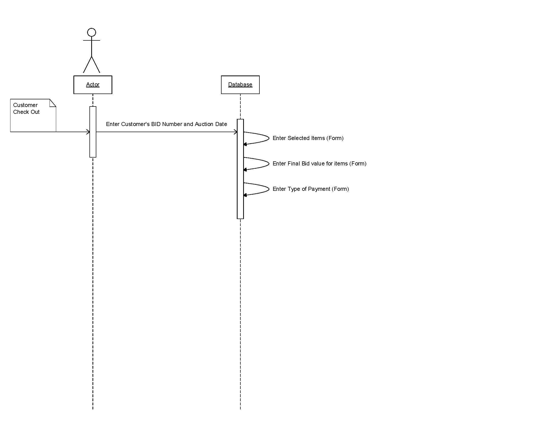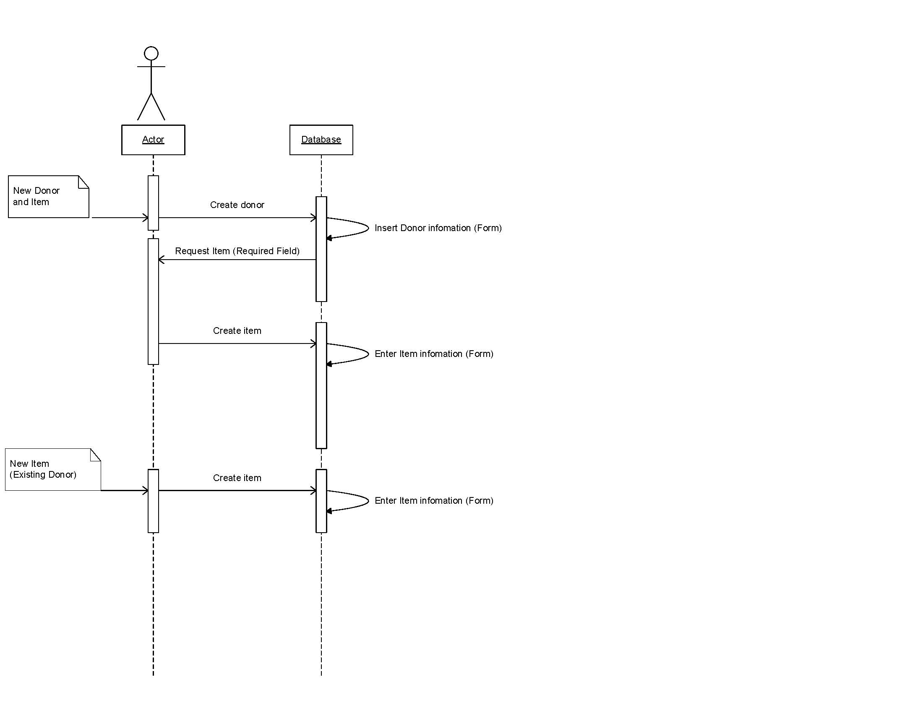

9. Updated Schedule
The updated PERT/GANTT chart is attached at the end of the document

10. Updated Budget
An updated budget is attached at the end of this document

11. Appendices
11.1 Definitions, Acronyms, Abbreviations
IDANRV- Intellectual Disabilities Agency of the New River Valley

