**Approach**

1. JMeter + Jenkins Integration – Approach 1 (Freestyle)
2. JMeter + Jenkins Integration – Approach 2 (Pipeline)

**Create Project 🡪 Build 🡪 Results**

* Create Project -> Freestyle or Pipeline
* Build -> Running the Job
* Results -> View the results

1. **JMeter + Freestyle execution from Github**

C:\Users\pdama\Downloads\apache-jmeter-5.5\bin\jmeter.bat //Path to my JMeter in folder

-n -t "TestPlan\BlazeDemo.jmx" //Path to my script (JMX file)

-p "TestPlan\Rubric_LoadTest.properties" -JTOTAL_THREADS=2 -JTEST_DURATION=30 //// LoadTest Configurations , -R server1,server2

l DemoRun.jtl //Path to report folder

**Results snapshot :**

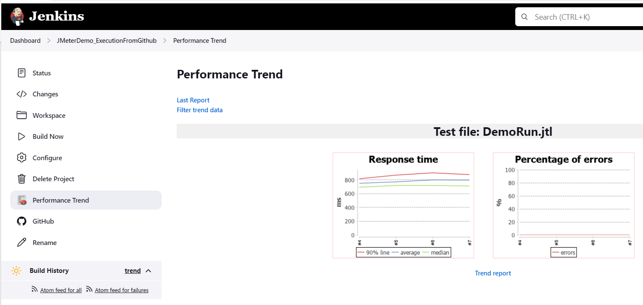

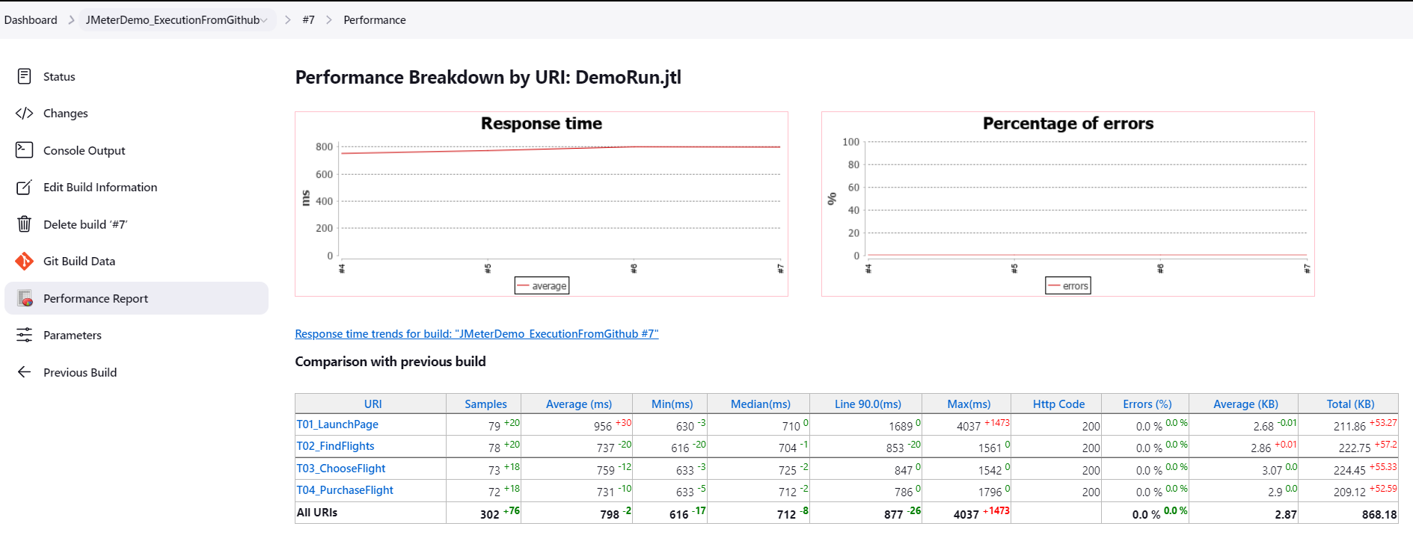

1. **JMeter + Pipeline execution from Github**

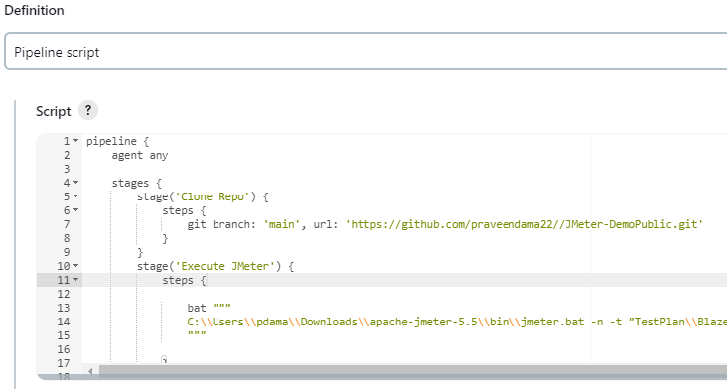

**Results snapshot :**

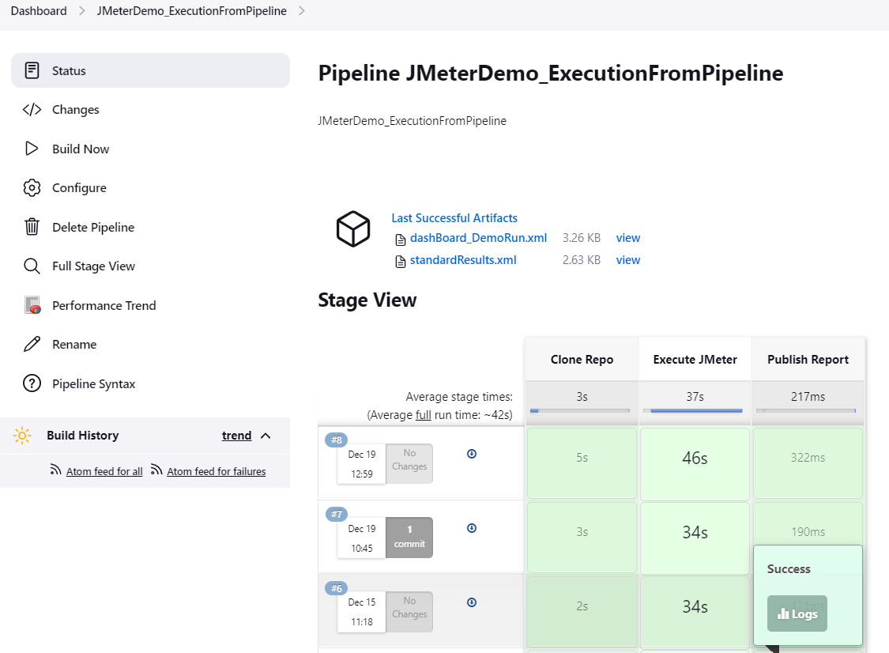

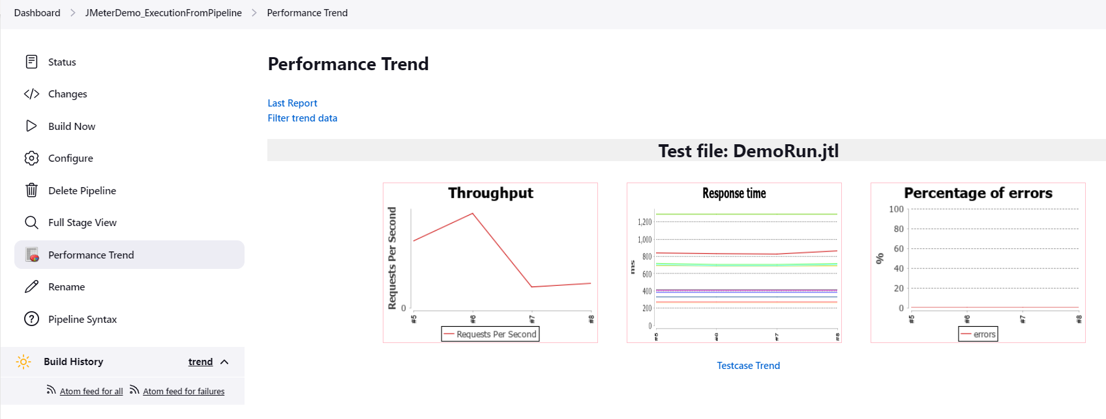

**Limitations for distributed load testing from remote hosts**

* Copy/Modify data files before test execution