Implementation of a 2-level Cache Simulator with a Hybrid Prefetcher
Praveen Ganapathy Narasimhan, Supraja Mahadevan, Sowmya Suresh Chander, Shanmathi Rajasekar

Abstract: This project is aimed at improving the performance of a given memory and CPU system by using a Hybrid Prefetcher module. Prefetchers are associated with memory hierarchy cache-systems to avoid the penalty associated with waiting for data from memory. The role of our prefetcher is to generate the requests to main memory so that the data can be in the L1or L2 caches before it would generate a processor stall. The Sequential prefetcher takes the advantage of spatial locality. While the stride prefetching takes advantage of the Reference Prediction Table (RPT) method of predicted memory accesses based on previous strides. This prefetcher takes the advantage of both the sequential and stride prefetching and produces a model that improves the efficacy and reduces the latency.

Specifications
We have a 2-way associative L1 cache (Data Cache) with 16 byte line size and an 8-way associative L2 cache with 32 byte line size between CPU and Main Memory. The L1 total size is 32KB and the access time from CPU is 1 cycle. This is Write-through, thus any changes in L1, notifies L2 cache whereas L2 cache is write back (changes not notified immediately to next level of memory) with a larger size of 256KB and access time of 20 cycles.
Three circular FIFO queues are used here – Write buffer/queue, L2 queue and Queue Mem. The first two circular queues are used between L1 and L2 cache. Write buffer is used to write the data (as L1 is Write through) into L2 and has a capacity of 10. L2 Queue (capacity=20) and Queue Mem (capacity= 10) are used to access L2 and main memory respectively. Queue Mem is used between L2 and Main Memory. The specifications of different level caches are shown in the Figure 1.
In our project, we use prefetcher to prefetch the data from main memory to L2 cache as size of L2 is larger and thus efficiency is better. L2 cache is pipelined (in-order) and main memory is not pipelined.
The input to our system is a trace file consisting of l/s (load or store), 32-bit PC, 32-bit effective memory address and number of cycles required to execute it. The input trace file is generated using a pintool- Memtracer. The command from linux terminal is as follows:
./pin -t memtracer -- /path/to/program
Trace file is shown below:
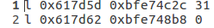

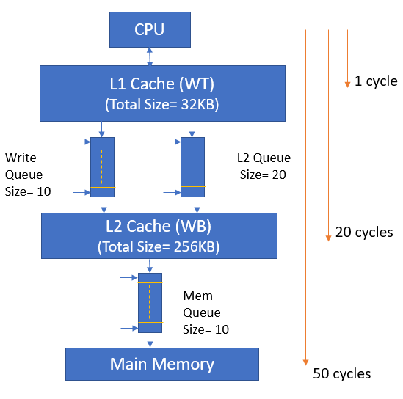Figure 1

Cache Memory
Cache memory is a subset of Main memory data that is recently used. As accessing main memory takes more number of cycles and has more execution time, we use L1 and L2 cache which results in lesser execution time and good performance.
The 32-bit effective address from the trace file is taken and index, offset and tag are found. The index determines the set and offset determines which block in the set where the address is available in cache. The effective address structure is shown in Figure 2.
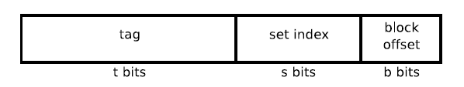
Figure 2

Valid bit is a bit of information that indicates whether the data in a block is valid (1) or not (0). Dirty bit indicates whether the data is modified after the access.
If tag and address in the cache matches and the valid bit in that cache location is 1, then it is a L1 cache hit, else L1 cache miss. If L1 cache miss, it should search in L2 cache. Similarly, it is done in L2 cache where cache miss goes to Main memory. The latency increases as misses increases.
When a cache miss occurs, a least recently used data in that cache is evicted and replaced by the required data. This is known as Least Recently Used (LRU) method. In our program, this is implemented by setting the LRU value of a particular address to 0 on a cache hit and incremented on a cache miss. The line having larger LRU value is evicted and replaced with the recent miss.

Memory Queue
Circular Queue is a linear data structure in which the operations are performed based on FIFO (First In First Out) principle and the last position is connected back to the first position to make a circle. Figure 3 represents Memory Queue.
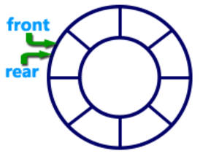
Figure 3
Initially, when queue is empty, the front and the rear points to the same element. As we add elements to the queue, the rear gets incremented. When rear reaches its capacity, the queue is full. To remove data, the front is incremented. When front is incremented to rear, then the queue is empty.
In our project, we use 3 queues- write buffer, L2queue and QueueMem as mentioned in Specifications. Write buffer is used between L1 cache and L2 to write into L2(if L1 data changes) as L1 is write through.
Duplicate element should be deleted from the queue. Duplicate element occurs when misses occurs for same data and should be fetched from higher level of memory through a buffer.

Memory cycles
The Processing unit comprises of five different states and they are:
- Idle - No request at the given time and is inactive.
- Ready - Request is ready and can be processed further.
- Waiting - Waiting for request to be fetched from L2 cache or Main Memory.
- Stalled_L2 - Stalled and waiting for D-L2 Bus to make room for the request.
- Stalled_WB – Stalled and waiting for write buffer to clear space to proceed with the request.

The above states are inter-related and advance from one state to another when specific condition holds good. Any request will begin to process when it is in the Ready state. While processing if the processor witnesses a full L2 Queue, the state changes from Ready to Stalled_L2. Similarly, if there is full write buffer then the processor puts the request in Stalled_WB state and waits until it creates space. If the request is processed and waiting for response, then it goes to Waiting state from Ready. The Stalled_L2 state gets updated to Waiting, once the L2 Queue is freed up and the request gets added to it. The Processor updates the Waiting and Stalled_WB states to Idle once the request is complete. The state progresses from Idle to Ready when the next instruction is ready to execute. This keeps going on in a cycle until all the instructions are executed successfully.

Prefetching
The idea of Prefetching is to fetch the data before the executing program needs it. In modern systems, prefetching is usually done in cache block granularity. This involves predicting the addresses that will be needed in the future. The main advantage of prefetching a block is the reduced latency. More the prefetching accuracy, lesser the latency and the compulsory cache misses. The accuracy of the prefetcher depends on the prefetching type followed—Data or Instruction prefetching and Hardware or Software prefetching. While Instruction type is usually followed in the former category due to its ease of predictability, Hardware prefetching in the latter part provides a sophisticated approach to detect access patterns on cache structures. The Hybrid prefetcher that is being discussed here, falls in the above combination.

Challenges in Prefetching:
Prefetching useless data wastes resources like memory bandwidth, cache buffer space and energy consumption. These could be utilized by demand requests or more accurate prefetch requests. A prefetcher initiated too early, might cause data eviction even before it is used and one that is initiated too late might not hide the whole memory latency. So, the prefetching algorithm should consider all these criteria while predicting access patterns using the existing storage structures. The hybrid algorithm here, is a combination of the below explained Sequential and Stride Prefetching models.
    - Sequential Prefetching:
This is the simplest form of prefetching which prefetches the next N cache lines after a demand access (or a demand miss). The main advantage of this prefetcher is that it needs no sophisticated pattern detection and it works well for sequential access patterns. But with irregular patterns, this method wastes the system bandwidth. Nevertheless, this pattern gives us a necessary improvement in overall system performance, when compared to the system with no prefetcher (shown in the results section).
    - Stride Prefetching:
This method is based on the prediction that when a memory address is missed, an address that is offset by a distance from the missed address is likely to be missed in the future. So, when there is an address miss, an address that is offset (called a stride) by a certain distance is prefetched. This address, if it gets hit in the next cycle, next address block is fetched with the same stride or offset. This stride now has a high confidence level since it resulted in a hit. But when there is a miss with this stride, the confidence level is lowered while the next address is fetched with an updated stride and this process is continued. These values are stored in the Reference prefetching table (RPT), which is shown below. This table consists of the tag and check bit for notifying whether the prefetcher data is used and denoting the confidence level of the current stride. This is specific to a row of the table containing the program counter value, the effective memory address and the stride used. This prefetching is used mainly to eliminate the compulsory and capacity misses.

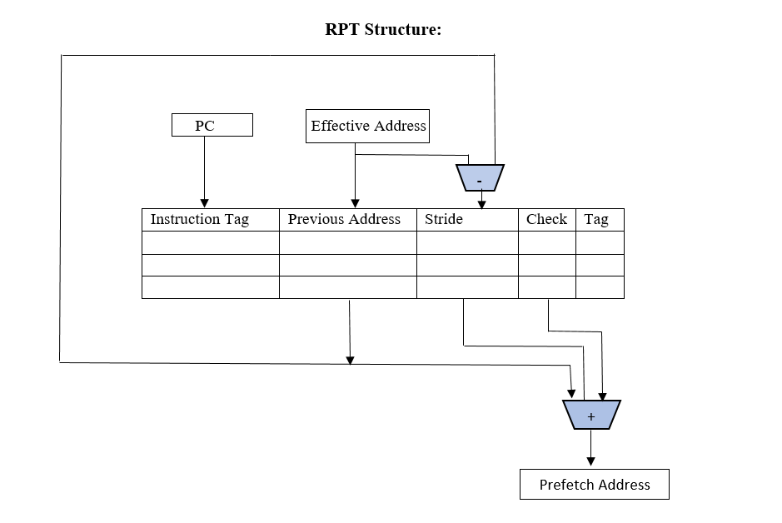

    - Hybrid Prefetching:
As the name suggests, this model combines the algorithms of both Sequential and Stride Prefetching models. So, instead of choosing a random initial stride value, N cache lines (as in sequential model) are prefetched, which reduces the initial compulsory misses in the system. Then, the stride value is calculated with the help of the address and the last fetched memory. Again, as in the stride model, if this stride results in a hit, the confidence level of this stride is set to high and this stride is followed for the next fetch. If there is a miss, the stride is set to low and the sequential prefetcher value is used to fetch the next block of addresses. This way, both capacity and compulsory misses are reduced, thereby increasing the cache hit rates. The following parameters are evaluated in this model:
- Total Run Time
- D-Cache Total Hit Rate
- L2 Total Hit Rate
- Average Memory Access Time
- Average Memory Queue Length
- D-Cache-to-L2 bandwidth utilization
- Memory bandwidth utilization

Results
A Hybrid model Prefetcher is designed and implemented along with a Standard Memory Model. This has a considerable effect on the performance of the Model. A comparison between the Standard Memory Model without Prefetcher and the Hybrid Prefetcher Model is made using a set of seven chosen parameters for two different Traces and the results are plotted as graphs.

- From figure (a) Average Memory Access Time (AMAT) for the sequential prefetcher module for different size of blocks fetched is plotted. It is observed that the Memory access time, till a value, reduces with the increase in number of blocks prefetched. This is because more the number of blocks fetched from memory and sent to cache, the probability of the misses is diminished.

- From figure (b) AMAT for the RPT prefetcher module for different size of the table is plotted. More the number of entries in the table then more the chances of finding a block, thus lowering the memory access time and misses.

- From figures (c), (d, (e), (f) AMAT and the Run Time parameters are found to decrease when we go from the Standard Memory Model without prefetcher to the Hybrid Model. However, D-cache Hit rate, L2 Hit rate, Average Memory Queue Length (AMQL), D- cache to L2 bandwidth utilization and Memory bandwidth utilization parameters are observed to have an increase in value when drifted from without prefetcher model to Hybrid model prefetcher. This pattern in the parameters is witnessed because of the infusion of an extra Hybrid prefetcher module that predicts and fetches the blocks from the main memory and gives it to the cache, which reduces the miss rate, Latency and increases the performance.

- In the last figure (g), compulsory misses are compared for each of the traces with and without prefetcher. It is shown that the ratio of misses were reduced by over 75%, which shows the efficiency and the accuracy of the hybrid model.












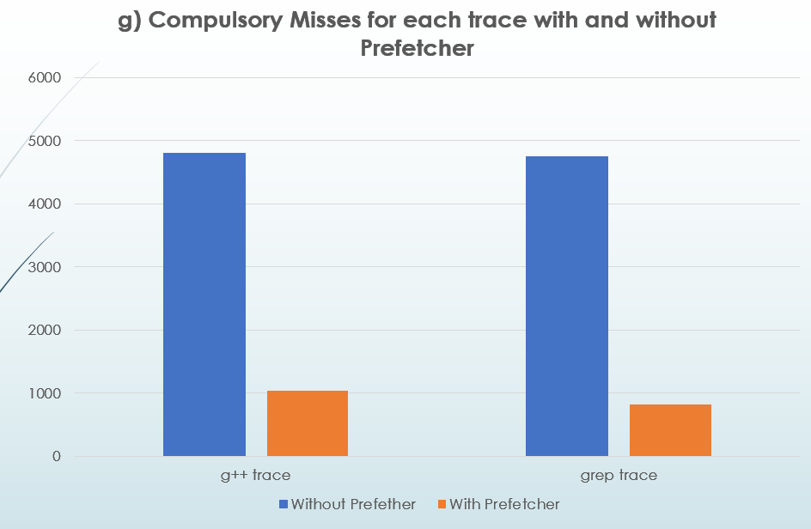

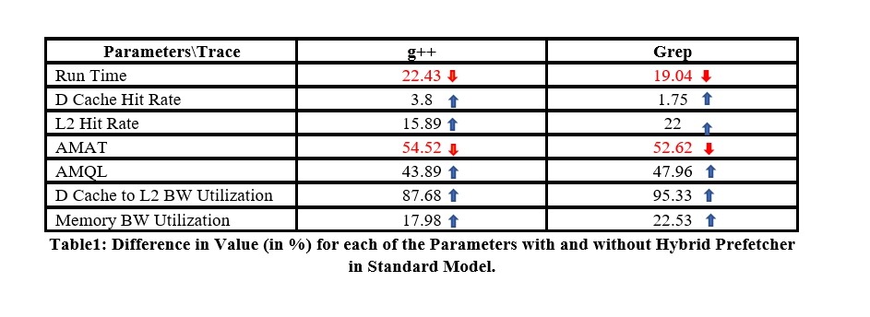 VII. References
[1] S. Sharma, J. G. Beu and T. M. Conte. Spectral Prefetcher: An Effective Mechanism for L2 Cache Prefetching. ACM Transactions on Architecture and Code Optimization, Vol 2, No. 4, December 2005, Pages 423-450. North Carolina State University. December 2005.
[2] S. P. Vander Wiel and D. J. Lilja. Data Prefetch Mechanisms. ACM Computing
Surveys (CSUR) Vol 32, No 2, June 2000, Pages 174-199. University of Minnesota. June 2000.
[3] T. F. Chen and J. L. Baer. Reducing Memory Latency via Non-blocking and Prefetching Caches. Technical Report. 92-06-03, Department of Computer Science, University of Washington, Seattle WA, June 1992.

