HTTP CLIENT AND SERVER

In this project, we have implemented sliding window protocols – Go-Back-N (GBN) and Selective Repeat (SR) - using an unreliable channel (i.e. UDP in our case). We compute the checksum of the segment and place it along with the segment that also needs to be parsed at the other end accordingly. As expected, this project requires two Programs/ processes - sender process and receiver process.

Environment:
The program has been developed in C++ and the program has been neatly segregated into sub-functions each handling a feature. The program has been run and tested in a windows environment and the standard used for testing was C++11. It also includes only headers from the standard library.

The following is a brief overview of both the process and the various scenarios included in both the protocols.

- Selective Repeat and Go-Back N are two sliding protocols which differ mainly by the sliding mechanism and how the sender and receiver communicate information with each other.
- Information such as type of the protocol, number of sequence bits, window size, timeout value and maximum segment size are given to the program as an input file.
- Command line arguments are also used to input information into the program. Information such as port number and total number of packets.
- Acknowledgement is sent based on the packet number received i.e., Packet 1 → Ack 1 will be sent in both the protocols.
- There are two main iterators SF (first packet) and WinLast (last packet) in both Go-Back-N and Selective Repeat protocols that will slide based on the total number of packets sent/received in each window.
- RF and RN are two iterators used in the Selective Repeat protocol that will slide based on the total number of packets.
- Sequence number space vary per each protocol. In Go-Back-N, the sequence numbers vary from (0 to 2^{No_of_bits}-1). In Selective-Repeat, the sequence numbers vary from 0 to 2^{NoOfBits - 1}
- Random numbers are generated using standard library features and these are used to infuse a certain amount of uncertainty into the system.
- Random values are generated and help in achieving the following situations:
  - Lost Packet
  - Lost Acknowledgement
  - Check Sum Error
- Timers are implemented intuitively where the above-mentioned situations are identified, handled and rectified based mainly on the window values and help in maintained efficient functioning of the protocol.
- The following is a brief overview of the error induced scenarios and how the system’s behavior varies based on that.
  - LOST PACKET: We introduce a lost packet into the system with the help of a random number which initiates a random loss of a packet based on probability. When there is a lost packet, the receiver does not receive a packet for that sequence number. In Selective Repeat, the other packets in the window are processed and would receive an acknowledgement if received successfully. Once the packets in the window are sent, the lost packet is identified and sent and then the window slides based on that.

  - BIT ERROR/CHECKSUM ERROR: Just before sending the packet, we intentionally modify the checksum of the packet to be sent to check if the error is identified by the receiver. The behavior in both the protocols are such that, when the check sum gets computed by the receiver prior to sending an acknowledgement, the error is identified and the packet is discarded. This forces the server to re-send the packet after getting timed out such that the window slides and other packets are queued to be communicated with the receiver.

  - LOST ACKNOWLEDGEMENT: The lost acknowledgement is handled in a way similar to the lost packet. One happens in the sender whereas the other happens in the receiver. A lost acknowledgement is introduced via randomness into the system and this stops the window from sliding further. Once the other packets are sent by the sender, not receiving an ACK for a previous packet prompts a timeout and hence causes the sender to re-send the packet in order to slide the window and process the other packets.

Instructions to be followed to run each protocol:

SELECTIVE REPEAT:

- There are two folders GBNandSRServer and GBNandSRClient that contain both the source programs.
- A text file called Sample.txt should be contained in the GBNandSRClient folder.
- The text file is used as input to the program and should be specified in a format.
- The Client program should be compiled using two arguments, SocketSize (ex:5000) and Number of packets (ex:50)
- The command line (Command prompt) for the Server should be of the format:
  - g++ server.cpp
  - ./a.exe 5000
- The command line (Command prompt) for the Server should be of the format:
  - g++ client.cpp
  - ./a.exe sample.txt 5000 50

GO-BACK-N:

- There are two folders GBNandSRServer and GBNandSRClient that contain both the source programs.
- A text file called Sample.txt should be contained in the GBNandSRClient folder.
- The text file is used as input to the program and should be specified in a format.
- The Client program should be compiled using two arguments, SocketSize (ex:5000) and Number of packets (ex:50)
- The command line (Command prompt) for the Server should be of the format:
  - g++ server.cpp
  - a.exe 5000
- The command line (Command prompt) for the Server should be of the format:
  - g++ client.cpp
  - a.exe sample.txt 5000 50

SCREENSHOTS:

SELECTIVE REPEAT:

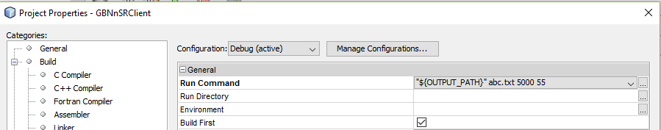
- Input specification format for client program

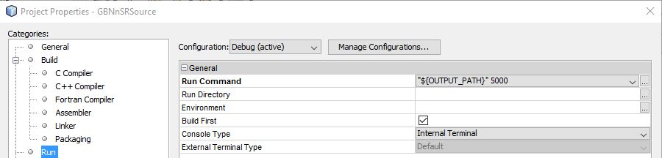
- Input specification format for server program

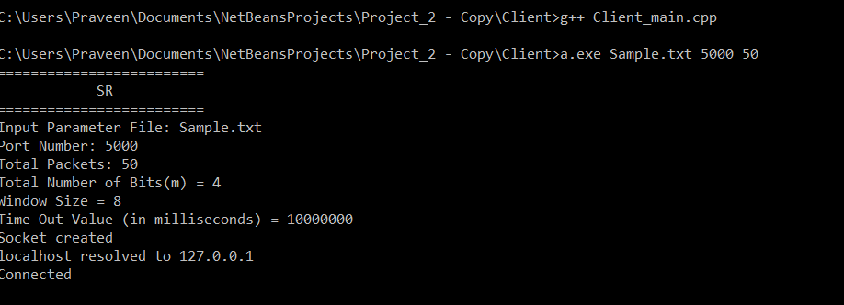
- Client program specifications
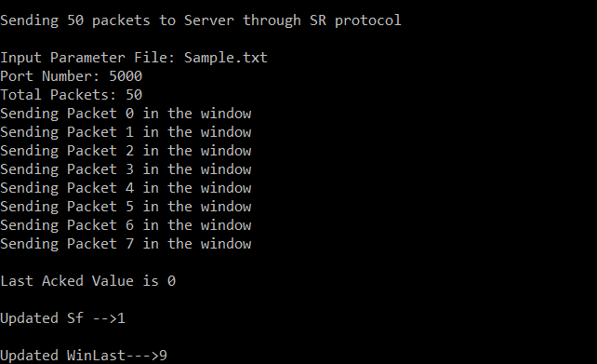
- Sending packets from Client to Server and Receiving ACK

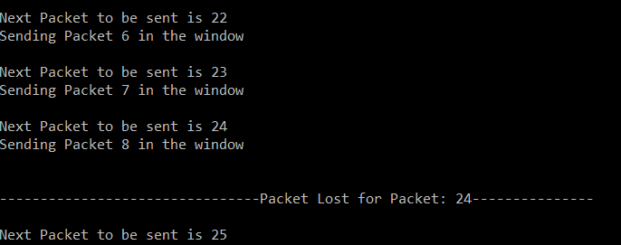
- Lost packet scenario

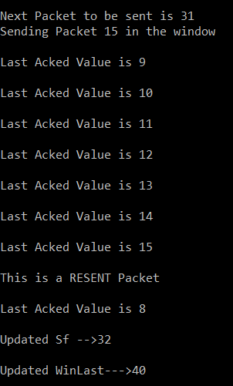
- Sending the RESENT packet after receiving ACKS

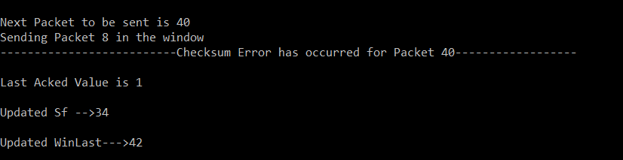
- Checksum error has occurred

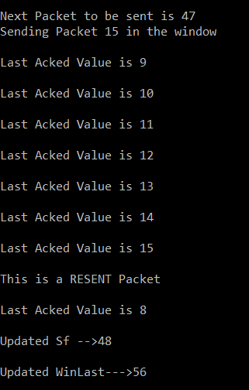
- Packet for which a checksum was received is RESENT after receiving ACKs for the previous packets

SERVER
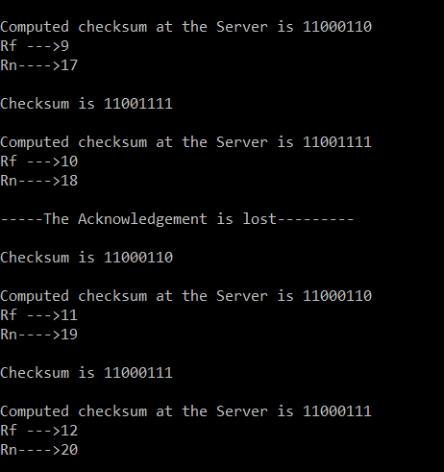
- Lost Acknowledgement

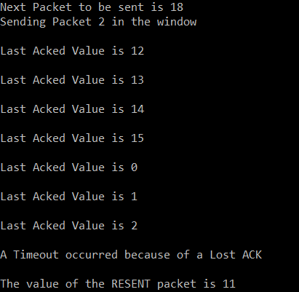
- Packet times out after not receiving an ACK and is hence RESENT

GO-BACK-N:

- Client Side:

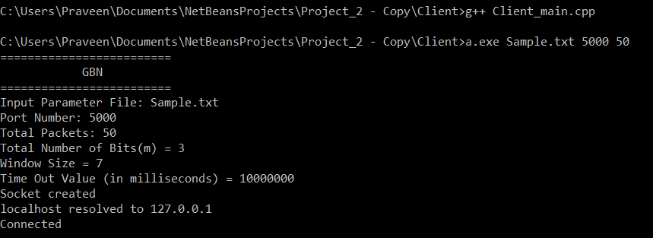
Fig.2a) Go-Back N Initial Setting

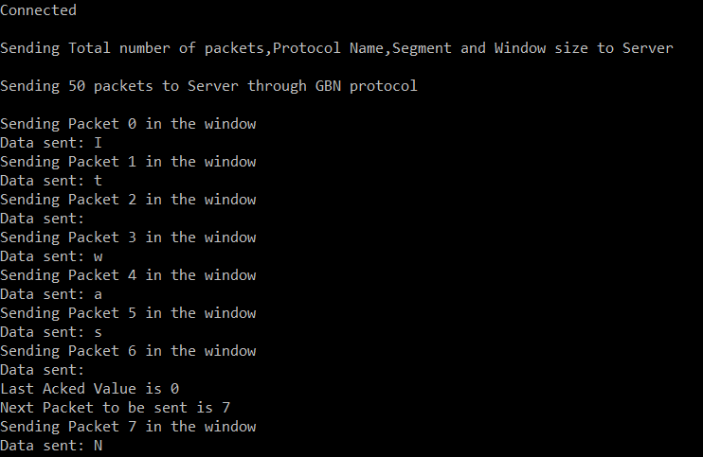
Fig.2b) Go-Back N Normal Client Operation—Before ACK reception

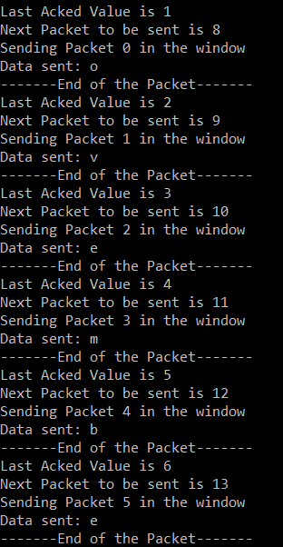
Fig.2c) Go-Back N Normal Client Operation—After ACK reception

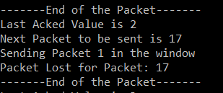
Fig.2d) Go-Back N Normal Client Packet Lost Notification

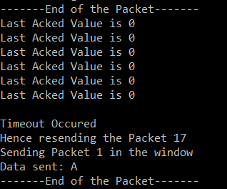
Fig.2e) Go-Back N Client—Handling of Packet Loss Scenario through Timeout and resending

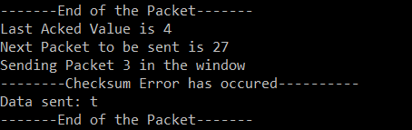
Fig.2f) Go-Back N Client side Checksum Error Notification

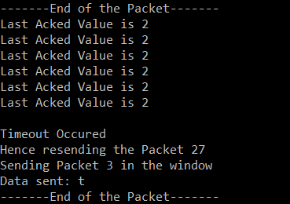
Fig.2g) Go-Back N Client side Checksum Error timeout and Resending

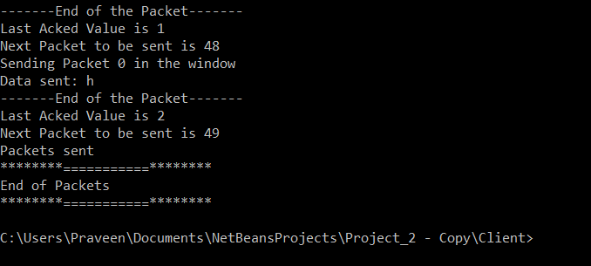
Fig.2h) Go-Back N Client side Complete Packets Sent Notification

- Server:

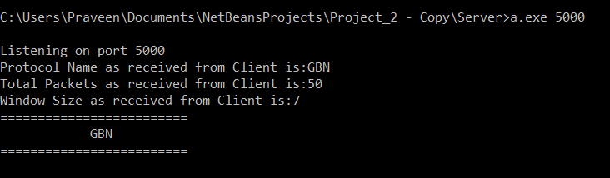
Fig.2i) Go-Back N Server side Initial Setting

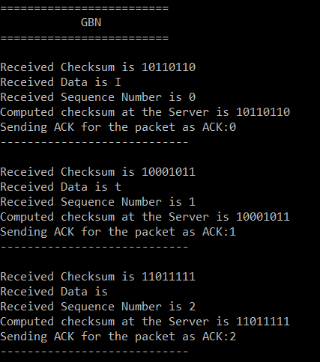
Fig.2j) Go-Back N Server side Normal Operation

Cases Considered:

- The first packet sent to the receiver is lost.
- The last acknowledgement sent to the sender is lost
- The last window of packets is not full
- The number of packets given as a command line argument is lesser than the input sequence given in the file for Go-Back-N protocol

