**Step to configuration SonarCloud.io for Maven Projects:**

**https://dzone.com/articles/integration-jenkins-jacoco-and-sonarqube**

1. Navigate to <https://sonarcloud.io>
2. Click on **Sign-In** at the right top corner.

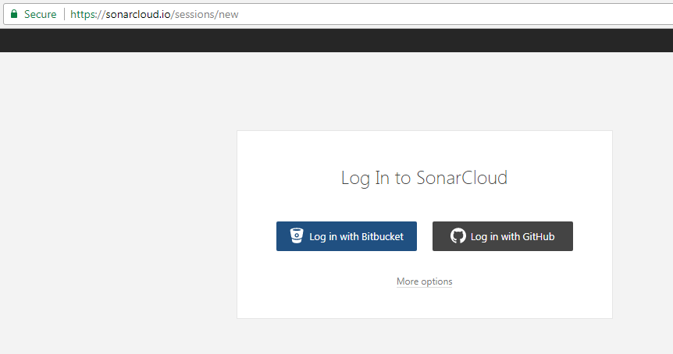

1. In above screen click login with **Github using account already created**.

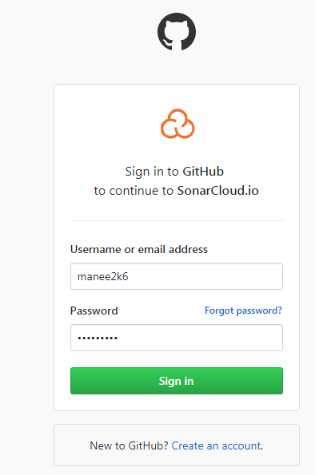

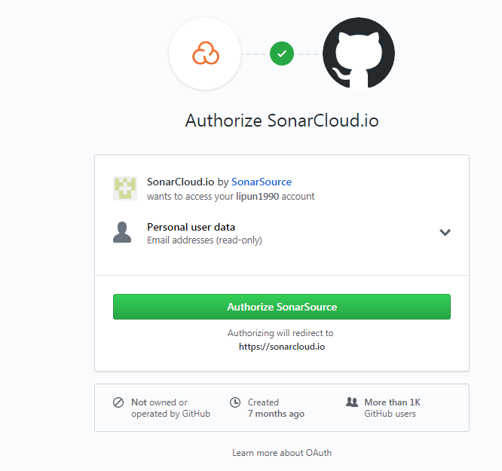

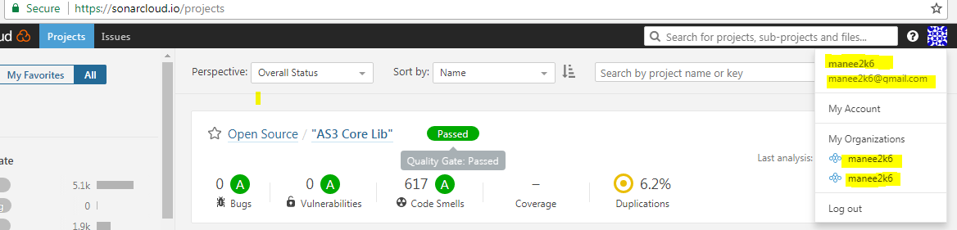

1. Go to **My Account**🡪 Select **Security tab**🡪 **Generate Token** and copy it notepad.

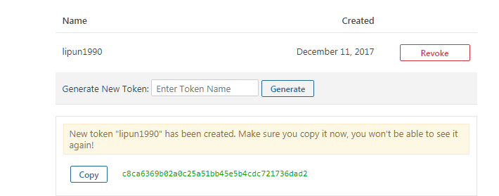

1. On the same page **select Organizations**🡪 **Create Organizations** as below.

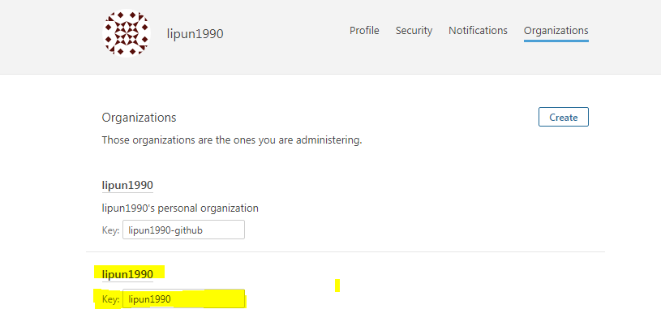

1. Create a **Maven goals** as below in a text file: <https://about.sonarcloud.io/news/2016/09/01/sonarqubedotcom-open-to-aynone.html>

mvn sonar:sonar \

-Dsonar.projectKey=maven_apps \

-Dsonar.organization=itrainbatman \

-Dsonar.host.url=https://sonarcloud.io \

-Dsonar.login=0767bb0a33926d7ea765c0ef95c6f8d67cdd5

1. Goto Jenkins and install **SonarQube Scanner for Jenkins plugins**.

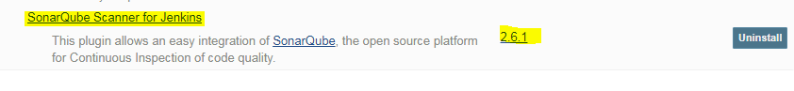

1. Goto **Manage Jenkins**🡪 **Configure Systems**🡪Under **SonarQube Server**🡪 Fill in Server URL & Authentication token created in Step 4🡪 **Apply and Save** this configuration.

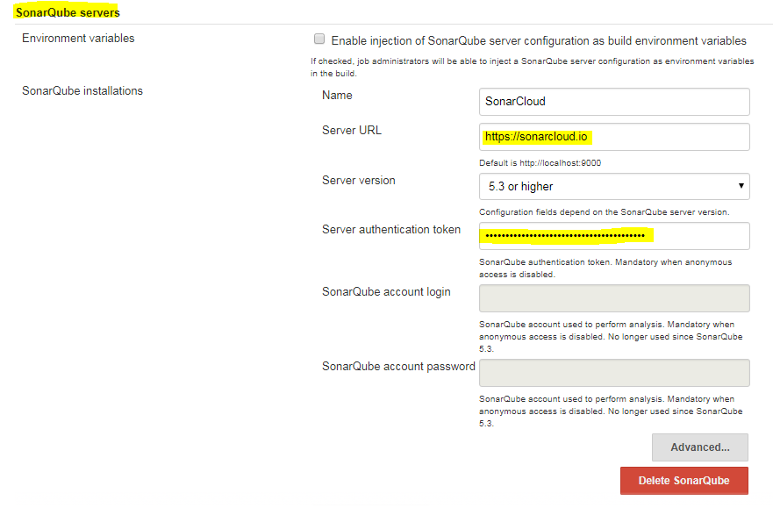

1. Goto **Manage Jenkins**🡪**Global Tool Configuration**🡪Under **SonarQube Scanner** config 🡪 Click Apply and Save.

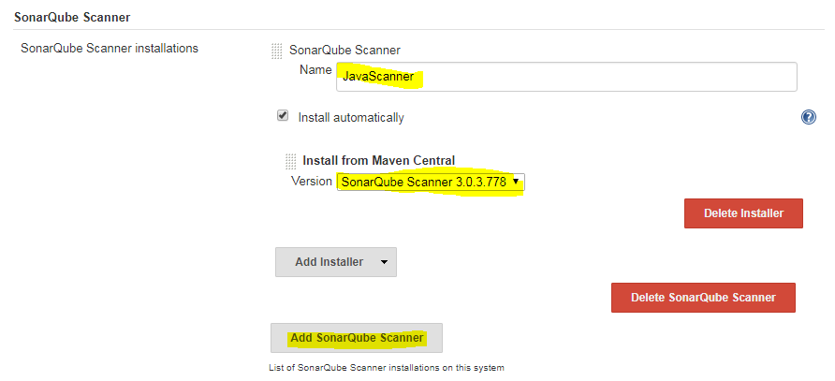

1. Navigate to **Jenkins Dashboard**🡪 **Create New Maven Job**🡪 Under **Build section** copy the maven goal in step 6(exclude mvn)🡪 **Save Job**🡪 Build Now.

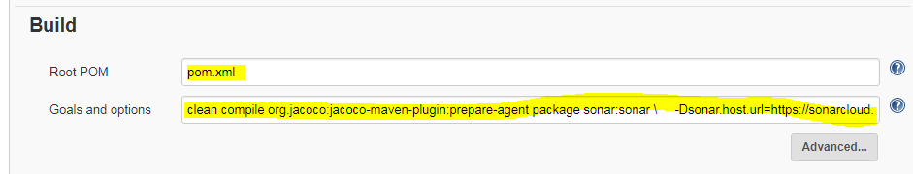

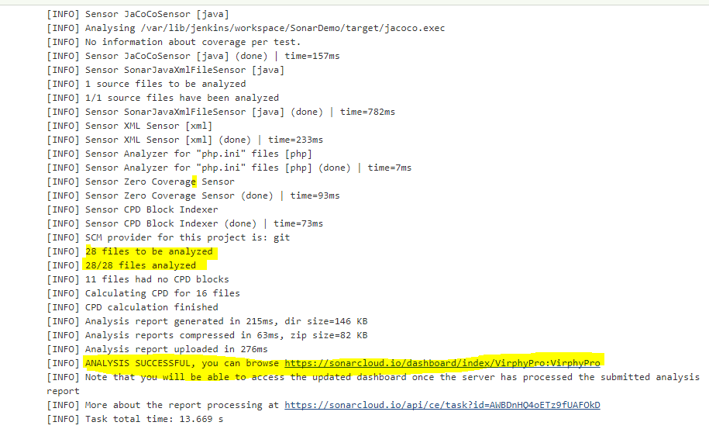

1. Sonar Dashboard as below:

