 

INSTITUTE FOR ADVANCED

COMPUTING AND

SOFTWARE DEVELOPMENT

AKURDI, PUNE

Documentation On

**“Local Mart”**

PG-DAC FEB 2020

*Submitted By:*

**Group No: 88**

**1175 Rahul Rajendra Patil.**

**1183 Praveen Sambhaji Koli.**

**Prashant Karhale Mr. Akshay Sir**

**Centre Coordinator Project Guide**

# Table of Contents

1. **Introduction ……………………………………………………………………….4**

1.1 Purpose ……………………………………………………………………… 4

1.2 Scope ………………………………………………………………………... 4

1.3 Definition …………………………………………………………………….4

1.4 Overview…………………………………………………………………….. 4

1.5 Additional information………………………………………………….…….5

1.6 General description…………………………………………………………...5

1. **Functional requirement …………………………………………………………..5**

2.1 Description……………………………………………………..……….…… 5

2.2 Technical issue…………………………….………………………………….6

2.3 Hardware interface ……………….………………………………………...…6

2.4 Software interface ……………………………………………………………..6

2.5 Performance requirement………………………………………………………6

2.6 Design constraints……………………………………………………………...6

1. **Non-Functional requirement ……………………………………………………….7**

3.1 Security ………………………………………………………………………...7

3.2 Reliability………………………………………………………………………7

3.3 Availability……………………………………………………………………..7

3.4 Maintainability…………………………………………………………………7

3.5 Portability………………………………………………………………………7

3.6 Accessibility…………………………………………………………………….7

3.7 Policies…………………………………………………………………………7

3.8 Efficiency………………………………………………………………………7

* 1. Safety…………………………………………………………………………..7

3.10 Modularity……………………………………………………………………8

**4.Operational scenario………………………………………………………………..8**

4.1 Customer interaction……………………………………………………………8

**5.Preliminary schedule………………………………………………………………..8**

**6.System Diagram .................................................................................................................9**

4.1 Activity Diagram .....................................................................................................9

4.2 Data Flow Diagram ..................................................................................................10

* 1. Use Case Diagram ....................................................................................................11

4.4ER Diagram ...............................................................................................................12

**7.Table Structure ...................................................................................................................13**

7.1 Relations between table……......................................................................................13

7.2 User table ...................................................................................................................14

7.3 Product table................................................................................................................14

8. **Conclusion ........................................................................................................................15**

9**. Future Scope** ....................................................................................................................15

**10.References ..........................................................................................................................15**

10.1 Online reference……………………………………………………………………..15

# List of Figures

Figure 1 Activity Diagram...............................................................................................9

Figure 2 Data Flow Diagram...........................................................................................10

Figure 3 Use Case Diagram.............................................................................................11

Figure 4 ER Diagram.......................................................................................................12

1. **Introduction**

**1.1 Purpose**

The aim is to design and implement aweb-based application for local mart shopping website. The proposed system aims to simplify the process of shopping products and selling product. Our main goal is to help farmer by giving good value for their product and also customer get quality product at resonably price.

Customer can buy products directly by farmer. There will be no middleman. So both customer and sell will get benifited.

**1.2 Scope**

The propose system allow customer to get quality product directly from producer. Customer will get variety of options on single platform.

User get fulfill all his need using one platform on fingertips. Also user get variety of options to differentiate.

Seller can increase his income by connecting the large group of customers. Easy interface to manage his products.

**1.3 Definitions**

SRS – Software Requirement Specifications.

GUI – Graphical User Interface.

UML – Unified Modeling Language. (visualising System in the form of diagrams)

RDBMS – Relational Database Management System.

**1.4 Overview**

This system provides an easy solution to customers to buy grocessry, daily essentials, food etc through online porter by just clicking few buttons.

User has to register to buy a product. After registering user can also add any product if he has. Portal provide various options to get all product, get products by category, add product, update product and delete product etc. He can then add products to cart and buy them. Here customer can be seller and seller can be customer.

**1.5 Additional Information**

The system work on internet server, so it will be operated by any end user for the buying essential products with secure platform.This system protects the integrity of the sellers and buyers, provides easy returns and offers.

**1.6 General Description**

The local mart product will use the internet as the sole method for selling products to its consumers and helps to manage the items in the shoppers' carts and also helps consumers to purchase.

**2. Functional Requirement:**

This section provides requirement overview of the system. Various functional modules that can be implemented by system.

**2.1 Description:**

**Product List module:** It is the main component and it appears as home page. Here user can get the list of all product. Here we provide various category options so user can filter the list as per his requiremnet. It is responsive module as it changes according to user screen.

**Navigation module:** This module help user to navigate around different pages. We have developed responsive navigation bar. It will change according to screen size. Also depend on user or visitor it will show the route.

**Login**:Customer logins to the system by entering valid user id and password for shopping. End User can browse products, their categories as well, he/she can add products to his/her wish list.

**Registration**: If customer wants to buy the product then he/she must be registered, Unregistered user cannot get to shopping cart but he can view about us page and signup/login page.

**Shopping Cart:** This module offers to add, delete and modify the products in the cart, after this shopping cart module will be reflected towards payment module.

**Search :** Easy interface to find what he want by eliminating unncessary things.

**Email Notification :** Get all information of intereasted customer on registered mail.

**Logout:** After the payment of the product the customer will logged out.

**Report Generation:** After all transaction the system can generate the portable file (.pdf)

then sent one copy to customer's email- address and another one for the system database to calculate the monthly transaction.

The term client/server refers primarily to an architecture or logical division of responsibilities,

the client is the application (also known as the front-end), and the server is the RDBMS (also known as the back-end).

A client/server system is a distributed system in which some sites are client sites and others are server sites.

All the data resides at the server sites.

All applications execute at the client sites.

**2.2 Technical Issues**

It is a client and server-based application so it contains of various web pages which changes as per client requirement. Client side always requires browser to run our application e.g. chrome.

**2.3 Hardware Interface**

Minimum requirement

Same for both parties which are as follows:

Processor: Dual Core

RAM: 2 GB

Hard Disk: 3 GB

NIC: For each party

**2.4 Software Interface:**

Minimum requirement

1) OS: Windows 7

2) JAVA development toolkit.

3) Chrome or any browser

**2.5 Performance Requirements**

In order to maintain an acceptable speed at maximum number of uploads allowed from a particular customer as any number of users can access to the system at any time. Also, the connections to the servers will be based on the attributes of the user like his location and server will be working 24X7 times.

**2.6 Design Constrains**

This system should be developed using Standard Web Page Development Tool, which conforms GUI standards such like HTML, XML, JSON etc.

The system should support various RDMS and Cloud Technologies.

**3.Non-Functional Requirements:**

**3.1 Security:**

The System use SSL (Secure Socket Layer) in all transactions that include any confidential customer information.

The system must automatically log out all customers after a period of inactivity.

The system should not leave any cookies on the customer's computer containing user password.

JWT tokens to authenticate and validate user requests after login.

The system's back-end servers shall only be accessible to authenticated administrators.

Sensitive data will be encrypted before being sent over insecure connections like internet.

The proper firewalls should be developed to avoid intrusions from the internal or external sources.

**3.2 Reliability:**

1) As we use MySQL database technology updation, insertion and delete took place very fast on server side.

2) GUI will be user friendly and both will use it with ease.

**3.3 Availability**

The system should be available at all times. Meaning the user can access it using web browser, only restricted by the down time of the server on which the system runs.

**3.4 Maintainability**

A commercial database is used for maintaining the database and application server takes care of the site. The maintainability can be done efficiently.

**3.5 Portability**

The application is HTML So the end user part is fully portable and any system using any web browser should be able to use the features of the system, including any hardware platform that is available or will be available in the future. An end-user is used this system on an OS; either it is Windows or Linux. The System shall run on PC, Laptops and PDA.etc. The technology should be transferable to different environments easily.

**3.6Accessibility**

Only registered users should be allowed to process the orders after authentication.

Only GUI access of the system should be permitted to end users.

**3.7 Policies**

The system should maintain security related to sensitive data.

**3.8 Efficiency**

The system should provide good throughput and response to multiple users without burdening the system by using appropriate servers.

**3.9 Safety**

Software should not harm ethical and environmental conditions of the end users’ machine.

**3.10 Modularity**

The system should have user friendly interface. It should be easily updated,modified and reused.

**4.Operational Scenario:**

**4.1Customer Interaction:**

The Customer want to buy medicines and healthcare essentials. The system shows all categories to customer. If customer selects item then those items are listed in shopping cart for buying. The payment will be made with credit card or debit card. If customer wants to cancel the order before shopping then he or she can cancel it. Customer can see the buying report on account details. Customer will receive email about purchase confirmation.

**5.Preliminary Schedule**

1.Login

2.Manage products database

3.Add or remove products from cart

4.Update products category

5.Place order

6.Logout

7.Give feedback

8. Search products

9. Email notification

10. Visit Site

11.Confirmation email

12.Customer Support

# 6.System Design:

## 6.1 Activity Diagram

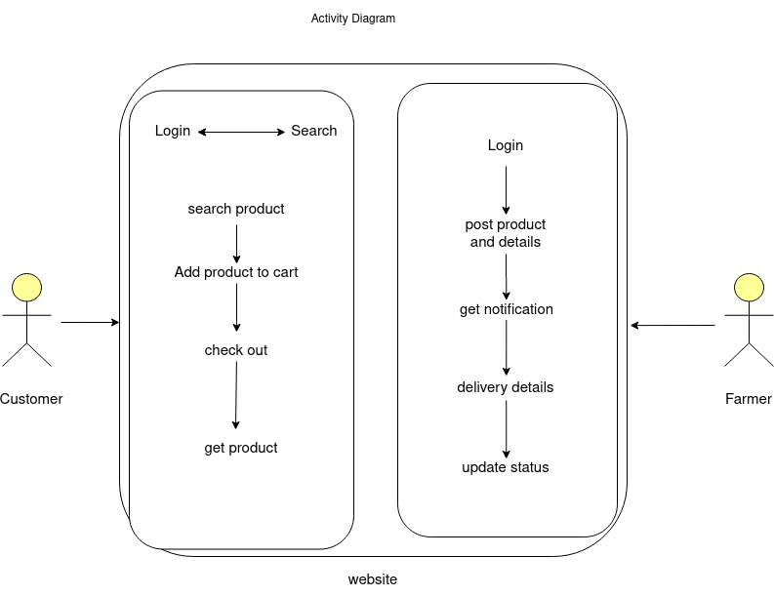

**Figure 1: Admin and Customer Activity Diagram**

## 6.2 Data Flow Diagram

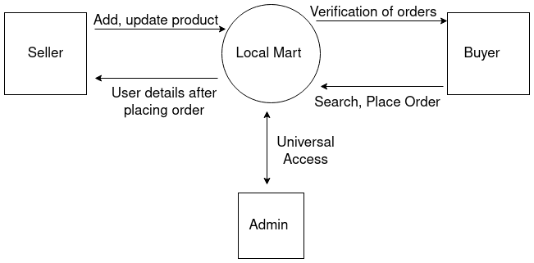

**Figure 2: Data Flow Diagram**

## 

## 6.3 Use Case Diagram

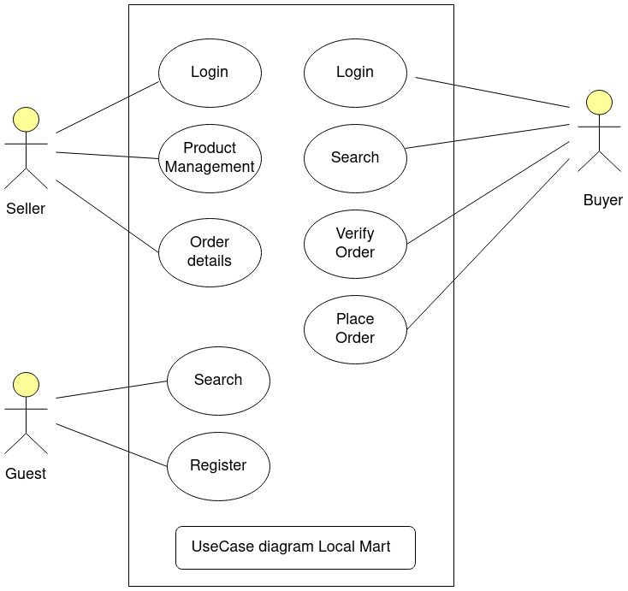

**Figure 3: Use Case Diagram**

## 6.4 ER Diagram

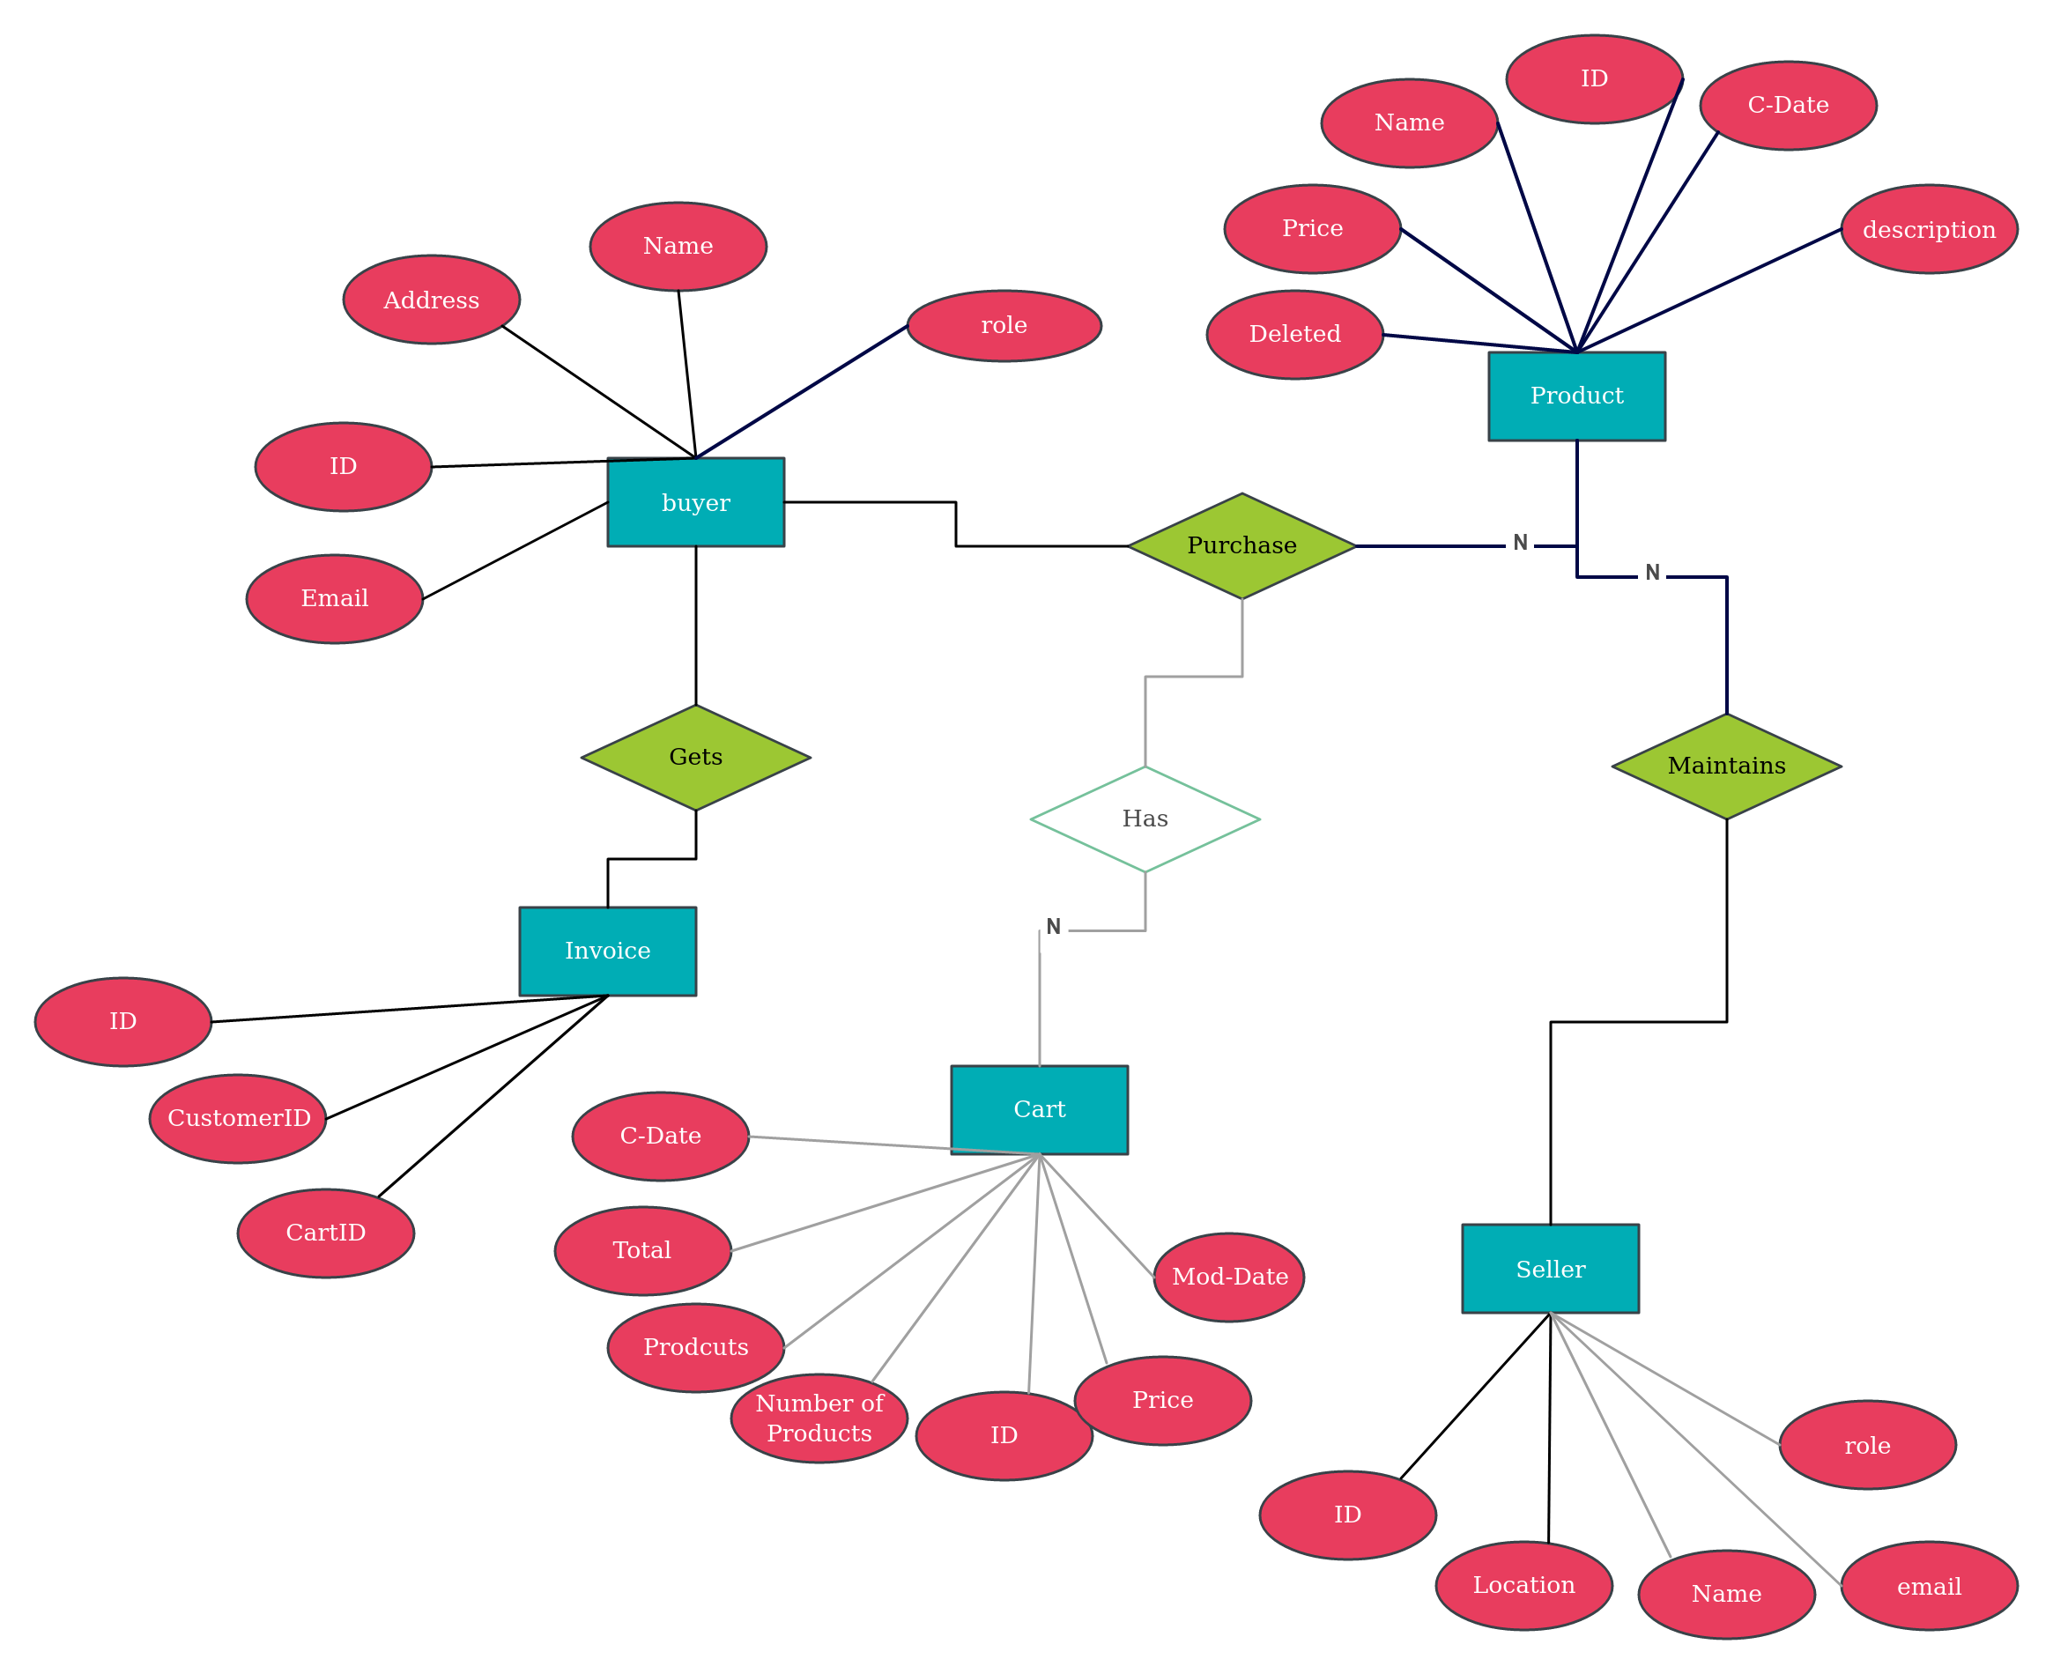

**Figure 4: ER Diagram**

# 7. Table Structure:

**7.1 Relation between tables**

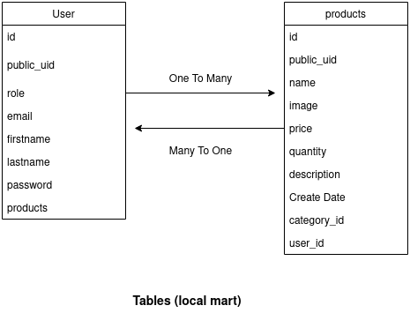

**7.2 User table:**

|  |  |  |
| --- | --- | --- |
| ColumnName | DataType | Key Constraint |
| id | int | PK, autoincrement |
| Public_uid | int | NN |
| role | varchar (15) | NN |
| email | varchar (50) | NN |
| First_name | varchar (15) | NN |
| Last_name | varchar (15) | NN |
| password | varchar (15) | NN |
| products | varchar (15) | NN |

|  |  |  |
| --- | --- | --- |
| ColumnName | DataType | Key Constraint |
| id | int | PK, autoincrement |
| Public_uid | int | NN |
| name | int | NN |
| image | int | FK |
| price | varchar (20) | NN |
| quantity | int | NN |
| description | int | FK |
| create _date | date | NN |
| Category_id | int | NN |
| User_id | int | Foreign Key |

**7.3 Products table:**

**8.Conclusion:**

Local Mart makes both selling and buying to to rural customers. Here seller no longer need to search the buyer. And buyer get all products at one place. He can search what he want and show interest. And buyer contact needy customer and sell product. It make everything easy and on tip of fingerprint. There can be scope of improvement ease of access and adding more layer of security in this website.

# 9.Future Scope:

-Adding payment gateway to provide security to customer.

- Adding component to filter the products.

- Add labels to product so using label one can search the product.

- Adding Review and rating support.

**10. References:**

**10.1 ONLINE REFERENCE**

1. https://material.angular.io
2. <https://getbootstrap.com/docs/4.0>
3. <https://www.codejava.net/frameworks/spring-boot/email-verification-example>
4. <https://docs.spring.io/spring-boot/docs/current/reference/htmlsingle/>
5. https://developer.mozilla.org/en-US/docs/Web/Guide/HTML/HTML5