Department of Mechanical Engineering

Indian Institute of Technology Bombay
ME415: Computational Fluid Dynamics & Heat Transfer Spring 2023
Term Project: Computational Fluid Dynamics for Cartesian Geometry on a Uniform Staggered Grid: Flux based Solution Methodology
Weightage: 10% Instructor: Prof. Atul Sharma
Date Posted: 08th March. 2023 (Wednesday) Tutorial: 5-7 PM, 15th & 22nd March, 2023 (Wednesdays)@CLR-Lab@PPCLT@Energy-Dept. Deadline for Submission: 27th March, Monday@2 AM (26th March midnight). VIVA for Submission: 27th March., Monday@5-7:30PM@F-24@MED NOTE: Absence in VIVA will lead to zero-marks for the term-project. WITH BEST WISHES!

Example 9.1 (Sharma, 2017): Lid driven cavity flow probably is the most commonly used problem for testing of an in-house Navier-Stokes (NS) solver. This is shown in Fig. 1, as a square cavity with the left, right and bottom wall as stationary. The top wall, called here as the lid, acts like a long conveyor-belt and is moving horizontally with a constant velocity U₀.
The motion results in a lid driven recirculating flow inside the cavity. The cavity is represented by a closed 2D Cartesian square domain of size L₁=L₂, with all the boundaries as the solid-walls. Figure 1 also shows the initial and boundary conditions for the non-dimensional computational set-up of the problem. The simplicity in the shape of the domain and the boundary conditions has led to the wide application of the LDC flow as the benchmark problem for a NS solver.
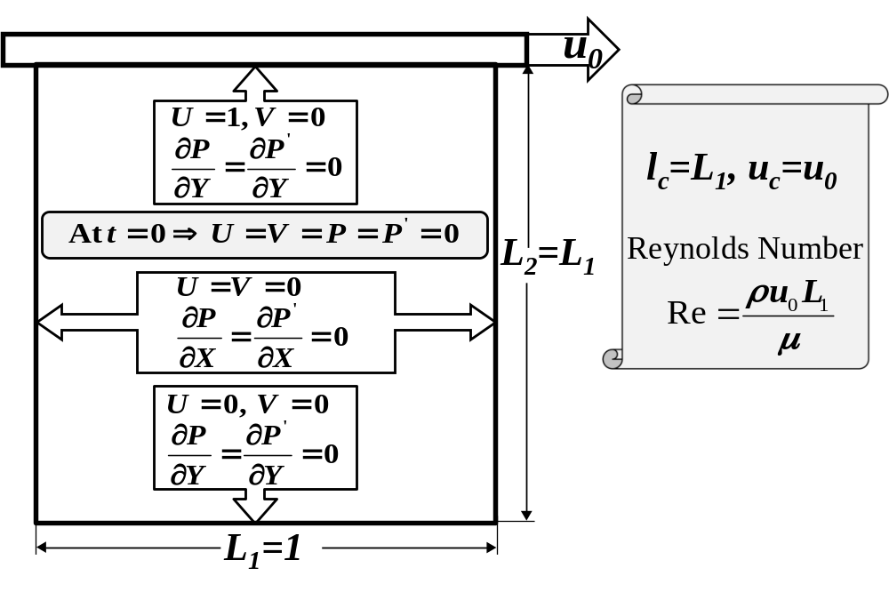
Fig. 1: Computational domain and boundary conditions for the lid driven cavity flow.

Using the flux based solution methodology of the CFD development presented in the class for the FOU scheme, develop a computer program for the semi-explicit method based 2D unsteady NS solver on a uniform staggered grid. The code should be written in a non-dimensional form, with the length of the cavity L₁ as the characteristic length, and the lid velocity U₀ as the characteristic velocity scale. They are shown in Fig. 1, along with the governing-parameter for the isothermal flow as Reynolds number Re=ρU₀L₂/μ. The Re is implemented in the code by a computational set-up as ρ=U₀= L₂=1 and μ=1/Re. Use the developed and tested codes in the previous chapters (for conduction and advection heat transfer) as the generic subroutines in the present code-development for the NS solver. After the CFD development, run the code with a convergence tolerance of ε_{st}=10⁻³ for the steady-state, and ε=10⁻⁸ for the mass-conservation; and perform the following study:
- Steady-State flow-patterns: For a Reynolds number of 100 and a grid size of 42×42, present and discuss a figure for the velocity-vector, U-velocity contour, and pressure-contour in the flow domain (3 figures).
- Grid-independence and code-verification study: For the Reynolds number of 100 and four uniform grid sizes (7×7, 12×12, 22×22, and 42×42), draw an overlap plot of the results (on all the grid sizes) as follows (1 figure):
- Variation of U-velocity along the vertical centerline.
- Variation of V-velocity along the horizontal centerline.
Discuss on the variation in the results with the change in the grid size. Along with the results for the grid independence study, overlap the benchmark results reported by Ghia et al. (1982) (find attached files: ghia_data_Y&U_Re100.dat & ghia_data_X&V_Re100.dat, with first column as the coordinate and the second column as the velocity); and discuss the accuracy of the present results (on the grid size of 42×42) as compared to the benchmark results.

References
- Sharma A., (2017), Introduction to Computational Fluid Dynamics: Development, Application and Analysis, Ane Books Pvt. Ltd., New Delhi, Chapter 9, pp. 302-306.
- Ghia U., Ghia K. N., and Shin C. T. (1982). High-Re solutions for incompressible flow using the Navier-Stokes equations and a multigrid method, J. Comp. Phys., vol. 48, pp. 387-411.

BEST OF LUCK
Keep Playing with the Codes in Future also.

Answer Sheet
Problem # 1: CFD Code Development and Testing for a Lid Driven Cavity Flow:
- Steady-State flow-patterns: For a Reynolds number of 100 and a grid size of 42×42, present and discuss a figure for the velocity-vector, U-velocity contour, and pressure-contour in the flow domain (3 figures).

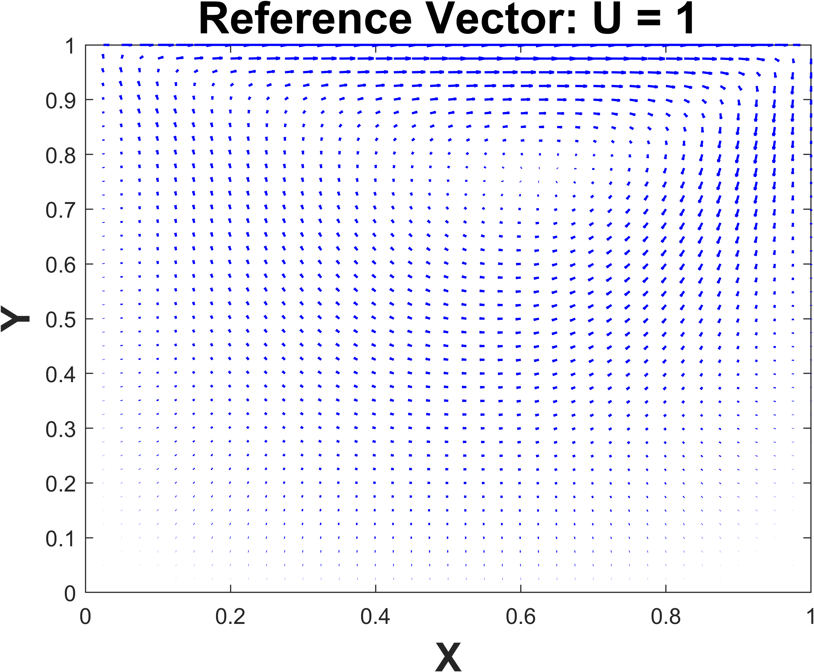
(a)
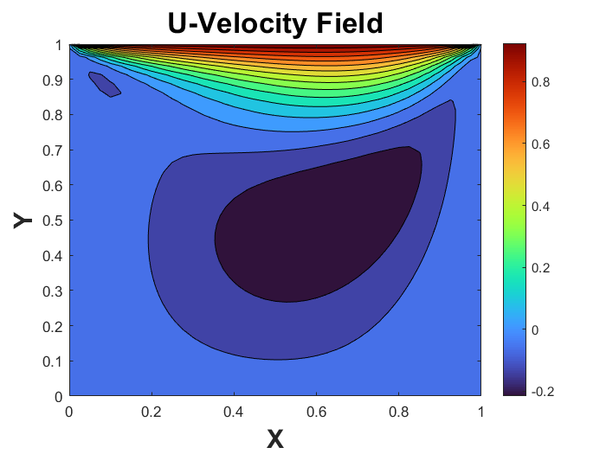
(b)
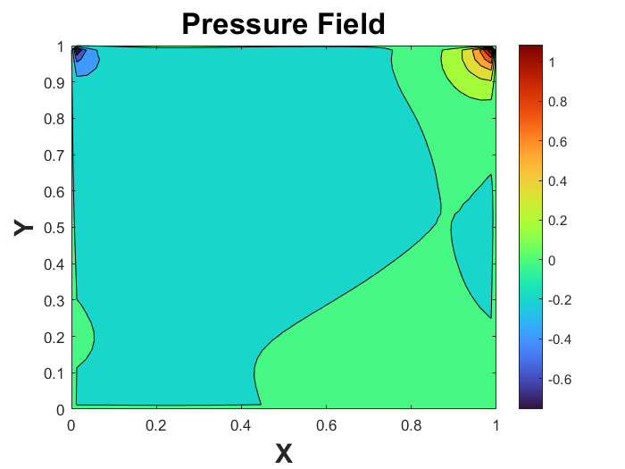
(c)

Fig. 1: Steady state results obtained for a lid-driven cavity, on a grid size of 42×42, at Re=100: (a) Velocity vector, (b) U-velocity contour and (c) pressure-contour.

- Plot and discuss the variation of U-velocity along the vertical and V-velocity along the horizontal centerline of the cavity and its comparison with the benchmark results, on a grid size of 7×7, 12×12, 22×22, and 42×42 at Re=100. Overlap the results obtained by Ghia et al. (1982), with symbols for published and line for present results.

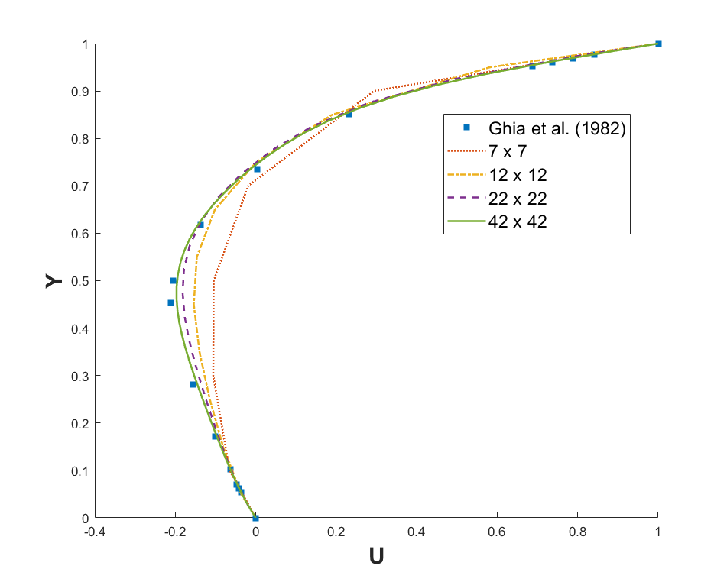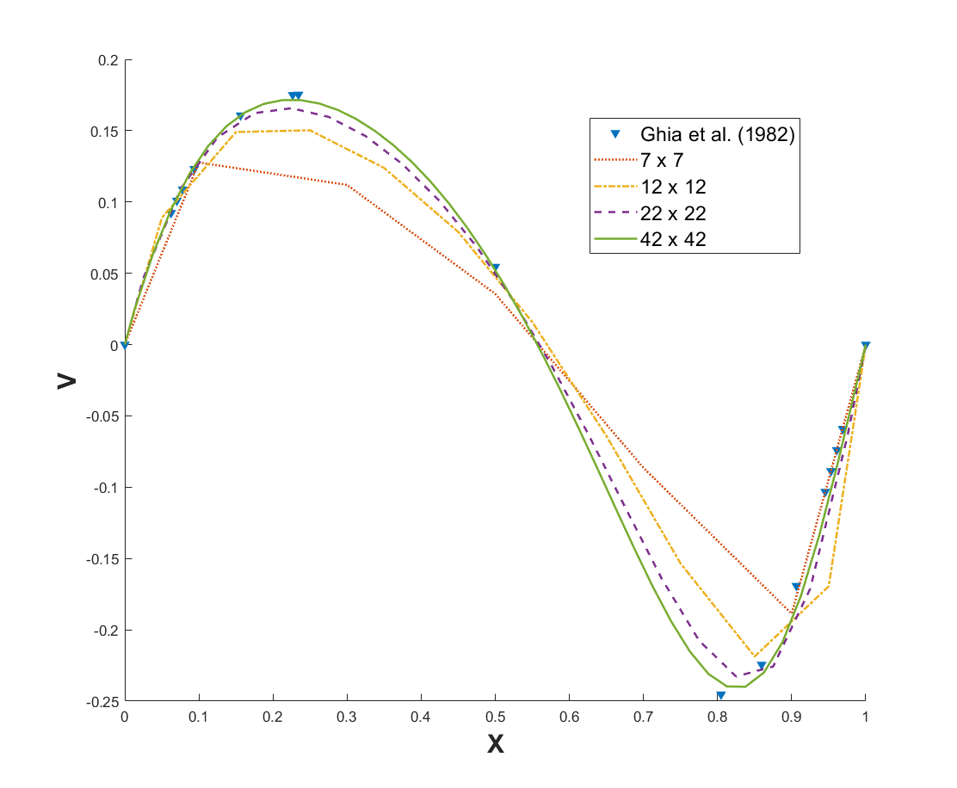

Fig. 2: Steady state results obtained for a lid-driven cavity at Re=100: (a) U-velocity along the vertical centerline, (b) V-velocity along the horizontal centerline; considering the four different uniform grid sizes.. Here, the symbols and lines represent published and present results, respectively.

Discuss Fig. 1 and 2 here, limited inside this text box only

The steady state results obtained from running on the 4 different grids are shown in Fig2. It can be observed that the obtained centerline velocities match the reported value of Ghia et al. very nicely for 42x42 grid size.
The variation of centerline velocity shown in Fig2. is in accordance with the velocity variation as observed from the velocity vector plot shown in Fig1.
Also it can be observed that the variation in velocity is much larger for coarser grids compared to the variation for finer grids. This indicates further improvement in results will be much much less for more fine grid sizes as 42x42 grid size itself is giving a very good agreement and further grid refinement will also give similar results for more computational cost.
In Fig1. From the u-velocity contour (42x42 grid) it can be observed the u-velocity is maximum at the top wall and is less as we go near side and bottom walls. Also from the velocity vector plot we can see a clockwise vortex in the flow domain.
From the pressure plot also it can be seen that on the right side the pressure is little higher and on the left side it is bit lower, which also make complete sense based on the flow pattern.

