PROJECT TITLE

Observability and DevOps Analytics Platform

PROJECT DESCRIPTION
This project aims to implement a complete observability system for monitoring cloud infrastructure and applications using DevOps tools.
The system enables real-time tracking of system performance, collection of metrics, and visualization through dashboards. It also automates infrastructure creation and configuration using modern DevOps practices.
By combining monitoring and automation tools, this project helps in improving system reliability, performance analysis, and faster issue detection.

TOOLS USED
- Amazon Web Services (AWS) – Used to create and manage cloud infrastructure like servers, storage, and networking resources.
- Git – Used to track and manage changes in project code
- GitHub – Used to store and share code repositories online
- Docker - used to run a website inside a container.
- Terraform – Used to create cloud infrastructure automatically
- Jenkins – Used to automate the DevOps workflow
- Ansible – Used to configure servers and install software
- Prometheus – Used to collect system and application metrics
- Grafana – Used to create dashboards for monitoring
- AWS CloudWatch – Used to monitor AWS resources

PROJECT ARCHITECTURE

1. Overview

This project follows a DevOps-based microservices architecture integrating Continuous Integration/Continuous Deployment (CI/CD), containerization, and cloud infrastructure provisioning. The system uses Jenkins for automation, Docker for containerization, Kubernetes (EKS) for orchestration, and Terraform for infrastructure management.

2. Components Description

1. Developer
- Writes application code and pushes it to the Git repository.

2. Git Repository
- Stores source code and configuration files.
- .gitignore ensures unnecessary files are excluded.

3. Jenkins CI/CD Pipeline
- Defined using a Jenkinsfile.
- Automates build, test, and deployment processes.

4. Application Modules
- pro1: Advanced application with Docker, YAML, and Nginx configuration.
- pro2: Simple Docker-based static application.
- pro3: Frontend application with HTML, CSS, and JavaScript.
- pro4: Static web application with multimedia content.

5. Docker
- Each application is containerized using Dockerfiles.
- Creates portable Docker images for deployment.

6. Deployment Configuration
- Deploy docker.yml manages container deployment.
- May use Docker Compose or Ansible.

7. Kubernetes (EKS)
- Manages container orchestration.
- Handles scaling, load balancing, and availability.

8. Terraform (Infrastructure as Code)
- Provisions AWS infrastructure.
- Creates resources such as EC2, EKS clusters, and networking.

3. Workflow Explanation
- Developer pushes code to Git repository.
- Jenkins detects changes and triggers the pipeline.
- Jenkins builds Docker images for all project modules.
- Docker images are deployed using deployment configuration files.
- Kubernetes orchestrates containers in the EKS cluster.
- Terraform provisions and manages the AWS infrastructure.
- Applications are made available to end users via deployed services.

4. Conclusion

This architecture demonstrates a complete DevOps lifecycle integrating CI/CD, containerization, orchestration, and cloud infrastructure. It ensures automation, scalability, and efficient deployment of multiple applications.

1. AWS ACCOUNT CREATION

1.1 What is AWS?
Amazon Web Services (AWS) is a cloud platform that lets you create servers, store data, and run applications over the internet instead of your own computer.
In this project, AWS is used to:
- Create a server (EC2 instance)
- Run monitoring tools like Prometheus and Grafana

1.2 Create AWS Account
🔗 Official Link:
👉 Create AWS Account

1.3 Step-by-Step Procedure

Step 1: Open AWS Website
- Click the link above
- Click on “Create a Free Account”

Step 2: Enter Account Details
- Enter your Email address
- Give a name for your account (e.g., your name)
- Click Verify email
You will receive an OTP → enter it to verify

Step 3: Create Password
- Set a strong password
- Confirm password

Step 4: Add Contact Information
- Choose Personal account
- Fill:
  - Full Name
  - Phone number
  - Address

Step 5: Add Payment Details
- Enter your Debit/Credit card
Important:
AWS may charge ₹2–₹5 temporarily for verification and it will be refunded

Step 6: Phone Verification
- Enter your phone number
- Enter OTP received

Step 7: Choose Plan
- Select Basic Plan (Free)

Step 8: Sign In
- Go to AWS Console
- Login using your email & password

Result
You now have an AWS account and access to the AWS Management Console

2. CREATE EC2 INSTANCE (SERVER SETUP)

2.1 What is EC2?
EC2 (Elastic Compute Cloud) is a virtual server in the cloud.
In simple terms:
- It is like a computer running online
- We will install Prometheus and Grafana inside this server

2.2 Steps to Create EC2 Instance

Step 1: Login to AWS Console
- Go to AWS Console
- Search for EC2 in search bar
- Click on EC2

Step 2: Launch Instance
- Click “Launch Instance”

Step 3: Name Your Instance
Enter name:
DevOps-Monitoring-Server

Step 4: Choose Operating System (AMI)
Select:
Ubuntu Server 22.04 LTS
Why Ubuntu?
- Easy to use
- Best for beginners
- Supports DevOps tools

Step 5: Choose Instance Type
Select:
t3.micro
Why?
- Free tier eligible
- Enough for this project

Step 6: Create Key Pair (IMPORTANT)
Click Create new key pair
Enter:
Name: devops-key
Type: RSA
Format: .pem
Click Create
File will download automatically
This key is used to connect to your server — keep it safe

Step 7: Configure Network Settings
Allow:
- SSH (port 22)
- HTTP (port 80)
- HTTPS (port 443)
We will add more ports later (Prometheus, Grafana)

Step 8: Configure Storage
Keep default:
8 GB

Step 9: Launch Instance
- Click Launch Instance

Result
Your EC2 server is now created
Status will show:
Running
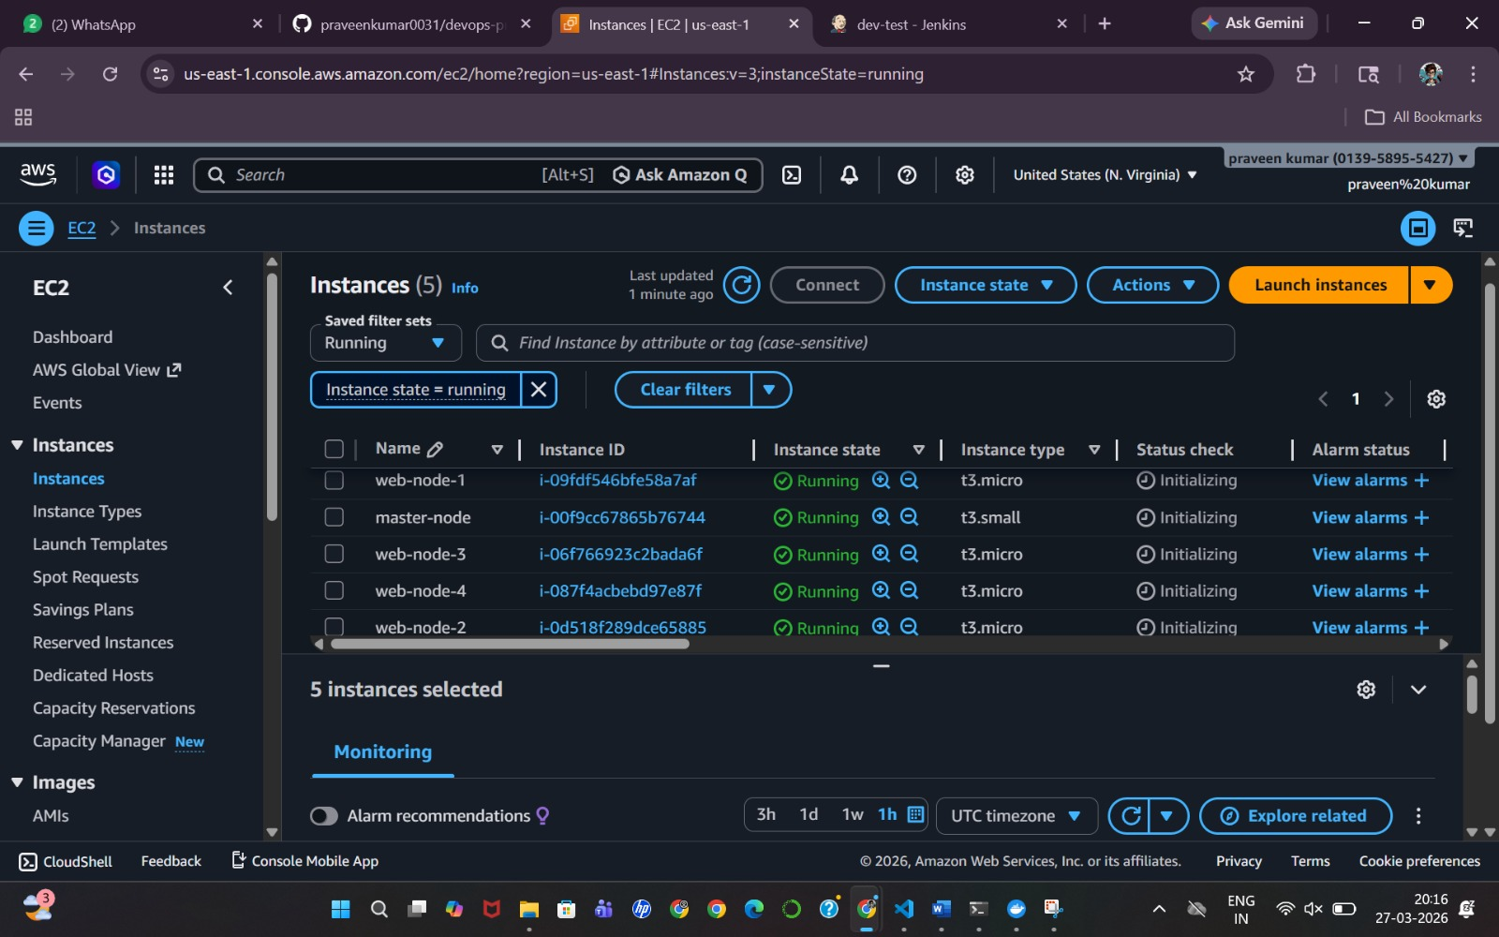

3. CONNECT TO EC2 INSTANCE

3.1 Get Public IP
- Go to EC2 Dashboard
- Click your instance
Copy:
Public IPv4 address

3.2 Connect Using Terminal

Step 1: Open Terminal / Command Prompt

Step 2: Navigate to Key Location
cd Downloads

Step 3: Set Permission (Important for Mac/Linux)
chmod 400 devops-key.pem

Step 4: Connect to Server
ssh -i devops-key.pem ubuntu@<your-public-ip>
Example:
ssh -i devops-key.pem ubuntu@13.232.100.45

Result
You are now inside your cloud server
You will see something like:
ubuntu@ip-xxx-xxx-xxx:~$

FINAL OUTPUT OF THIS STEP
You have successfully:
- Created AWS account
- Created EC2 instance
- Connected to your cloud server

4. DOCKER INSTALLATION AND SETUP

4.1 What is Docker?
Docker is a platform used to package applications and their dependencies into containers so they can run anywhere.

In simple terms:
- It creates a portable environment
- Your application runs the same on any system
In this project:
- Docker is used to run a website inside a container

4.2 INSTALL DOCKER (ON EC2 SERVER)

Steps to Install Docker

Step 1: Update System Packages
sudo apt update

Step 2: Install Docker
sudo apt install docker.io -y

Step 3: Start Docker Service
sudo systemctl start docker

Step 4: Enable Docker (Auto Start)
sudo systemctl enable docker

Step 5: Verify Installation
docker --version

Result
- Docker installed successfully on EC2

4.3 DOCKER CLI SETUP (RUN WITHOUT SUDO)

Steps:

Step 1: Add User to Docker Group
sudo usermod -aG docker ubuntu

Step 2: Restart Session
exit
Reconnect to server again using SSH

Step 3: Test Docker
docker run hello-world

Result
- Docker runs without using sudo

4.4 CREATE A SIMPLE WEBSITE

Step 1: Create Project Folder
mkdir my-website
cd my-website

Step 2: Create HTML File
nano index.html

Step 3: Add Website Code
Paste:
<!DOCTYPE html>
<html>
<head>
<title>DevOps Project</title>
</head>
<body>
<h1>Hello from Docker</h1>
<p>This is my DevOps monitoring project</p>
</body>
</html>
Save and exit:
- Press CTRL + X
- Press Y
- Press Enter

Result
- A simple website is created

4.5 CREATE DOCKERFILE

What is Dockerfile?
A Dockerfile is a set of instructions to build a Docker image.

Step 1: Create Dockerfile
nano Dockerfile

Step 2: Add Code
FROM nginx:latest
COPY index.html /usr/share/nginx/html/index.html

Explanation
- FROM nginx → Uses Nginx server
- COPY → Copies website file into container

Result
- Dockerfile created successfully
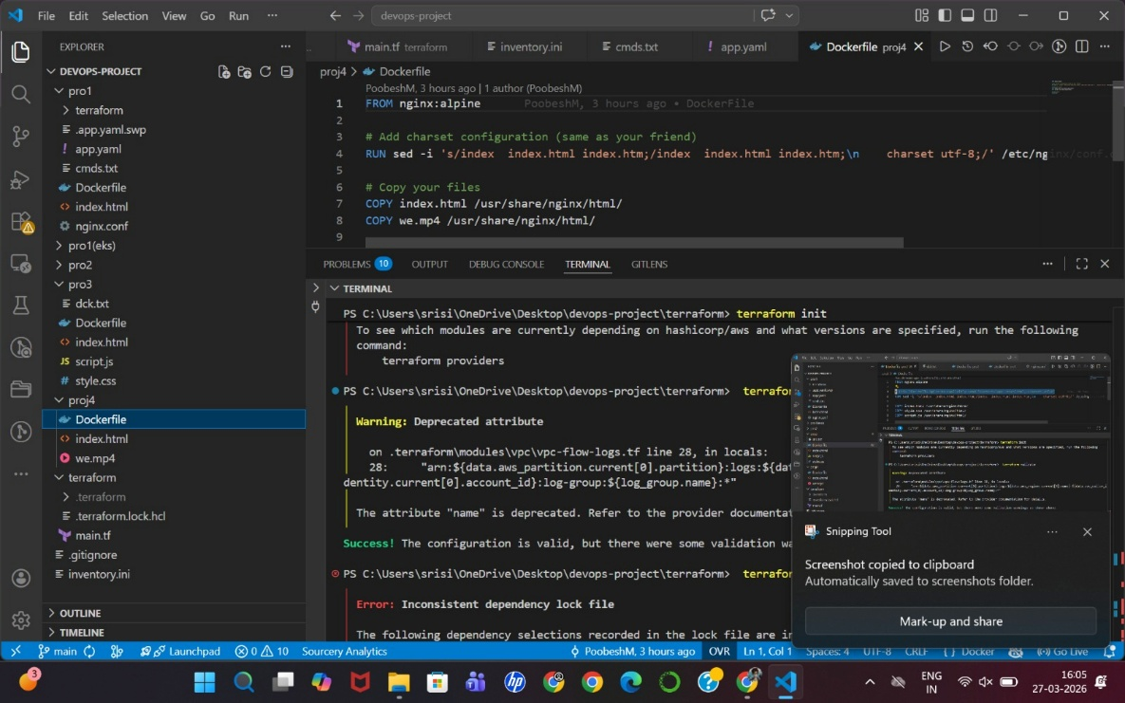

4.6 BUILD DOCKER IMAGE

What is Docker Image?
A Docker image is a packaged version of your application.

Step
docker build -t my-website .

Explanation
- -t my-website → Name of the image
- . → Current folder

Result
- Docker image created

4.7 RUN DOCKER CONTAINER

What is Container?
A container is a running instance of a Docker image.

Step
docker run -d -p 80:80 my-website

Explanation
- -d → Run in background
- -p 80:80 → Map server port
- my-website → Image name

Result
- Website is now running inside Docker container

4.8 ACCESS WEBSITE

Steps
- Open browser
- Enter:
http://<your-ec2-public-ip>

Result
- Your website will be visible

4.9 FINAL OUTPUT OF THIS STEP
You have successfully:
- Installed Docker
- Configured Docker CLI
- Created a website
- Created Dockerfile
- Built Docker image
- Ran Docker container
- Deployed website on EC2

5. GIT AND GITHUB SETUP

5.1 What is Git?
Git is a tool used to track changes in your code and manage different versions of a project.
In simple terms:
- It saves your project history
- Allows you to go back to previous versions
- Helps manage code efficiently

5.2 What is GitHub?
GitHub is an online platform where you can store your Git repositories.
In simple terms:
- It is like cloud storage for your code
- Used for sharing and collaborating

5.3 INSTALL GIT

Steps

Step 1: Update System
sudo apt update

Step 2: Install Git
sudo apt install git -y

Step 3: Verify Installation
git --version

Result
- Git installed successfully

5.4 CONFIGURE GIT

Steps

Step 1: Set Username
git config --global user.name "Your Name"

Step 2: Set Email
git config --global user.email "your@email.com"

Step 3: Verify Configuration
git config --list

Result
- Git is configured with your identity

5.5 CREATE GITHUB ACCOUNT

Steps

🔗 Official Link: Create GitHub Account

Step 1: Open Website
- Click the link
- Click Sign Up

Step 2: Enter Details
- Email
- Password
- Username

Step 3: Verify Account
- Complete verification (OTP / captcha)

Step 4: Complete Setup
- Choose free plan
- Finish setup

Result
- GitHub account created

5.6 CREATE A REPOSITORY

What is Repository?
A repository (repo) is a folder where your project code is stored.

Steps

Step 1: Go to GitHub Dashboard

Step 2: Click “New Repository”

Step 3: Enter Details
- Repository Name:
devops-monitoring-project
- Select:
  - Public / Private

Step 4: Click “Create Repository”

Result
- Repository created successfully

5.7 CONNECT LOCAL PROJECT TO GITHUB

Steps

Step 1: Initialize Git
git init

Step 2: Add Files
git add .

Step 3: Commit Changes
git commit -m "Initial commit"

Step 4: Add Remote Repository
git remote add origin <repository-url>
Example:
git remote add origin https://github.com/username/devops-monitoring-project.git

Step 5: Push Code to GitHub
git push -u origin main

Result
- Your project is now uploaded to GitHub

5.8 CLONE REPOSITORY (OPTIONAL)

Steps
git clone <repository-url>

Result
- Repository downloaded to your system

5.9 FINAL OUTPUT OF THIS STEP
You have successfully:
- Installed Git
- Configured Git
- Created GitHub account
- Created repository
- Uploaded project to GitHub

6. TERRAFORM SETUP (INFRASTRUCTURE AS CODE)

6.1 What is Terraform?
Terraform is used to create and manage cloud resources using code instead of manual steps.
In simple terms:
- Instead of clicking in AWS
- You write code → Terraform creates everything automatically
In this project:
- Terraform will create an EC2 instance

6.2 PREREQUISITES
Before starting, ensure:
- AWS account is created
- AWS CLI is configured (aws configure)
- Terraform is installed

6.3 CREATE TERRAFORM PROJECT

Step 1: Create Project Folder
mkdir terraform-project
cd terraform-project

Step 2: Create Main File
nano main.tf

6.4 TERRAFORM CONFIGURATION FILE

Add the Following Code
provider "aws" {
region = "ap-south-1"
}
resource "aws_instance" "devops_server" {
ami = "ami-0f5ee92e2d63afc18"
instance_type = "t2.micro"
key_name = "devops-key"
tags = {
Name = "Terraform-Server"
}
}

Explanation
- provider "aws" → Connects Terraform to AWS
- region → Mumbai region
- resource "aws_instance" → Creates EC2
- ami → Ubuntu image
- instance_type → Free tier
- key_name → Your existing key pair
- tags → Name of instance

Result
- Terraform configuration file created

6.5 INITIALIZE TERRAFORM

Step
terraform init

Explanation
- Downloads required plugins
- Prepares Terraform environment

Result
- Initialization successful

6.6 VALIDATE CONFIGURATION

Step
terraform validate

Result
- Confirms syntax is correct
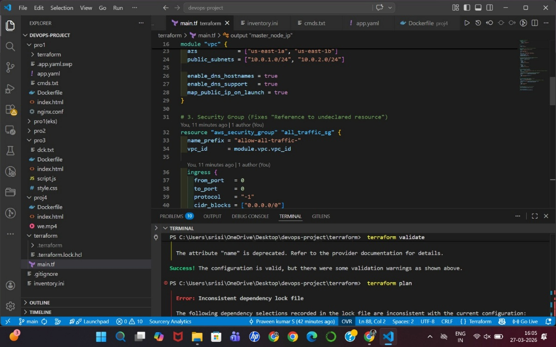

6.7 PLAN EXECUTION

Step
terraform plan

Explanation
- Shows what Terraform will create
- No changes are made yet

Result
- Preview of EC2 creation
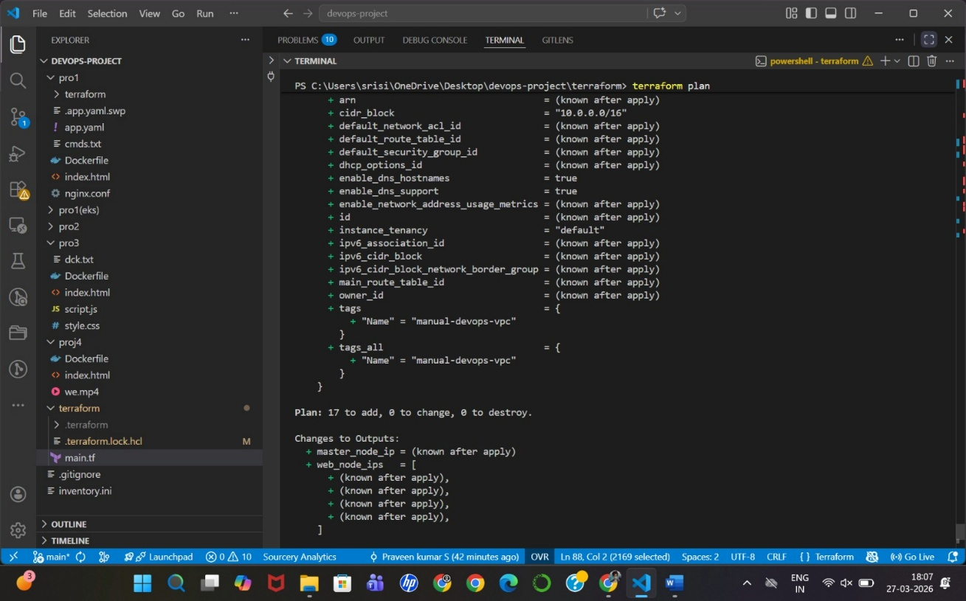

6.8 APPLY CONFIGURATION (CREATE EC2)

Step
terraform apply
- Type: yes

Explanation
- Terraform creates EC2 automatically

Result
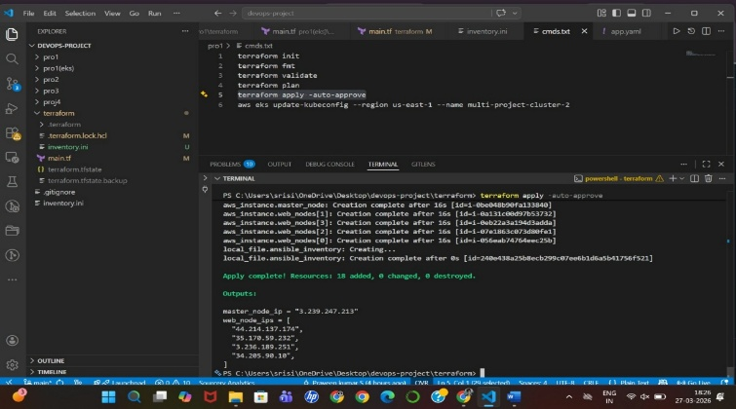

6.9 VERIFY IN AWS

Steps
- Go to AWS Console
- Open EC2 Dashboard
- Check instance:
Terraform-Server

Result
- EC2 instance visible and running

6.10 DESTROY INFRASTRUCTURE (OPTIONAL)

Step
terraform destroy

Explanation
- Deletes all created resources

Result
- Clean removal of infrastructure

6.11 FINAL OUTPUT OF THIS STEP
You have successfully:
- Created Terraform configuration
- Initialized Terraform
- Planned infrastructure
- Created EC2 instance automatically

7. JENKINS SETUP (AUTOMATION SERVER)

7.1 What is Jenkins?
Jenkins is a tool used to automate tasks like building, testing, and deploying applications.
In simple terms:
- It runs your tasks automatically
- No need to manually execute commands
In this project:
- Jenkins will automate:
  - Terraform execution
  - Ansible configuration
  - Deployment process

7.2 INSTALL JENKINS (ON EC2 SERVER)

Steps to Install Jenkins

Step 1: Update System
sudo apt update

Step 2: Install Java (Required for Jenkins)
sudo apt install openjdk-11-jdk -y

Step 3: Add Jenkins Repository
curl -fsSL https://pkg.jenkins.io/debian/jenkins.io.key | sudo tee \
/usr/share/keyrings/jenkins-keyring.asc > /dev/null
echo deb [signed-by=/usr/share/keyrings/jenkins-keyring.asc] \
https://pkg.jenkins.io/debian binary/ | sudo tee \
/etc/apt/sources.list.d/jenkins.list > /dev/null

Step 4: Install Jenkins
sudo apt update
sudo apt install jenkins -y

Step 5: Start Jenkins
sudo systemctl start jenkins

Step 6: Enable Jenkin
sudo systemctl enable jenkins

Step 7: Check Status
sudo systemctl status jenkins

Result
- Jenkins is installed and running
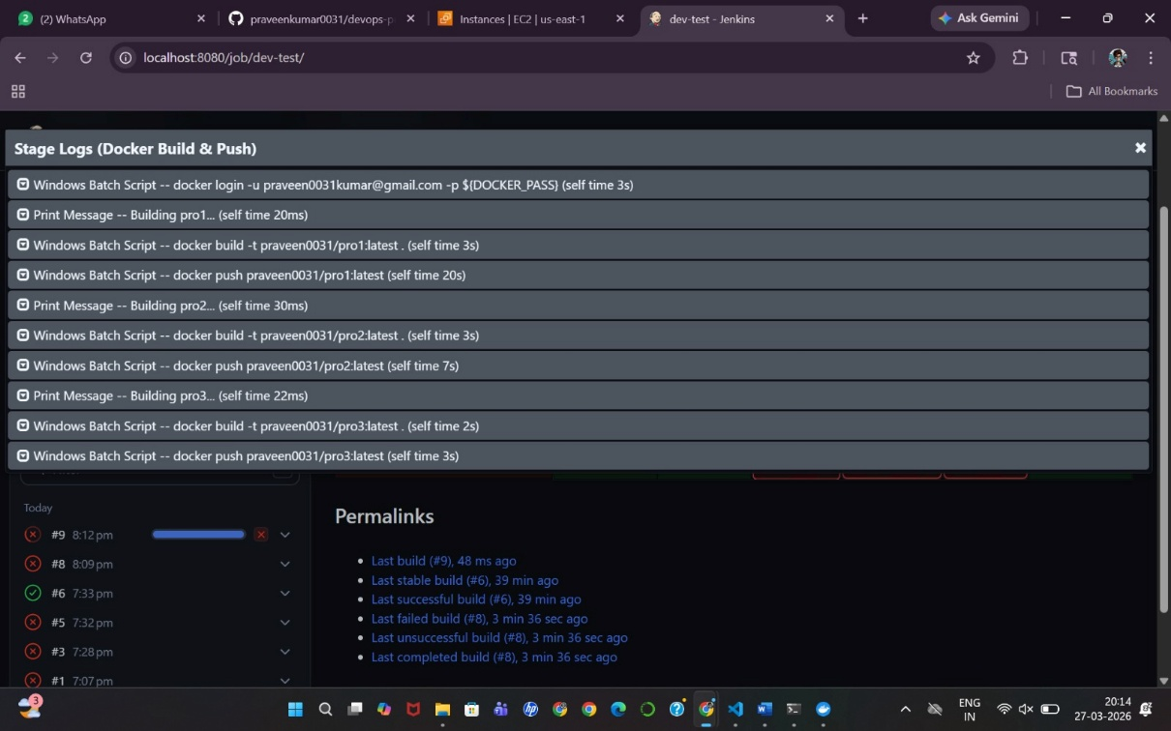

7.3 CONFIGURE SECURITY GROUP (IMPORTANT)

Steps
- Go to AWS EC2
- Select your instance
- Click Security → Security Groups
- Add inbound rule:
Port: 8080
Type: Custom TCP

Result
- Jenkins accessible from browser

7.4 ACCESS JENKINS

Step
Open browser and enter:
http://<your-ec2-public-ip>:8080

Result
- Jenkins setup page opens

7.5 UNLOCK JENKINS

Step
Run:
sudo cat /var/lib/jenkins/secrets/initialAdminPassword
- Copy the password
- Paste in browser

Result
- Jenkins unlocked

7.6 INSTALL PLUGINS

Step
- Select:
Install Suggested Plugins

Result
- Required plugins installed

7.7 CREATE ADMIN USER

Steps
- Enter:
  - Username
  - Password
  - Email
- Click Save and Continue

Result
- Jenkins admin account created

7.8 CREATE FIRST JOB

Steps

Step 1: Click “New Item”

Step 2: Enter Name
DevOps-Pipeline

Step 3: Select
Freestyle Project

Step 4: Configure Build Step
- Scroll to Build Section
- Click Execute Shell

Step 5: Add Command
echo "Hello from Jenkins"

Step 6: Save

Step 7: Build Job
- Click Build Now

Result
- Jenkins job executed successfully

7.9 INTEGRATE WITH GITHUB

Steps

Step 1: Go to Job Configuration

Step 2: Source Code Management
- Select Git
- Enter repository URL

Step 3: Add Credentials (if private repo)

Step 4: Build Trigger
- Enable:
GitHub hook trigger for GITScm polling

Result
- Jenkins connected with GitHub

7.10 FINAL OUTPUT OF THIS STEP
You have successfully:
- Installed Jenkins
- Configured Jenkins
- Opened Jenkins dashboard
- Created a job
- Executed automation

8. ANSIBLE SETUP (CONFIGURATION MANAGEMENT)

8.1 What is Ansible?
Ansible is used to automate server setup and software installation.
In simple terms:
- Instead of manually installing tools
- You write instructions once
- Ansible executes everything automatically
In this project:
- Ansible will install:
  - Prometheus
  - Grafana
  - Node Exporter

8.2 PREREQUISITES
Ensure:
- EC2 instance is running
- You can connect via SSH
- Ansible is installed (WSL/Linux)

8.3 CREATE ANSIBLE PROJECT

Step 1: Create Folder
mkdir ansible-project
cd ansible-project

Step 2: Create Inventory File
nano inventory

Step 3: Add EC2 Details
[servers]
<your-ec2-public-ip> ansible_user=ubuntu ansible_ssh_private_key_file=~/Downloads/devops-key.pem

Explanation
- [servers] → Group name
- IP → Your EC2 public IP
- ansible_user → Default Ubuntu user
- Key file → Your PEM file

Result
- Inventory file created

8.4 TEST CONNECTION

Step
ansible -i inventory servers -m ping

Result
- You should see:
SUCCESS => pong

8.5 CREATE ANSIBLE PLAYBOOK

Step 1: Create Playbook File
nano setup.yml

Step 2: Add Playbook Code
---
- name: Install Monitoring Tools
hosts: servers
become: yes
tasks:
- name: Update packages
apt:
update_cache: yes
- name: Install Docker
apt:
name: docker.io
state: present
- name: Start Docker
service:
name: docker
state: started
enabled: yes
- name: Run Node Exporter container
docker_container:
name: node_exporter
image: prom/node-exporter
state: started
ports:
- "9100:9100"

Explanation
- Updates system
- Installs Docker
- Starts Docker
- Runs Node Exporter container

Result
- Playbook created

8.6 RUN ANSIBLE PLAYBOOK

Step
ansible-playbook -i inventory setup.yml

Result
- All tasks executed automatically

8.7 VERIFY NODE EXPORTER

Step
Open browser:
http://<your-ec2-ip>:9100

Result
- Node Exporter metrics page visible

8.8 FINAL OUTPUT OF THIS STEP
You have successfully:
- Created Ansible inventory
- Tested server connection
- Created playbook
- Installed Docker automatically
- Deployed Node Exporter

9. PROMETHEUS SETUP (METRICS COLLECTION)

9.1 What is Prometheus?
Prometheus is an open-source tool used to collect and store system metrics.
In simple terms:
- It collects data like CPU, memory, and system performance
- Stores metrics over time
- Helps in monitoring system health
In this project:
- Prometheus will collect metrics from:
  - Node Exporter (EC2 server)

9.2 PREREQUISITES
Ensure:
- EC2 instance is running
- Node Exporter is running (Port 9100)
- You are connected to EC2

9.3 INSTALL PROMETHEUS

Step 1: Download Prometheus
wget https://github.com/prometheus/prometheus/releases/latest/download/prometheus-2.47.0.linux-amd64.tar.gz

Step 2: Extract Files
tar -xvf prometheus-2.47.0.linux-amd64.tar.gz

Step 3: Navigate to Folder
cd prometheus-2.47.0.linux-amd64

Step 4: Check Files
ls
You will see:
- prometheus
- prometheus.yml
- promtool

Result
- Prometheus files downloaded and ready

9.4 CONFIGURE PROMETHEUS

Step 1: Open Configuration File
nano prometheus.yml

Step 2: Modify Configuration
Replace or edit:
scrape_configs:
- job_name: "node_exporter"
static_configs:
- targets: ["localhost:9100"]

Explanation
- job_name → Name of monitoring job
- targets → Where Prometheus collects data from
- localhost:9100 → Node Exporter

Result
- Prometheus configured to collect system metrics

9.5 RUN PROMETHEUS

Step
./prometheus --config.file=prometheus.yml

Result
- Prometheus server starts

9.6 CONFIGURE SECURITY GROUP

Steps
- Go to AWS EC2
- Open Security Group
- Add rule:
Port: 9090
Type: Custom TCP

Result
- Prometheus accessible from browser

9.7 ACCESS PROMETHEUS

Step
Open browser:
http://<your-ec2-ip>:9090

Result
- Prometheus dashboard opens

9.8 VERIFY TARGETS

Steps
- In Prometheus UI
- Go to:
Status → Targets

Result
- You should see:
node_exporter → UP

9.9 TEST METRICS

Step
In Prometheus search bar, type:
node_cpu_seconds_total
Click Execute

Result
- CPU metrics displayed

9.10 FINAL OUTPUT OF THIS STEP
You have successfully:
- Installed Prometheus
- Configured metrics collection
- Connected Node Exporter
- Verified system metrics

10. GRAFANA SETUP (DATA VISUALIZATION)

10.1 What is Grafana?
Grafana is an open-source tool used to create dashboards and visualize data.
In simple terms:
- Prometheus collects data
- Grafana shows it in graphs and charts
In this project:
- Grafana will display:
  - CPU usage
  - Memory usage
  - System performance

10.2 PREREQUISITES
Ensure:
- Prometheus is running (Port 9090)
- Node Exporter is running (Port 9100)
- EC2 instance is running

10.3 INSTALL GRAFANA

Step 1: Add Grafana Repository
sudo apt install -y software-properties-common
sudo add-apt-repository "deb https://packages.grafana.com/oss/deb stable main"

Step 2: Add GPG Key
wget -q -O - https://packages.grafana.com/gpg.key | sudo apt-key add -

Step 3: Update Packages
sudo apt update

Step 4: Install Grafana
sudo apt install grafana -y

Step 5: Start Grafana
sudo systemctl start grafana-server

Step 6: Enable Grafana
sudo systemctl enable grafana-server

Step 7: Check Status
sudo systemctl status grafana-server

Result
- Grafana installed and running

10.4 CONFIGURE SECURITY GROUP

Steps
- Go to AWS EC2
- Open Security Group
- Add inbound rule:
Port: 3000
Type: Custom TCP

Result
- Grafana accessible from browser

10.5 ACCESS GRAFANA

Step
Open browser:
http://<your-ec2-ip>:3000

Default Login
Username: admin
Password: admin
You will be asked to change password

Result
- Grafana dashboard opens

10.6 ADD PROMETHEUS DATA SOURCE

Steps

Step 1: Go to Settings

Step 2: Click “Data Sources”

Step 3: Add Data Source
- Select: Prometheus

Step 4: Enter URL
http://localhost:9090

Step 5: Save & Test

Result
- Prometheus connected successfully

10.7 IMPORT DASHBOARD

Steps

Step 1: Click “+” → Import

Step 2: Enter Dashboard ID
1860
(Node Exporter Full Dashboard)

Step 3: Select Data Source
- Choose Prometheus

Step 4: Click Import

Result
- Dashboard created with system metrics

10.8 VIEW METRICS
You can now see:
- CPU usage
- Memory usage
- Disk usage
- Network activity

10.9 FINAL OUTPUT OF THIS STEP
You have successfully:
- Installed Grafana
- Connected Prometheus
- Created dashboards
- Visualized system metrics

11. AWS CLOUDWATCH SETUP (CLOUD MONITORING)

11.1 What is CloudWatch?
AWS CloudWatch is a monitoring service provided by AWS to track resources and applications.
In simple terms:
- It monitors AWS services like EC2
- Collects metrics automatically
- Shows graphs and alerts
In this project:
- CloudWatch will monitor:
  - EC2 CPU usage
  - Network traffic
  - Disk activity

11.2 PREREQUISITES
Ensure:
- EC2 instance is running
- AWS account is active

11.3 ACCESS CLOUDWATCH

Steps
- Go to AWS Console
- Search for: CloudWatch
- Click on CloudWatch

Result
- CloudWatch dashboard opens

11.4 VIEW EC2 METRICS

Steps

Step 1: Go to Metrics
- Click: Metrics

Step 2: Select EC2
- Click:
EC2 → Per-Instance Metrics

Step 3: Select Your Instance
- Choose your EC2 instance

Result
You will see:
- CPU Utilization
- Network In/Out
- Disk Read/Write

11.5 CREATE CLOUDWATCH DASHBOARD

Steps

Step 1: Go to Dashboards
- Click: Dashboards

Step 2: Create Dashboard
- Click: Create Dashboard

Step 3: Enter Name
DevOps-Monitoring-Dashboard

Step 4: Add Widget
- Select: Line Graph

Step 5: Select Metrics
- Choose:
  - EC2
  - CPU Utilization

Step 6: Add to Dashboard

Result
- Dashboard created successfully

11.7 FINAL OUTPUT OF THIS STEP
You have successfully:
- Accessed CloudWatch
- Monitored EC2 metrics
- Created dashboard
- Created alert system

FINAL PROJECT OUTPUT
You have built a complete:

Observability and DevOps Analytics Platform

Achievements:
- Created cloud infrastructure (AWS EC2)
- Automated setup (Terraform, Ansible, Jenkins)
- Containerized application (Docker)
- Collected metrics (Prometheus)
- Visualized data (Grafana)
- Monitored cloud resources (CloudWatch)

