PROJECT TITLE

Observability and DevOps Analytics Platform

PROJECT ARCHITECTURE

1. Overview
This project follows a DevOps-based microservices architecture integrating Continuous Integration/Continuous Deployment (CI/CD), containerization, and cloud infrastructure provisioning. The system uses Jenkins for automation, Docker for containerization and Terraform for infrastructure management.
________________________________________

2. Architecture Diagram
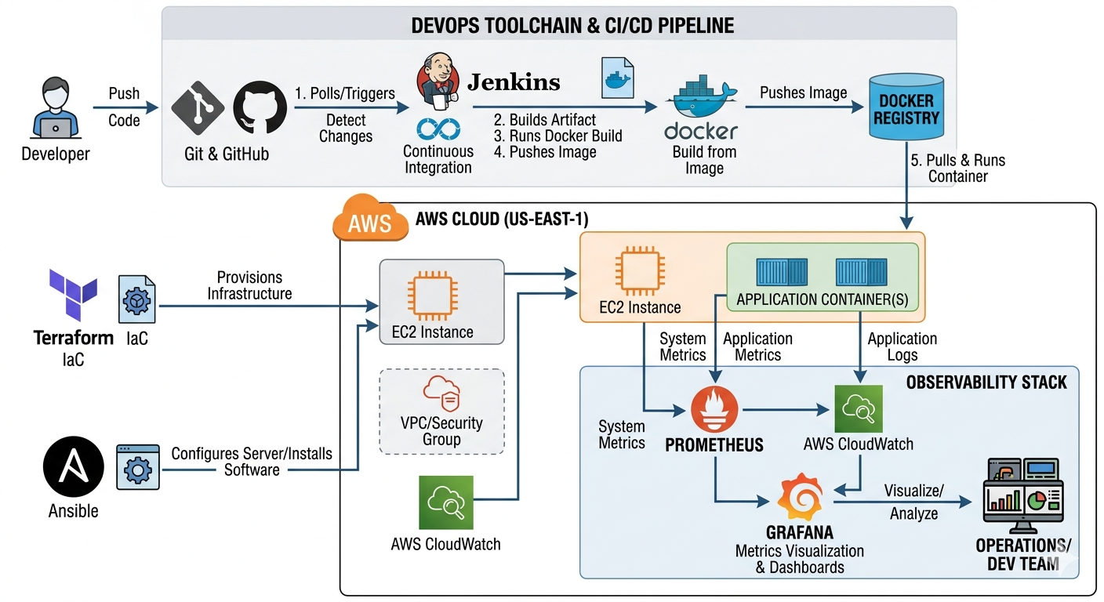
________________________________________

3. Components Description

1. Developer (Source Code Management)
- Code Submission: Writes application code and configuration files (Dockerfiles, Playbooks, Terraform scripts).
- Version Control: Pushes code to GitHub, which serves as the "Single Source of Truth."
- Trigger: Commits automatically trigger the Jenkins pipeline via Webhooks.
2. Docker Build and Push (Containerization)
- Image Creation: Jenkins executes docker build to package application modules (pro1-pro4) into lightweight, portable images.
- Registry Management: Jenkins runs docker push to upload these images to a Docker Registry (Docker Hub or AWS ECR).
- Consistency: Ensures the application environment remains identical from build to production.
3. Terraform (Infrastructure as Code)
- Cloud Provisioning: Jenkins triggers Terraform to automate the creation of AWS resources.
- Resource Lifecycle: Provisions the VPC, Security Groups, and EC2 instances required to host the applications.
- State Management: Maintains a consistent cloud state, eliminating manual configuration errors.
4. Ansible (Configuration & Deployment)
- Agentless Setup: Jenkins executes Ansible Playbooks to configure the newly created AWS EC2 instances.
- Software Installation: Automatically installs the Docker engine, Nginx, and required dependencies on the target servers.
- Container Deployment: Runs docker.yml to pull the latest images and launch the application containers.
5. Prometheus (Metrics Collection)
- Real-time Scraping: Monitors the health of the EC2 instances and the running Docker containers.
- Time-Series Data: Captures performance metrics (CPU, Memory, Request Latency) at regular intervals.
- Querying: Uses PromQL to filter and analyze system behavior and identify bottlenecks.
6. Grafana (Visualization & Analytics)
- Unified Dashboard: Connects to Prometheus to create dynamic, interactive visual representations of the system.
- Observability: Provides a "single pane of glass" to view infrastructure health and application performance side-by-side.
- Proactive Alerting: Configures thresholds to notify the team (via Slack or Email) before system issues impact users.

7. Jenkins (The Automation Engine)
- Pipeline-as-Code: Uses a Jenkinsfile to define the entire lifecycle of the project, ensuring the workflow is version-controlled and repeatable.
- Central Orchestrator: Acts as the "glue" between all tools, triggering Terraform for infrastructure, Docker for builds, and Ansible for deployment in a single sequence.
- Continuous Integration: Automatically pulls code from GitHub upon every developer commit, ensuring that bugs are caught early through automated build stages.
- Continuous Deployment: Handles the secure transfer of Docker images and executes remote commands on AWS EC2 to ensure the live application is always up to date.
- Credential Management: Securely manages AWS keys, Docker Registry logins, and SSH keys required to interact with the various platforms in the pipeline.

________________________________________

4. The Full Execution Flow (Jenkins Orchestration)
To put it all together for your documentation or presentation, here is the final consolidated flow:
- Developer: Pushes code to GitHub.
- Jenkins: Detects the push and starts the pipeline.
- Docker Build & Push: Jenkins builds the image and pushes it to the registry.
- Terraform: Jenkins runs Terraform to ensure the AWS environment is ready.
- Ansible: Jenkins triggers Ansible to configure the server and deploy the Docker container.
- Prometheus & Grafana: Jenkins ensures the monitoring agents are active to begin data collection.
________________________________________

5. Conclusion

This architecture demonstrates a complete DevOps lifecycle integrating CI/CD, containerization, orchestration, and cloud infrastructure. It ensures automation, scalability, and efficient deployment of multiple applications.

