**FINANCIAL LITERACY MANAGEMENT AND**

**MASTERING**

**(FILIM.in)**

**PROJECT REPORT**

***Submitted by***

**NAVEEN KUMAR C (714023205083)**

**PRAVEEN KUMAR S (714023205099)**

**RITHIN AR (714023205111)**

***In partial fulfilment for the award of the degree of***

**BACHELOR OF TECHNOLOGY**

**in**

INFORMATION TECHNOLOGY

**SRI SHAKTHI**

**INSTITUTE OF ENGINEERING AND TECHNOLOGY**

**An Autonomous Institution, Accredited by NAAC with “A” Grade**

**ANNA UNIVERSITY: CHENNAI 600025**

JUNE 2024

**BONAFIDE CERTIFICATE**

Certified that this project report “**FINANCIAL LITERACY MANAGEMENT AND MASTERING FILIM.in**” is the bonafide work of “**NAVEEN KUMAR C (714023205083), PRAVEEN KUMAR S (714023205099), RITHIN A R (714023205111)**” who carried out the project work under the supervision.

**Project Guide Project Co-Ordinator**

Mrs.M. Kirubadevi, Dr. M. Deepa,

Assistant Professor, Associate Professor,

Dept. of Information TechnologyDept. of Information Technology

**Head of the Department**

Dr. S. Prakash,

Professor,

Dept. of Information Technology

**Submitted for the project work Viva Voce Examination held on………………….…..**

**Internal Examiner External Examiner**

**ACKNOWLEDGEMENT**

We extend our heartfelt gratitude to our honourable Chairman, **Dr. S. Thangavelu** for providing a wonderful platform to educate our minds, inculcate ideas and implement the technological changes in the real-world environment.

Deepest thanks to our dynamic Joint Secretary, **Mr. T. Sheelan** for monitoring the infrastructure and for providing the work atmosphere to implement the project and providing an excellent and maintaining the decorum and discipline of the students.

We are tremendously thankful to our beloved Principal, **Dr.D. Elangovan,M.E.,Ph.D.** for his incredible support to make us follow ethics and morality in our life and also for allocating sufficient time and resources.

A big salute to our vibrant Head of the Department, **Dr. S. Prakash** for imbibing scope of the project and systematic procedure in execution. We express our genuine thanks for encouraging us throughout the project period to complete it successfully.

Our great thanks to the Project mentor, **Mrs.M. Kirubadevi** for her ever lasting contribution in making the project a smooth journey and also for her valuable guidance and for making us realize our potential and be successful.

Our great thanks to the Project Co-Ordinator, **Dr. M. Deepa** for her ever lasting contribution in making the final year project phase a smooth journey and also for her valuable guidance and for making us realize our potential and be successful. We also thanks for her kind help and Cooperation throughout the research period to make us a grant successful completion of project.

**NAVEEN KUMAR C**

**PRAVEEN KUMAR S**

**RITHIN AR**

**ABSTRACT**

This Financial Literacy Quiz is to make users to bring up the idea about money, economy, and Financial Literacy. Financial Literacy is a vital knowledge to run our day-to-day life economically. This Quiz enlightens the users with Money and Its Important aspects. The Website consists of pages including Learning, Evaluating and also Exploring. Benefits of financial literacy include better financial decisions, effective debt management, greater financial goals achievement, reduced expenses, less financial stress, increased ethical decision-making, and the creation of a structured budget. Developing financial literacy is essential for ensuring financial stability and reducing anxiety.

**TABLE OF CONTENTS**

|  |  |  |
| --- | --- | --- |
| CHAPTER NO | TITLE | PAGE NO |
|  | ABSTRACT |  |
|  | LIST OF FIGURES |  |
|  | LIST OF ABBREVIATIONS |  |
| 1 | INTRODUCTION | 8 |
|  | * 1. Introduction To Firebase and JS   2. Introduction to HTML and CSS |  |
| 2 | LITERATURE REVIEW | 9 |
| 3 | EXISTING METHOD | 11 |
|  | 3.1 Disadvantages of Existing System  3.2 Differences | 11  12 |
| 4 | PROPOSED METHOD | 13 |
|  | 4.1 Additions in the Existing System  4.2 Why FILIM.in?  4.3 Learning and Leaping Forward  4.4 Flowchart | 13  14 |
| 5 | SOFTWARE DESCRIPTION | 15 |
|  | 5.1 HTML  5.2 CSS  5.3 JAVASCRIPT  5.4 FIREBASE | 16 |
| 6 | SOURCE CODE | 17 |
|  | 6.1 HTML CODE  6.2 JAVASCRIPT CODE  6.3 CSS CODE  6.4 FIREBASE LINK | 18  19  22  26 |
| 7 | RESULT AND ANALYSIS | 27 |
|  | 7.1 HOME PAGE  7.2 LOGIN PAGE  7.3 LEARN PAGE  7.4 EVALUATE QUIZ PAGE | 27  27  28  28 |
| 8 | CONCLUSION AND FUTURE SCOPE | 29 |
|  | 8.1 CONCLUSION  8.2 FUTURE SCOPE  8.3 MOBILE APP DEVELOPMENT | 29 |
| 9 | REFERENCES | 30 |
|  | 9.1 INTERNET REFERENCES  9.2 BOOKS REFERRED |  |

**LIST OF FIGURES**

|  |  |  |
| --- | --- | --- |
| FIGURE.NO | TITLE | PAGE NO |
| 1.1 | Existing Method(FINRA) | 13 |
| 1.2 | Existing Method(NISM) | 13 |
| 1.3 | Flowchart (FILIM.in) | 15 |
| 1.4 | Homepage | 28 |
| 1.5 | Login Page | 28 |
| 1.6 | Register Page | 28 |
| 1.7 | Learn Page | 29 |
| 1.8 | Quiz Page | 29 |
| 1.9 | Contact Page | 29 |

**LIST OF ABBREVIATIONS**

**HTML** – Hyper Text Mark-up Language

**CSS** – Cascading Style Sheet

**JS**  – Java Script

**SQL**  - Structured Query Language

**NISM** - National Institute of Security Management

**INTRODUCTION**

Filim.in is a website which helps you to learn and evaluate your financial knowledge . Here, your ultimate destination for mastering financial literacy through engaging quizzes and interactive learnings. In today world, understanding money management, investments, budgeting, and financial planning is crucial for personal and professional success. This project is designed to make financial education both fun and accessible, offering a wide range of quizzes that help to educate all levels of financial knowledge.

Whether you're a beginner looking to grasp the basics or an experienced individual aiming to refine your expertise, this project provides the tools and resources you need to boost your financial confidence. This website leads you to the journey towards financial empowerment.

This project dedicated to enhancing your financial literacy in an engaging and interactive manner. It is a great platform which offers a diverse set of quizzes that cover essential topics such as budgeting, investing, saving, credit management, and financial planning.

Each quiz is designed to evaluate in various levels, ensuring that whether you are a beginner or a financial expert, you will find some challenges and educates. This project’s mission is to empower individuals with the knowledge and skills necessary to make informed financial decisions, promoting financial independence and securities.

**LITERATURE REVIEW**

1. **Faulkner, Ash. (2022). Financial literacy resources in US public libraries: website analysis. Reference Services Review. 50. 10.1108/RSR-02-2022-0008.**

The author completed a website analysis of the largest 48 US public libraries, as defined by the four sets of criteria in the American Library Association (ALA) publication. Website analysis was completed via a standardized checklist assessment covering full-site searching, catalogue content, the availability of relevant guides and/or workshops, and any other relevant online resources.

**Findings:**

Public libraries provide many resources relevant to patrons searching for personal finance topics, but some of these resources are not ideally highlighted on libraries' websites. Site search tools are generally less efficient than catalogue search tools. Only half of the studied libraries have relevant online guides, but all libraries have some relevant online resources.

**Advantages:**

1. This Journal has some information about the needs of financial literacy for all, but in some places, it was difficult to find content for the topics and some of the contents were not found.
2. This will help the website to make a step in that kind of places where the library doesn’t have such topics of Financial Literacy and the places where there is no importance for financial literacy.

**Disadvantages:**

1. As mentioned above it is suggested that this website will be helpful to the places as of the journal, but to make a website free flowing and useful one it might need to allow people to understand and use this website which will definitely take some time.
2. **Lusardi, A. Financial literacy and the need for financial education: evidence and implications. *Swiss J Economics Statistics* 155, 1 (2019).** [**https://doi.org/10.1186/s41937-019-0027-5**](https://doi.org/10.1186/s41937-019-0027-5)

The first is ***simplicity***: the questions should measure knowledge of the building blocks fundamental to decision-making in an intertemporal setting. The second is ***relevance***: the questions should relate to concepts pertinent to peoples’ day-to-day financial decisions over the life cycle; moreover, they must capture general rather than context-specific ideas. Third is ***brevity***: the number of questions must be few enough to secure widespread adoption; A growing number of financial instruments have gained importance, including alternative financial services such as payday loans, pawnshops, and rent to own stores that charge very high interest rates. Simultaneously, in the changing economic landscape, people are increasingly responsible for personal financial planning and for investing and spending their resources throughout their lifetime.it witnessed changes not only in the asset side of household balance sheets but also in the liability side.

**Advantages:**

1. Financial literacy affects everything from day-to-day to long-term financial decisions, and it has implications for both individuals and society.
2. Low levels of financial literacy across countries are correlated with ineffective spending and financial planning, and expensive borrowing and debt management.
3. These low levels of financial literacy worldwide and their widespread implications necessitate urgent efforts.

**Disadvantages:**

1. There are a variety of websites that are used to go through and master the aspects of Financial Literacy.
2. As of now to get into the world of Learning the Aspects of Financial Literacy as a beginner all of us need some time and have to go through a long process until become user friendly.

**EXISTING METHOD**

There are a variety of websites that is used to evaluate yourselves with the Financial Literacy. The already existing websites include websites like

1.FINRA

2.NISM

3.MMS(mymoneysense.gov.in)

These websites allow you to attend quizzes of any topics related to the Finance and Economy. These websites also help to record your score and evaluate yourself by the scores.

**Disadvantages:**

The main disadvantages of these websites are

1. These websites don’t have a Sector for Learning.

2. Not all the websites allow you to Evaluate your Scores and provide your report of the answers.

3. Some websites don’t provide a user-friendly environment.

4. Each and every topic of the Finance and Economy is not covered in all the websites.

**Differences:**

The existing systems have some differences between them like,

1. Scores Evaluation
2. Reports
3. Secure Environment
4. Data Safety
5. Learning Criteria

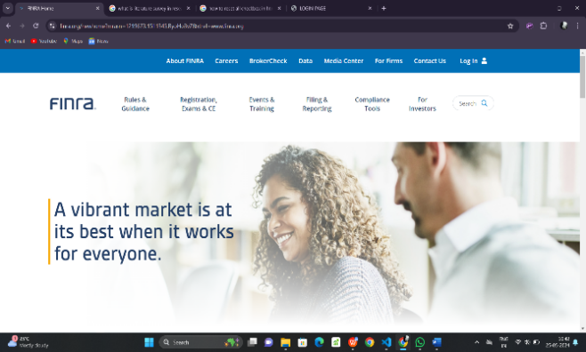FIGURE 1.1 EXISTING METHOD (FINRA)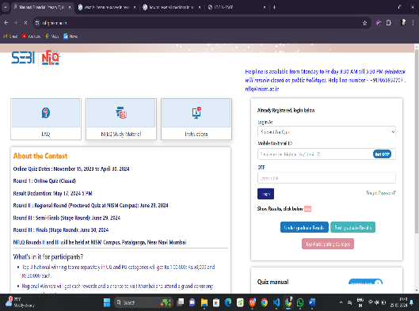

FIGURE 1.2 EXISTING METHOD (NISM)

**PROPOSED METHOD**

**FILIM.in (Financial Literacy Management and Mastering)**

This Website Filim.in had overcome all the disadvantages of the Existing System.

To the already existing system, this website additionally includes the following,

1.Learning Sector

2.Score Evaluator

3.Grade Provider (to mail)

4.User Friendly Access to the website.

**Why FILIM.in?**

Financial Literacy is one of the most important aspects to learn for our daily needs and to lead an Economical life.

Filim.in helps you to learn about all the topics of the financial literacy and helps you to evaluate your own self with others who also use this website. This website allows you to Learn, Evaluate and Master the art of Financial Literacy.

This also helps you to manage the Economy of your personal and professional Life.

The levels are in this website makes you to deeply learn one and move to the next level by mastering the levels.

This is a next level website to learn and evaluate yourselves with the Finance and Economy.

Learning and Leaping Forward

As per the title given, this project allows the users to Learn about the topics involved in the Finance and Economy. This website will help the users to learn and evolve around the topics of Financial Literacy.

**FLOWCHART**

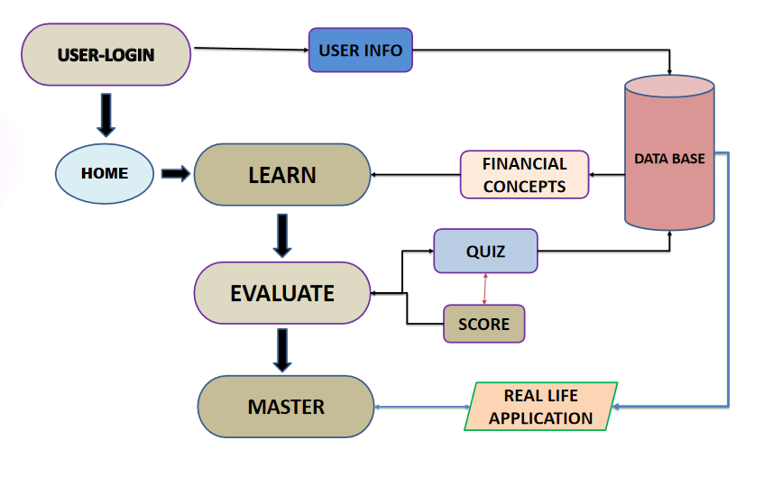

FIGURE 1.3 FLOWCHART OF FILIM.IN

**SOFTWARE DESCRIPTION**

**HTML :**

HTML, or Hypertext Markup Language, is the standard markup language used to create and design web pages. It provides a basic structure for web content by using a set of tags that define elements such as headings, paragraphs, links, images, and more.

HTML allows web browsers to interpret and display content in a structured manner, forming the backbone of every web page on

the internet. As a simple and essential language, HTML is often combined with other technologies like CSS (Cascading Style Sheets) and JavaScript to create visually appealing and interactive websites. It serves as the foundation for building web pages and is crucial for anyone involved in web development.

**CSS :**

CSS, or Cascading Style Sheets, is a styling language used in web development to enhance the presentation and appearance of HTML documents. It provides a set of rules that define how elements on a webpage should be displayed, allowing developers to control layout, typography, colours, and other visual aspects.CSS works in tandem with HTML, allowing developers to separate the structure (HTML) from the style (CSS) of a web page. By applying CSS rules to

HTML elements, designers can achieve consistent and aesthetically pleasing layouts across different devices and screen sizes. Key features of CSS include its ability to apply styles consistently across multiple pages, its cascading nature, where styles can be inherited or overridden, and its support for responsive design, enabling the creation of websites that adapt to various screen sizes and resolutions. Overall, CSS plays a crucial role in web design by providing a powerful and flexible means to control the look and feel of web content, contributing to a better user experience and improved visual appeal.

**JAVASCRIPT :**

JavaScript is a lightweight, cross-platform, single-threaded, and interpreted compiled programming language. It is also known as the scripting language for webpages. It is well-known for the development of web pages, and many non-browser environments also use it.

JavaScript is a weakly typed language (dynamically typed). JavaScript can be used for Client-side developments as well as Server-side developments. JavaScript is both an imperative and declarative type of language. JavaScript contains a standard library of objects, like Array, Date, and Math, and a core set of language elements like operators, control structures, and statements.

**BACKEND**

**FIREBASE :**

Firebase is a product of Google which helps developers to build, manage, and grow their apps easily. It helps developers to build their apps faster and in a more secure way. No programming is required on the firebase side which makes it easy to use its features more efficiently. It provides services to android, iOS, web, and unity. It provides cloud storage. It uses NoSQL for the database for the storage of data.

**SOURCE CODE**

**HTML&JS(Homepage):**

<html>

    <head>

        <title>HOME PAGE</title>

        <link rel="stylesheet" href="AR.css">

    </head>

    <body>

        <div class="navbar">

            <a href="index.html"> CONTACT US</a>

            <a href="tl.html"> ABOUT</a>

            <a href="learn.html">LEARN</a>

            <a href="login.html">LOG IN</a>

            <a href="home.html">HOME</a>

          <img src="icon.png" width="80px"; height="80px" href="icon.png” >

          </div>

          <DIV class="OVERALL">

            <div class="flip-card">

              <div class="flip-card-inner">

                <div class="flip-card-front">

                  <span class="text">BUDGETING</span>

                </div>

                <div class="flip-card-back">

                  <h1>BUDGETING</h1>

                  <p>A budget is a plan you write down to decide how you will spend your money each month. A budget helps you make sure you will have enough money every month. Without a budget, you might run out of money before your next pay check.

                   <br><br> <a href="BUDGET QUIZ.html">GET INTO QUIZ</a></p>

                </div>

              </div>

            </div>

            <div class="flip-card">

                <div class="flip-card-inner">

                  <div class="flip-card-front">

                    <span class="text">SAVING</span>

                  </div>

                  <div class="flip-card-back">

                    <h1>SAVING</h1>

                    <p>Savings is the amount of money left over after spending and other obligations are deducted from earnings. Savings represent money that is otherwise idle and not being put at risk with investments or spent on consumption. Savings accounts are very safe but tend to offer very low rates of return as a result.

                     <br><br> <a href="savingquiz.html">GET INTO QUIZ</a></p>

                  </div>

                </div>

              </div>

            </DIV>

            <DIV class="OVERALL">

                <div class="flip-card">

                  <div class="flip-card-inner">

                    <div class="flip-card-front">

                      <span class="text">DEBT MANAGEMENT</span>

                    </div>

                    <div class="flip-card-back">

                      <h1>DEBT MANAGEMENT</h1>

                      <p>Debt management is a way to get your debt under control through financial planning and budgeting. The goal of a debt management plan is to use these strategies to help you lower your current debt and move toward eliminating it.

                       <br><br> <a href="debtmanagemnetquiz.html">GET INTO QUIZ</a></p>

                    </div>

                  </div>

                </div>

                <div class="flip-card">

                    <div class="flip-card-inner">

                      <div class="flip-card-front">

                        <span class="text">INVESTMENT</span>

                      </div>

                      <div class="flip-card-back">

                        <h1>INVESTING</h1>

                        <p>The act of investing has the goal of generating income and increasing value over time. An investment can refer to any mechanism used for generating future income. This includes the purchase of bonds, stocks, or real estate property, among other examples.

                         <br><br> <a href="INVESTINGQUIZ.HTML">GET INTO QUIZ</a></p>

                      </div>

                    </div>

                  </div>

                </DIV>

                <DIV class="LAST">

                    <div class="flip-card">

                      <div class="flip-card-inner">

                        <div class="flip-card-front">

                          <span class="tax">TAXES</span>

                        </div>

                        <div class="flip-card-back">

                          <h1 >TAXES</h1>

                          <p>A tax is a mandatory fee or financial charge levied by any government on an individual or an organization to collect revenue for public works providing the best facilities and infrastructure. The collected fund is then used to fund different public expenditure programs.

                           <br><br> <a href="taxesquiz.html">GET INTO QUIZ</a></p>

                        </div>

                      </div>

                    </div>

                    </DIV>

    </body>

</html>

**HTML&JS(Login):**

<html>

    <head>

        <link rel="stylesheet" href="log.css">

        <link rel="stylesheet" href="AR.css">

        <title>LOGIN-PAGE</title>

    </head>

    <body>

    <div class="box">

        <img class="logo" width="100px"; height="100px" src="icon.png" >

        <form action="">

    <div class="outerbox">

        <div class="login-box">

            <h1>USER LOGIN</h1>

            <div class="inbox">

                <ion-icon name="person-circle-outline"></ion-icon>

                <input id="user" type="text"required>

                <label for="">USER NAME</label>

            </div>

            <div class="inbox">

                <ion-icon name="person-circle-outline"></ion-icon>

                <input id="email" type="email"required>

                <label for="">EMAIL</label>

            </div>

            <div class="inbox">

                <ion-icon name="eye-outline"></ion-icon>

                <input id="pass" type="password" required >

                <label for="">PASSWORD</label>

            </div>

            <div class="forgt">

                <a href="forgot.html" >FORGET PASSWORD</a>

            </div>

            <input type="submit" id="reg" value ="Login" />

            <div class="signin">

                <p>CREATE A NEW ACCOUNT <a href="register.html" style="color: yellow;">REGISTER</a></p>

            </div>

        </div>

    </div>

</form>

    </div>

        <script type="module" src="https://unpkg.com/ionicons@7.1.0/dist/ionicons/ionicons.esm.js"></script>

<script nomodule src="https://unpkg.com/ionicons@7.1.0/dist/ionicons/ionicons.js"></script>

    </body>

</html>

**HTML&JS (Learn Sector):**

<!DOCTYPE html>

<html>

  <head>

  <link rel="stylesheet" href="learn.css">

</head>

  <body>

    <div class="navbar">

      <a href="index.html"> CONTACT</a>

      <a href="tl.html"> ABOUT</a>

      <a href="learn.html"> LEARN</a>

      <a href="login.html">LOGIN</a>

      <a href="home.html"> HOME</a>

    <img src="icon.png" width="80px"; height="80px" href="icon.png” >

    </div>

    <div class="overall">

     <div class="card">

      <a href="stocks.html">STOCKS</a>

     </div>

     <div class="card">

      <a href="funding.html" target="_blank">FUNDING</a>

     </div>

     <div class="card">

      <a href="trade.html" target="_blank">TRADE</a>

     </div>

     <div class="card">

      <a href="CRYPTO.html" target="_blank">CRYPTO</a>

     </div>

     <div class="card">

      <a href="debt.html" target="_blank">DEBT</a>

     </div>

    </div>

    <div class="overall">

      <div class="card">

       <a href="CREDIT.HTML" target="_blank">CREDIT</a>

      </div>

      <div class="card">

       <a href="LOAN.HTML" target="_blank">LOAN</a>

      </div>

      <div class="card">

       <a href="compound interest.html" target="_blank">COMPOUND INTEREST</a>

      </div>

      <div class="card">

       <a href="SIMPLE INTEREST.HTML" target="_blank">SIMPLE INTEREST</a>

      </div>

      <div class="card">

        <a href="LEVERAGE.HTML" target="_blank">LEVERAGE</a>

       </div>

       <div class="card">

       <a href="asset.html" target="_blank">ASSET</a>

      </div>

      <div class="card">

        <a href="TAX.HTML" target="_blank">TAX</a>

       </div>

     </div>

     <div class="overall">

      <div class="card">

       <a href="https://www.consumerfinance.gov/ask-cfpb/what-is-a-credit-score-en-315/" target="_blank">CREDIT SCORE</a>

      </div>

      <div class="card">

       <a href="https://capital.com/monetary-value-definition" target="_blank">MONEY VALUE</a>

      </div>

      <div class="card">

       <a href="https://corporatefinanceinstitute.com/resources/accounting/liquidity/" target="_blank">LIQUIDITY</a>

      </div>

      <div class="card">

       <a href="https://www.investopedia.com/terms/r/rateofreturn.asp" target="_blank">RATE OF RETURN</a>

      </div>

     </div>

  </body>

</html>

**CSS(Home):**

. navbar

 {

  width: 100%;

  background-color: black;

  overflow: none;

  margin-top: -8;

}

body {

    background: url('stack.jpg')no-repeat;

    background-position: center;

    background-size: cover;

    font-family: Arial, Helvetica, sans-serif;

    margin: 0;

    padding: 0;

    box-sizing: border-box;

}

.navbar

{

 width: 100%;

 background-color: rgb(93, 61, 190) ;

 overflow: none;

 margin-top: -8;

}

.navbar a {

 float: right;

 text-align: center;

 padding: 15px;

 color: white;

 text-decoration: none;

 font-size: 23px;

}

.navbar a:hover {

 background-color: green;

 padding-top: 12px;

}

.active {

 background-color: blue;

}

@media screen and (max-width: 500px) {

 .navbar a {

   float: none;

   display: block;

 }

}

a {

  color: white;

  opacity: 0.8;

  text-decoration: none;

  font-family: sans-serif;

  font-weight: bold;

  margin-top: 0.9rem;

}

.flip-card {

  background-color: transparent;

  margin:20px 20px;

  width: 50%;

  height: 320px;

  perspective: 1000px;

}

.flip-card-inner {

  position: relative;

  margin: 20px;

  width: 100%;

  height: 320PX;

  text-align: center;

  font-size: 10px;

  transition: transform 0.6s;

  transform-style: preserve-3d;

  box-shadow: 0 4px 8px 0 rgba(0,0,0,0.2);

}

.flip-card:hover .flip-card-inner {

  transform: rotateY(180deg);

}

.flip-card-front, .flip-card-back {

  position: absolute;

  width: 100%;

  height: 100%;

  -webkit-backface-visibility: hidden;

  backface-visibility: hidden;

}

.flip-card-front {

  background-color: rgb(27, 27, 54);

  color: black;

  border-radius: 25px;

  border-style:double;

  border-color: whitesmoke;

  border-width: 6px;

}

.flip-card-back {

  background: radial-gradient(purple,violet);

  color: white;

  transform: rotateY(180deg);

  font-size: 20px;

  border-radius: 25px;

}

p{

  justify-content: center;

  padding: 30px;

  font-weight: bolder;

}

h1{

  font-weight: 100;

  text-decoration-line: underline;

}

.LAST{

      margin:20px;

      margin-top: 50px;

      align-items: center;

      width: 2870px;

    }

    .text {

      position:absolute;

      top: 50%;

      right: 50%;

      transform: translate(50%,-50%);

      text-transform: uppercase;

      font-family: verdana;

      font-size: 8em;

      font-weight: 100;

      color: #f5f5f5;

      text-shadow:

      1px 12px 6px rgba(16,16,16,0.4),

      1px 22px 10px rgba(16,16,16,0.2),

      1px 25px 35px rgba(16,16,16,0.2),

      1px 30px 60px rgba(16,16,16,0.4);

    }

    .OVERALL{

      display:flex;

    }

    span.tax{

      position:absolute;

      top: 50%;

      right: 50%;

      transform: translate(50%,-50%);

      text-transform: uppercase;

      font-family: verdana;

      font-size: 10em;

      font-weight: 100;

      color: #f5f5f5;

      text-shadow:

      1px 12px 6px rgba(16,16,16,0.4),

      1px 22px 10px rgba(16,16,16,0.2),

      1px 25px 35px rgba(16,16,16,0.2),

      1px 30px 60px rgba(16,16,16,0.4);

    }

.film{

  color: black;

  display: block;

  float: left;

  padding-bottom: 15%;

}

Backend (Firebase):

        <script type="module"

src="https://unpkg.com/ionicons@7.1.0/dist/ionicons/ionicons.esm.js"></script>

<script nomodule src="https://unpkg.com/ionicons@7.1.0/dist/ionicons/ionicons.js"></script>

This project includes the link of the Firebase Database and the data will be got and Stored in the server which is also connected to the Mail and the data will be available for the particular mail id and it also include more mail id of teammates.

**RESULT AND ANALYSIS**

**HOME PAGE:**

The Home page is a basic webpage with its components of the topic in the screen with a Navbar and its components.

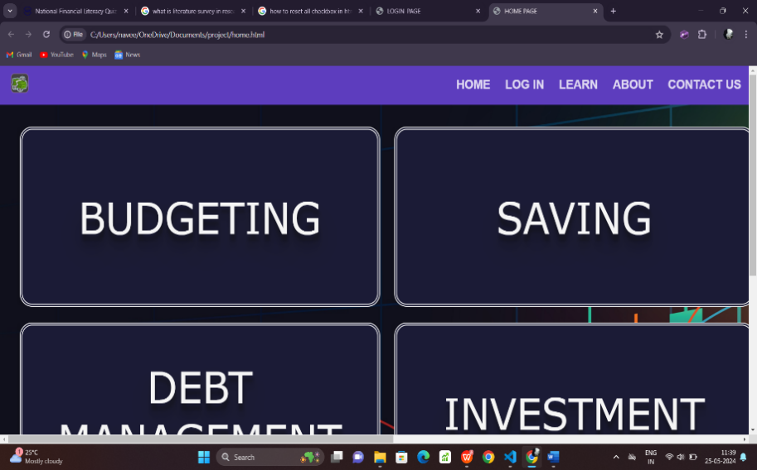

FIGURE 1.4 HOME PAGE

**LOGIN PAGE:**

The Login page allows you to Login to your account and save your progress and also the Register page allows you to create an account if you don’t have one.

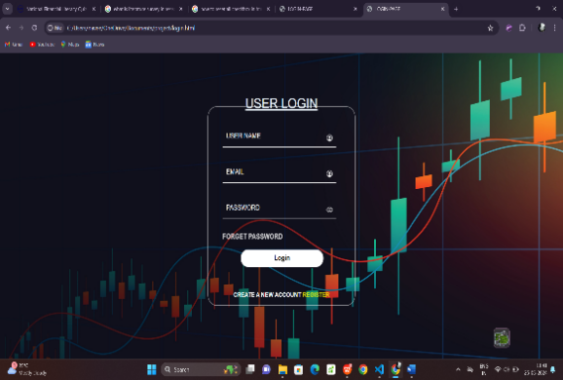 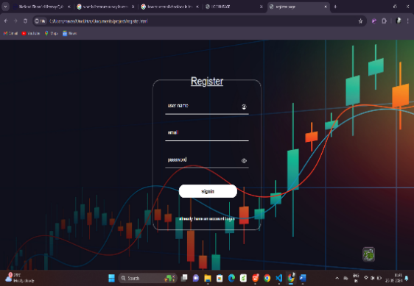

FIGURE 1.5 LOGIN PAGE FIGURE 1.6 REGISTER PAGE

**LEARN AND EVALUATE SECTOR:**

The Learn Sector gets you to know about and to learn all the financial topics based on your level.

All these Learning topics have a video Source to get a clear view of the topic and to Get as easy as possible to that topic.

The Evaluate sector consists of the quiz and helps you to evaluate what you learnt.

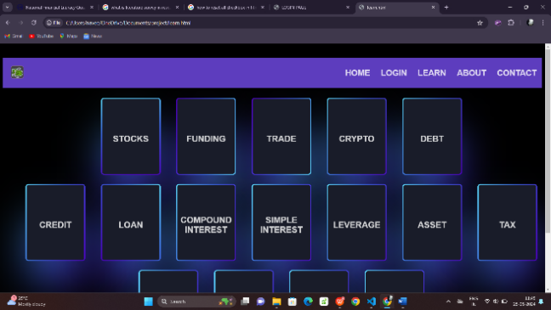 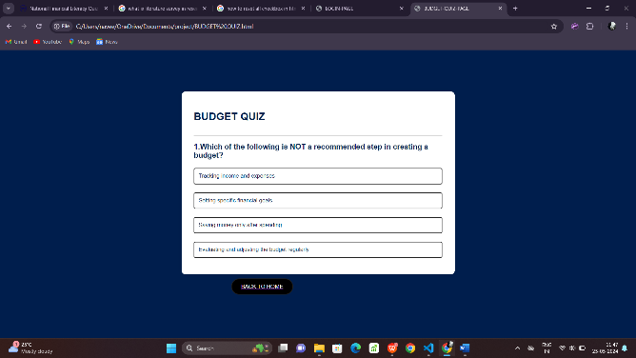

FIGURE 1.7 LEARN PAGE FIGURE 1.8 QUIZ PAGE

**CONTACT PAGE:**

The contact page allows the users to provide feedbacks about the websites and also give suggestions on the work done.

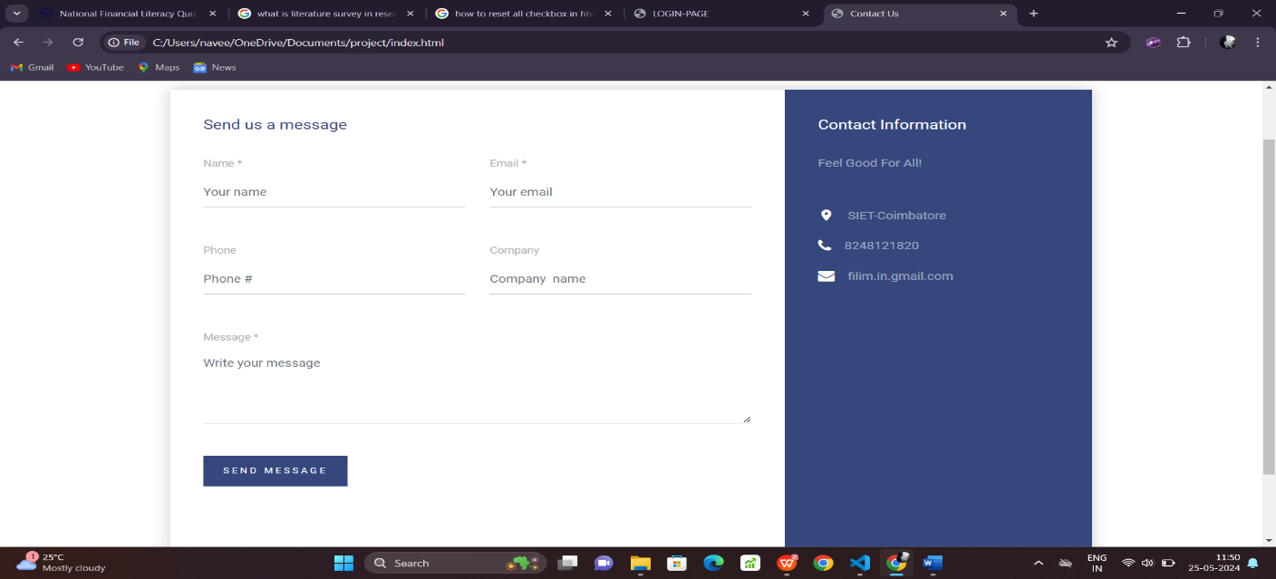

FIGURE 1.9 CONTACT PAGE

**CONCLUSION AND FUTURE SCOPE**

**CONCLUSION:**

Financial literacy Management and Mastering FILIM.in is a website to Learn and Master the Aspects of Financial Literacy and for that it used a Few Languages such as HTML,CSS,JS and for the backend connectivity this project has an inclusion of the Firebase .

With that this website has an inclusion of a homepage, Login page , register page, a page to learn about Financial Literacy,

and a linked page in the home page to quizzes and to evaluate yourselves.

**FUTURE SCOPE :**

Financial literacy Managing and Mastering web application known as FILIM.in is a website to Master the financial literacy to make aware of all the terms that included in our day to day to life.

After a certain number of testings, this will be updated based on the audience feedback and updating will be done to the current trend.

**Mobile Application Development:**

To create a mobile application for making this project user friendly and available for the electronic device so that the primary idea of this project “To make every individual aware of the finance and economy .” will be a great success.

In this world where money matters a lot. People have to update themselves to sustain in this environment. So, this project makes sure of that and keep the audience up to date and attain a financial freedom and knowledge.

**REFERENCE:**

Faulkner, Ash. (2022). Financial literacy resources in US public libraries: website analysis. Reference Services Review. 50. 10.1108/RSR-02-2022-0008.

Pšenák, Peter & Ildikó, Pšenáková & Szabo, Tibor & Kovac, Urban. (2019). The Interactive Web Applications in Financial Literacy Teaching. 661-666. 10.1109/ICETA48886.2019.9040011.

D. L. Remund, “Financial Literacy Explicated: The Case for a

Clearer Definition in an Increasingly Complex Economy,”

Journal of Consumer Affairs, vol. 44, no. 2, pp. 276–295, 2010.

L. Klapper, A. Lusardi, and P. van Oudheusden, “Financial

Literacy Around the World:” p. 28.

K. Rentková, Ľ. Mitková, and V. Mariak, “Financial (i)literacy:

does the financial advisor help?” in Leadership & management:

integrated politics of research and innovations : LIMEN 2018,

Belgrade: Association of Economists and Managers of the

Balkans, 2018, pp. 166–172.

Ministerstvo školstva, vedy, výskumu a športu Slovenskej

republiky, and Ministerstvo financií Slovenskej republiky,

“Národný štandard finančnej gramotnosti verzia 1.2,” 2017.

[Online]. Available: https://www.minedu.sk/data/att/11358.pdf.

[Accessed: 19-Oct-2019].

“R: The R Project for Statistical Computing.” [Online]. Available:

https://www.r-project.org/. [Accessed: 01-Oct-2019].

“Stack Overflow Developer Survey 2019,” Stack Overflow.

[Online]. Available:

https://insights.stackoverflow.com/survey/2019/?utm_source=soci

al-share&utm_medium=social&utm_campaign=dev-survey-2019.

[Accessed: 21-Oct-2019].

“Shiny.” [Online]. Available: https://shiny.rstudio.com/.

[Accessed: 20-Oct-2019].

“shinyapps.io.” [Online]. Available: https://www.shinyapps.io/.

[Accessed: 20-Oct-2019].

“Stack Overflow - Where Developers Learn, Share, & Build

Careers,” Stack Overflow. [Online]. Available:

https://stackoverflow.com/. [Accessed: 21-Oct-2019].

“R-bloggers | R news and tutorials contributed by hundreds of R

bloggers.” [Online]. Available: https://www.r-bloggers.com/.

[Accessed: 21-Oct-2019].