ARTIFICIAL INTELLIGENCE | NATURAL LANGUAGE PROCESSING | INFORMATION RETRIEVAL

24ADI006 – Deep Learning
Agentic RAG-Based
Internship Recommendation System
(InternAI) – Project Report

TEAM-11
[
Rithesh P – 24BAD098
Praveen Kumar – 24BAD090
Shaqeeq – 24BAD109
Rohith John – 24BAD100
Mohammed Aslam – 24BAD073
]

A practical implementation of natural-language understanding, dense text embeddings and retrieval-based ranking for student internship discovery.

DOCUMENT DETAILS | IMPLEMENTATION
Project domain | Applied Deep Learning, NLP and Retrieval-Augmented Generation
Application stack | HTML, CSS, JavaScript, Node.js and Express
AI service | Python and Flask
Local model runtime | Ollama
Language model | Qwen2.5:1.5b
Embedding model | nomic-embed-text:latest
Retrieval backend | PostgreSQL with pgvector when configured; local vector-search fallback in code

- | PROJECT OVERVIEW

Abstract and problem definition
InternAI is an AI-assisted internship discovery system that converts a student's natural-language request into a structured search and recommendation process. A student may describe academic information, skills, preferred technical domain, location, work arrangement and stipend expectations in a single message. The system interprets that request, retrieves semantically related internship records and then applies eligibility and ranking logic before presenting the final list.
The central engineering idea is to avoid treating internship discovery as a keyword-search problem alone. Two descriptions may use different words but express similar requirements. Dense embeddings help identify that semantic relationship. At the same time, semantic similarity is not sufficient for deciding whether an opportunity is suitable: an internship in another city or for a different academic year may be irrelevant even when its description is similar. InternAI therefore separates semantic retrieval from hard eligibility checks.

Objectives
  - Extract student profile details and internship preferences from conversational input into a structured JSON representation.
  - Create dense numerical representations of search intent for semantic similarity retrieval.
  - Retrieve a shortlist of internship records from a vector store, with a local retrieval fallback available in the pipeline.
  - Apply deterministic eligibility rules for academic branch, year, experience, location, work mode and stipend requirements.
  - Use an LLM-based second-stage reranking step and freshness checks to improve candidate ordering.
  - Calculate a weighted match score and attach a readable explanation to each recommended opportunity.

Scope and technical boundary
The reviewed implementation contains two neural models: Qwen2.5:1.5b for language tasks and nomic-embed-text for text embeddings. The remaining selection stages are primarily conventional Python logic. The project does not show custom training or fine-tuning of either model; it uses pretrained model weights for local inference through Ollama.

IN SCOPE | NOT ESTABLISHED BY THE SHARED IMPLEMENTATION
Prompt-based extraction; embedding generation; vector retrieval; Python filtering; Qwen reranking; freshness and weighted ranking. | A custom-trained neural network; a separate classification model; an independently trained reranker; or a multi-agent planner that autonomously creates and delegates tasks.
A modular application / AI-service arrangement using Node.js, Flask and Ollama. | A verified production ingestion crawler, scheduled refresh service, or end-to-end benchmark suite.

- | SYSTEM ARCHITECTURE

Application architecture and component responsibilities
The system is divided into a browser-facing layer, an application API, an AI microservice and a local model runtime. This separation keeps request handling and user-interface concerns outside the Python recommendation pipeline. The AI service coordinates specialist modules rather than placing every responsibility in one large function.

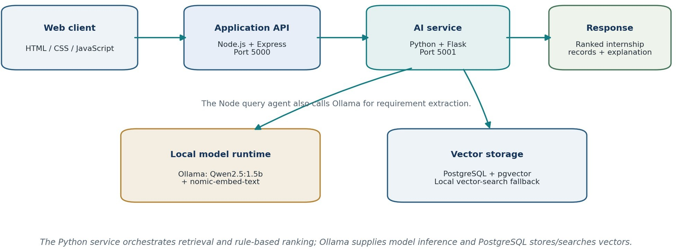

Figure 1. High-level deployment and processing architecture of InternAI.

COMPONENT | TECHNICAL RESPONSIBILITY
Frontend - HTML, CSS, JavaScript | Collects the student request and renders recommendation details.
Node.js + Express - port 5000 | Application backend. The shared query-agent code invokes Ollama for requirement extraction and passes structured requirements into the AI-service flow.
Python + Flask - port 5001 | Hosts the AI service. The shared project notes identify /api/search,  /api/health, /api/embed and /api/seed endpoints.
Ollama - port 11434 | Runs the local Qwen2.5 language model and the nomic-embed-text embedding model.
vector_store.py | Connects to PostgreSQL/pgvector for similarity search and exposes a local similarity-search fallback.
Python pipeline modules | Build the search query, filter candidates, rerank, assess freshness, calculate scores and generate explanations.

Request and response path
A typical request begins in the browser and reaches the Node.js application backend. The query agent calls the Ollama generation endpoint with the extraction prompt and the student message, requests JSON output and parses the returned JSON. The Python service receives the structured requirements and starts the recommendation pipeline. On completion, the service returns structured internship records and associated metadata for the application layer to display.

GitHub Repo link: https://github.com/praveenkumar01a/RAG-internship-Recommendation/tree/main

- | DEEP-LEARNING MODEL 1

Qwen2.5:1.5b - language understanding and generation
Qwen2.5:1.5b is the project's general-purpose language model. The shared query-agent implementation sends the extraction prompt and the current student message to Ollama at the local generation endpoint. It requests a non-streaming JSON response, checks that the returned text is not empty and parses it into a JavaScript object. In the pipeline, the Qwen-based reranker is also called after eligibility filtering.

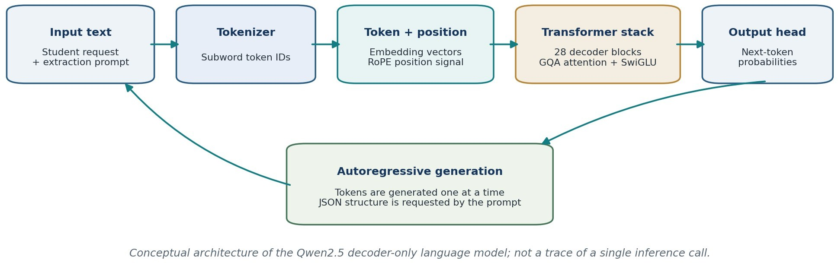

Figure 2. Simplified Transformer decoder flow for Qwen2.5. The diagram shows the model family architecture, not an instrumented runtime trace.

Model architecture
Qwen2.5 belongs to the decoder-only Transformer family. The official Qwen2.5-1.5B model card reports approximately
1.54 billion parameters, 28 Transformer layers, grouped-query attention with 12 query heads and 2 key/value heads, and a 32,768-token context length for the 1.5B variant. The documented architecture includes rotary positional embeddings (RoPE), RMSNorm, SwiGLU feed-forward layers, attention QKV bias and tied word embeddings [1].

DEEP-LEARNING ELEMENT | ROLE IN THE MODEL
Tokenization | Converts the input text into token IDs that can be processed by the neural network.
Token embeddings | Maps token IDs to learned dense vector representations.
RoPE positional information | Encodes token-position relationships for attention.
Self-attention with GQA | Uses query, key and value projections to contextualize tokens; grouped-query attention reduces the number of key/value heads.
RMSNorm and SwiGLU | Normalize intermediate activations and provide the gated feed-forward transformation within each Transformer block.
Causal language-model head | Predicts a distribution over the next token; generation repeats this process until the requested output is complete.

How Qwen is used in InternAI
For requirement extraction, Qwen reads the student message in the context of a prompt that requests structured fields. The intended output includes a student profile, internship requirements and preference values. For reranking, the pipeline passes a shortlist of eligible records and the search query to rerank_candidates(), then reads a rerank_score from each returned candidate. This is a second-stage relevance assessment; it does not replace the hard eligibility filter.
Inference, not project-specific training
No training loop, labelled internship dataset, optimizer, loss curve or fine-tuning run was supplied for Qwen. The project uses a pretrained model for inference. Do not describe Qwen as trained on this project's internship data.

- | DEEP-LEARNING MODEL 2

nomic-embed-text - dense semantic representation
The embedding model has a different purpose from the language model. It does not generate conversational answers. It converts a text input into a dense numerical vector. InternAI uses the vector generated from the consolidated search query as the input to similarity search. The corresponding internship records must have compatible vectors generated using the same embedding model and compatible preprocessing.

How text becomes an embedding
  - The text is tokenized and passed through the pretrained text encoder.
  - The encoder builds contextual representations for the input tokens.
  - A pooling / representation step produces a fixed-size vector for the complete text.
  - The resulting vector is compared with stored internship vectors to identify semantically close records.
The Nomic Embed v1.5 model card describes a long-context text embedder based on a BERT-style encoder and trained through contrastive learning followed by higher-quality supervised fine-tuning. It documents a 768-dimensional default representation and Matryoshka Representation Learning, which allows shorter output dimensions to be selected when the retrieval system is configured consistently [2]. The Ollama library provides the local `nomic-embed-text:latest` model tag used in the project [3].

Training principle and inference behaviour
Nomic Embed v1.5 uses contrastive learning during model development. In simplified terms, training presents related text pairs as positive examples and unrelated or less relevant pairs as negative examples. The encoder is optimized so that related texts receive closer vector representations than unrelated texts. This is why a query such as “machine learning internship for an AI student” can retrieve a listing that describes “applied predictive modelling work” even when the phrases do not match exactly. The model is pretrained before it is used by InternAI; the project does not repeat this contrastive training step.
The model card also describes mean pooling over token representations, normalization and Matryoshka Representation Learning. Matryoshka training allows a vector to be shortened to selected dimensions while retaining useful semantic information. In a deployed retrieval system, the chosen dimension must be identical for stored internship vectors, query vectors and the PostgreSQL vector column [2].

Query and document preparation
For retrieval tasks, the Nomic model card recommends distinguishing document inputs from query inputs with task prefixes such as search_document: and search_query: [2]. The shared project excerpt confirms that generate_embedding(search_query) is called, but it does not include the body of embedding_service.py. Therefore, this report cannot confirm whether those prefixes are applied to queries or to the internship records during indexing. This should be checked before final evaluation because consistent task formatting is part of the embedding model's intended usage.

Semantic similarity (cosine)
A common comparison for dense vectors is cosine similarity. For query vector q and internship vector d, cosine similarity is calculated as:
cos(q, d) = (q · d) / (||q|| × ||d||)
The value expresses the angular similarity between two vectors. In a typical normalized embedding space, a larger cosine similarity indicates that the texts are more closely related in meaning. It is a retrieval signal, not a probability that the student will be selected for the internship.

MODEL | INPUT | OUTPUT | ROLE IN THE PROJECT
Qwen2.5:1.5b | Natural-language prompt and student request / candidate set | Generated text or structured JSON; reranking score is consumed by the pipeline | Understand requests and reassess shortlisted candidate relevance.
nomic-embed-text:latest | Search-query text | Dense embedding vector | Represent meaning for nearest-neighbour retrieval.
Dimension and context validation
The pipeline logs the generated embedding length instead of hardcoding it in the orchestration code. The vector column and all stored internship embeddings must use the same dimension and model version. The exact vector length observed in the user's local run was not included in the supplied excerpts, so this report does not claim a measured runtime dimension.

- | RETRIEVAL WORKFLOW

End-to-end RAG pipeline
InternAI follows a staged retrieve-then-refine process. The language model first converts conversational input into structured information. The query builder then creates a natural-language string for semantic search and a separate dictionary of hard filters. The embedding model represents the query, and the vector store retrieves a manageable candidate set. Rule-based and model-assisted stages then refine that set.

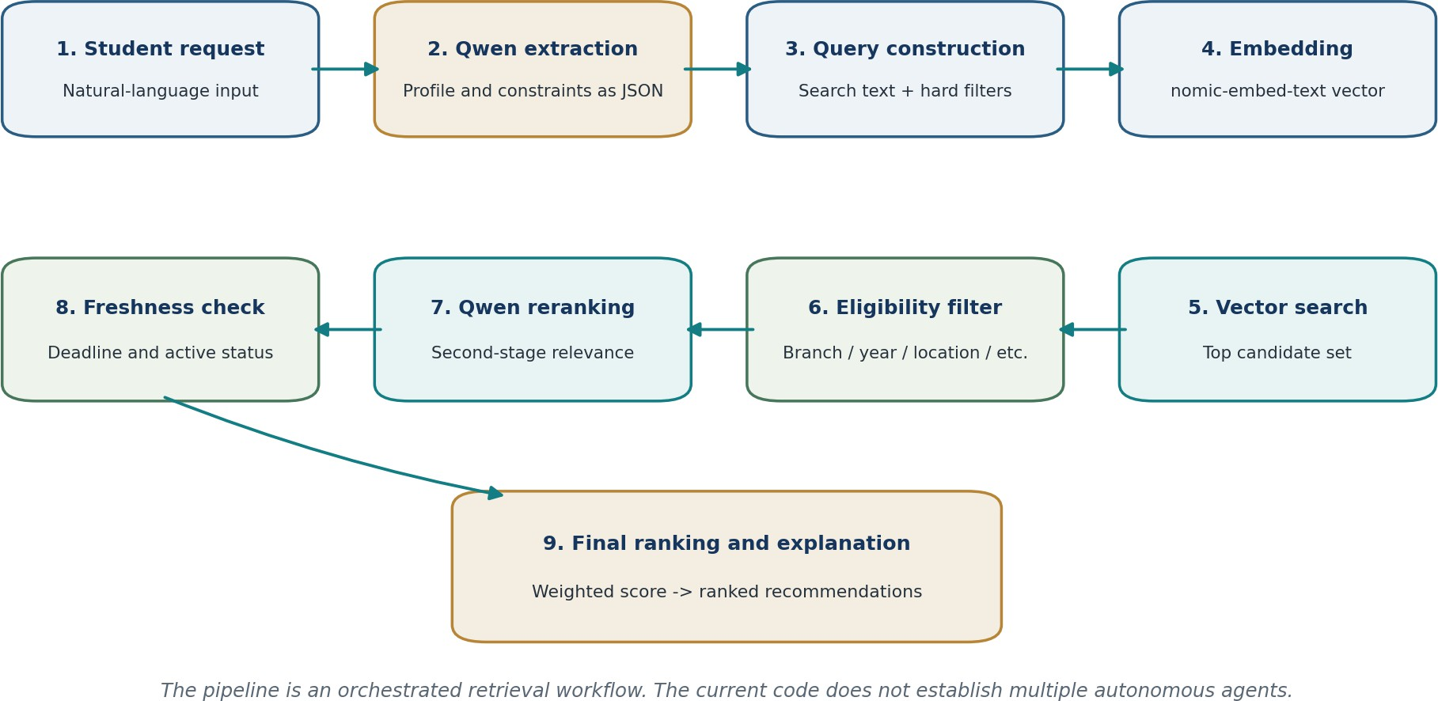

Figure 3. End-to-end retrieval, filtering and ranking workflow.

Pipeline stages mapped to code

MODULE / FUNCTION | OPERATION
queryAgent.js + prompt.js | Calls Qwen through Ollama and parses the structured JSON requirements.
query_builder.py | build_search_query() forms the semantic query; extract_hard_filters() creates deterministic constraints.
embedding_service.py | generate_embedding() converts the query into a dense vector.
vector_store.py | similarity_search() retrieves the top candidate set; local_similarity_search() is used if database access fails.
eligibility_filter.py | Checks academic and opportunity constraints, including the strict-location changes tested during development.
reranker.py | rerank_candidates() applies Qwen-assisted relevance scoring to the eligible shortlist.
freshness_checker.py | Checks freshness and deadline-related status.
final_ranker.py + explainer.py | Computes the final score, sorts the candidates and attaches explanations.
The code comments identify a default semantic retrieval limit of 20 candidates and a reranking cap of 15. The final response is limited by max_results, whose default value in run_pipeline() is 10. These are pipeline limits, not claims about the total number of internships stored in the database.

- | ELIGIBILITY AND RECOMMENDATION SCORE

Hard filters, freshness and weighted ranking

Eligibility filtering
Eligibility is implemented as deterministic Python logic. It is responsible for checks that should not be overridden by semantic similarity, including branch compatibility, academic year, experience, location, work mode and stipend conditions. The updated location test normalizes the requested city and the internship location, and the supplied self-test reported one eligible result - “Coimbatore ML Intern” - out of four sample candidates. The output stated that the strict-location filtering test passed.

Freshness assessment
After reranking, freshness_checker.py assesses whether the opportunity is still relevant and active. The pipeline uses the returned freshness structure to expose overall status, label, deadline status and days until deadline. This stage is rule/data-based in the shared design; it is not a separately trained deep-learning model.

Final multi-factor score
final_ranker.py combines five signals into a composite match percentage. The weights documented in the code are:
Match % = 100 × (0.30S + 0.25R + 0.20E + 0.15F + 0.10P)

SYMBOL | WEIGHT | SIGNAL
S | 30% | Semantic similarity from vector retrieval.
R | 25% | Qwen reranking score normalized from a 0-100 scale.
E | 20% | Eligibility checks passed, normalized to a score.
F | 15% | Freshness score from the freshness module.
P | 10% | Preference match, including skills and stipend-related preferences.
Candidates are sorted in descending order of match_percentage. The percentage is a ranking index formed from the five signals; it is not a calibrated probability of acceptance or a guarantee of placement.

Important integration issue identified in the shared code

The shared final_ranker.py excerpt also awards partial preference credit to a remote listing or a non-matching city. That scoring behavior must not be used to soften a mandatory location rule. Hard constraints should be enforced before ranking; preference scores should only order candidates that have already passed eligibility.

- | IMPLEMENTATION AND VALIDATION

Runtime, interfaces and observed test evidence

Runtime arrangement

SERVICE | LOCAL ADDRESS / RUNTIME | PURPOSE
Node.js / Express | http://localhost:5000 | Main application backend.
Python / Flask | http://localhost:5001 | AI recommendation service.
Ollama | http://localhost:11434 | Local model inference for Qwen and nomic embeddings.
Vector storage | PostgreSQL + pgvector when configured | Persistent vector similarity retrieval; local fallback is present in the pipeline.

Important implementation modules

FILE | RESPONSIBILITY
queryAgent.js / prompt.js | Prompt construction, Ollama generation request and JSON parsing.
ai_server.py | Flask endpoints and hand-off to run_pipeline().
query_builder.py / embedding_service.py | Search query construction, hard-filter extraction and query vector generation.
vector_store.py / db_setup.py | Vector database connection, similarity search and database setup.
eligibility_filter.py / reranker.py | Hard eligibility checks and Qwen-assisted second-stage scoring.
freshness_checker.py / final_ranker.py | Opportunity freshness and weighted candidate scoring.
explainer.py / pipeline.py | Recommendation explanations, stage orchestration and response assembly.

Validation evidence supplied during development

CHECK | OBSERVED OUTPUT | INTERPRETATION
Python compilation | eligibility_filter.py compiled successfully. | Syntax check passed for that module.
Eligibility unit test | “All branch matching tests passed.” | The branch checks covered by the test passed.
Strict-location self-test | 1 eligible out of 4 candidates; only “Coimbatore ML Intern” was retained. | The isolated strict-location test passed for the sample data.
End-to-end strict location | The shared pipeline contains a fallback that restores rejected candidates when the eligible list is empty. | End-to-end strict location must not yet be claimed as guaranteed.

Limitations:
  - The shared query-agent code processes the current prompt; stable session-based profile persistence and cross-turn merging were not demonstrated.
  - The exact local embedding vector dimension and database schema were not included in the excerpts and must be verified against the running instance.
  - No measured retrieval benchmark, precision@k, recall@k, nDCG@k or end-to-end latency distribution was supplied.
  - The complete reranker and explainer implementations were not available for line-by-line review; their internal prompt and fallback behavior are not asserted here.

- | ENGINEERING ASSESSMENT

Conclusion and recommended next steps
InternAI brings together two complementary pretrained neural models and a deterministic recommendation pipeline. Qwen2.5:1.5b interprets student requests and supports second-stage candidate reranking. nomic-embed-text converts search text into dense vectors so the system can retrieve internship records by semantic similarity. The Python stages then apply hard constraints, freshness checks and a transparent weighted score before returning structured recommendations with explanations.
This separation is technically appropriate for the problem: semantic relevance is used to discover potentially useful opportunities, while eligibility rules protect the student from results that do not meet mandatory conditions. The project also benefits from a local Ollama runtime and a modular service design. The main reliability issue found in the shared pipeline is the eligibility-relaxation fallback, which can negate strict filtering when no candidate passes.
The implementation is best described as a local, LLM-assisted RAG recommendation pipeline rather than a fully autonomous multi-agent system. Its deep-learning contribution is concentrated in Transformer-based language understanding and dense text embeddings. Filtering, freshness and the final decision score remain explainable Python logic. With the hard-filter bypass corrected and retrieval quality measured systematically, the architecture provides a sound foundation for a more reliable internship recommendation application.

Glossary

TERM | MEANING IN THIS PROJECT
LLM | Large language model used for text understanding and generation.
Embedding | Dense vector representation of text meaning.
RAG | Retrieval-Augmented Generation; here, retrieval and ranking are combined with LLM-based interpretation.
pgvector | PostgreSQL extension for storing and searching vector representations.
Reranking | A second relevance-scoring stage applied to an initial candidate shortlist.
Hard filter | A mandatory rule that a result must satisfy to remain eligible.

- | TECHNICAL REFERENCES

TEAM CONTRIBUTION

Team Member | CONTRIBUTION
Praveen Kumar – 24BAD090 | Designed the overall system architecture and coordinated backend integration
Shaqeeq – 24BAD109 | Worked on RAG implementation, vector database integration and internship retrieval.
Rohith John – 24BAD100 | Worked on AI model integration, requirement extraction and semantic matching using Qwen and Nomic embeddings.
Mohammed Aslam – 24BAD073 | Prepared project documentation, test cases and presentation materials.
Rithesh P – 24BAD098 | Worked on eligibility filtering, freshness checking and final internship ranking.

Project files reviewed / referenced

AREA | FILES
Request understanding | queryAgent.js, prompt.js
Search preparation | query_builder.py
Embedding and retrieval | embedding_service.py, vector_store.py, db_setup.py
Candidate refinement | eligibility_filter.py, reranker.py, freshness_checker.py
Ranking and orchestration | final_ranker.py, explainer.py, pipeline.py
Service boundary | server.js, ai_server.py

Model documentation and implementation references
The architecture and model facts below are drawn from official model documentation. Project-specific implementation statements are based on the code excerpts, module names, runtime details and test output shared during development.

External model references
- Qwen Team. “Qwen2.5-1.5B / Qwen2.5-1.5B-Instruct Model Card.” Hugging Face. Architecture details include parameter count, layer count, GQA heads, RoPE, SwiGLU, RMSNorm and context length. https://huggingface.co/Qwen/Qwen2.5-1.5B-Instruct
- Nomic AI. “nomic-embed-text-v1.5: Resizable Production Embeddings with Matryoshka Representation Learning.” Hugging Face model card. Describes the encoder, embedding representation and Matryoshka dimensions. https://huggingface.co/nomic-ai/nomic-embed-text-v1.5
- Ollama. “nomic-embed-text.” Ollama Model Library. Model purpose, local model tag and embedding API usage. https://ollama.com/library/nomic-embed-text
- Ollama. “qwen2.5.” Ollama Model Library. Local model family and available parameter-size tags. https://ollama.com/library/qwen2.5
- Nussbaum, Z., Morris, J. X., Duderstadt, B. and Mulyar, A. “Nomic Embed: Training a Reproducible Long Context Text Embedder.” arXiv:2402.01613, 2024. https://arxiv.org/abs/2402.01613

