**Kubernetes Study Notes - Day 30**

**1. Introduction to Kubernetes**

**What is Kubernetes?**

* **Definition**: Kubernetes (K8s) is an **open-source container orchestration platform** designed to automate the deployment, scaling, and management of containerized applications.
* **Key Features**:
  + **Auto-scaling** (Handles traffic spikes)
  + **Auto-healing** (Self-recovery of failed containers)
  + **Multi-host deployment** (Cluster-based architecture)
  + **Enterprise-grade support** (Load balancing, security, networking)

**Image: Kubernetes Overview**

**Why Kubernetes?**

* Docker is great for **single-host container management**, but lacks:
  + **Scalability**
  + **High availability**
  + **Enterprise features** (Firewall, API Gateway, Load Balancing)
* Kubernetes solves these problems by providing a **cluster-based approach**.

**2. Problems with Docker & How Kubernetes Solves Them**

| **Problem with Docker** | **Kubernetes Solution** |
| --- | --- |
| **Single-host limitation** (All containers run on one machine) | **Multi-node cluster** (Pods can run across multiple nodes) |
| **No Auto-healing** (If a container crashes, manual restart is needed) | **ReplicaSets & Deployments** (Automatically restarts failed containers) |
| **No Auto-scaling** (Manual scaling required) | **Horizontal Pod Autoscaler (HPA)** (Scales based on traffic) |
| **Lacks Enterprise features** (No built-in load balancer, firewall, etc.) | **Ingress Controllers, Network Policies, Custom Resources** |

**3. Key Kubernetes Concepts**

**1. Kubernetes Cluster**

* A **group of nodes** (servers) that run containerized applications.
* **Components**:
  + **Master Node (Control Plane)** – Manages the cluster.
  + **Worker Nodes** – Run the actual workloads (Pods).

**Image: Kubernetes Cluster Architecture**

**2. Pods**

* **Definition**: The smallest deployable unit in Kubernetes.
* **Contains**:
  + One or more containers (usually **one main container + sidecars**).
  + Shared storage & network.

**Example YAML:**

apiVersion: v1

kind: Pod

metadata:

name: nginx-pod

spec:

containers:

- name: nginx

image: nginx:latest

**3. ReplicaSets & Deployments**

* **ReplicaSet**: Ensures a specified number of Pod replicas are running.
* **Deployment**: Manages ReplicaSets (enables rolling updates & rollbacks).

**Example YAML:**

apiVersion: apps/v1

kind: Deployment

metadata:

name: nginx-deployment

spec:

replicas: 3

selector:

matchLabels:

app: nginx

template:

metadata:

labels:

app: nginx

spec:

containers:

- name: nginx

image: nginx:latest

**4. Services & Load Balancing**

* **Service**: Exposes Pods to the network (ClusterIP, NodePort, LoadBalancer).
* **Ingress**: Manages external access (HTTP/HTTPS routing).

**Example YAML:**

apiVersion: v1

kind: Service

metadata:

name: nginx-service

spec:

selector:

app: nginx

ports:

- protocol: TCP

port: 80

targetPort: 80

type: LoadBalancer

**5. Horizontal Pod Autoscaler (HPA)**

* Automatically scales Pods based on CPU/memory usage.

**Example YAML:**

apiVersion: autoscaling/v1

kind: HorizontalPodAutoscaler

metadata:

name: nginx-hpa

spec:

scaleTargetRef:

apiVersion: apps/v1

kind: Deployment

name: nginx-deployment

minReplicas: 1

maxReplicas: 10

targetCPUUtilizationPercentage: 80

**4. Kubernetes Architecture**

**Control Plane (Master Node) Components**

| **Component** | **Role** |
| --- | --- |
| **API Server** | Entry point for all commands |
| **Scheduler** | Assigns Pods to Nodes |
| **Controller Manager** | Ensures desired state (e.g., ReplicaSets) |
| **etcd** | Key-value store for cluster data |

**Worker Node Components**

| **Component** | **Role** |
| --- | --- |
| **Kubelet** | Ensures Pods are running |
| **Kube-proxy** | Manages networking rules |
| **Container Runtime** (Docker, containerd) | Runs containers |

**Image: Kubernetes Architecture**

**5. Summary & Key Takeaways**

✅ **Kubernetes vs. Docker**: Docker is for **single-host containers**, while Kubernetes is for **orchestrating multi-host clusters**.  
✅ **Auto-healing**: Kubernetes **restarts failed Pods automatically**.  
✅ **Auto-scaling**: Uses **HPA** to scale based on demand.  
✅ **Enterprise-ready**: Supports **load balancing, security policies, and networking**.

**Next Steps**

🔹 Learn **Kubernetes CLI (kubectl)**  
🔹 Practice **Deploying a Sample App**  
🔹 Explore **Helm for Package Management**

📌 **Quote from the Video**:

*"Kubernetes is easy. If you understand the* ***why****, the* ***how*** *becomes simple."*

🚀 **Stay tuned for Day 31: Deep Dive into Kubernetes Architecture!** 🚀

**Feedback & Discussion**

💬 **Questions?** Drop them in the comments!  
👍 **Like & Share** if you found this helpful!

**Author**: Abhishek  
**Channel**: Complete DevOps Course  
**Day**: 30  
**Topic**: Kubernetes Introduction

# **Kubernetes Study Notes - Day 30**

## **1. Introduction to Kubernetes**

### **What is Kubernetes?**

- **Definition**: Kubernetes (K8s) is an **open-source container orchestration platform** designed to automate the deployment, scaling, and management of containerized applications.

- **Key Features**:

- **Auto-scaling** (Handles traffic spikes)

- **Auto-healing** (Self-recovery of failed containers)

- **Multi-host deployment** (Cluster-based architecture)

- **Enterprise-grade support** (Load balancing, security, networking)

### **Why Kubernetes?**

- Docker is great for **single-host container management**, but lacks:

- **Scalability**

- **High availability**

- **Enterprise features** (Firewall, API Gateway, Load Balancing)

- Kubernetes solves these problems by providing a **cluster-based approach**.

---

## **2. Problems with Docker & How Kubernetes Solves Them**

| **Problem with Docker** | **Kubernetes Solution** |

|-------------------------|-------------------------|

| **Single-host limitation** (All containers run on one machine) | **Multi-node cluster** (Pods can run across multiple nodes) |

| **No Auto-healing** (If a container crashes, manual restart is needed) | **ReplicaSets & Deployments** (Automatically restarts failed containers) |

| **No Auto-scaling** (Manual scaling required) | **Horizontal Pod Autoscaler (HPA)** (Scales based on traffic) |

| **Lacks Enterprise features** (No built-in load balancer, firewall, etc.) | **Ingress Controllers, Network Policies, Custom Resources** |

---

## **3. Key Kubernetes Concepts**

### **1. Kubernetes Cluster**

- A **group of nodes** (servers) that run containerized applications.

- **Components**:

- **Master Node (Control Plane)** – Manages the cluster.

- **Worker Nodes** – Run the actual workloads (Pods).

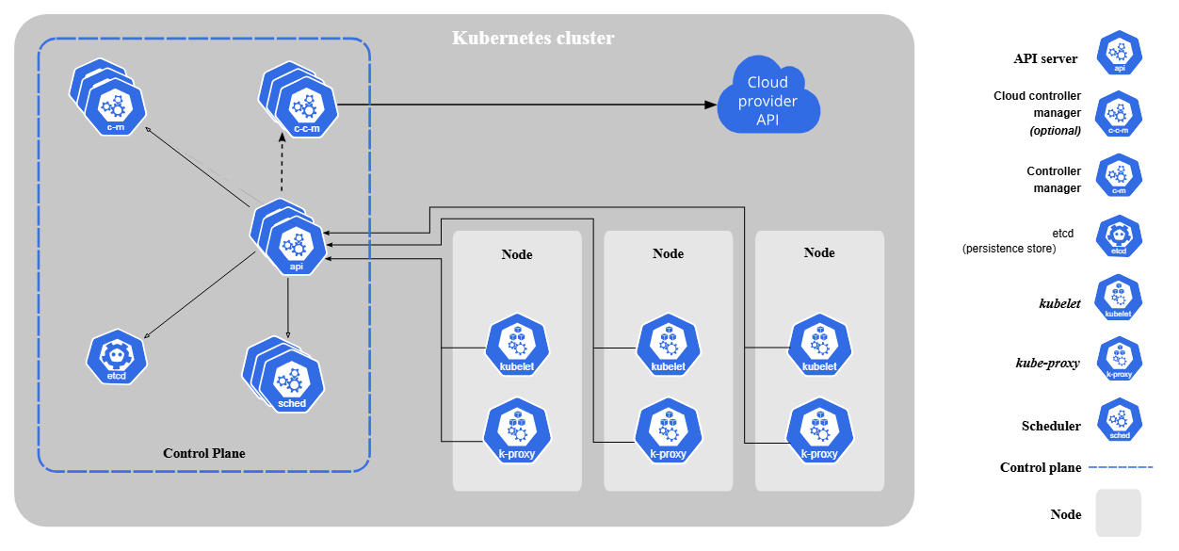

![Kubernetes Cluster](https://d33wubrfki0l68.cloudfront.net/2475489eaf20163ec0f54ddc1d92aa8d4c87c96b/e7c81/images/docs/components-of-kubernetes.svg)

### **2. Pods**

- **Definition**: The smallest deployable unit in Kubernetes.

- **Contains**:

- One or more containers (usually **one main container + sidecars**).

- Shared storage & network.

**Example**:

```yaml

apiVersion: v1

kind: Pod

metadata:

name: nginx-pod

spec:

containers:

- name: nginx

image: nginx:latest

```

### **3. ReplicaSets & Deployments**

- **ReplicaSet**: Ensures a specified number of Pod replicas are running.

- **Deployment**: Manages ReplicaSets (enables rolling updates & rollbacks).

**Example**:

```yaml

apiVersion: apps/v1

kind: Deployment

metadata:

name: nginx-deployment

spec:

replicas: 3

selector:

matchLabels:

app: nginx

template:

metadata:

labels:

app: nginx

spec:

containers:

- name: nginx

image: nginx:latest

```

### **4. Services & Load Balancing**

- **Service**: Exposes Pods to the network (ClusterIP, NodePort, LoadBalancer).

- **Ingress**: Manages external access (HTTP/HTTPS routing).

**Example**:

```yaml

apiVersion: v1

kind: Service

metadata:

name: nginx-service

spec:

selector:

app: nginx

ports:

- protocol: TCP

port: 80

targetPort: 80

type: LoadBalancer

```

### **5. Horizontal Pod Autoscaler (HPA)**

- Automatically scales Pods based on CPU/memory usage.

**Example**:

```yaml

apiVersion: autoscaling/v1

kind: HorizontalPodAutoscaler

metadata:

name: nginx-hpa

spec:

scaleTargetRef:

apiVersion: apps/v1

kind: Deployment

name: nginx-deployment

minReplicas: 1

maxReplicas: 10

targetCPUUtilizationPercentage: 80

```

---

## **4. Kubernetes Architecture**

### **Control Plane (Master Node) Components**

| **Component** | **Role** |

|--------------|---------|

| **API Server** | Entry point for all commands |

| **Scheduler** | Assigns Pods to Nodes |

| **Controller Manager** | Ensures desired state (e.g., ReplicaSets) |

| **etcd** | Key-value store for cluster data |

### **Worker Node Components**

| **Component** | **Role** |

|--------------|---------|

| **Kubelet** | Ensures Pods are running |

| **Kube-proxy** | Manages networking rules |

| **Container Runtime** (Docker, containerd) | Runs containers |

![Kubernetes Architecture](https://www.weave.works/docs/cloud/latest/images/kubernetes-architecture.png)

---

## **5. Summary & Key Takeaways**

✅ **Kubernetes vs. Docker**: Docker is for **single-host containers**, while Kubernetes is for **orchestrating multi-host clusters**.

✅ **Auto-healing**: Kubernetes **restarts failed Pods automatically**.

✅ **Auto-scaling**: Uses **HPA** to scale based on demand.

✅ **Enterprise-ready**: Supports **load balancing, security policies, and networking**.

---

## **Next Steps**

🔹 Learn **Kubernetes CLI (`kubectl`)**

🔹 Practice **Deploying a Sample App**

🔹 Explore **Helm for Package Management**

📌 **Quote from the Video**:

> *"Kubernetes is easy. If you understand the **why**, the **how** becomes simple."*

🚀 **Stay tuned for Day 31: Deep Dive into Kubernetes Architecture!** 🚀

---

### **Feedback & Discussion**

💬 **Questions?** Drop them in the comments!

👍 **Like & Share** if you found this helpful!

---

**Author**: Abhishek

**Channel**: Complete DevOps Course

**Day**: 30

**Topic**: Kubernetes Introduction