Task: Deploy Flask/FastAPI Application on Azure Web Apps

Objective:

Deploy a basic Flask or FastAPI application on Azure Web Apps.

Create a simple Flask or FastAPI application with a single endpoint that returns "Hello, Azure Web Apps!" when accessed. Set up a new Azure Web App to host the application. Configure the necessary settings for the Azure Web App, including any required environment variables. Deploy the application to the Azure Web App.

**Solution:**

**Code:**

**app.py:**

from flask import Flask

app = Flask(__name__)

@app.route('/')

def hello():

return 'Hello, Azure Web Apps!'

if __name__ == '__main__':

app.run()

**appFastAPI.py:**

from fastapi import FastAPI

app = FastAPI()

@app.get("/")

def hello():

return "Hello, Azure Web Apps!"

**requirements.txt:**

Flask

Fastapi

**Dockerfile:**

FROM python:3.9

WORKDIR /app

COPY requirements.txt /app

RUN pip install -r requirements.txt

COPY . /app

EXPOSE 5000

# ENV FLASK_APP=app.py

CMD ["python", "app.py"]

**GitHub Repository URL:** <https://github.com/praveenkumar0222/Triluxo>

<https://gitlab.com/PRAVEENKUMAR-P/triluxo>

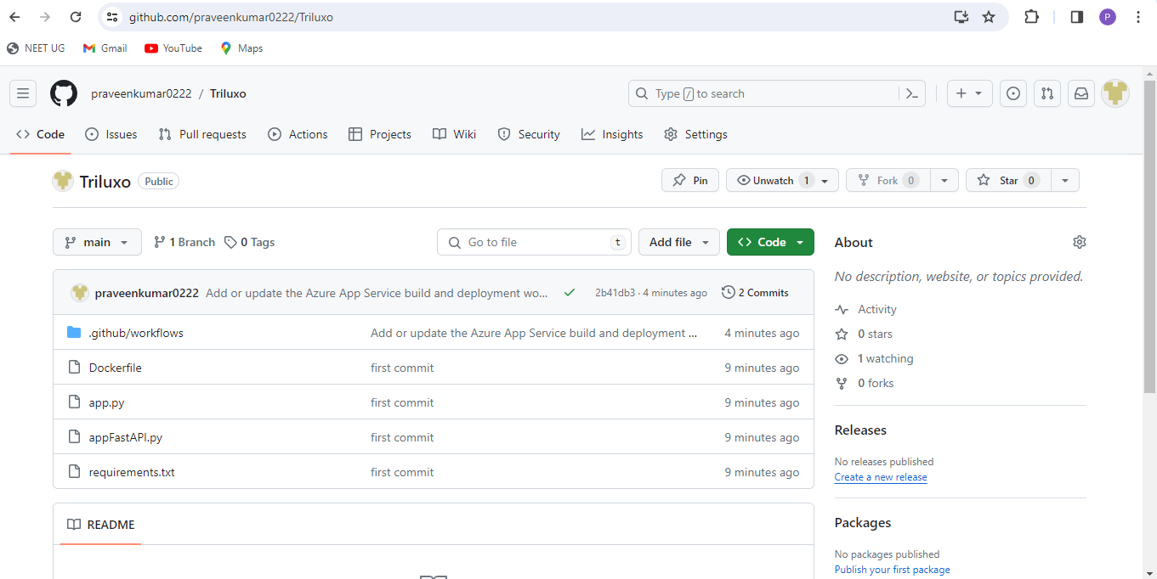

**Deploy the application to the Azure Web App:**

**Deployment URL:** [triluxo.azurewebsites.net](https://triluxo.azurewebsites.net/), https://triluxo.azurewebsites.net/

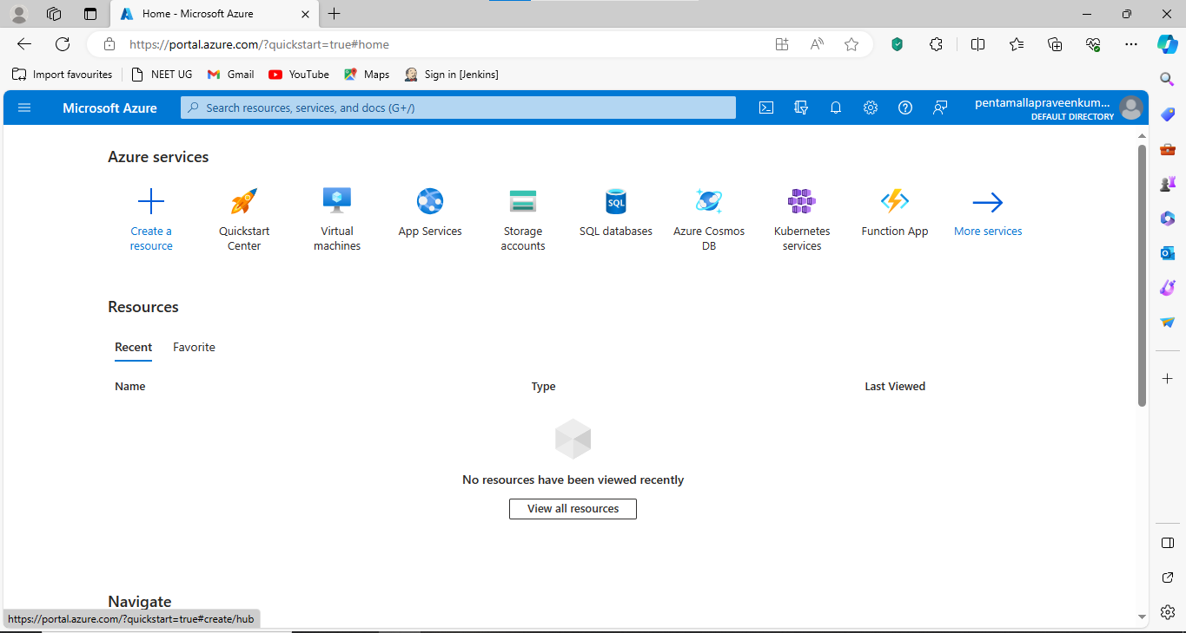

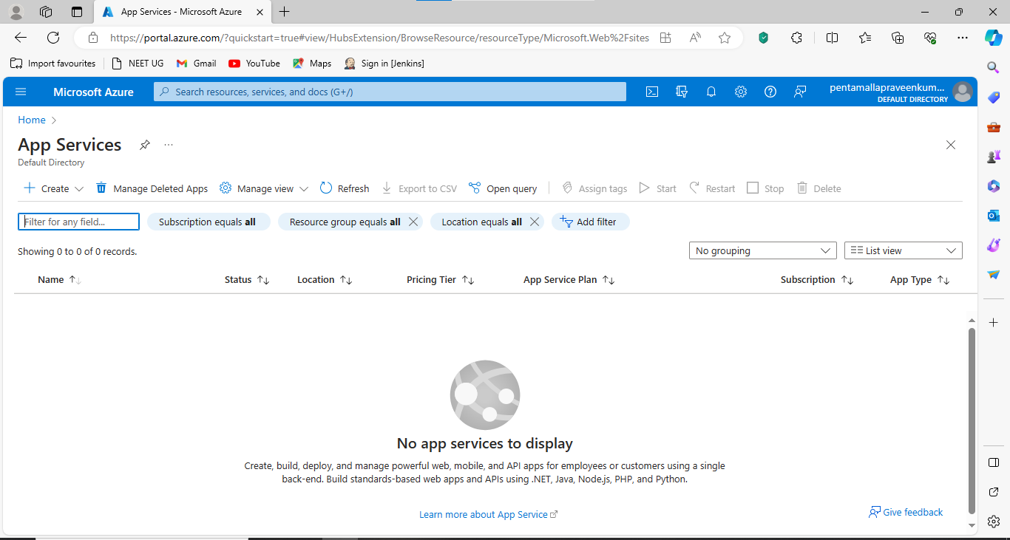

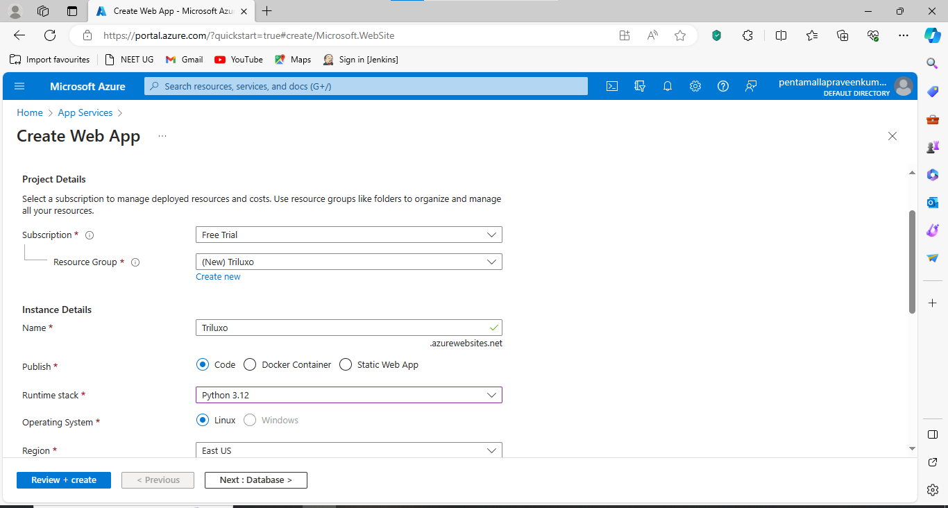

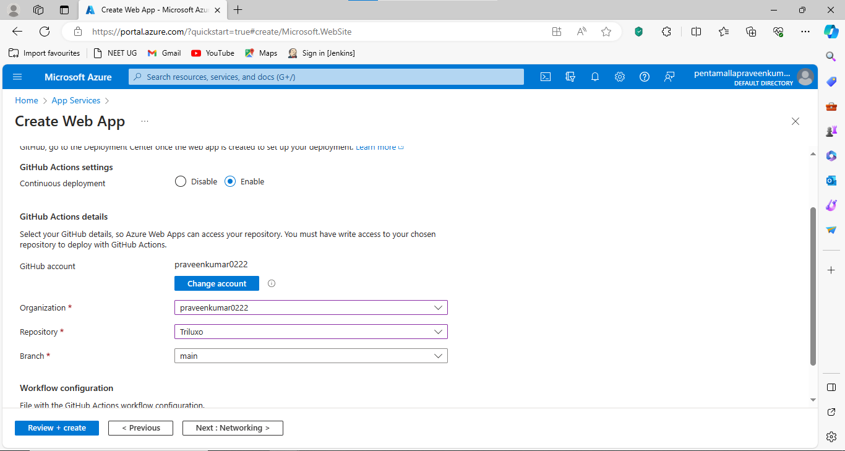

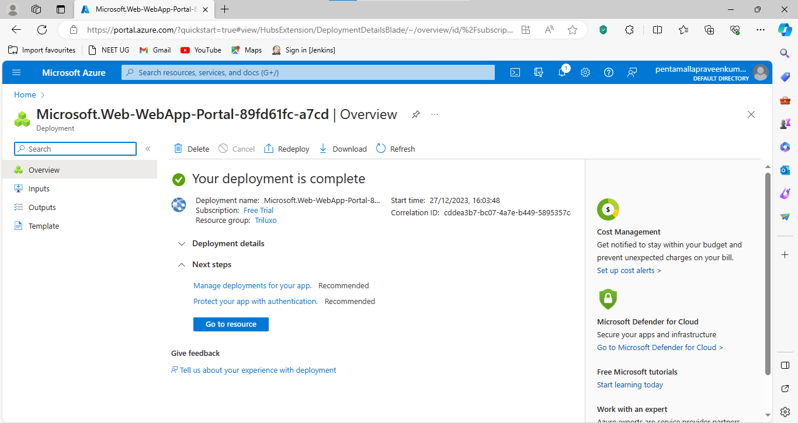

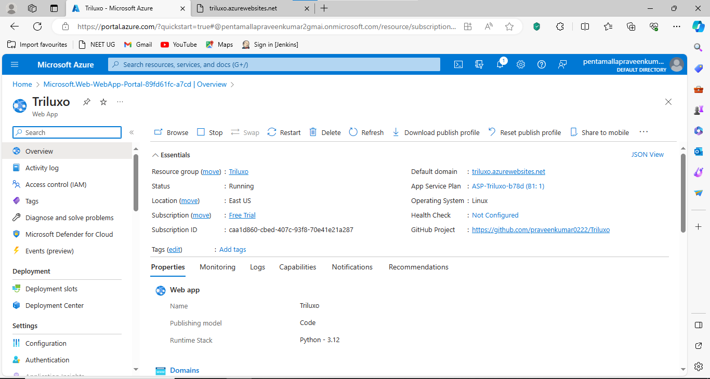

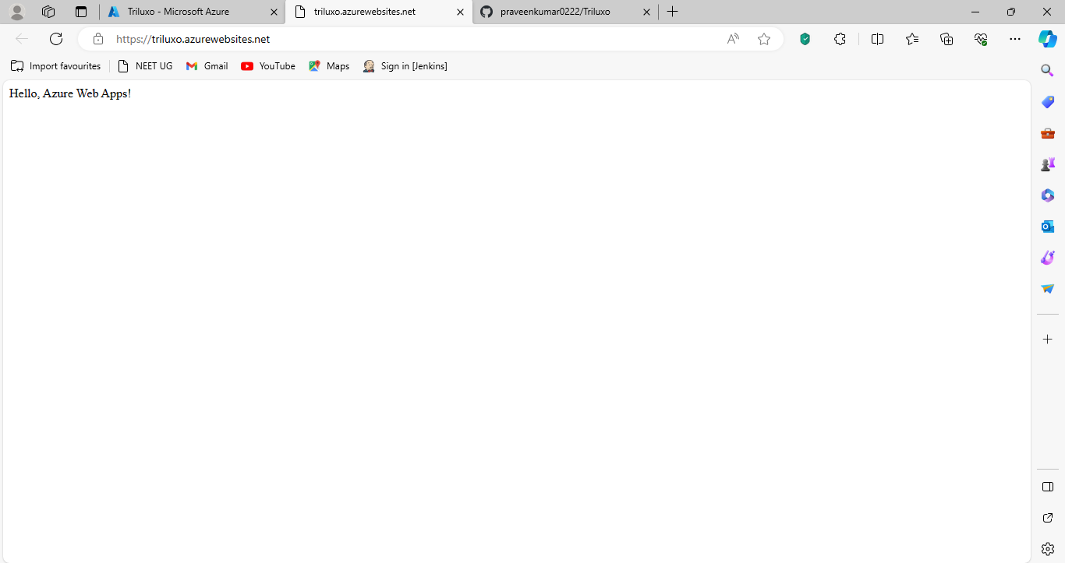

**Deployment URL:** [triluxo.azurewebsites.net](https://triluxo.azurewebsites.net/) or https://triluxo.azurewebsites.net/