Steps for installing Terraform, AWS account with security credentials, Keypair :-

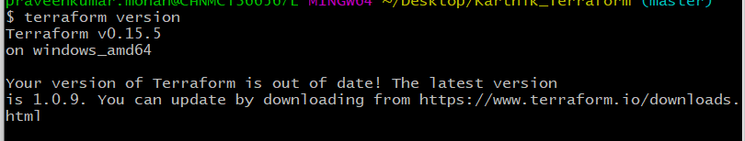





## 

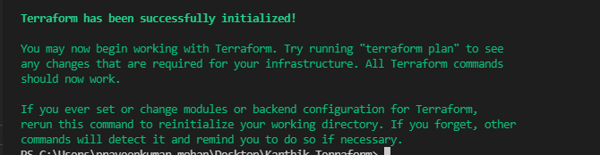

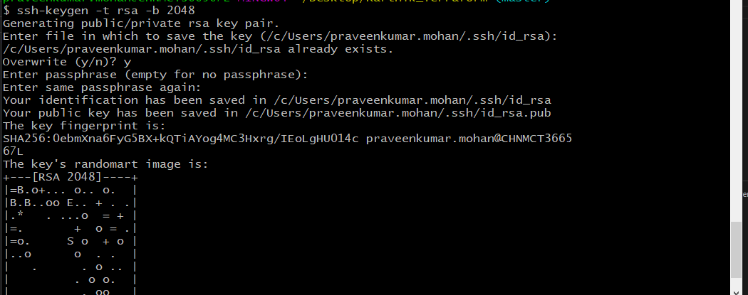

# Launch an EC2 instance using Terraform

Using aws instance resource to spin up the aws instance in console

resource "aws_instance" "instance" {

ami = var.ami

instance_type = "t2.micro"

key_name= "aws_key"

vpc_security_group_ids=[aws_security_group.main.id]

provisioner "remote-exec" {

inline = ["sudo apt-get update","sudo apt install python3 -y",

"sudo apt-get install ansible -y","sudo apt-get update -y",

"sudo apt-get update -y","sudo apt-get update -y",]

on_failure = "continue"

connection {

type = "ssh"

host = self.public_ip

user = "ubuntu"

private_key = file("/home/ec2-user/environment/Karthik_Terraform/aws_key")

timeout = "4m"

}

}

provisioner "local-exec" {

command = "sudo ANSIBLE_HOST_KEY_CHECKING=False sudo ansible-playbook -u ubuntu --private-key ./aws_key -i '${aws_instance.instance.public_ip},' master.yml"

}

lifecycle {

prevent_destroy = false

}

}

resource "aws_key_pair" "deployer" {

key_name = "aws_key"

public_key = "use your public key which you generator"

}

# Connect to the instance

We have Private key and public key so we will use "aws_key_pair" "deployer" resource to share public key

And use our privare key to login below screenshot for your reference



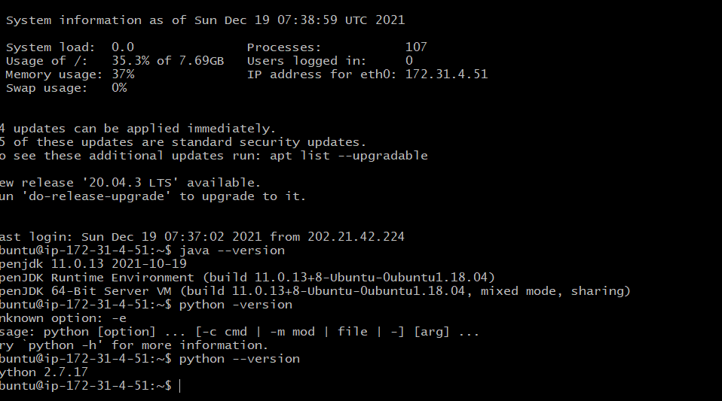



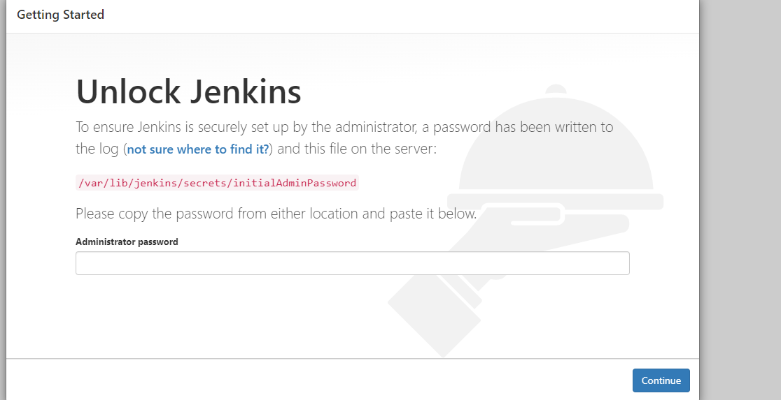

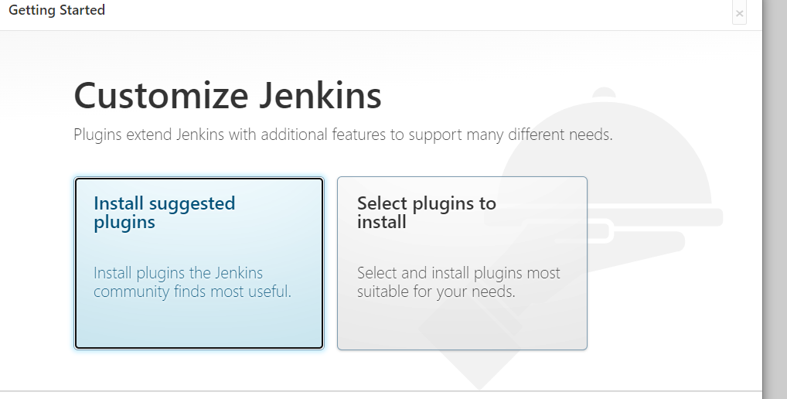

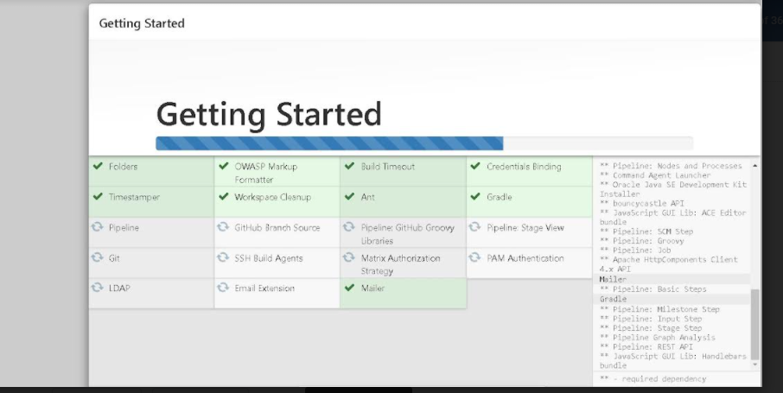

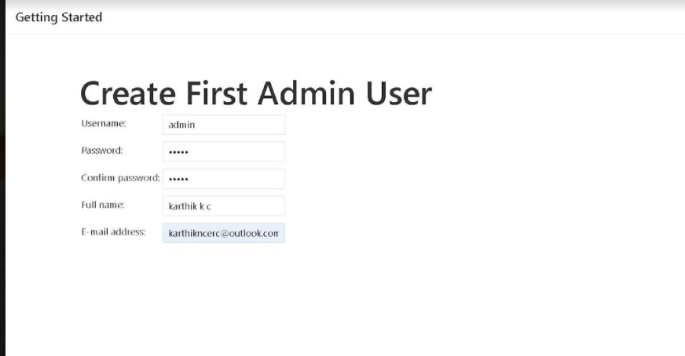

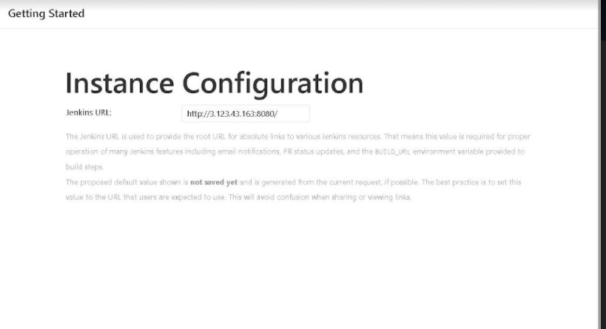

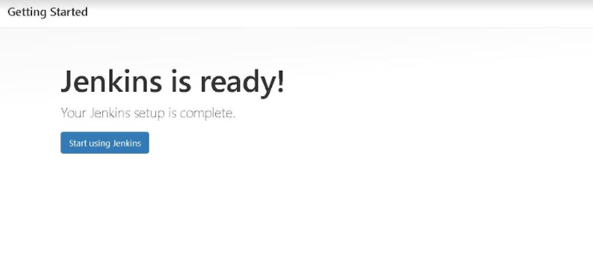

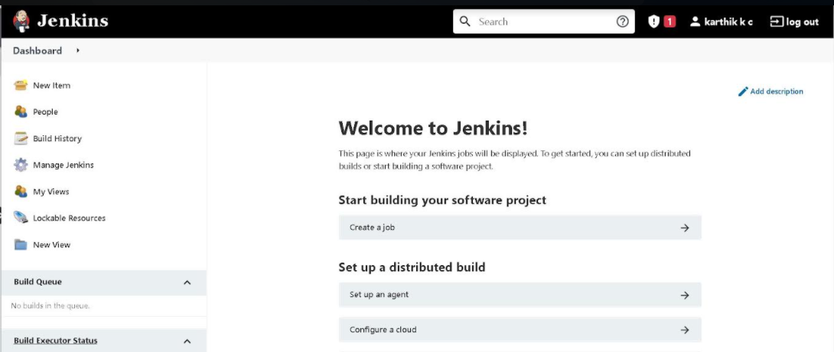

# Install Jenkins, Java, and Python in the instance

Install Jenkins , java and python in instances using ansible playbook master.yml file

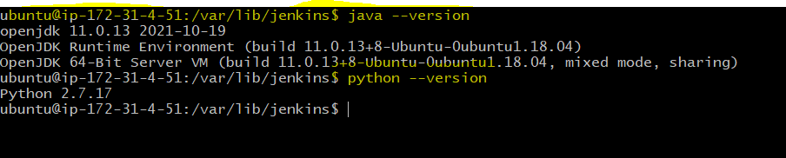

---

- hosts: all

remote_user: ubuntu

become: yes

tasks:

- name: Update APT package manager repositories cache

become: true

apt:

update_cache: yes

- name: Install Java using Ansible

become: yes

apt:

name: "{{ packages }}"

state: present

vars:

packages:

- openjdk-11-jdk

tasks:

- name: ensure the jenkins apt repository key is installed

apt_key: url=https://pkg.jenkins.io/debian-stable/jenkins.io.key state=present

become: yes

- name: ensure the repository is configured

apt_repository: repo='deb https://pkg.jenkins.io/debian-stable binary/' state=present

become: yes

- name: ensure jenkins is installed

apt: name=jenkins update_cache=yes

become: yes

- name: ensure jenkins is running

service: name=jenkins state=started

- name: Install Python

raw: apt -y update && apt install -y python-minimal

when: check_python.rc != 0