**CURRICULUM VITAE**

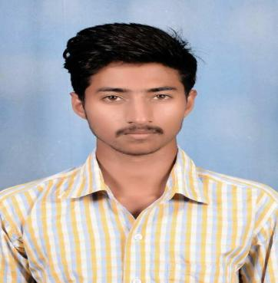

# PRAVEEN KUMAR K S

# Mobile: 9591384035

# Email:praveen1si18ec416@gmail.com

**CAREER OBJECTIVE**

To utilize my technical skills for achieving the target and developing the best performance in the organization .I would like to implement my innovative ideas, skills and creativity for accomplishing the projects.

**TRAINING**

* **Industrial Training** on “ **Automate identification and recognition of handwritten text from an image**” at **TCS-iON** in SIT Tumkuru for 45 days.
* **In Plant Training** on “**PCB Designing**” at **3N Electronics Pvt. Ltd.** in Sathyamangala Industrial Area ,Tumkuru for 1 week.

**TECHNICAL SKILLS**

* Time Management.
* Team Work.
* Hard Working.
* Good Knowledge on C.

**EDUCATION**

# BE in Electronics and Communication Engineering from Siddaganga Institute Of Technology, Tumkuru (CGPA : 7.15).

* **Diploma** in **Electronics and Communication Engineering** from **Siddaganga Polytechnic, Tumkuru (77.26%).**
* **S.S.L.C** in **Sumathi English School, Kyathasandra, Tumkuru (62.56%).**

**PROJECTS**

* **Smart Road Safety And Vehicle Accident Prevention System For Curve Roads.**

**Description:**

The main Aim of this project is to alert the driver about the vehicle coming from the other side. This is done by keeping the Ultrasonic Sensor on both sides of the road before the curve and keeping LED light after the curve, so that vehicles coming from the one side of the road are sensed by the ultrasonic sensor and LED light glows at the opposite side. By looking at the LED light driver become alert and slow down the speed of the vehicle.

**HOBBIES**

* Playing Cricket and Badminton.

**PERSONAL DETAILS**

Name: **Praveen Kumar K S**

Father’s Name: **K N Shivashankar**

Mother’s Name: **Anitha A M**

Date Of Birth: **05-june-1998**

Gender: **Male**

Nationality: **Indian**

Languages Known: **English, Kannada**

Permanent Address: **Behind BESCOM Quatress CM Extn, Kyathsandra,Tumkuru-572104.**

**DECLARATION**

I hereby declare that the above information furnished is true to the best of my knowledge and belief.

# Place: Tumkur Signature:Praveen ks