Online Learning Platform using MERN - Project Documentation

# Introduction

* + **Project Title**: Online Learning Platform using MERN

## Team members:

* + - Dharmalingam Praveen Kumar
    - Akash K
    - Gunalan K
    - Ashok Kumar P

# Project Overview

## Purpose:

The goal of this project is to create an online learning platform that offers a wide variety of courses. Students can access courses, track progress, and earn certificates, while instructors can upload and manage courses, and admins can oversee the platform’s operation.

## Features:

* + - **User Registration**: Allows students and instructors to create and manage accounts.
    - **Course Management**: Instructors can create, update, and delete courses.
    - **Student Dashboard**: Students can browse, enroll in, and track courses.
    - **Interactive Learning**: Includes discussions, quizzes, and assignments.
    - **Certification**: Students receive certificates upon course completion.
    - **Payment Gateway**: For purchasing paid courses.
    - **Admin Dashboard**: Admins can manage users, courses, and platform settings.

# Architecture

## Frontend:

The frontend is built using **React.js** for creating a dynamic and responsive user interface. The application uses **Material-UI** and **Bootstrap** for styling and provides an interactive user experience.

## Backend:

The backend is built using **Node.js** and **Express.js**, which manage server-side operations, including user authentication, course management, and communication between the frontend and database.

## Database:

The database is **MongoDB**, a NoSQL database that stores user information, courses, and progress in a flexible format. The backend interacts with the database using **Mongoose**.

# Setup Instructions

## Prerequisites:

1. **Node.js**: JavaScript runtime to run backend code.
2. **MongoDB**: Database to store user and course data.
3. **Vite**: For frontend development and build optimization.
4. **React.js**: Library for building the user interface.

## Installation:

1. Clone the repository:

https://github.com/praveenkumar262/Online-Learning-Platform-Mern.git

1. Navigate to the project directory: cd OnlineLearningPlatform
2. Install frontend dependencies: cd frontend && npm install
3. Install backend dependencies: cd ../backend && npm install
4. Set up environment variables for both frontend and backend (e.g., MongoDB connection URL, JWT secret, etc.).

# Folder Structure

## Client (Frontend):

* + - src/: Contains the React components and pages for the platform.
    - public : Static assets like images and fonts.

## Server (Backend):

* + - controllers/: Logic for handling requests.
    - models/: Defines the database schema.
    - routers/: API route handlers.
    - config : Database and environment variable configurations.

# Running the Application

## Frontend:

To run the frontend development server, navigate to the frontend folder and use:

npm start

## Backend:

To run the backend development server, navigate to the backend folder and use:

npm start

# API Documentation

## POST /login:

* + - **Request**:
      * email: User’s email.
      * password: User’s password.

## Response:

* + - * token: JWT token for authentication.

## GET /courses:

* + - **Request**: None.
    - **Response**: List of all available courses.

## POST /courses:

* + - **Request**:
      * course_name: Name of the course.
      * description: Course description.

## Response:

* + - * course: Newly created course object.

# Authentication

## JWT Authentication:

Users log in using their email and password. If successful, a JWT token is generated and sent to the user. This token is used for subsequent API requests to authenticate and authorize access to protected routes.

# User Interface

## Login Page:

Simple and clean UI for user login with form validation.

## Dashboard:

Displays enrolled courses, course progress, and the ability to enroll in new courses.

## Course Page:

Shows course details, modules, and the option to start or continue learning.

# Testing

## Unit Testing:

* + - Jest and React Testing Library for testing React components.
    - Mocha and Chai for backend API testing.

## Integration Testing:

Ensures that frontend and backend systems communicate effectively, especially for user authentication and course enrollment.

# Screenshots or Demo

Landing Pages:



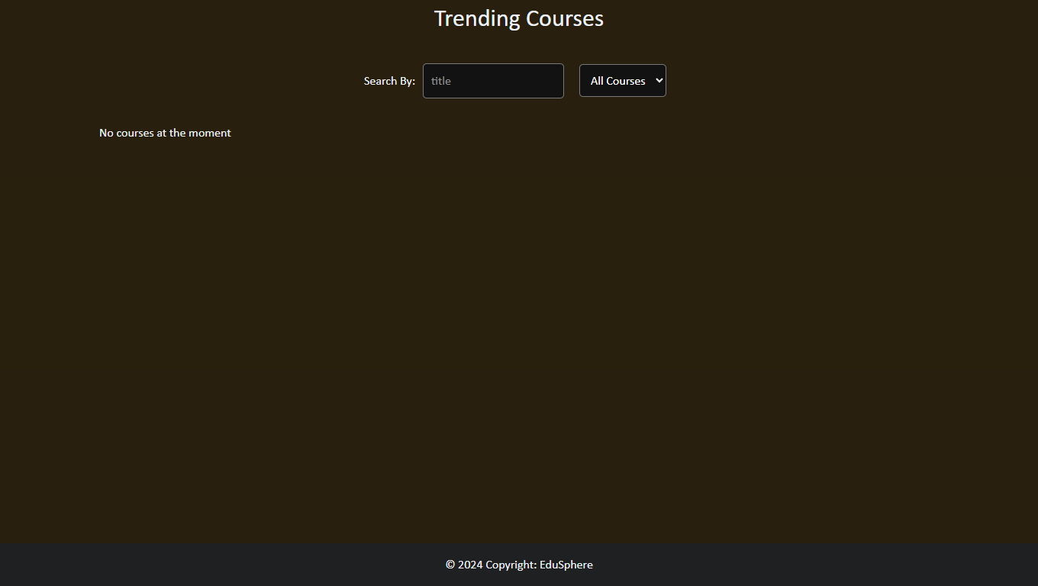

Login Page:

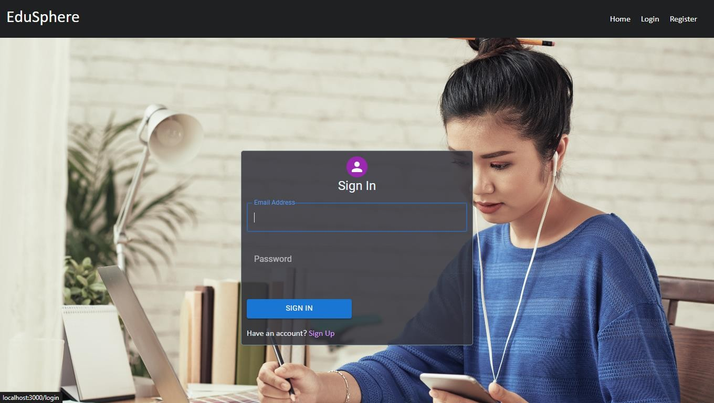

Register Page:

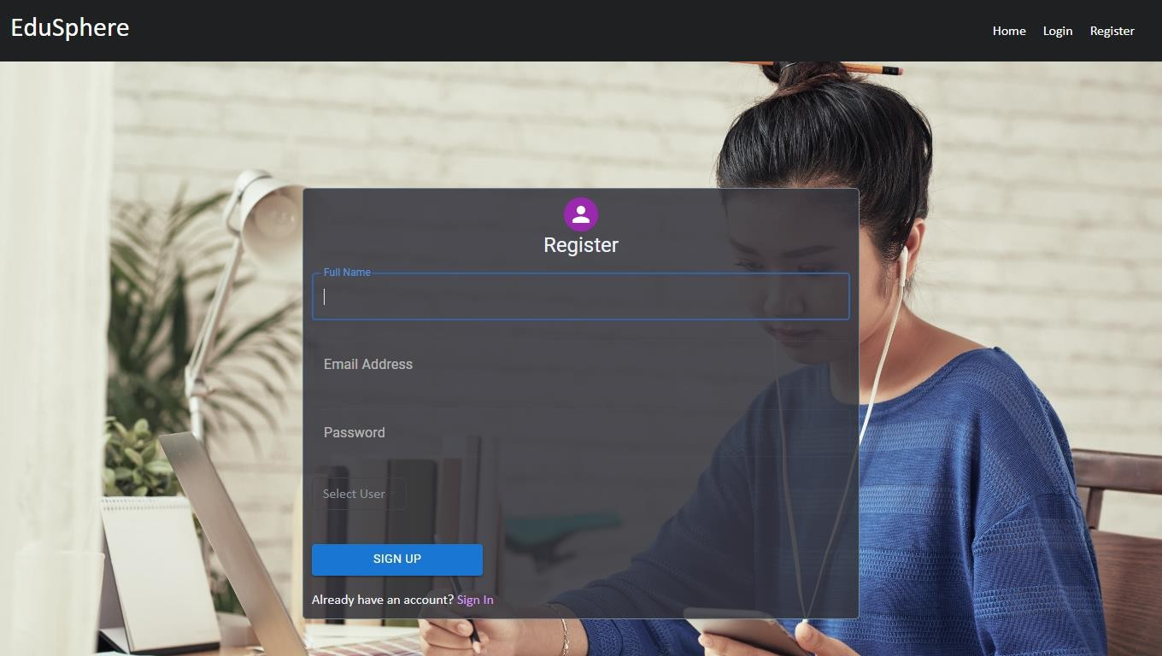

Admin Dashboard:

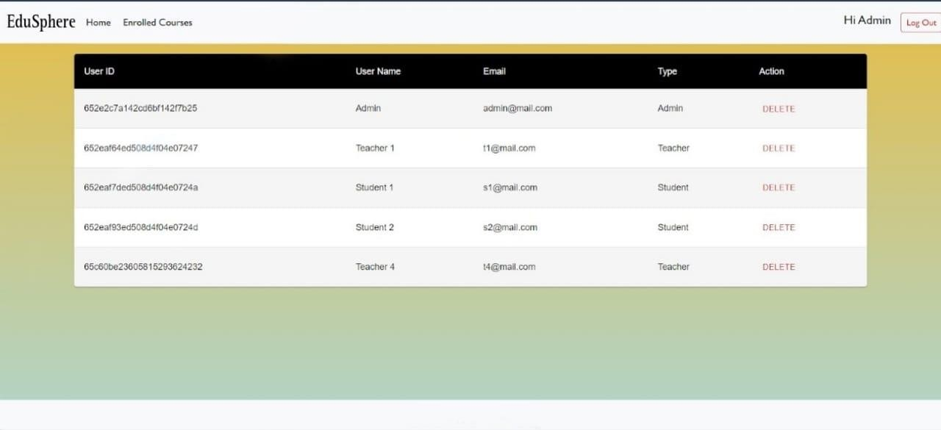

Teacher Dashboard:

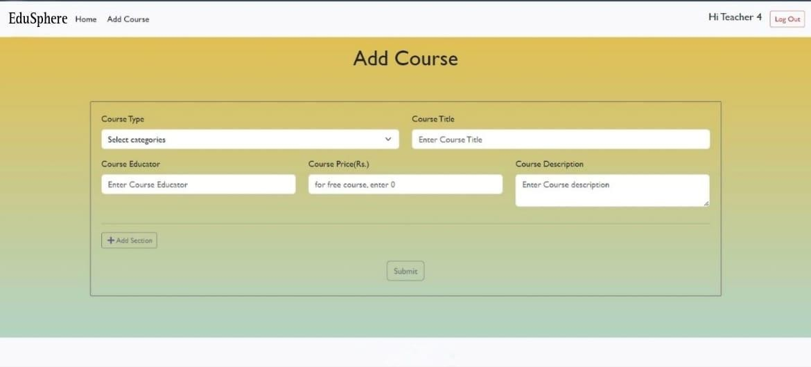

Student Dashboard:

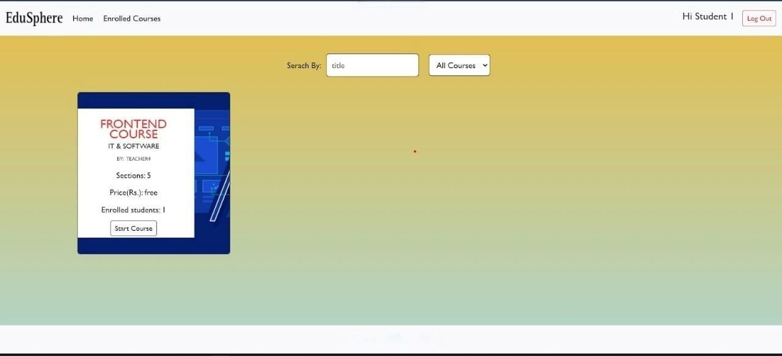

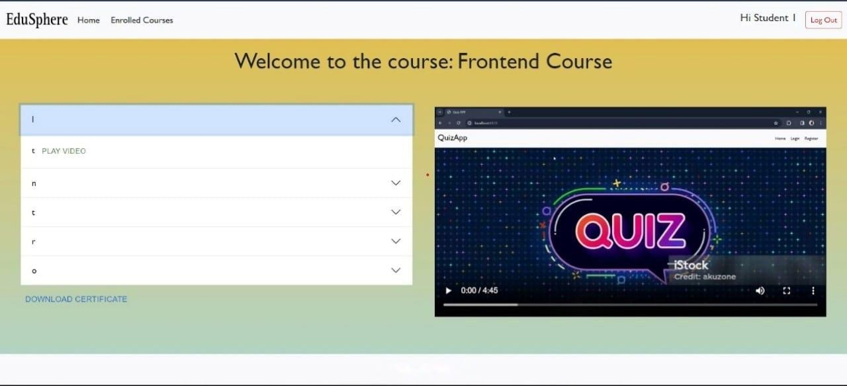

# Known Issues

* + Document any bugs, limitations, or areas needing improvement, such as performance issues with large data sets or specific edge cases in the shopping cart functionality.

# Future Enhancements

## Mobile App:

A mobile version of the platform for better accessibility.

## Advanced Analytics:

Add detailed analytics and reporting features for both students and instructors.