**3.Matplotlib**

* Matplotlib is a python library which is used for visualization and analysis purpose. Matplotlib is a cross-platform, data visualization and graphical plotting library (pie charts, scatter plots, bar charts, etc).
* It is having a pyplot as subpackage in matplotlib
* We can import matplotlib by using

Import matplotlib.pyplot as plt

**Ex:(plot)**

a=[13,23,29,26,80]

b=[1,2,3,4,5]

plt.plot(b,a)

plt.show()

**Output:**

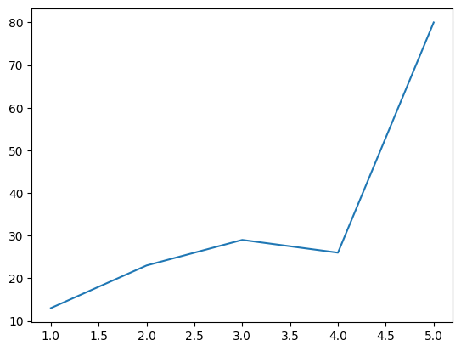

**Problem-1:**

Runs scored by 10 new players [100,50,91,78,89,25,34,19,9,10] wickets taken by same 10 new players[1,0,2,0,3,7,8,9,7,5] from clusters for batsmen and bowlers

**Code:**

runs=np.array([100,50,91,78,89,25,34,19,9,10])

wickets=np.array([1,0,2,0,3,7,8,9,7,5])

plt.scatter(runs,wickets,color='m',marker='+')

plt.show()

**Output:**

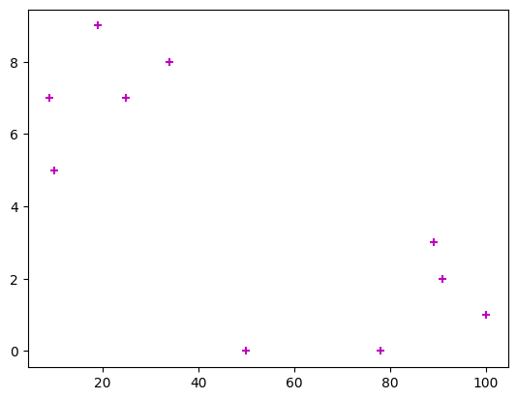

**- color reference**

r-red c-cyan g-green w-white k-black b-blue m -magenta y-yellow

**- linestyle**

: - dotted line

**- marker type**

H-hexagon,<,>,+,P-plus,d-diamond,x-X,O-circle,.-point,','-pixel,s-square

**Problem-2:**

Plot the scores of 2 students in 5 different subjects subjects as x axis and marks as y axis.

**Code:**

student1=[56,78,92,95,78]

student2=[77,89,91,23,45]

subjects=["maths","telugu","hindi","english","social"]

plt.plot(subjects,student1,label="student1")

**#labels are used to create a legend which describes the line**

plt.plot(subjects,student2,label="student2")

plt.title("students vs marks")

plt.legend()

plt.show()

**Output:**

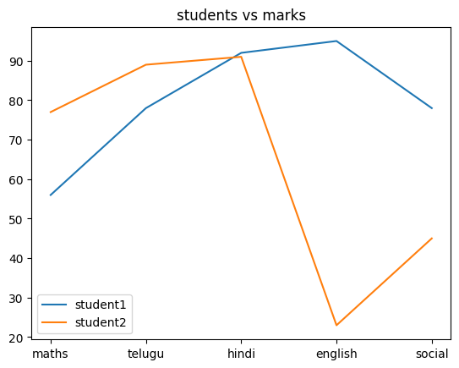

**Creating Subplots:** We have to use plt.subplot(2,1,1) #(rows,columns,positions)

**Problem-3:**

plot the subplots for scores of 2 students in 5 different subjects, subjects as x axis and marks as y axis.

**Code:**

student1=[56,78,92,95,78]

student2=[77,89,91,23,45]

subjects=["maths","telugu","hindi","english","social"]

plt.subplot(2,1,1)

plt.plot(subjects,student1,label="student1",color="m")

plt.legend()

plt.subplot(2,1,2)

plt.plot(subjects,student2,label="student2")

plt.legend()

plt.show()

**Output:**

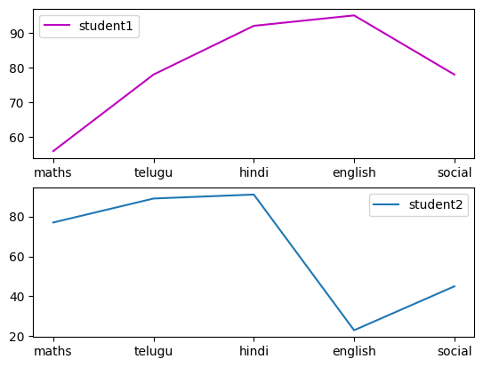

**Problem-4:(Bar graph)**

create subplots showing the profits of two companies

- revenue of company a and b in lakhs

- plt.bar()

|  |  |  |
| --- | --- | --- |
| Year | A | B |
| 2019 | 230 | 200 |
| 2020 | 560 | 160 |
| 2021 | 780 | 270 |
| 2022 | 127 | 127 |
| 2023 | 128 | 400 |

**Code:**

revenue_a=np.array([230,560,780,127,128])

print(revenue_a)

profit_a=np.diff(revenue_a)

print(profit_a)

revenue_b=np.array([200,160,270,127,400])

print(revenue_b)

profit_b=np.diff(revenue_b)

print(profit_b)

years=["19-20","20-21","21-22","22-23"]

plt.subplot(2,1,1)

plt.bar(years,profit_a,label="company A",color="k")

plt.legend()

plt.subplot(2,1,2)

plt.bar(years,profit_b,label="company B",color="g")

plt.legend()

plt.show()

**Output:**

[230 560 780 127 128]

[ 330 220 -653 1]

[200 160 270 127 400]

[ -40 110 -143 273]

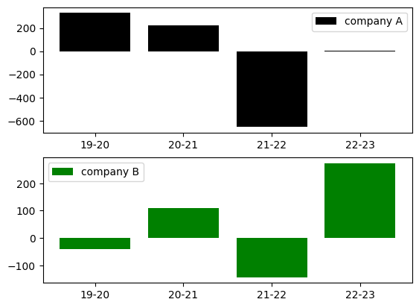

**#pie chart**

a=np.array([25,60,6,9])

labe=["AIML","PYTHON","NUMPY","PANDAS"]

plt.pie(a,labels=labe)

plt.show()

**output:**

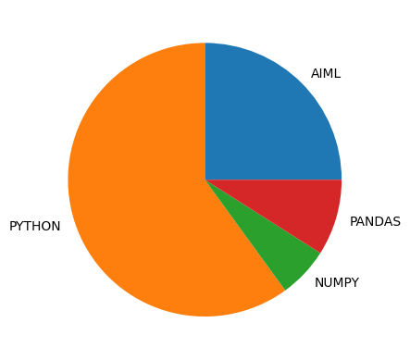

**Ex:**

a=np.array([25,60,6,9])

labe=["AIML","PYTHON","NUMPY","PANDAS"]

explo=[0.1,0,0,0]

plt.pie(a,labels=labe,explode=explo,startangle=180,shadow=True)

plt.legend()

plt.show()

**Output:**

