**Milestones –**

A milestone is an important event that signifies progress in a project. They are checkpoints which can propel a project towards completion. Milestones planning help project the progress of the report. Milestones not only includes deliverables but may also include deadlines or approvals. Following are the planned milestones for the project -

* Gathering complete user requirements and analyzing Moscow, SWOT, Budget, Risks and Budget plan.
* Completing the design ( planning the UI design and wireframe , application functionality, animations ).
* Initial Delivery - Integrating the UI/UX concept and development plan to create a working structure.(phase 1)
* Completing the testing, changes and updates based on feedback and additional features.(phase 2)
* Documenting all the technical, functional features as per the requirements.
* Deployment of the application.

Project plan -

Network%20plan.pdf

Network%20plan%20page%202.pdf

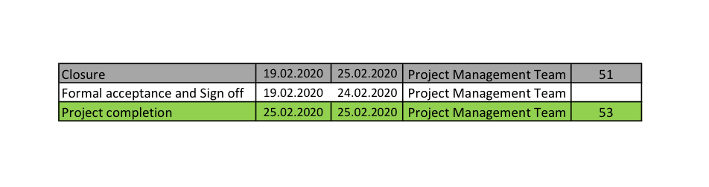

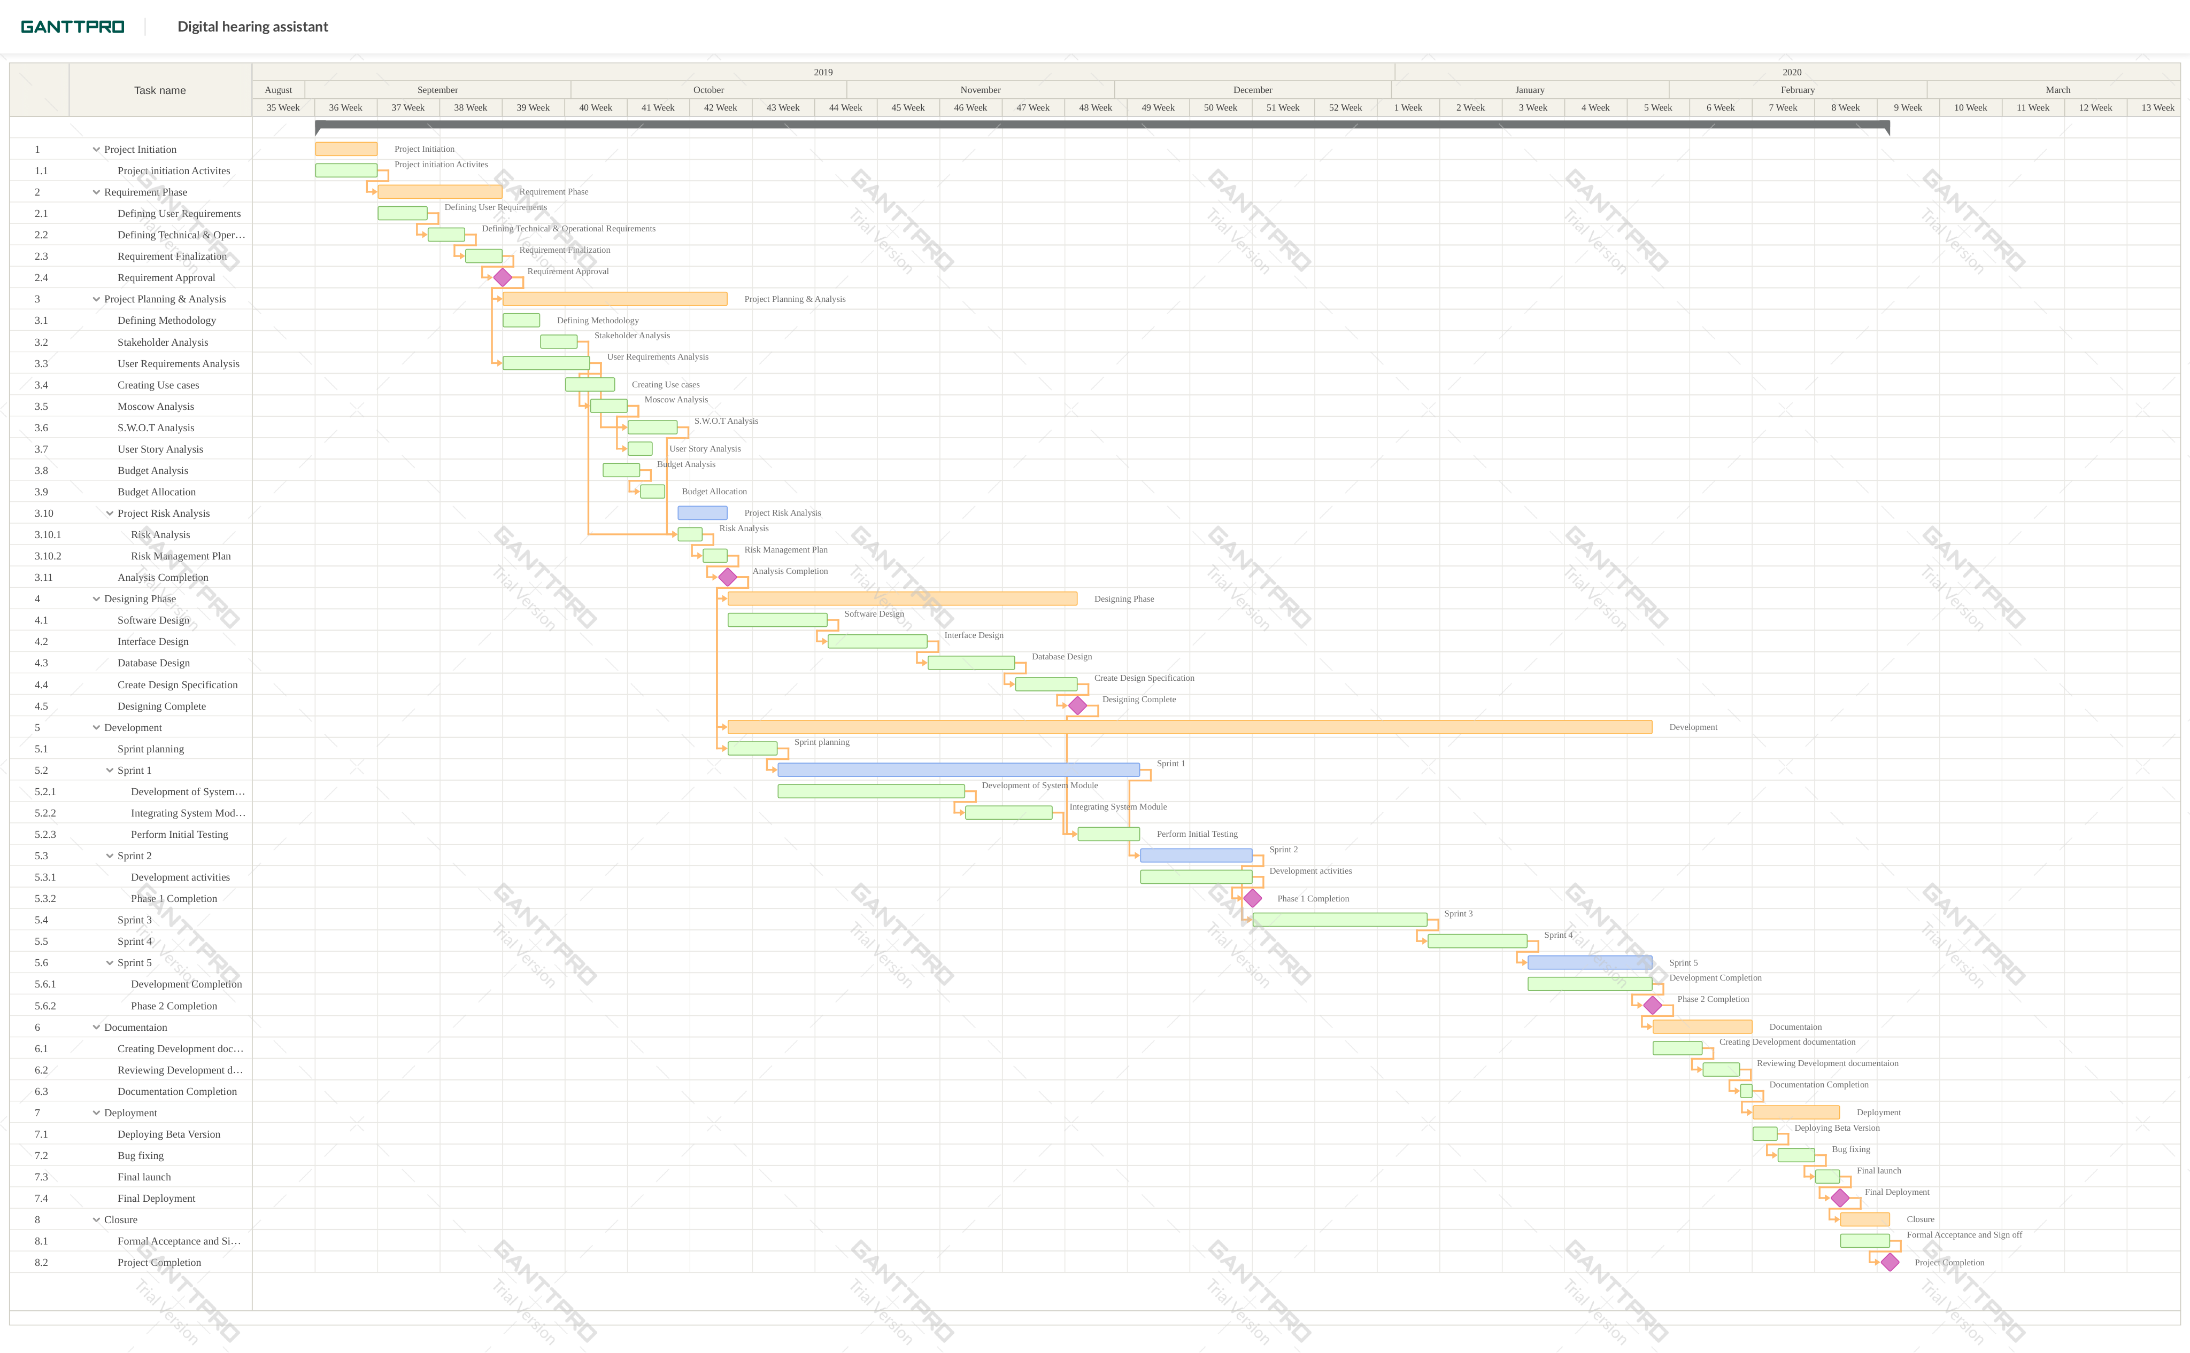

Figure shows the structure of the Network Plan. The Network Plan/ Gantt Chart is used to breakdown the project management phases into various work packages/activities and defines the milestones with timelines.