UNDERWATER WIRELESS SENSOR NETWORKS USING ENERGY EFFICIENT AND CO OPERATIVE ROUTING

Report submitted to the SASTRA Deemed to be

University as the requirement for the course

CSE302: COMPUTER NETWORKS

Submitted by

M.P.HARSHINI

(Reg. No.: 224003169, 3rd - Year)

COMPUTER.

February 2021


SCHOOL OF COMPUTING

THANJAVUR, TAMIL NADU, INDIA – 613 401

i



SCHOOL OF COMPUTING

THANJAVUR, TAMIL NADU, INDIA – 613 401

Bonafide Certificate

This is to certify that the report titled “An Efficient Routing Protocol for Underwater Wireless Sensor Networks ” submitted as a requirement for the course, CSE302: COMPUTER NETWORKS for B.Tech. is a bonafide record of the work done by

Shri. MALEPATI NAGENDRA DEEPAK, Reg. No.122015058, Information Technology during the academic year 2020-21, in the School of Computing.

Project Based Work Viva voce held on 18/02/2021.

Examiner 1 Examiner 2

ii
TABLE OF CONTENTS

BONAFIDE CERTFICATE ii

LIST OF FIGURES iv

LIST OF TABLES vi

NOTATIONS vii

ABBREVIATIONS viii

ABSTRACT ix

PROBLEM STATEMENT x

CHAPTER 1 1

INTRODUCTION 1

1.1 RELATED WORKS 4

1.2 PROPOSED WORK 7

1.3 MERITS & DEMERITS 15

CHAPTER 2 16

SOURCE CODE 16

CHAPTER 3 26

SNAPSHOTS 26

CHAPTER 4 34

PERFORMANCE EVALUATION 34

CHAPTER 5 40

CONCLUSION AND FUTURE ENHANCEMENTS 40

CHAPTER 6 41

REFERENCES 41

iii
List of Figures

Figure | Figure Name |  | Page
No. |  |  | No.
1.1. | Network Architecture |  | 2
1.2. | Applications of UWSNs |  | 3
1.2.1. | Network Architecture (UWSNs) |  | 8
1.2.2. | Network with two embedded sinks. |  | 9
3.1. | 100 Nodes and 6 sink nodes plotted |  | 26
3.2. | Delivery status and route of packet transmission of 1st node to 5th node |  | 27
3.3. | Delivery status and route of packet transmission of 6th | node to 10th | 27
3.3. | node |  | 27
3.4. | Delivery status and route of packet transmission of 11th | node to 15th | 28
3.4. | node |  | 28
3.5. | Delivery status and route of packet transmission of 16th | node to 20th | 28
3.5. | node |  | 28
3.6. | Delivery status and route of packet transmission of 21st | node to 25th | 29
3.6. | node |  | 29
3.7. | Delivery status and route of packet transmission of 26th | node to 30th | 29
3.7. | node |  | 29
3.8. | Delivery status and route of packet transmission of 50th | node to 54th | 30
3.8. | node |  | 30

iv
Figure | Figure Name |  | Page
No. |  |  | No.
3.9. | Delivery status and route of packet transmission of 61st | node to 65^{h} | 30
3.9. | node |  | 30
3.10. | Delivery status and route of packet transmission of 71st | node to 75th | 31
3.10. | node |  | 31
3.11. | Delivery status and route of packet transmission of 81st | node to 85th | 31
3.11. | node |  | 31
3.12. | Delivery status and route of packet transmission of 86th | node to 90th | 32
3.12. | node |  | 32
3.13. | Delivery status and route of packet transmission of 91st | node to 95th | 32
3.13. | node |  | 32
 | Delivery status and route of packet transmission of 97th | node to 100th
3.14. | node and average E2ED, throughput and PDR is also displayed |  | 33
4.1. | Graph between PDR and transmission |  | 37
4.2. | Graph between throughput range and transmission range |  | 37
4.3. | Graph between E2ED and transmission range |  | 37
4.4. | Graph between PDR and number of nodes |  | 39
4.5. | Graph between throughput and number of nodes |  | 39
4.6. | Graph between E2ED and number of nodes |  | 39

v
List of Tables

Table | Table Name | Page
No. |  | No.
4.1. | Parameters and their values used in the simulation | 34
4.2. | PDR, Throughput and E2ED for different node transmission range | 35
4.3. | PDR, Throughput and E2ED for different node transmission range | 36
4.4. | PDR, Throughput and E2ED for different number of nodes | 38

vi
NOTATIONS

Notation Description

Ed

Euclidean distance

Dlk

Distance between node l and node

Pforwarders

PFNs which are considered ad forwarders

vii

ABBREVIATIONS

E2ED End-to-end delay

PDR Packet Delivery Ratio

PFN Potential Forwarding Node

UWSN Underwater Wireless Sensor Network

WSN Wireless Sensor Network

viii

ABSTRACT

Wireless Sensor Network (WSN) may be a self-contoured gathering of spatially distributed and firm sensors with less framework that monitor and record the physical conditions of the surroundings and cooperatively pass the data through the network to a central location or sink wherever the data is noticed and analyzed.

Underwater environment is a demanding factor in the monitoring of underwater, coastal protection, disasters and military supervision, and much else. Underwater Wireless Sensor Networks (UWSNs) have a crucial role to play.

The multi-channel propagation, small bandwidth available, a long propagation delay, small energy resources and dynamic topology Present many difficulties for these networks.

Many routing protocols have been designed to address these problems and further improve the performance of the existing protocols.

A secure and speedy routing protocol is proposed in this work. The number of Potential forwarding nodes (PFNs) of the forwarder node and the shortest path from the forwarder to the closest sink are taken into account.

The PFNs of the forwarder also limits the prevention of void hole. In certain areas of the network with a high traffic density, two sinks are used to lower the network latency.

Subject to a distance between them and the transmission range, forwarders can pick their next destination from the sink node to the next neighboring node. The results of simulations suggest that the protocol is confirmed by a high packet delivery ratio (PDR), a lower end-to-end delay (E2ED) and a high throughput.

ix
PROBLEM STATEMENT

Underwater environment is a demanding factor in the monitoring of underwater, coastal protection, disasters and military supervision, and much else. Underwater Wireless Sensor Networks (UWSNs) have a crucial role to play.

The multi-channel propagation, small bandwidth available, a long propagation delay, small energy resources and dynamic topology Present many difficulties for these networks.

SOLUTION:

Many routing protocols have been designed to address these problems and further improve the performance of the existing protocols.

A secure and speedy routing protocol is proposed in this work.

The number of Potential forwarding nodes (PFNs) of the forwarder node and the shortest path from the forwarder to the closest sink are taken into account.

The PFNs of the forwarder also limits the prevention of void hole. In certain areas of the network with a high traffic density, two sinks are used to lower the network latency.

KEY WORDS: Routing protocol, wireless sensor networks, potential forwarding nodes (PFNs), transmission range, packet delivery ratio (PDR), end-to-end delay (E2ED), void hole.

x
CHAPTER – 1

INTRODUCATION

Underwater scrutiny cannot be shut since half of our world is filled by water. The rugged climate, high pressure, complex and poor visibility lead UWSNs to experience many difficulties. Furthermore, due to significant effects such as fouling and corrosion which affect the physical character of the sensor nodes the network longevity of underwater network devices is reduced.

UWSN is a network of independent sensor nodes spatially dispersed underwater to detect the characteristics of water and sensed data can be used in a variety of applications to support humans. They use acoustic communications signals, which are less reduced in water than conventional radio waves, which are significantly diminished in water.

Underwater connectivity is achieved primarily by means of a collection of nodes that relay their data through acoustic connections to buoyant port nodes, which transfer data through a set of rules understood to be protocols to the nearest coastal control and remote stations. These nodes collect and transfer data from the gate-like aquatic environment to offshore ports on the surface of the water, also called sinks.

There are sink nodes, anchored and relay nodes in the network architecture of the underwater world. As Fig.1 shows sink nodes are mounted on a water surface, while the relay nodes are transferred by water currents and located in various locations in water. It is used for transmitting and sensing purposes. At the bottom of the water anchored nodes that capture data from the subsurface are connected.

In anchored and relay nodes, acoustic links are used to communicate with each other and with sink nodes, and sink nodes use wireless connections to communicate with each other and the external base station and provide combined radio and acoustic modems.

If a packet enters the sink node and is sent to the outside base station, then it is transmitted successfully.

1
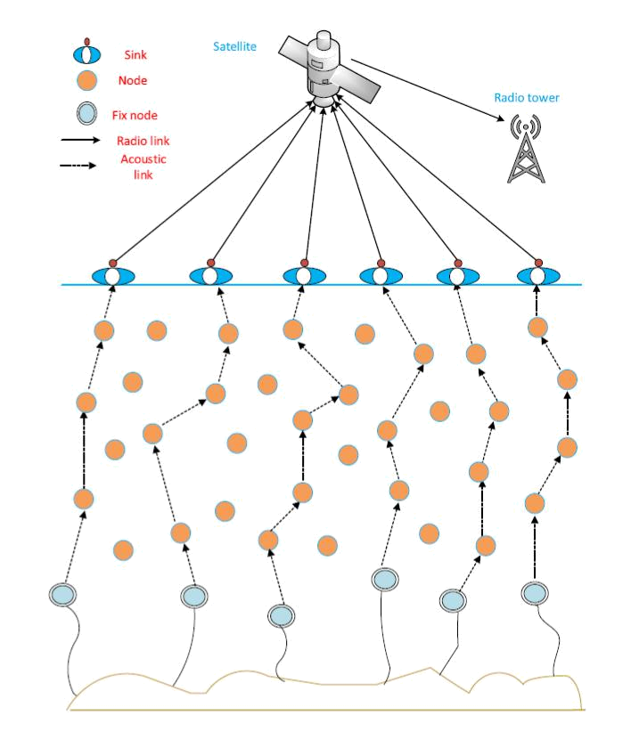

Fig: 1.1 :- Network Architecture

For UWSNs, numerous routing mechanisms were suggested. Professional routing protocols do not require complete location information unlike geographical routing protocols, only consider local sensor node depths whenever a packet arrives in a sensor node and uses sensor node depth information.

2

These routing protocols are however highly susceptible to a problem with void hole by excluding the second hop PFNs of the forwarder, which allow the routing mechanism to choose nodes with no additional PFNs, leading to a void hole and ultimately a decreased packet delivery rate.
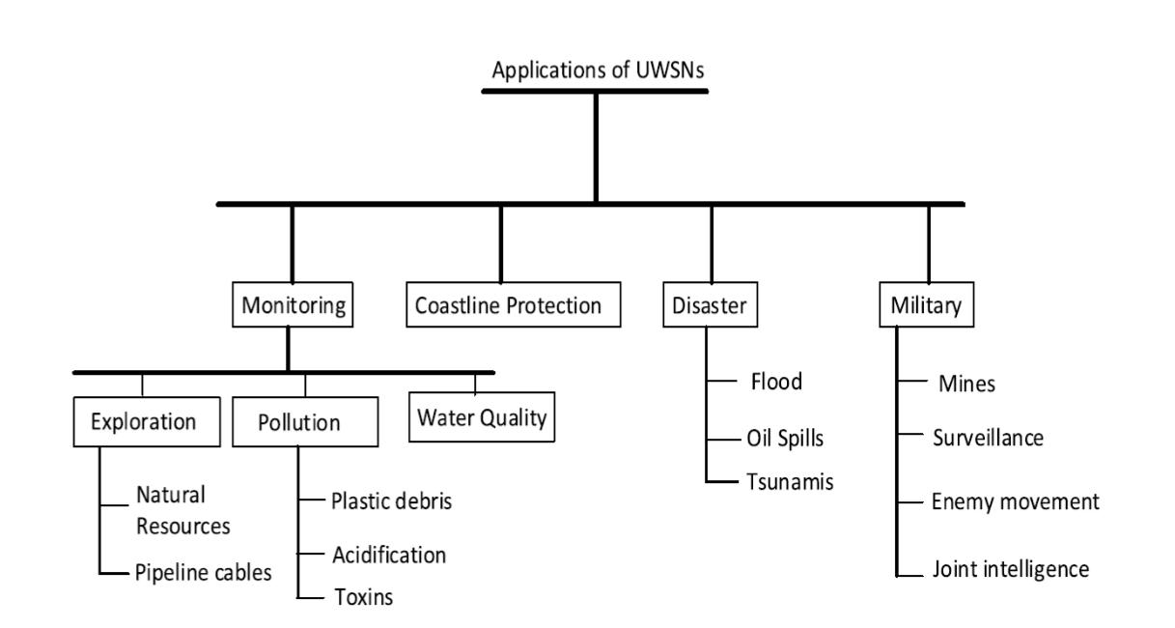

Fig: 1.2 :- Applications of UWSNs

3
CHAPTER – 1.1

RELATED WORK

UWSN routing protocols are split into geographical details, and geographical routing is free of charge. Many routing protocols that use sender and receiver node geographical details for the forwarding of data packets were introduced in current literature.

An underwater wireless sensor network (UWSN) is created by a community of sensor - connected acoustic nodes. In addition, sensor controls are a main component of the UWSN and is randomly used across the specified volume of the network for tracking, sensing, collection and transmission, because of the collaborative actions of sensing devices in the network: distant locations, physical climate, temperature, humidity, fighting areas, the oceans, volcanos and many more.

UWSN has small battery sensor nodes, which are critical in the creation of a routing strategy. In order to cut implementation and maintenance costs and prolong the network running period, the sustainable deployment of the sensor system also is needed.

UWSN routing protocols are divided into a geographically aware routing scheme. Many routing protocols that use sender and receiver node geographical details for the forwarding of data packets were introduced in current literature.

Saeed et. al (Saeed, 2020) proposed a Stable Energy Efficient and Cooperative Routing Protocol for UWSNs, which included a solid, effective, defensive mechanism to combat submarine attacks. It uses cooperative routing to improve network performance. The minimum formula for enforcing protection is used to keep it acceptable for submarine climate, considering the resource-restricted environment of UWSN.

The findings show that the number of living nodes, the transmission losses decreased by over 50%, the production rose by up to 9 per 100, the energy tax reduced by up to 23 % and the delay decreased by 25 percent.

There is a term called void hole generated because of a massive amount of energy consumption, which does not cause a forwarder node or node to die. This has

4

become a major networking problem, because most energy is used to build such void holes and because of the imbalance of the critical network implementation.

Hop vector routing approach is used under certain situations. The foundation of existing IP networks is Hop by Hop routing. This means that routing decisions are taken independently and locally on each router.

Therefore, even though a router is compromised it would not lead to a network outage. In fact, hop refers to the instrument that normally transfers the packet to a router.

Diverse protocols for avoiding void hole were suggested, of which a single hop selection based forwarding - weighting depth and forwarding area division-depth routing, which selects at least two optimal communication nodes to reduce the likelihood of the occurrence of vacuum hole, as well as preventing backward transmissions, has been developed, one of which was provided by Ahmad et al, (Ahmad, 2017).

Mobile sinks are placed on ships, vehicles etc. to reduce the data charges at intermediate nodes and retrieve data from the void areas.

To obtain interest information from the area of interest. The availability of mobile sinks allows the identification of minerals from waters that are not humanly monitorable, including but not limited to seabed surveys. A grid-based protocol, called powerful and efficient grid-based transformation by leveraging minimum hop count, is developed and evaluated by Al-Salti et. al (Al-Salti, 2019) and others (ERGR-EMHC).

This protocol partitions the network into a three-dimensional cell grid that is identified by the surrounding cells on the basis of their minimum hop count. Packets are distributed cell by cell through certain selected nodes known as cell heads.

Coutinho et. al (Coutinho, 2018) proposed to define the topology control algorithms using the main approach of modifying the topology of the network

Faheem et. al (Faheem 2017) suggested for UWSN the latest Quality of service-conscious evolutionary cluster based routing protocol (QERP).

The protocol suggested boosts PDR and decreases average electricity usage and total network energy.

5

A proposed energy-efficient adaptive cluster routing algorithm (ACUN), which utilizes a hierarchical multilevel network structure based on the distance between cluster heads, sinking kernel, and the cluster head's residual energy to assess competition radius scale, is proposed by Wan et al. (Wan, 2019).

Bu et. al (Bu, 2018) suggested a fluctuating logic vector-based routing protocol in which location information and sensor node energy information were all included in the desirability calculations. Moreover, parameters such as valid distance, projection, and battery node level are taken into consideration in the fluctuating logic system.

Energy Scaled and expanded vector-specific forwarding scheme Wadud et. al

(Wadud, 2017) proposes to increase holding hours by utilizing the residual energy of the node to the scale and the vector pipeline distance ratio.

There is a major change in the resulting reduction and extension of held time in all transmitting nodes in order to eliminate multiple transmission, which decreases electricity usage and energy balance in the network. It reduces holding time and rapidly transfers data packets upstream if a node is held at least between its neighbors.

Yu et. al (Yu, 2016) suggested an even more effective Depth Based Routing Protocol, called Weighting Depth and Forwarding Area Division-Depth Based Routing, weighting depth and forwarding area division.

The next forwarding nodes are chosen in this protocol according to the weighting total of the difference in depth of two hops, which takes into account not only the current de pth, but also the predicted next hop depth.

6
CHAPTER – 1.2

PROPOSED WORK

A packet transmission forms a source node, simply transmits the packet and then the packet is received by all sensor nodes in the transmission range. If the transmitting region involves a sink node, the packet is supplied effectively, and is passed directly to the base station.

In the absence of a sink node, the packet is passed to the next forwarder of the next node, and is continued until the packet reaches a sink node. A packet is missed if the transmitting range of the source node does not cover adjacent nodes.

PFNs are considered to pick the next forwarder node. If the sensor node is sending a packet, PFNs must forward it, help to improve reliability and reduce the possibility of a void hole incident, when the sensor node has no PFN, the packet is lost .

Nodes near the sink are like bridges between the sinks and the rest of the network; they are suffering from the high volume of traffic and relay the entire network packets. The nodes first hit the closest sink by the

Euclidean (Ed) formulation.
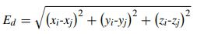

The packet will be successfully transmitted if the gap is beyond the transmitting range. If no sink node is located in the set, distances are measured and the shortest of the nodes is the forwarding system chosen. This process is continued before distribution or shipment failure is complete. If no PFNs are in the set, a packet would be lost.

NETWORK ARCHITECTURE:

The network structure (from the fig) involves sink nodes, relay nodes and fixed nodes.

7

As the names indicate, sink nodes on the surface of the water are often located on the water bottoms, which gather information from the water beneath the water where they are mobile and travel alongside water currents as the relay nodes randomly placed at various water points and are used for transmission and sensing.

Sink nodes are connected with radio connections where acoustic connections are used to communicate with each other and with the sink nodes as relay nodes and anchored nodes. If a packet enters a sink node further sent to the outside base station, it is successfully transmitted.
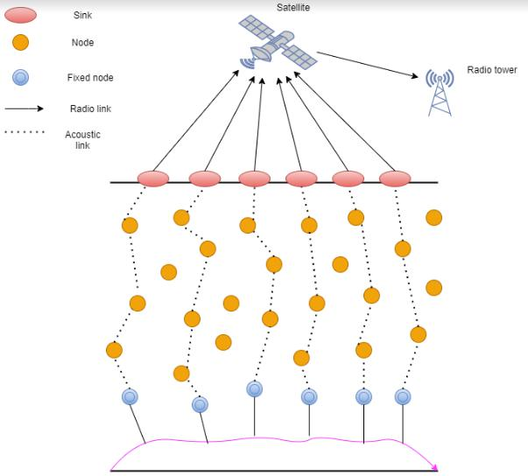

Fig: 1.2.1 :- Network Architecture

8
SINK DEPLOYMENT:

In network sensor networks, network traffic is a significant limitation, since there are two sinks at these high-density locations in the network region. Packets approaching a sink are called good packets because the packets can safely be sent to the base station.

If the nodes in high traffic areas transfer the received packet to the next sink rather than forward the packet further, high delivery ratio at very low cost can be achieved. Figure 2 displays a 2 embedded sink network.
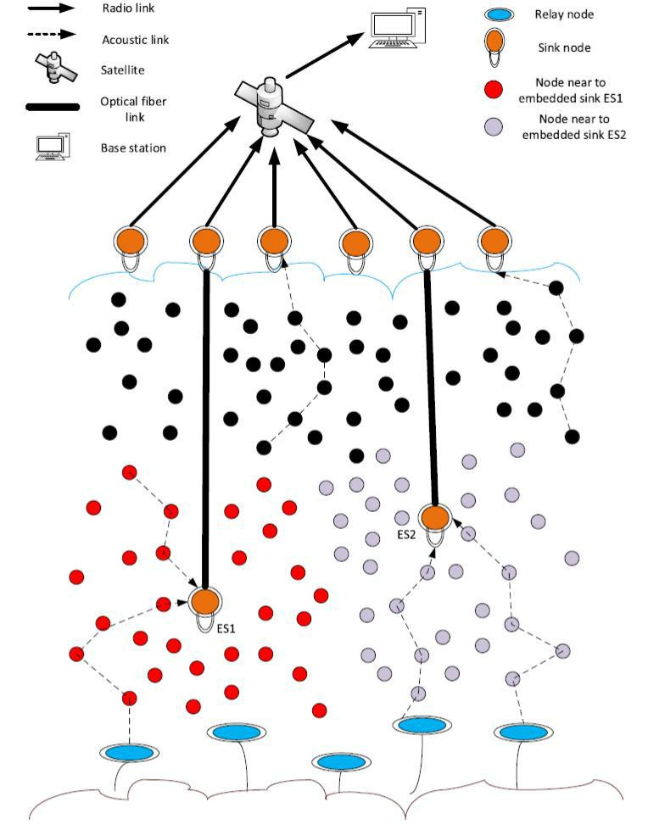

Fig: 1.2.2 :- Network with two embedded sinks.

9

ALGORITHM FOR THE SELECTION OF APTHOP TO BE TAKEN:
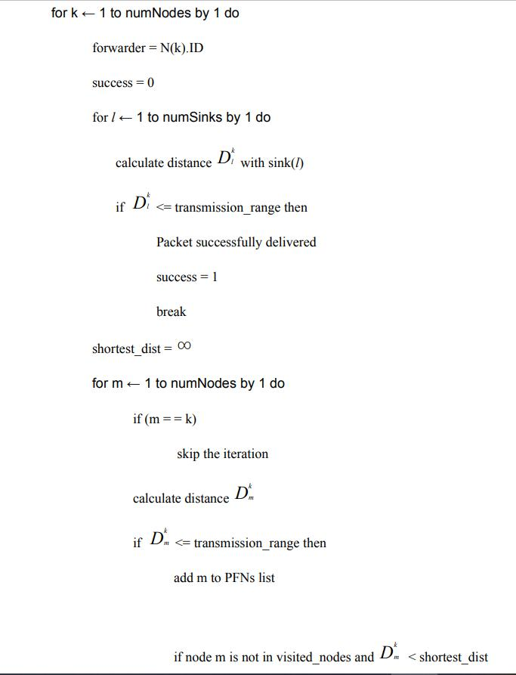

10

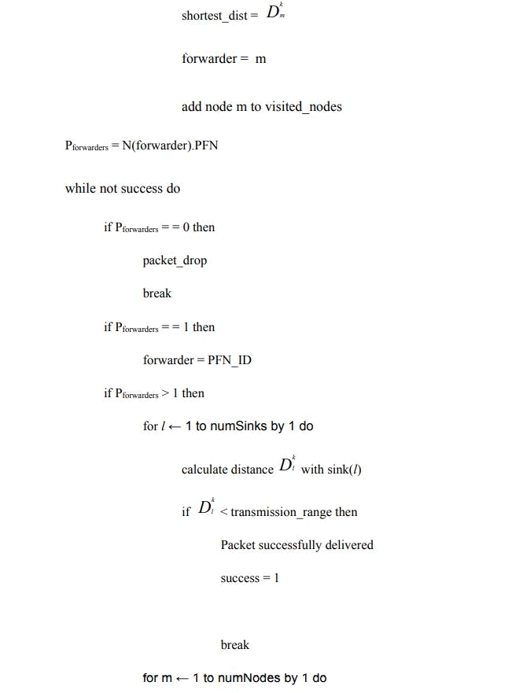

11
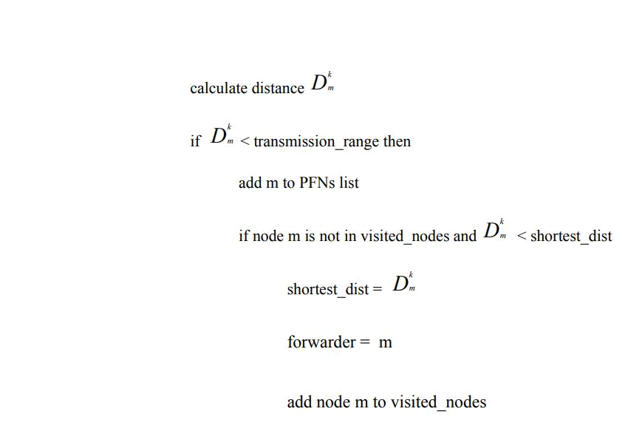

Let numNodes be the overall number and each node tries to send a packet into its nearest sink node, except sinks in UWSN.

In a loop from first node (k = 1) to last node (k = numNodes), let us consider each node transmitting a packet according to the distance between the nodes

The k^{th} node will be chosen step by step before the packet is successfully supplied to the sink node or the packet is lost:

Initialize the forwarder to k^{th} node, forwarder = N(k).ID
Initialize the success variable that reveals whether or not the packet was transmitted at the start with 0, that is, the packet has already not been delivered (success 12 P = 0).

If the success of the vector is equal to 1, the packet was sent successfully to the sink node.

12

We have to verify if there is a sink node within the transmitting range for the kth node such that the node can transfer the packet directly to the sink node in one hop.

- For the l = 1 loop, the distance between the k^{th} node and the l^{th} sink node is determined with Euclidean distance,

- Dl^{k} refers to the distance from k node to l sink node.

- If the packet is supplied successfully with a Dl^{k} < = transmitting range, the success vector is modified to 1 and the loop splits and falls out from the iteration of the k ^{th} loop.

If the k^{th} node does not have any sink node in its transmission range it hops to the nearest node in its transmission range, initially give shortest_dist as infinity, shortest_dist =

In a loop for m = 1 to numNodes,

- If m = = k, skip the iteration

- Calculate the distance between k^{th} node and m^{th} node, Dm^{k}

- if D km <= transmission_range,

  - add node m to PFNs list, they are the neighboring nodes

  - visited_nodes list includes all the nodes which are visited in the node k transmission route

- if node m is not in the list and if Dm^{k} is less than the shortest_dist, shortest_dist = Dm^{k}

forwarder = m

13
node m is added to visited_nodes list

- Pforwarders include all the PFNs which are considered as forwarders for the next hop

- In a loop while success is not equal to 1,

  - if there are no Pforwarders, that is there are no sink nodes or any relay nodes in the transmission range of the k^{th} node, packet is simply dropped, break the loop and come out of the iteration of k^{th} node in the for loop.
  - if there is only one Pforwarders, forwarder = PFN_ID

  - else if Pforwarders > 1,

- check if there is any sink node within the transmission range. In a loop, for l = 1 to number of sinks : calculate the distance Dl^{k}

If Dl^{k} < = transmission range then, the packet is successfully delivered and success variable is changed to 1, break the loop and come out of the iteration of kth node in the for loop

- If the k^{th} node does not have any sink node in its transmission range. In a loop for m =

  - to numNodes,

    - if m = = k, skip the iteration

    - calculate the distance between k^{th} node and m^{th} node

    - if Dm^{k} <= transmission_range

- add node m to PFNs list

if m is not in visited_nodes and if Dm^{k} < shortest_dist,

shortest_dist = Dm^{k}

forwarder = m , node m is added to visited_nodes list

14
CHAPTER – 1.3

MERITS & DEMERITS

MERITS:

- Void holes are avoided, PDR and throughput are improved by considering PFNs,

- For Residual Energy Consideration Feature it increase network life time.

- Prioritizing PFNs By holding time Feature, it Reduces Duplicate Packets

- High delivery ratio and low E2ED is achieved by the embedded sinks feature,.

- Control Transmission Power Near to Sink Feature , it decreased Etax.

- Considering greater transmission range and more number of nodes increase the efficiency

DEMERITS:

- For Residual Energy Consideration & Prioritizing PFNs By holding time Feature it increase E2ED.

- High cost on physical connection to surface Sinks achieved by embedded Sinks feature

- Duplicate packets to surface links achieved by Control Transmission power near to sink.

15
CHAPTER – 2

SOURCE CODE

This code finds the path from the specific node to the sink node for the packet transmission. Each packet transmits all the nodes, it is tested first if there is a sink node inside the transmission range.

When there is one, the distance between the nodes is passed directly or not, search which nodes lie within the range for transmission, locate the node neighbors, find the node closest to them and pick the forwarder accordingly.

This procedure is carried out until the packet is transmitted successfully or the packet is destroyed. Usually, when nodes are in its transfer radius, a packet is lost

CODE:

- close and clear everything running in the command window clc;

clear all; close all;

- Initialize transmission range

transRange = 250;

- Initialize number of nodes numNodes = 100;

16

- Initialize minimum range of x,y,z co-ordinates of the network plot min.x = 0;

min.y = 0; min.z = 0;

- Initialize maximum range of x,y,z co-ordinates of the network plot max.x = 1000;

max.y = 1000; max.z = -1000;

- Initialize x,y,z co-ordinates for six sinks including two embedded sinks

- embedded sink 1

sink(1,1)=250;

sink(1,2)=250;

sink(1,3)=0;

- embedded sink 2 sink(2,1)=250; sink(2,2)=0; sink(2,3)=250;

- sink 3 sink(3,1)=100; sink(3,2)=1000;

17
sink(3,3)=100;

- sink 4 sink(4,1)=250; sink(4,2)=1000; sink(4,3)=250;

- sink 5 sink(5,1)=750; sink(5,2)=100; sink(5,3)=500;

- sink 6 sink(6,1)=500; sink(6,2)=500; sink(6,3)=500;

- Plot nodes randomly using createNodes function nodePositions = createNodes(min, max, numNodes); plot3(nodePositions(:, 1), nodePositions(:, 2),nodePositions(:, 3), '+'); hold on

- Plot sink nodes

plot3(sink(1, 1), sink(1, 2), sink(1, 3), 'S', 'MarkerFaceColor', 'y'); plot3(sink(2, 1), sink(2, 2), sink(2, 3), 'S', 'MarkerFaceColor', 'y');

18

plot3(sink(3, 1), sink(3, 2), sink(3, 3), 'S', 'MarkerFaceColor', 'r'); plot3(sink(4, 1), sink(4, 2), sink(4, 3), 'S', 'MarkerFaceColor', 'r'); plot3(sink(5, 1), sink(5, 2), sink(5, 3), 'S', 'MarkerFaceColor', 'r'); plot3(sink(6, 1), sink(6, 2), sink(6, 3), 'S', 'MarkerFaceColor', 'r');

- Initialize lost packets and average time taken for one packet delivery as zero lostPackets = 0;

avgTime = 0;

- Initialize t1 to current starting time

t1 = clock;

- loop for transmitting one packet from each node to a sink node

- for i = 1 to numNodes

for i=1:numNodes

- Initialize an empty list for visited nodes visitedNodes = [];

- Initialize source as ith node and forwarder node as the source source = i;

forwarder = source; fprintf('Node %d \n', i);

- find the route of the packet from the ith node to any of the sink node using the function

19

- find_route function returns neighbours of the given node, delivery status (success/failure) and nearest node of the neighbors, this function takes forwarder node, sink nodes, transmission range, number of nodes, nodes positions and visited nodes list as parameters

[neighbours, success, nearestNode] = find_route (forwarder, sink, transRange, numNodes, nodePositions, visitedNodes);

- Add source to visited nodes list visitedNodes(end+1) = source;

- if the ith node could not find a sink node in its transmission range

- while packet status is undelivered or neighbors list is empty while (success == 0 || isempty(neighbours) == 0)

- change forwarder to the nearest node obtained previously forwarder = nearestNode;

- if forwarder is unreachable, packet is said to be lost and break the loop if (forwarder == Inf)

success = 0; disp('Packet Lost') lostPackets = lostPackets + 1; break;

end

- Add forwarder node to visited nodes list

visitedNodes(end+1) = forwarder;

20
% Find the route for the ith packet from the new forwarder to any of the sinks

[neighbours, success, nearestNode] = find_route (forwarder, sink, transRange, numNodes, nodePositions, visitedNodes);

end

- display the whole route of the packet transmitted from the ith node disp('Route in which the packet travelled:')

disp(visitedNodes)

- note the time t2 for ith packet transmission time

t2 = clock;

e = etime(t2,t1);

- calculate average delay of one packet transmission avgTime = (avgTime + e)/ i;

end

- display average end to end delay for a packet transmission in milliseconds fprintf("Average end to end delay = %f ms \n", avgTime*1000)

- note the ending time after all the packets transmission

t3 = clock;

totalTime = etime(t3,t1);

- calculate number of packets delivered packetsDelivered = numNodes - lostPackets;

- initialize average packet size and convert from bytes to bits 21
averagePacketsize = 80*8;

% calculate throughput and display it in kbps

throughput = (packetsDelivered * averagePacketsize)/totalTime;

fprintf("Throughput = %f kbps \n", throughput/1000)

- calculate packet delivery ratio and display it pdr = (numNodes - lostPackets)/numNodes; fprintf('Packet Delivery Ratio = %f \n', pdr);

- function for randomly generating nodes

function [nodePositions]= createNodes(min, max,numNodes)

for i=1:numNodes

nodePositions(i,1) = (rand) * (max.x);

nodePositions(i,2) = (rand) * (max.y);

nodePositions(i,3) = (rand) * (max.z);

end

end

- function for finding route of the packet to any of the sinks, if no sink in the transmission range it returns the nearest node in its range

- find_route function returns neighbours of the given node, delivery status( success/failure) and nearest node of the neighbors, this function takes forwardernode, sink nodes, transmission range, number of nodes, nodes positions and visited nodes list as parameters

22

function[neighbours, success, nearestNode] = find_route(forwarder, sink, transRange, numNodes, nodePositions, visitedNodes)

- initialize packet status as undelivered (success = 0) and allocate an empty neighbors list

success = 0;

neighbours = [];

index = 1;

- Initialize nearest node and shortestDist to it as infinity nearestNode = 1/0;

shortestDist = 1/0;

- copy x,y,z co-ordinates of forwarding node

fx = nodePositions(forwarder,1);

fy = nodePositions(forwarder,2);

fz = nodePositions(forwarder,3);

- Check whether any of the sink is in the transmission range for i=1: 6

sink_x = sink(i,1); sink_y = sink(i,2); sink_z = sink(i,3);

- find the distance between forwarder and nearest sink

dst_sink = sqrt((fx- sink_x)^2 + (fy- sink_y)^2 + (fz- sink_z)^2);

23
if (dst_sink < shortestDist)

shortestDist = dst_sink;

end

- If sink is a neighbour, packet is sent to sink successfully if( shortestDist <= transRange)

success = 1;

disp('Packet reached at sink node successfully') return;

end end

- if there is no sink in the range, find the nearest node in the transmission range for i=1: numNodes

- if forwarder is ith node, skip the iteration and continue

if (forwarder == i)

continue;

end

- Copy x,y,z co-ordinates of neighbor x = nodePositions(i,1);

y = nodePositions(i,2); z = nodePositions(i,3);

24

- find distance between the forwarder and the ith node distance = sqrt((fx-x)^2 + (fy-y)^2 + (fz-z)^2);

- if the distance is less than or equal to the transmission range, add the node to the neighbors list

if (distance <= transRange)

neighbours(index)=i;

index = index +1;

- among the neighbors, find the nearest and assign it to nearestNode neighbours(ismember(neighbours,visitedNodes)) = [];

if (distance < nearestNode & neighbours(ismember(neighbours,i))) nearestNode = i;

end end end return end

25
CHAPTER – 3

SNAPSHOTS

PROJECT RESULTS:
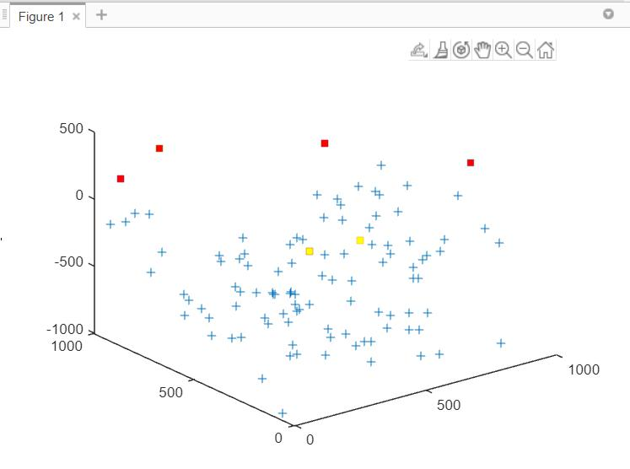

Fig: 3.1 :- 100 Nodes and 6 sink nodes plotted

- This figure is a 1000 cubic meter underwater network

- If 100 nodes have to be marked as "+," embedded sink nodes are marked as yellow square boxes and sink nodes are marked as red square boxes on the surface of the water.

26
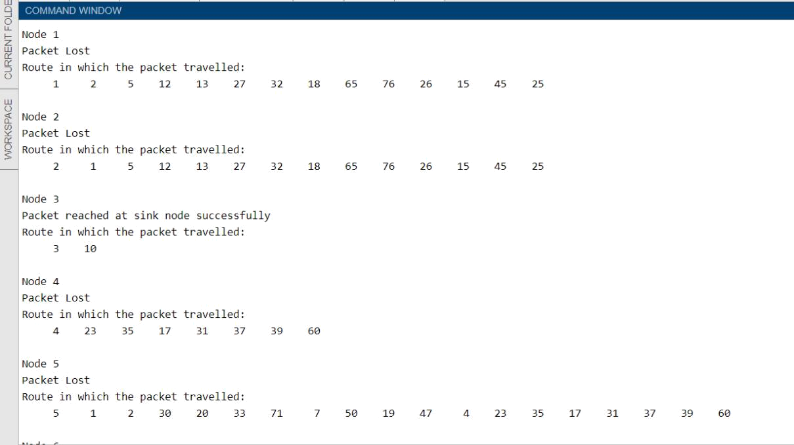

Fig: 3.2 :- Delivery status and route of packet transmission of 1st node to 5th node
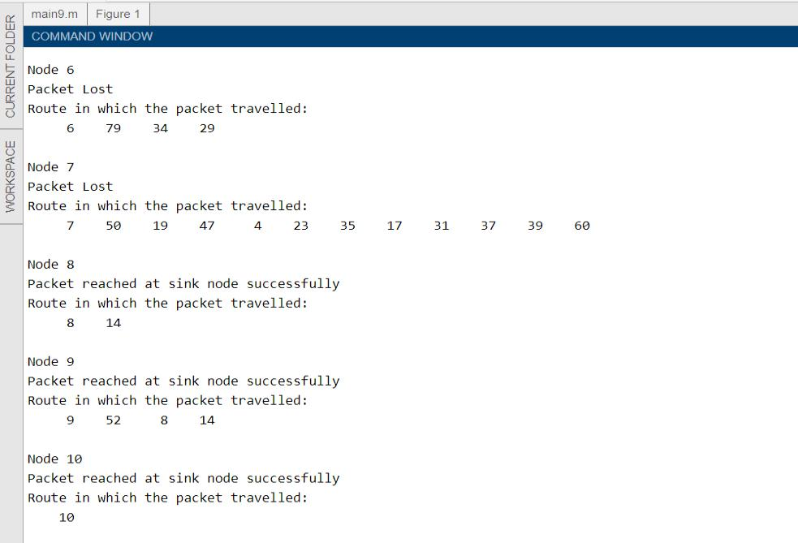

Fig: 3.3 :- Delivery status and route of packet transmission of 6th node to 10th node

27
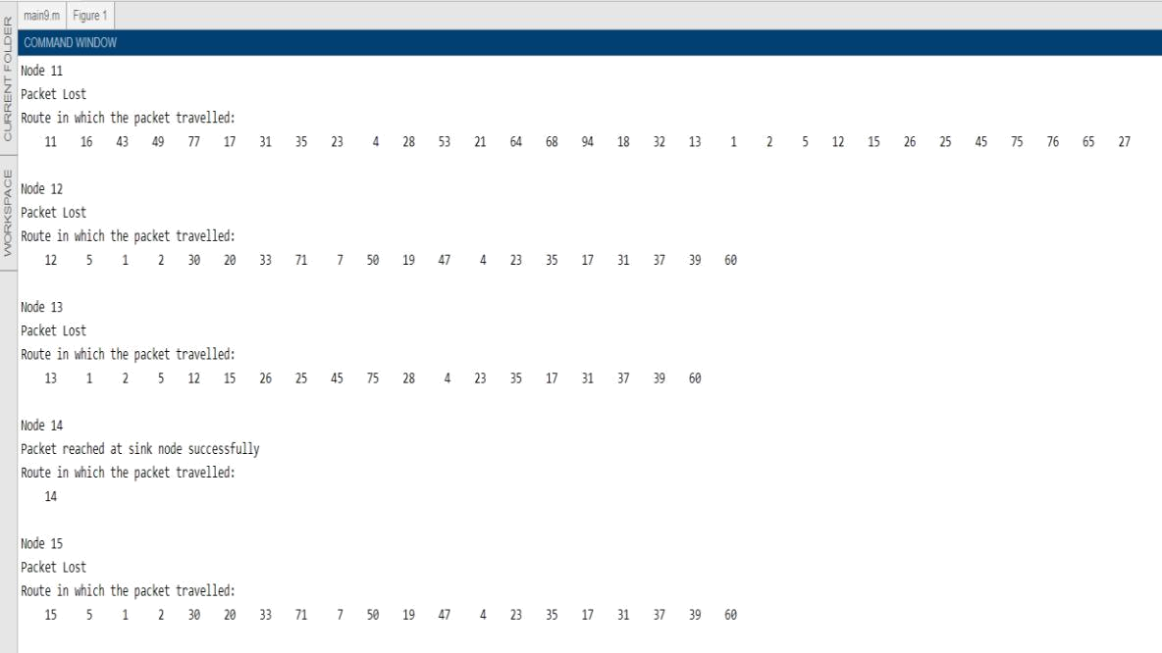

Fig: 3.4 :- Delivery status and route of packet transmission of 11th node to 15th node
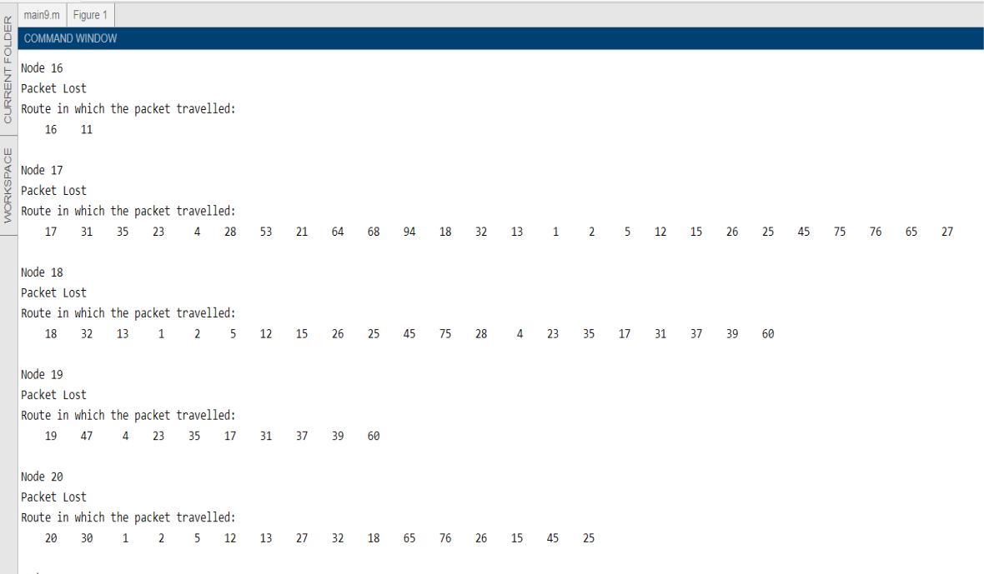

Fig: 3.5 :- Delivery status and route of packet transmission of 16th node to 20th node

28

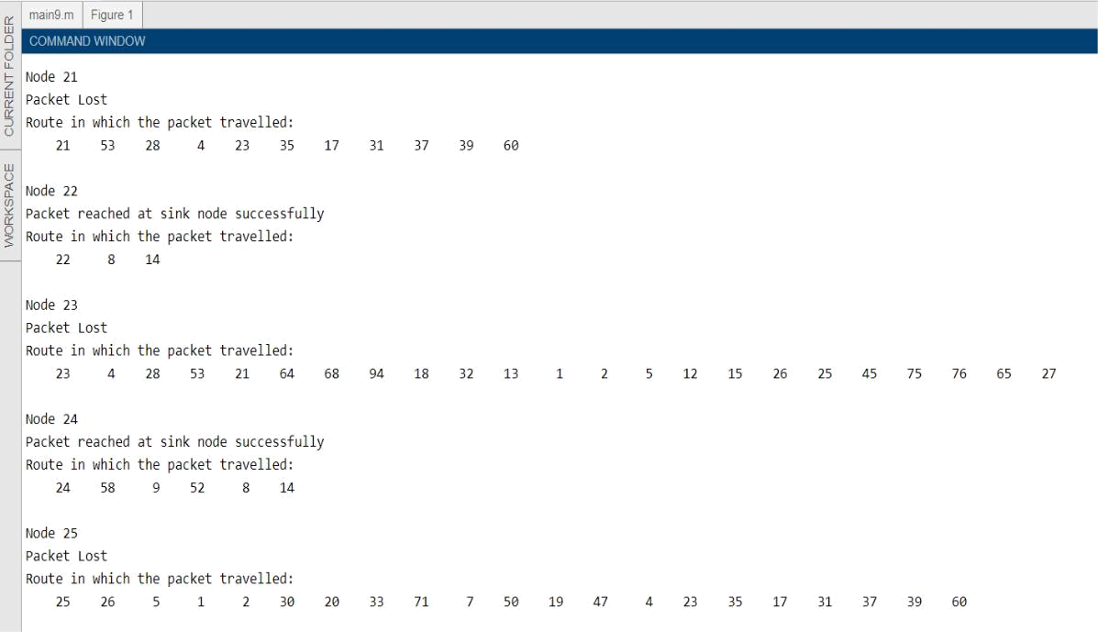

Fig: 3.6:- Delivery status and route of packet transmission of 21st node to 25th node
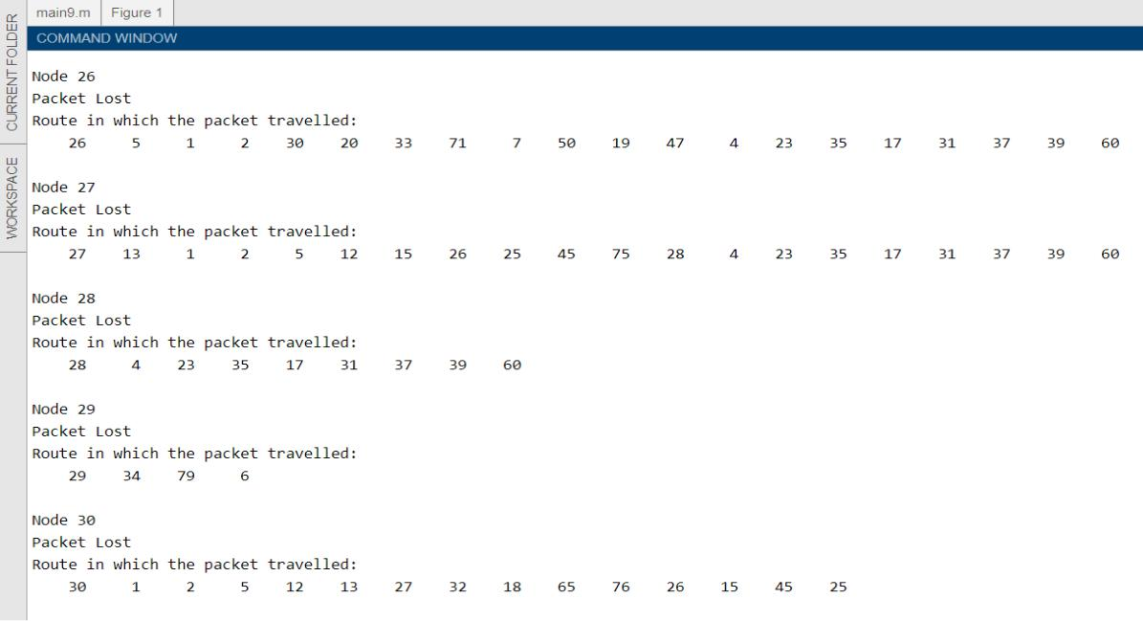

Fig: 3.7 :- Delivery status and route of packet transmission of 26th node to 30th node

29
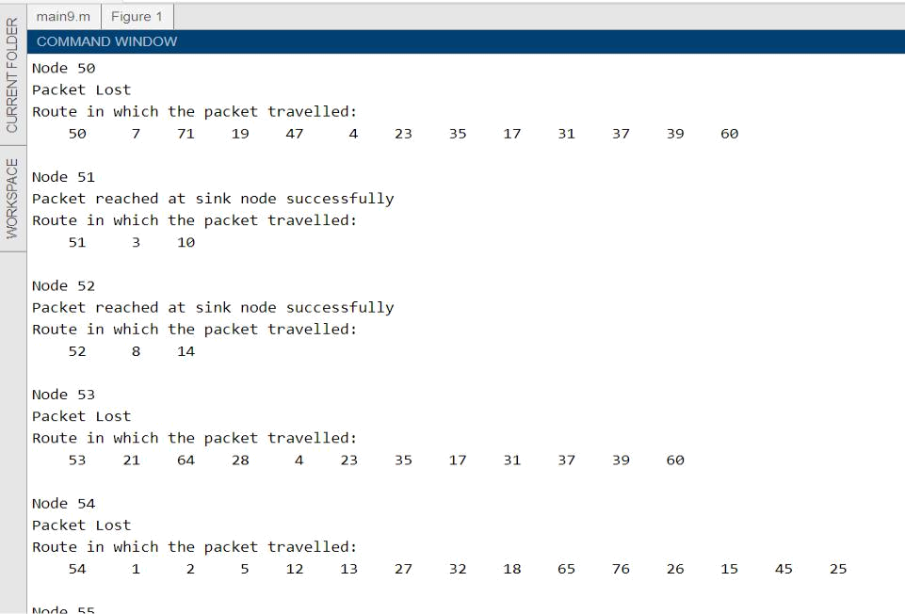

Fig: 3.8 :- Delivery status and route of packet transmission of 50th node to 54th node
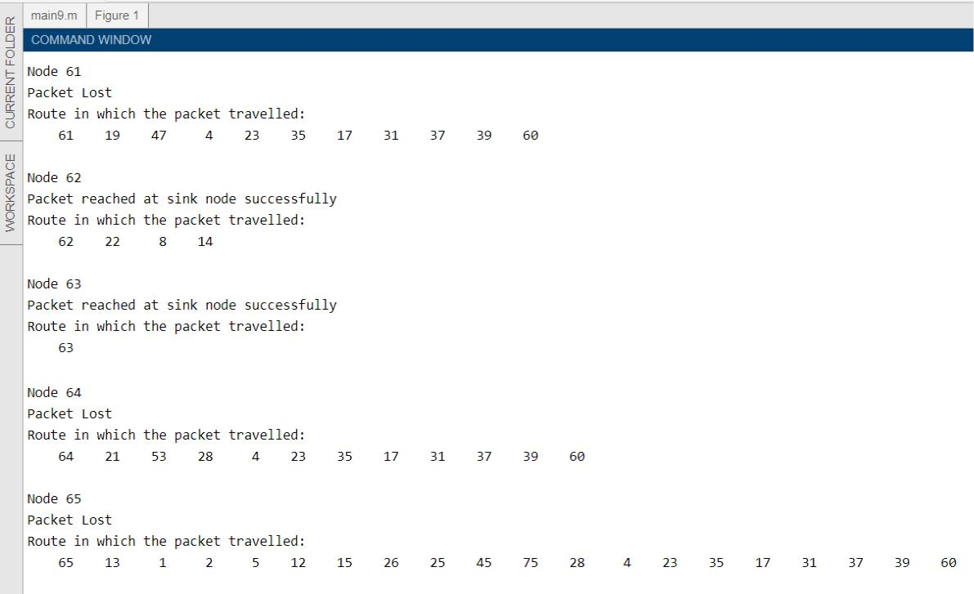

Fig: 3.9 :- Delivery status and route of packet transmission of 61st node to 65^{h} node

30

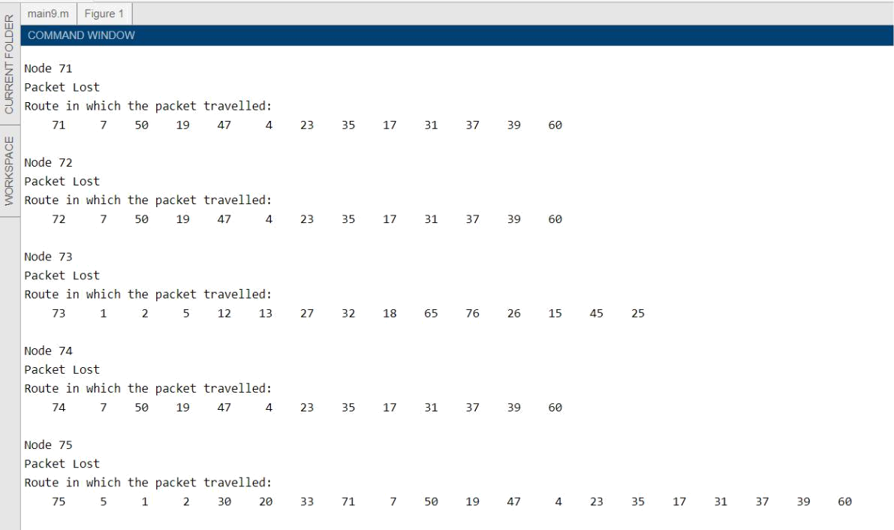

Fig: 3.10 :- Delivery status and route of packet transmission of 71st node to 75th node
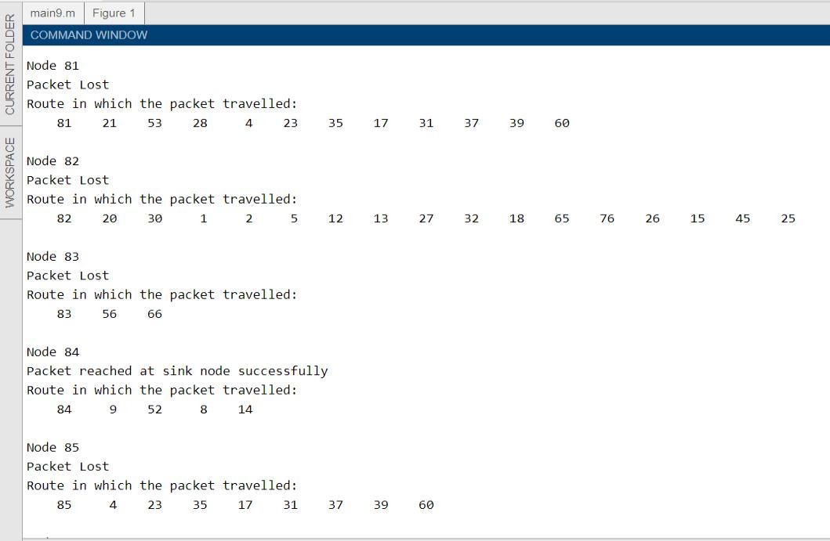

Fig: 3.11 :- Delivery status and route of packet transmission of 81st node to 85th node

31
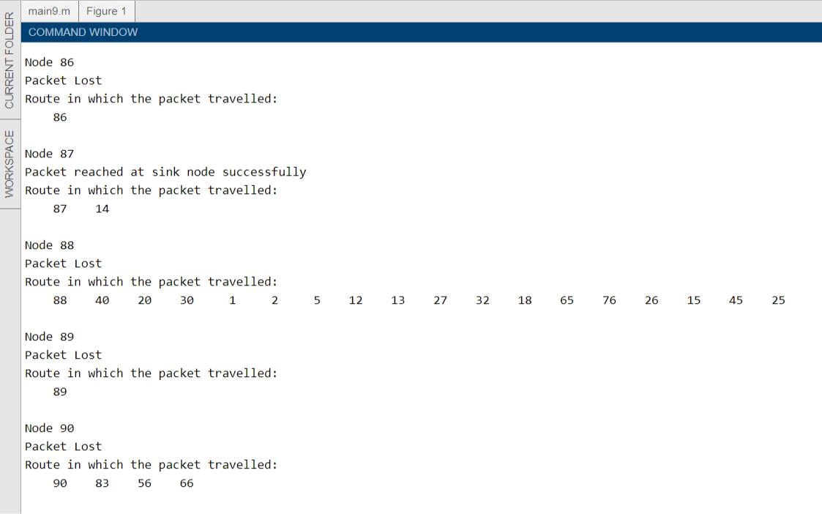

Fig: 3.12:- Delivery status and route of packet transmission of 86th node to 90th node
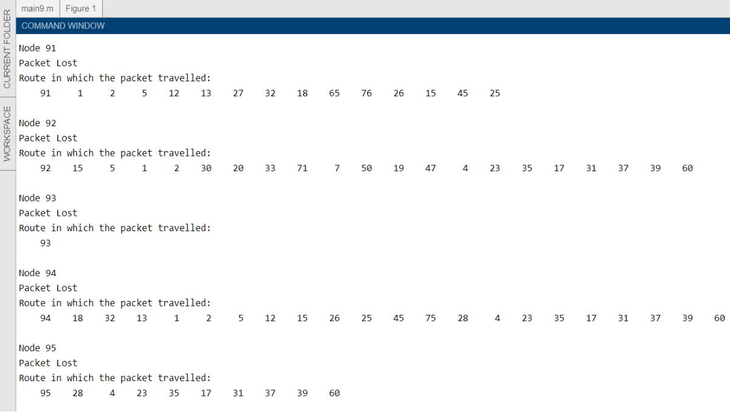

Fig: 3.13 :- Delivery status and route of packet transmission of 91st node to 95th node

32
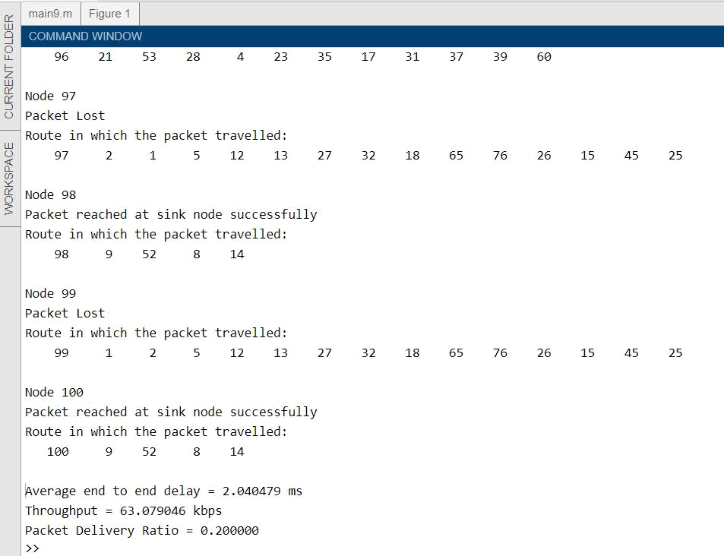

Fig: 3.14 :- Delivery status and route of packet transmission of 97th node to 100th node and average E2ED, throughput and PDR is also displayed.

33
CHAPTER – 4

PERFORMANCE EVALUATION

We provide you a thorough evaluation of our protocol in this section. Initially 100 sensor nodes were implemented with a volume of 1000 m3 (i.e. Length=1000 m, width=1000 m, height=1000 m) in a 3-dimensional space. Initially a node's transmission range is 250 m. The average packet size to be transmitted is 80 bytes (640 bits).

Six sinks are now being installed, two of which are deployed under water in the places that are most likely to flow across the networks, which are built -in sink nodes, and the remaining four sinks are deployed on the water. Different node densities are simulated such that the average volume covered by a node will differ. The following Table shows the parameters used in the simulation.

variable | value
Sinks deployed on the water surface | 4
Sinks deployed under water | 2
Nodes deployed | 100
Total Network Area | 1000 m x 1000 m x 1000 m
Node transmission range | 250 m
Signal propagation speed | 1500 m/s
Average Packet Size | 80 bytes

Table 4.1 : Parameters and their values used in the simulation

34

We take into account PDR, output and E2ED for testing protocol results. PDR is the percentage of the cumulative number of packets collected successfully from sink nodes to the network's total packets.
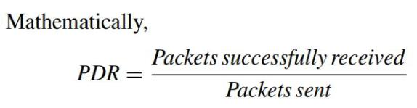

The throughput tests the amount of bits obtained at destination per second.
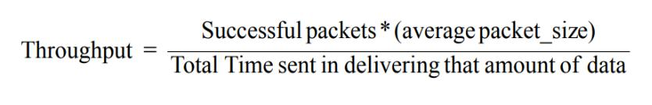

The average time spent between a node beginning transmission and the packet received on the sink is E2ED. Several sinks will accept the packet in a multiple sink situation, the shortest one to pick. E2ED is a mixture of time spent on propagation, time spent on transmission, time cycle and processing.

We analyze the results in different transfer range and for different nodes in order to check the efficiency of the protocol.

Table 4.2 : PDR, Throughput and E2ED for different node transmission range

Node transmission | PDR | Throughput (in | E2ED (in ms)
range |  | kbps)
100 | 0.015000 | 2.909091 | 1.10553
150 | 0.035000 | 11.606218 | 1.939672
200 | 0.240000 | 15.891207 | 2.738814

35
Node transmission | PDR | Throughput (in | E2ED (in ms)
range |  | kbps)
250 | 0.310000 | 19.919679 | 3.005178
300 | 0.955000 | 25.353312 | 3.959848
350 | 1.000000 | 48.743336 | 4.191289
400 | 1.000000 | 52.315072 | 5.899672

Table 4.3 : PDR, Throughput and E2ED for different node transmission range

Table 2 & 3 displays PDR, transmission and E2ED values for various node transmission ranges. For the above simulations, the number of nodes is set at 200.

PDR improves as the transmission range increases and reaches to maximum value of 1 at range equal to 350m, with a larger transmission range there is a greater likelihood of having a sink node in its range resulting in a single and direct hop from source node to sink node.

The number of packets transmitted successfully increases, which means that the PDR is increasing. Figure 19 indicates that the PDR increases as the propagation range of the nodes increases.

If the number of active packets increases with time, throughput is also increased with the expansion of the transmission spectrum of nodes. The map demonstrates the improved capability by increasing the transmitting range in

Figure 20. E2ED also expands the propagation range, which is a disadvantage for this protocol. As the time to look up a sink node marginally increases, E2ED increases as well. Figure 21 indicates that the transmission range of E2ED increases.

36
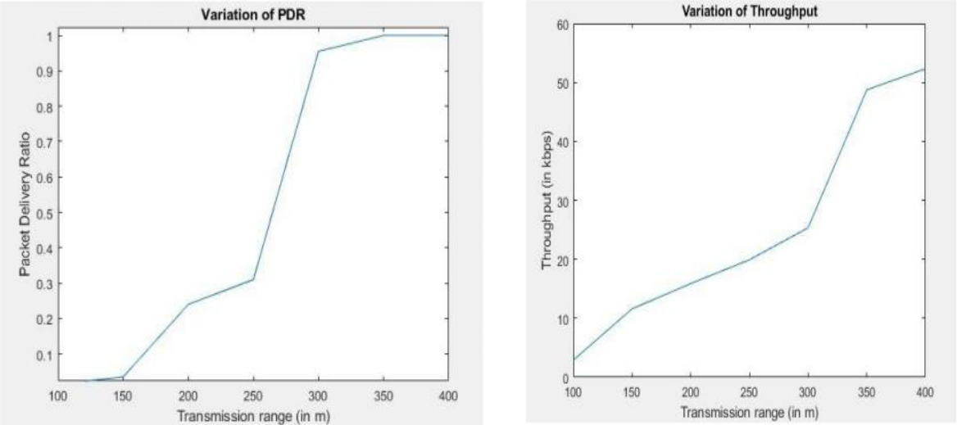

Fig: 4.1 :- Graph between PDR and | Fig: 4.2 :- Graph between throughput
transmission | range and transmission range
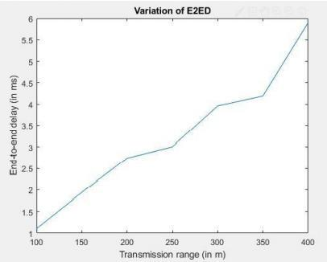

Fig: 4.3 :- Graph between E2ED and transmission range

37
Node transmission | E2ED (in ms) | Throughput (in | PDR
range |  | kbps)
100 | 1.248675 | 3.478261 | 0.010000
150 | 1.684640 | 7.119048 | 0.020000
200 | 2.035151 | 7.901235 | 0.075000
250 | 2.530129 | 12.151899 | 0.148000
300 | 3.601991 | 24.318814 | 0.236667
350 | 4.790854 | 32.952779 | 0.371429
400 | 4.995006 | 36.268806 | 0.482500
450 | 6.367500 | 53.258741 | 0.628889
500 | 7.569157 | 57.427210 | 0.878000

Table 4.4 : PDR, Throughput and E2ED for different node transmission range

For different nodes, Table 4 displays the values PDR, throughput and E2ED. For the above simulations, the transmission range of the nodes shall be set to 150m. PDR grows with increasing numbers of nodes, lower packet loss is creating a higher number of nodes. The graph shows that the PDR has risen with the number of nodes.

Figure 22. If the number of effective deliveries increases in the given time, the output also increases as the number of nodes increases. Figure 23 shows the rising throughput of the number of nodes.

E2ED also improves, which is again a downside of the protocol, by increasing the number of nodes. There is more time to measure and pick distances for more nodes, and therefore there are more hops as the number of nodes is higher, thereby increasing E2ED. The

increases of E2ED in number of nodes as seen in Figure 24

38

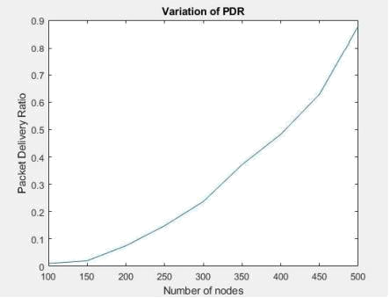

Fig: 4.4 :- Graph between PDR and number of nodes

Fig: 4.5 :- Graph between throughput and number of nodes
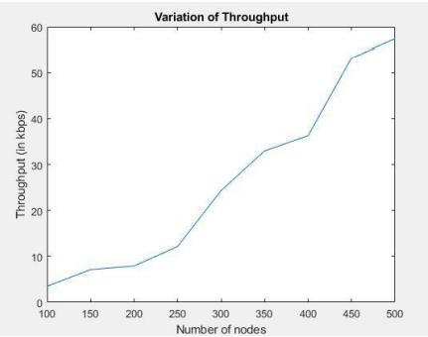
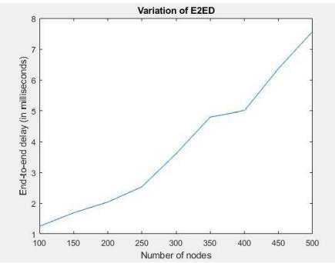

Fig: 4.6 :- Graph between E2ED and number of nodes

39

CHAPTER – 5

CONCLUSION AND FUTURE ENHANCEMENTS

CONCLUSION:

There are numerous benefits and flaws of the efficient and expeditious routing protocol suggested. Vacuum holes are prevented, PDR and throughput are enhanced by taking into account PFNs, while E2ED is concurrently increased. With more transmission and more nodes, productivity is increasing, but this is at the cost of an increased E2ED.

The embedded sinks are achieving a high delivery and low E2ED ratio, but high communication is recorded with the surface sinks. Overall, this protocol has increased performance, improved PDR and reduced packages decline at E2ED costs.

The Packet drop is reduced and therefore, PDR is improved with the simultaneous selection of a high node density path. As a result, the performance is also increased.

FUTURE ENHANCEMENTS:

It is possible to broaden the proposed scheme to reduce E2ED. In our protocol to inspect your neighbours, we first compute the distance between a specific node and all the other nodes in the network, and then check which node is in the range of transmission and select an of them; instead we first fix the transmission range for the source node. This can dramatically reduce E2ED and also contribute to improved performance.

40
CHAPTER – 6

REFERENCES

- [1] I. F. Akyildiz, D. Pompili ‘‘Under water acoustic sensor networks: Research challenges,’’ Ad Hoc Netw., vol. 3, no. 3, pp. 257–279, Mar. 2005.

- [2] W. K. G. Seah and H.-X. Tan, ‘‘Multipath virtual sink architecture for underwater sensor networks,’’ in Proc. OCEANS Asia–Pacific, May 2006, pp. 1–6.

- [3] H. Yan, Z. J. Shi, and J.-HCui ‘‘DBR: Depth- based routing for underwater sensor networks,’’ in Proc. Int. Conf. Res. Netw. Berlin, Germany: Springer, 2008, pp. 72–86.

- [4] M. R. Jafri, M. M. Sandhu, K. Latif, Z. A. Khan, A. U. Yasar, and N. Javaid, ‘‘Towards delay-sensitive routing in underwater wireless sensor networks,’’ Procedia Comput. Sci., vol.

37, pp. 228–235, Jan. 2014.

- [5]D. Braginsky ‘‘Rumor routing algorthim for sensor networks,’’ in Proc. 1st Int.

Workshop Wireless Sensor Netw. Appl., 2002, pp. 22–31.

- [6] F. Ye, G. Zhong, S. Lu ‘‘GRAdient broadcast: A robust data delivery protocol for large scale sensor networks,’’ Wireless Netw., vol. 11, no. 3, pp. 285–298, 2005.

- [7] Y. Yao and ‘‘The cougar approach to in-network query processing in sensor networks,’’ ACM SIGMOD Rec., vol. 31, no. 3, pp. 9–18, 2002.

- [8] P. Xie, Z. Zhou, N. Nicolaou, A. See, J.-H. Cui, and ‘‘Efficient vector-based forwarding for underwater sensor networks,’’ EURASIP J. Wireless Commun. Netw., vol. 2010, no. 1,
2010, Art. no. 195910.

- [9] F. Ye, H. Luo, J. Cheng, S. Lu, and LZhang ‘‘A two- tier data dissemination model for large-scale wireless sensor networks,’’ in Proc. 8th Annu. Int. Conf. Mobile Comput. Netw.,
2002, pp. 148–159.

41

- [10] N. Javaid, M. R. Jafri, S. Ahmed, M. Jamil, Z. A. Khan, U. Qasim, and S. S. Al-Saleh,

‘‘Delay-sensitive routing schemes for underwater acoustic sensor networks,’’ Int. J. Distrib.

Sensor Netw., vol. 11, Mar. 2015, Art. no. 532676.

- [11] T. Ali, L. T. Jung, and I. Faye, ‘‘Diagonal and vertical routing protocol for underwater wireless sensor network,’’ Proc.—Social Behav. Sci. vol. 129, pp. 372–379, May 2014.

- [12] M. Zuba, M. Fagan, Z. Shi, and J.-H. Cui, ‘‘A resilient pressure routing scheme for underwater acoustic networks,’’ in Proc. IEEE Global Commun. Conf., Dec. 2014, pp. 637– 642.

- [13] Y. Noh, U. Lee, P. Wang, B. S. C. Choi ‘‘VAPR: Void-aware pressure routing for underwater sensor networks,’’ IEEE Trans. Mobile Comput., vol. 12, no. 5, pp. 895–908, May 2013.

- [14] Z. Wadud, K. Ullah, S. Hussain, X. Yang, and A. B. Qazi, ‘‘Dow-pr DOlphin and whale pods routing protocol for underwater wireless sensor networks (UWSNs),’’ Sensors, vol. 18, no. 5, p. 1529, 2018.

- [15] H. Yu, N. Yao, and J. Liu, ‘‘An adaptive routing protocol in underwater sparse acoustic sensor networks,’’ Ad Hoc Netw., vol. 34, pp. 121–143, Nov. 2015.

- [16] T. Hafeez, N. Javaid, A. R. Hameed, A. Sher, Z. A. Khan, and U. Qasim, ‘‘AVN-AHH-VBF: Avoiding void node with adaptive hop-by-hop vector based forwarding for underwater wireless sensor networks,’’ in Proc. 10th Int. Conf. Innov. Mobile Internet Services

Ubiquitous Comput. (IMIS), Jul. 2016, pp. 49–56.

- [17] Z. Wadud, S. Hussain, N. Javaid, S. H. Bouk, N. Alrajeh, M. S. Alabed ‘‘A n energy scaled and expanded vector-based forwarding scheme for industrial underwater acoustic sensor networks with sink mobility,’’ Sensors, vol. 17, no. 10, p. 2251, 2017.

- [18] E. Magistretti, J. Kong, U. Lee, M. Gerla ‘‘A mobile delay-tolerant approach to long-term energy- efficient underwater sensor networking,’’ in Proc. IEEE Wireless Commun.

Netw. Conf., Hong Kong, Mar. 2007, pp. 2866–2871.

42

- [19] A. Wahid, S. Lee, H.-J. Jeong, and D. Kim, ‘‘EEDBR: Energy-efficient depth-based routing protocol for underwater wireless sensor networks,’’ in Proc. Int. Conf. Adv. Comput. Sci. Inf. Technol. Berlin, Germany: Springer, 2011, pp. 223–234.

- [20] C.-H. Yang and K.-F. Ssu. ‘‘A n energy-efficient routing protocol in underwater sensor networks,’’ in Proc. 3rd Int. Conf. Sens. Technol., Tainan, Taiwan, Nov. /Dec. 2008, pp. 114–118.

- [21] O. Cayirpunar, E. Kadioglu-Urtis, and B. Tavli, ‘‘Optimal base station mobility patterns for wireless sensor network lifetime maximization,’’ IEEE Sensors J., vol. 15, no. 11, pp. 6592–6603, Nov. 2015.

- [22] S. K. Dhurandher, M. S. Obaidat, and M. Gupta, ‘‘Providing reliable and link stability-based geocasting model in underwater environment,’’ Int. J. Commun. Syst., vol. 25, no. 3, pp.
356–375, 2012.

43

