Suspicious IP Checker
Project Report - Mini Project

1. Abstract
The Suspicious IP Checker is an educational cybersecurity tool that checks IP reputation against multiple threat intelligence sources, monitors server log files in real-time, and generates alerts via dashboard and email when suspicious activity is detected. Built with Python and Streamlit, it demonstrates practical application of network security concepts, API integration, and event-driven alerting.

2. Problem Statement
System administrators need tools to quickly identify potentially malicious IP addresses accessing their servers. Existing enterprise solutions are complex and costly. This project provides a lightweight, open-source approach to:
- Check an IP against threat-intelligence sources
- Display available reputation information
- Flag IPs listed as suspicious
- Alert via dashboard and email
- Monitor server logs in real-time

3. Technology Stack
Component | Technology
Web Framework | Streamlit (Python)
Language | Python 3.10+
Data Analysis | Pandas, Matplotlib
HTTP Client | requests
Email | smtplib (SMTP)
Threat Intel APIs | AbuseIPDB, VirusTotal, AlienVault OTX, ip-api.com

4. System Architecture
The system consists of 5 modules:
- app.py - Main Streamlit dashboard (5 tabs)
- config.py - Configuration management (API keys, email, thresholds)
- ip_reputation.py - Threat intelligence API integration layer
- log_monitor.py - Real-time log file tailing and threshold detection
- alert_engine.py - Alert creation, severity routing, SMTP email dispatch
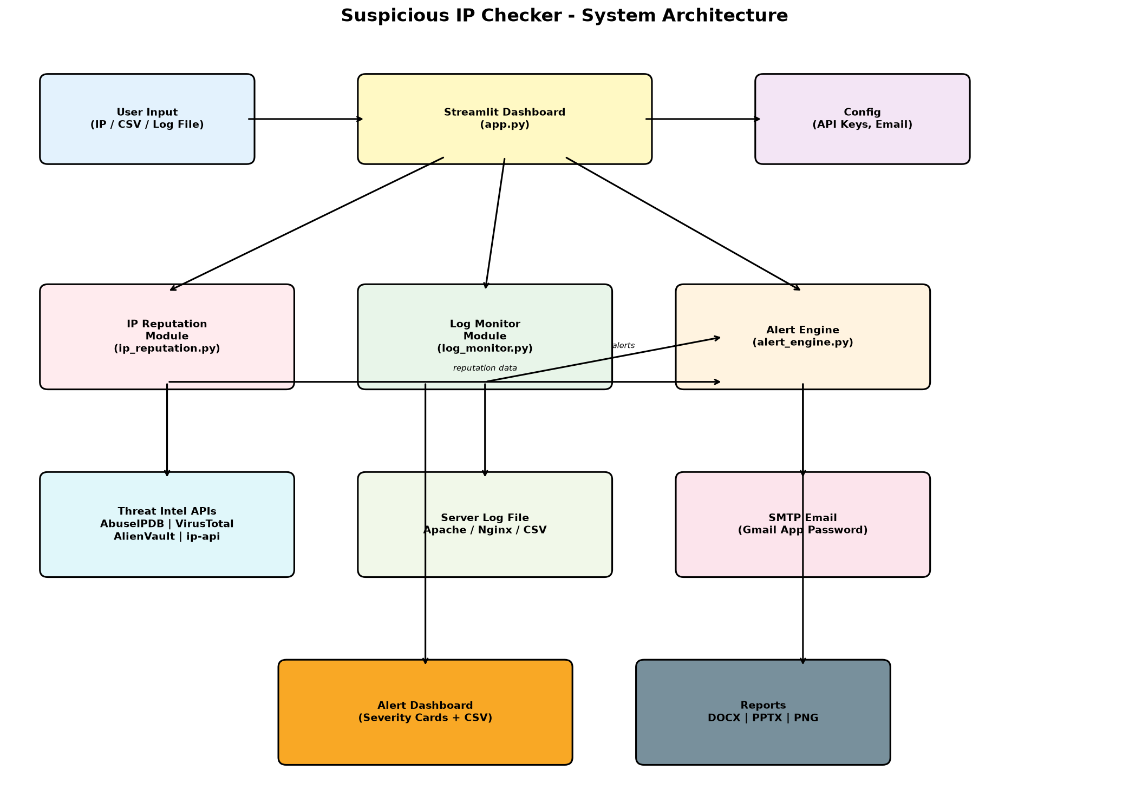

5. Implementation Details

5.1 IP Reputation Checking
The ip_reputation module queries 4 providers: AbuseIPDB (abuse confidence score), VirusTotal (90+ engine detection ratio), AlienVault OTX (threat pulse associations), and ip-api.com (free geolocation + proxy/hosting detection). Results are combined into a ReputationResult dataclass. An IP is flagged if any source indicates risk.

5.2 Live Log Monitoring
The log_monitor module runs a background thread that polls a log file for new lines. It parses Apache Combined, Nginx, or CSV formats. For each IP, it tracks request count and failure count against configurable thresholds. When exceeded, an IP is flagged and a callback fires the alert engine.

5.3 Alert System
The alert_engine creates Alert objects with severity levels (low/medium/high/critical). High/critical alerts automatically trigger email notifications via SMTP. All alerts appear in the dashboard's Alerts tab with acknowledge/clear functionality.

6. Limitations
- Free API tiers have daily rate limits (AbuseIPDB: 100/day, VirusTotal: 500/day)
- Private IPs cannot be checked against external threat intelligence
- Rule-based flagging produces false positives; not proof of malice
- Does not identify persons or exact physical locations
- No active blocking/defense - detection only

7. Conclusion
The Suspicious IP Checker successfully demonstrates how to build a multi-source threat intelligence lookup tool with real-time log monitoring and tiered alerting. The modular architecture makes it easy to add new IP reputation providers, different alert channels (Slack, Teams), or more complex detection rules. As an educational project, it highlights practical cybersecurity concepts without requiring expensive enterprise tools.

