- 1.Explain end to end devsecops architecture with git, gitlab, maven, nexus, checkmarx, fortify, MEND and docker?
Sol: Here is a clear end-to-end DevSecOps architecture using the tools: Git, GitLab, Maven, Nexus, Checkmarx, Fortify, MEND, and Docker. The goal is to integrate security at every stage of the CI/CD pipeline without slowing down development.

🔁 Overview of the DevSecOps Pipeline Stages
- Plan & Code
- Build
- Test
- Security Scan
- Package
- Deploy
- Monitor

🛠️ DevSecOps Architecture (Tool-by-Tool Integration)
1. Source Code Management – Git + GitLab
- Developers push code to GitLab (Git is the underlying VCS).
- Branching strategies like main, dev, feature/* used for control.
- GitLab CI/CD pipelines are triggered on code commits or merge requests.

2. Build Stage – Maven
- GitLab Runner executes mvn clean install using Maven to compile code and run unit tests.
- If build fails, pipeline stops.
- Dependency checking starts here with Maven plugins (e.g., OWASP Dependency-Check).

3. Static Code Analysis – Checkmarx / Fortify
- After a successful build:
  - Checkmarx (SAST tool) scans source code for vulnerabilities like XSS, SQL injection, etc.
  - Fortify SCA can also scan either as a backup or deeper scan if needed.
- These are integrated in GitLab pipelines via custom scripts or plugins.
- Reports are generated and gates set – pipeline fails if critical vulnerabilities found.

4. Open-Source Dependency Scanning – MEND (WhiteSource)
- MEND scans open-source libraries used in the project (e.g., via Maven's pom.xml).
- Checks for:
  - License compliance.
  - Known CVEs in libraries.
- Integrated via CLI in GitLab pipeline (whitesource.sh or Docker container).

5. Artifact Repository – Nexus
- On successful scan & test:
  - Maven packages the application (e.g., .jar, .war, or .zip).
  - Uploads to Nexus as a versioned artifact (mvn deploy).
- Nexus acts as both a proxy for external dependencies and a private internal repo.

6. Containerization – Docker
- Docker file builds image from the application artifact.
- Docker image is:
  - Built: docker build -t app-name: version .
  - Scanned for vulnerabilities (e.g., using Trivy or Docker Scout).
  - Pushed to Docker registry (GitLab Container Registry / Nexus / DockerHub).

7. Deployment
- Container image is deployed to:
  - Test/Staging/Prod using GitLab CI jobs.
  - Can use Kubernetes (GitLab + Helm), Docker Compose, or direct Docker run.
- Ansible or Terraform can be optionally integrated for Infra as Code (IaC).

8. Monitoring & Feedback
- Security dashboards in Checkmarx, MEND, and Fortify feed back into Jira or GitLab issues.
- Devs fix issues and trigger rebuilds.
- Logs and metrics collected using tools like Prometheus, ELK, or Splunk (optional).

📌 Example GitLab Pipeline Snippet
yaml
CopyEdit
stages:
- build
- scan
- test
- package
- deploy

build:
stage: build
script:
- mvn clean install

checkmarx_scan:
stage: scan
script:
- ./run-checkmarx-scan.sh

mend_scan:
stage: scan
script:
- ./wss-unified-agent.sh

docker_build:
stage: package
script:
- docker build -t my-app:${CI_COMMIT_SHORT_SHA} .
- docker scan my-app:${CI_COMMIT_SHORT_SHA}
- docker push registry.gitlab.com/my-app:${CI_COMMIT_SHORT_SHA}

deploy:
stage: deploy
script:
- docker run -d my-app:${CI_COMMIT_SHORT_SHA}

🔐 Security at Every Stage (DevSecOps Mindset)
Stage | Security Practice | Tools Involved
Plan & Code | Code commit signing, branch protection | Git + GitLab
Build | Dependency validation | Maven, OWASP Plugin
Scan | SAST, OSS analysis | Checkmarx, Fortify, MEND
Package | Image scanning | Docker + Trivy or built-in scan
Deploy | Secrets management, signed images | Docker, Vault, GitLab Secrets
Monitor | Alerting on new vulnerabilities | GitLab, Nexus IQ, Fortify SSC

✅ Benefits of This Architecture
- Early and automated vulnerability detection.
- Seamless integration into developer workflows.
- Gatekeeping via policy enforcement (fail build if critical bugs).
- Full traceability of artifacts from code to production.

CapGemini Interview on March 27 2025:
1.what are your daily activities?
2. what kind of AWS Services are effective compared to Azure?
3. what is AWS Lambda?
4. what is Containerisation?
5. what exactly Jenkins is used for?
6. I have an EC2 server I don’t want to run evening 9 pm to morning 7 pm what is the yaml code we have to write?(that means ec2 instance should stop between 9 pm to 7 am write a simple yaml code)
7. I want to create an image in docker that image it has to launch a web page it’s a kind of web application can u write those docker commands. How to do that?
8. do u have knowledge on AWS Lamda what are the languages supported by AWS Lambda?
9. what are the languages supported by AWS Lambda?
Sol: AWS Lambda natively supports Python, Node.js, Java, .NET (C#), PowerShell, Go, and Ruby, and allows you to use virtually any other programming language through the Lambda Runtime API for custom runtimes. This flexibility enables developers to write serverless functions in the language of their choice
10. do u have knowledge or experience on database?
11. Can u explain DevOps model end to end? Or DevOps lifecycle?
12. Do u know what is terraform?
13. I want to deploy web application via terraform how?
14. any certifications?
Hyderabad Interview on Sep 3 2025:
1.When will be deployments in your organization weekly or for every two weeks?
2. what are the branching strategies you use in your environment?
3. what is the workflow for feature branch in Git? What you do on feature branch? How do you work on feature branch? To which branch you push the code after working on feature branch? How do you test on feature branch? What type of workflows u work on feature branch?
4. what is the use of feature branch when we already have development branch?
5. Assume there is feature branch1 u need to work or test on it and then u need to merge to development branch how will you do?
6. what is the use of hotfix branch?
7. don’t u have separate production branch or only master branch u have?
8. how do u store container images like artifacts?
9. can u write a simple declarative Jenkins pipeline for creating a docker image?
10. when we have GitLab why do we need Jenkins?
11. what is the filename where u specify container images are stored?
Sol: maybe /var/lib/docker directory
On Linux, all Docker-related data, including images, containers, volumes, and networks, is stored within the /var/lib/docker directory, known as the root directory
12. how do u actual create docker container image?
13. we have artifacts
14. in terms of kubernetes what is the deployment target in cdsl or any previous company?
15. what is the difference between EBS and S3 in AWS?
16. which is cheaper ebs or s3 in aws?
17. why people go for EBS when we have S3?
18.what is the ssl certificate?
19. what is the use of HELM in kubernetes?

Crisil Interview on June 30 2025:
1.what are your technical activities on your latest project?
2. Do u have any Cloud Experience which Cloud? Linux Administration?
3. what is NFS, Samba and DNS?
4. What are the services you have worked on AWS?
5. what is S3 Glacier?
6. what are the advantages and disadvantages of S3 Glacier?
7. what is ECR in aws?
8. what is Aws Cloud trail?
9. what is aws cloud formation?
10. how do you create custom alert in aws cloud watch?
11. how do you create private subnet in aws?
12. Do you know where NAT Gateway sits in which subnet? Public or private?
Ans: Public subnet
13. How NAT Gateway connects to internet?
14. how do u find 10th word in a file in linux?
15. how do u find 100th word in a file in linux?
16. how do u find how many times a name occurred in a file?
17. in DNS what is forward and reverse lookup?
Ans: Forward and reverse DNS lookups are two inverse processes of the Domain Name System (DNS) that resolve names to IP addresses and vice versa. A forward lookup takes a human-friendly domain name (e.g., www.google.com) and finds its corresponding IP address (e.g.,
172.217.160.142172.217 .160 .142
172.217.160.142
). A reverse lookup takes an IP address and finds its associated domain name.
18. what is recursive DNS resolver?
19.what is static and dynamic DNS record?
20. what is TTL in DNS?
21. what is NSlookup?

Nov 28 2025 DevOps interview:
1. How big is your infrastructure?
2. Are you responsible to handle your entire infrastructure or any other teams are there in your organization?
3. what are your top 3 skill sets in DevOps that u have hands on experience?
4. do u have experience on Linux and networking?
5. what are your day-to-day tasks in Linux?
Ans: DevOps engineers frequently interact with Linux-based systems for a wide range of tasks. These day-to-day activities primarily involve:
1. System Monitoring and Troubleshooting:
- Checking System Health:
Using tools like top, htop, ps, and free -m to monitor CPU, memory, and process usage.
- Log Analysis:
Employing commands like tail -f, grep, and less to analyze application and system logs for error detection and debugging.
- Network Diagnostics:
Utilizing ping, netstat, ss, and curl to check network connectivity and troubleshoot communication issues between services.
2. Infrastructure Management:
- File and Directory Management: Using ls, cd, mkdir, rm, cp, mv, chmod, chown, and find to manage files, directories, and permissions.
- Package Management: Installing, updating, and removing software packages using distribution-specific package managers (e.g., apt, yum, dnf).
- User and Group Management: Creating, modifying, and managing user accounts and groups.
3. Automation and Scripting:
- Shell Scripting:
Writing and executing shell scripts (Bash, Zsh) to automate repetitive tasks, manage configurations, and orchestrate deployments.
- Infrastructure as Code (IaC):
Interacting with tools like Terraform, Ansible, or Puppet to provision and configure infrastructure, often involving command-line interfaces (CLIs) for these tools.
4. CI/CD Pipeline Management:
- Deployment and Release Management: Triggering and monitoring deployments, managing application versions, and troubleshooting deployment failures within CI/CD pipelines.
- Build and Test Execution: Running and monitoring automated build and test processes.
5. Security and Compliance:
- Security Audits: Performing basic security checks, managing firewall rules, and ensuring system hardening.
- Patching and Updates: Applying security patches and system updates to maintain system integrity.
6. Collaboration and Communication:
- Version Control: Interacting with Git repositories for code management and collaboration.
- Documentation: Creating and updating documentation for infrastructure, processes, and troubleshooting steps.

6. what is a default ssh port?
Ans: 22
7.How can we check the open port in linux?
Ans: netstat
8. how to check list of open ports or listening ports in linux?
Ans: by netstat command.
9. how can we increase the disk partition in linux?
Ans: LVM
10. when we create a VPC in AWS we need to select the IP ranges so can u tell which IP range we need to select or which CIDR block we need to select?
Ans: When creating a Virtual Private Cloud (VPC) in AWS, you must specify an IPv4 CIDR block. The choice of CIDR block depends on your specific needs and network architecture.
Recommended Practices for Choosing a CIDR Block:
- Use Private IP Address Ranges:
It is strongly recommended to use private IPv4 address ranges as defined in RFC 1918. These ranges are not routable on the public internet, providing inherent security. The private ranges are:
  - 10.0.0.0 - 10.255.255.255 (10/8 prefix)
  - 172.16.0.0 - 172.31.255.255 (172.16/12 prefix)
  - 192.168.0.0 - 192.168.255.255 (192.168/16 prefix)
- Consider Future Growth:
Choose a CIDR block large enough to accommodate your current and future resource needs within the VPC. A /16 netmask provides 65,536 IP addresses, while a /28 netmask provides only 16. While you can add secondary CIDR blocks later, planning for sufficient space initially can simplify management.
- Avoid Overlapping with Other Networks:
If your VPC will connect to other networks (e.g., on-premises networks via VPN or Direct Connect, or other AWS VPCs via VPC Peering), ensure that your chosen CIDR block does not overlap with the IP ranges used in those networks. This prevents routing conflicts.
- Commonly Used CIDR Blocks:
  - 10.0.0.0/16
  - 172.31.0.0/16 (This is often the default used by AWS Control Tower)
  - 192.168.0.0/16
Example:
If you are creating a new VPC for a development environment and anticipate moderate growth, you might choose a CIDR block like 10.0.0.0/16. This provides a large address space within the private range and is unlikely to conflict with other private networks unless you have a very complex existing infrastructure.
Important Note: While you must specify an IPv4 CIDR block, you can also associate an Amazon-provided IPv6 CIDR block with your VPC if you require IPv6 support.
11. Can you tell me whats the difference between public IP and private IP in AWS?
Ans: In AWS, the main difference is that a public IP address is used for communication with the internet and is accessible from anywhere, while a private IP address is for communication within a virtual private cloud (VPC) or private network and is not directly accessible from the internet. Public IPs can be assigned directly or are Elastic IPs that can be remapped, whereas private IPs are the default internal address for resources like EC2 instances.
In AWS, private IPs are static within the VPC, meaning they don't change when an instance is stopped and started. Public IPs assigned by default are dynamic and change when an instance is stopped and started. For a static public IP, you must use an Elastic IP (EIP)
12. in linux to list the files in the command ls-lrth what is ls and what is lrth?
Ans: In Linux, ls -lrth is a command used to list the contents of a directory with specific formatting and sorting options.
- ls:
This is the core command, which stands for "list." Its primary function is to list the files and directories within a specified directory (or the current working directory if none is specified).
- -lrth:
This is a combination of several options or "flags" applied to the ls command, each modifying its behavior:
  - -l (long format): This option displays a detailed, "long" listing of the files and directories. This includes information such as file permissions, number of hard links, owner, group, size, last modification date and time, and the file or directory name.
  - -r (reverse order): This option reverses the order of the listing. When combined with other sorting options like -t, it changes the direction of that sort.
  - -t (sort by modification time): This option sorts the listed files and directories by their last modification time, with the newest files typically appearing first by default.
  - -h (human-readable sizes): This option, when used with -l, displays file sizes in a human-readable format (e.g., 1K, 234M, 2G) instead of in bytes.
Therefore, ls -lrth provides a detailed, long listing of files and directories, sorted by their last modification time in reverse order (oldest first), with file sizes displayed in a human-readable format.
13. Suppose I am running an Ec2 instance every day I shut down the VM and the next day I come and start the VM next day it is not properly booting up what could be the reason and how to resolve?
Ans: When an EC2 instance fails to boot properly after being stopped and started, the issue is typically related to misconfiguration of internal operating system files, filesystem corruption, or dependency failures, rather than the simple act of stopping/starting itself. The stop function in AWS is a graceful shutdown, but issues within the guest OS can manifest on the next boot.
Common Reasons for Boot Failure
- Incorrect /etc/fstab entries: This is a very common issue. If a volume is specified in the /etc/fstab file using a device name instead of a UUID or label, the name might change after a stop/start cycle on certain instance types (especially when moving to Nitro-based instances). The instance will enter emergency mode or fail to boot if a specified mount point cannot be found.
- Kernel issues or misconfigured GRUB: Errors can occur if the Linux kernel is corrupted, an update went wrong, or the GRUB configuration file is incorrect or missing necessary drivers (like ENA or NVMe drivers for Nitro instances).
- Filesystem corruption: While less common with proper shutdowns, underlying disk errors or file system issues can prevent a clean boot. This can sometimes be exacerbated if the instance was terminated abruptly previously, though the AWS environment is designed to be resilient.
- Disk space exhaustion: If the root volume or a partition (such as /var/log or /var/log/audit) is completely full, certain system services (like the audit daemon) might halt the system during boot to prevent further issues.
- System status check failures: Issues within the guest OS can cause system status checks to fail, leading to the instance becoming unavailable.
How to Resolve
The primary method for troubleshooting a non-booting instance is to examine the system logs and, if necessary, use a rescue instance to manually correct the configuration.
Step 1: Check System Logs and Status
- View the System Log: Access the instance's console output from the EC2 console. This log often contains specific error messages that indicate exactly where the boot process is failing (e.g., "Dependency failed for /mnt" or "Kernel panic").
  - In the AWS Management Console, navigate to EC2 instances, select your instance, and choose Actions > Monitor and troubleshoot > Get system log.
- Check Instance Status Checks: In the console, review the Status checks tab for the instance. It will show if either the system status check (underlying hardware issue, often fixed by stopping/starting the instance which moves it to new hardware) or instance status check (guest OS issue) is failing.
Step 2: Use a Rescue Instance (for advanced fixes)
If the logs point to a configuration file error (like /etc/fstab), you must use a separate, healthy "rescue" instance to edit the problematic volume.
- Stop the problematic instance (ensure you have backups/snapshots first).
- Detach its root EBS volume from the AWS console.
- Launch a new, temporary (rescue) instance in the same Availability Zone.
- Attach the detached volume to the rescue instance as a secondary device (e.g., /dev/sdf).
- SSH into the rescue instance, create a mount point, and mount the attached volume (e.g., sudo mount /dev/xvdf1 /mnt/rescue).
- Navigate to and edit the problematic files (e.g., /mnt/rescue/etc/fstab) to correct errors like incorrect device names (use UUIDs or the nofail option).
- Unmount the volume (sudo umount /mnt/rescue) and detach it from the rescue instance.
- Reattach the volume to the original instance as its root device (/dev/sda1 or /dev/xvda).
- Start the original instance to verify the fix.
Preventive Measures
- Use UUIDs in /etc/fstab: Always use UUIDs or labels when defining mount points in /etc/fstab to avoid issues with changing device names after a stop/start event.
- Take regular snapshots: Create snapshots of your EBS volumes regularly to ensure you have a point-in-time backup for recovery.
- Monitor disk space: Use Amazon CloudWatch to monitor disk usage and set up alerts to prevent disks from becoming full.
- Utilize the EC2 Serial Console: For Linux instances, you can enable the EC2 Serial Console for interactive troubleshooting of boot issues, including accessing the GRUB menu, which can be faster than using a rescue instance.
14. what is the difference between Application load balancer and network load balancer?
Ans: Application load balancer is for HTTP and HTTPs traffic and Network load balancer is for TCP traffic.
15. Do u have any production grade experience on Kubernetes?
16. I want to run a Database any database but I need to setup in such a way that the setup should be highly available in Docker?
Ans: bind mounts and volumes also correct, but elaborate response is below:
Achieving high availability for a database in Docker typically involves using a combination of techniques, as running a single database container on a single host is inherently not highly available.
Here are the key approaches to consider:
- Database Replication:
  - Most modern databases (e.g., PostgreSQL, MySQL, MongoDB) offer built-in replication features. This involves setting up a primary database and one or more replica databases.
  - In a Dockerized environment, you would run multiple containers, each hosting an instance of your chosen database, configured for replication.
  - Example (Conceptual for PostgreSQL):
Code
# Dockerfile for Primary PostgreSQL
FROM postgres:16
# ... primary configuration
Code
# Dockerfile for Replica PostgreSQL
FROM postgres:16
# ... replica configuration, pointing to primary
- Docker Swarm or Kubernetes:
  - These container orchestration platforms are designed for managing and scaling containerized applications, including databases, and provide features for high availability.
  - Service Replication: You can define a service with multiple replicas of your database container. If one container fails, the orchestrator automatically starts a new one.
  - Volume Management: Use persistent volumes (e.g., Docker volumes, Kubernetes Persistent Volumes) to ensure data is not lost when containers are restarted or moved.
  - Node Affinity/Anti-affinity: Configure rules to ensure replicas are distributed across different physical nodes to prevent single points of failure.
  - Load Balancing: The orchestrator can automatically handle load balancing across healthy database replicas.
- External Load Balancer:
  - If you are not using an orchestrator like Swarm or Kubernetes, you can use an external load balancer (e.g., HAProxy, Nginx) in front of multiple independent Docker hosts running your database containers.
  - The load balancer would distribute traffic and perform health checks, directing requests only to healthy database instances.
Important Considerations:
- Data Persistence:
Databases require persistent storage. Ensure you are using Docker volumes or bind mounts to store your database data outside the container, so it persists even if the container is removed or recreated.
- Quorum and Consistency:
When using replication, understand how your chosen database handles quorum and data consistency in a highly available setup.
- Automated Failover:
Implement mechanisms for automated failover to a replica in case the primary database becomes unavailable. This might involve tools like Patroni for PostgreSQL or orchestrator-specific health checks and recovery policies.
- Monitoring and Alerting:
Monitor the health and performance of your database instances and set up alerts for any issues.
17. in git suppose I gave u raw code I want u to push that to central repository GitHub or GitLab What will be step by step process?
18. In Git suppose I am having some changes in the repo when I switched to a branch there are already some un-committed changes which are not pushed to central repository without disturbing the existing changes how to do?
19. what is the difference between Git Fetch and Git Pull?
20. if infrastructure costs increasing rapidly what will be the strategies to reduce the cost like AWS or any cloud based what will be strategy?

ENTRYPOINT vs CMD:
Interview Question: What is the difference between ENTRYPOINT and CMD?
The Concept
In Docker, both instructions define what command runs when a container starts, but they handle arguments differently:
ENTRYPOINT: The "Fixed" executable. It defines the main command of the container.
CMD: The "Flexible" default. It provides default arguments that can be easily overridden by the user at runtime.

Practical Walkthrough

1. Setup the Application
Create a directory named myapp and add a simple Python script (app.py):

import sys
# sys.argv[1] captures the first argument passed to the script
if len(sys.argv) > 1:
print(f"Hello, {sys.argv[1]}! This is your container speaking.")
else:
print("Hello! You didn't provide a name.")

2. Define the Dockerfile
In the same folder, create a Dockerfile:

Dockerfile
FROM python:3.9-slim

WORKDIR /app
COPY app.py .

# ENTRYPOINT: The command that ALWAYS runs
ENTRYPOINT ["python", "app.py"]

# CMD: The default argument (overridable)
CMD ["Stranger"]

3. Build the Image
Open your terminal inside the myapp folder and build the image:
docker build -t my-greeting-tool .

The Comparison (The "Why")
Scenario A: Using the Default
Run the container without any extra arguments:
docker run my-greeting-tool

Output: Hello, Stranger! This is your container speaking.

Explanation: Since no argument was provided, Docker used the default value defined in CMD (Stranger).

Scenario B: Overriding the Default
Run the container with a specific name:
docker run my-greeting-tool Praveen

Output: Hello, Praveen! This is your container speaking.

Explanation: The input Praveen overrides the CMD instruction. Docker keeps the ENTRYPOINT (python app.py) but replaces Stranger with your new input.

Key Summary for Interviews
Use ENTRYPOINT when you want the container to behave like a specific executable (e.g., a web server or a CLI tool). It makes the container's purpose "fixed."

Use CMD to provide "sane defaults" that users can change without having to redefine the entire command.

Combining them allows you to create a "Command + Default Argument" pattern, which is the industry best practice for flexible DevOps images.

If you are a complete beginner then follow the below steps in the Visual Studio Code:
prerequisites: Docker, Python

Open VS
Create a new folder named DockerTest
inside this folder create a new folder myapp
add a new app.py file in this myapp folder
#Write the simple code like below

########################################################################
import sys

# sys.argv[0] is the script name, sys.argv[1] is the first argument
if len(sys.argv) > 1:
print(f"Hello, {sys.argv[1]}! This is your container speaking.")
else:
print("Hello! You didn't provide a name.")

########################################################################

Now in the same myapp folder create a new file named Dockerfile

Write the below code into the Dockerfile created

########################################################################
FROM python:3.9-slim

WORKDIR /app
COPY app.py .

# The 'Fixed' part of the command
ENTRYPOINT ["python", "app.py"]

# The 'Overridable' default argument
CMD ["Stranger"]

#######################################################################

Now open the VS terminal and nacvigate to inside myapp folder
type and run the command "docker build -t my-greeting-tool ."

with the above command we are going to build a new docker image. you can check it using "docker images" command

#######################################################################

Now test this:
run
docker run my-greeting-tool

we can see the "Hello, Stranger! This is your container speaking." as output

now test this:
run
docker run my-greeting-tool Praveen

You can see the below as output in this case:

Hello, Praveen! This is your container speaking.

########################################################################

Now the WHY PART of the whole flow?

when we just gave the command to run "docker run my-greeting-tool" the docker executes the default CMD part which has Stranger
while when we have run the "docker run my-greeting-tool Praveen"
docker has some input argument Praveen to take care of so this will execute what is in the execute part and overrides CMD in the Dockerfile code

So this is what the difference between ENTRYPOINT and CMD

🚀 AWS CLI Profiles Made Simple (Step-by-Step Guide)
Managing multiple AWS accounts? Here’s a quick guide to setting up and switching between AWS CLI profiles like a pro 👇

🔹 Step 1: Create the Default Profile
This is your primary account configuration.
aws configure
- Enter Access Key & Secret Key
- Set region (e.g., us-east-1)
- Output format: json

🔹 Step 2: Create Named Profiles
Useful for DevOps, learning, or client environments.
aws configure --profile praveen-devops
👉 You can create multiple profiles like:
- dev
- test
- client-work

🔹 Step 3: Verify Profiles
aws configure list-profiles
You’ll see all configured profiles (default + others).

🔹 Step 4: Switch Between Profiles
✅ Option A: One-time usage (Safest)
aws sts get-caller-identity --profile praveen-devops
✅ Option B: Session-based (Best for multiple commands)
Windows CMD
set AWS_PROFILE=praveen-devops
PowerShell
$env:AWS_PROFILE = "praveen-devops"

🔹 Step 5: Always Verify ("Where am I?" Check)
aws sts get-caller-identity
👉 Check the ARN to confirm which account you're using

💡 Pro Tip:
Always verify your active profile before running critical commands to avoid deploying or deleting resources in the wrong AWS account.

#AWS #DevOps #CloudComputing #AWSCLI #Learning #Cloud #Automation #SRE #TechTips #DevOpsEngineer
1.what is docker compose?
Sol: It is a YAML file consisting of all the details regarding various services, networks, and volumes that are needed for setting up the Docker-based application. So, docker compose is used for creating multiple containers, host them and establish
communication between them. For the purpose of communication amongst the
containers, ports are exposed by each and every container.
2.what is def in Jenkins function?
Ans: - defines variable.
3.shell scripting question?
4. What is difference between docker copy and add?
Ans: - Docker COPY takes in a source and destination. It only lets you copy in a local or directory from your host (the machine-building the Docker image) into the Docker image itself. ADD lets you do that too, but it also supports 2 other sources. First, you can use a URL instead of a local file/directory
5.jenkins parameter plugins scenario?
Ans: normal Jenkins pipeline build process along with installing parameter plugin
6.jenkins pipeline from scratch?
Ans: no I haven’t done in my environment.
7.jenkins cli

8.how u remove data in commit id in git?

Ans: Example git log
Number | Hash | Commit Message | Author
1 | 2c6a45b | (HEAD) Adding public method to access protected method | Tom
2 | ae45fab | Updates to database interface | Contractor 1
3 | 77b9b82 | Improving database interface | Contractor 2
4 | 3c9093c | Merged develop branch into master | Tom
5 | b3d92c5 | Adding new Event CMS Module | Paul
6 | 7feddbb | Adding CMS class and files | Tom
7 | a809379 | Adding project to Git | Tom
Using Rebase
Using the git log above we want to remove the following commits; 2 & 3 (ae45fab & 77b9b82). As they are consecutive commits we can use rebase.
git rebase --onto <branch name>~<first commit number to remove> <branch name>~<first commit to be kept> <branch name>
e.g to remove commits 2 & 3 above
git rebase --onto repair~3 repair~1 repair
Using Cherry Pick
Step 1: Find the commit before the commit you want to remove git log
Step 2: Checkout that commit git checkout <commit hash>
Step 3: Make a new branch using your current checkout commit git checkout -b <new branch>
Step 4: Now you need to add the commit after the removed commit git cherry-pick <commit hash>
Step 5: Now repeat Step 4 for all other commits you want to keep.
Step 6: Once all commits have been added to your new branch and have been commited. Check that everything is in the correct state and working as intended. Double check everything has been commited: git status
Step 7: Switch to your broken branch git checkout <broken branch>
Step 8: Now perform a hard reset on the broken branch to the commit prior to the one your want to remove git reset --hard <commit hash>
Step 9: Merge your fixed branch into this branch git merge <branch name>
Step 10: Push the merged changes back to origin. WARNING: This will overwrite the remote repo! git push --force origin <branch name>
You can do the process without creating a new branch by replacing Step 2 & 3 with Step 8 then not carry out Step 7 & 9.

9.how, you copy file in linux?
Ans: cp filename
10. how u integrate web server in aws?
Ans: create ec2 instance and install apache web server
11.how u create multiple branches in git ?
Ans: by using worktree feature in Git.
12. what is the purpose of Jenkins home directory?
Ans: it contains all Jenkins info like target directory, xml file etc.. in it.

Quest Global interview questions:
13. Jenkins xml file related
14. how u build in Jenkins?
Ans:
1. Login ton Jenkins
2. click new item
3. give name for new item
4. select freestyle project.
5. Configure with required settings like taking source code from Git etc..
15. what is virtualization? In docker?
Ans: Docker is basically using the OS-level virtualization, Linux namespaces and control groups, for example. Its overhead is very thin compared to a virtualization technique, like Hypervisor used by virtual machines

16. how many docker components are there?
Ans: There are three parts to the Docker Engine: Server: The Docker daemon (dockerd) is in charge of creating and managing containers. Rest API: The Rest API enables the communication between applications and Docker and gives Dockerd instructions. Command Line Interface (CLI): Docker commands are executed using the CLI.
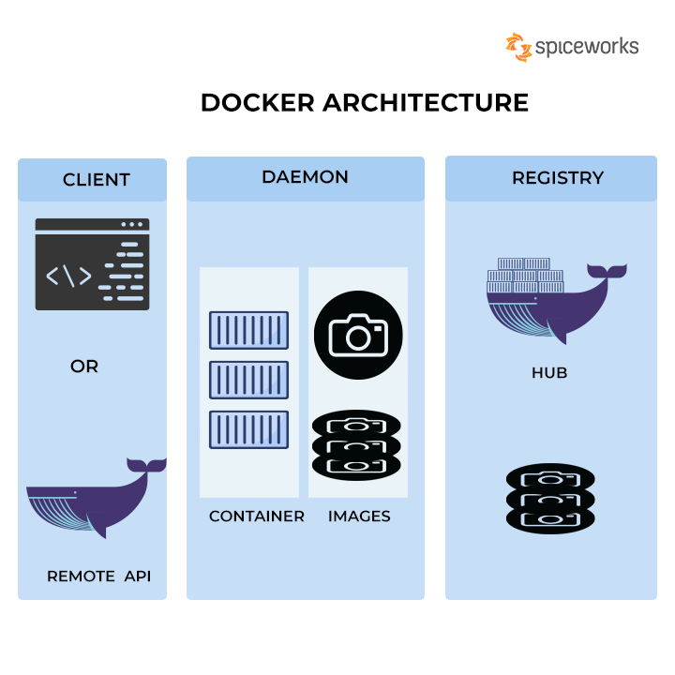
17. what is docker hub?
Ans: Docker Hub is a service provided by Docker for finding and sharing container images with your team.
18. what is docker image registry?
Ans: A Docker registry is a storage and distribution system for named Docker images. The same image might have multiple different versions, identified by their tags. A Docker registry is organized into Docker repositories , where a repository holds all the versions of a specific image.
19 how you delete file in git?
Ans: The easiest way to delete a file in your Git repository is to execute the “git rm” command and to specify the file to be deleted. Note that by using the “git rm” command, the file will also be deleted from the filesystem
20. how can you copy Jenkins from one server to another server?
- Ans: Install a fresh Jenkins instance on the new server
- Be sure the old and the new Jenkins instances are stopped
- Archive all the content of the JENKINS_HOME of the old Jenkins instance
- Extract the archive into the new JENKINS_HOME directory
- Launch the new Jenkins instance
- Do not forget to change documentation/links to your new instance of Jenkins :)
- Do not forget to change the owner of the new Jenkins files : chown -R jenkins:jenkins $JENKINS_HOME

21. how you do Jenkins pipeline job in your environment?
22. how you check free space in linux?
Ans: df-Ah
Df -ak
Df -am
24. how you delete a file in linux?
Ans: $rm filename

NTT DATA:
25.what is git rebase? Difference between git rebased and.. git merge?
Git merge is a command that allows you to merge branches from Git.
Merging is a common practice for developers. Whether branches are created for testing, bug fixes, or other reasons, merging commits changes to another branch. It takes the contents of a source branch and integrates it with a target branch.
Git rebase is a command that allows developers to integrate changes from one branch to another.
Git rebase compresses all the changes into a single “patch.” Then it integrates the patch onto the target branch. Unlike merging, rebasing flattens history. It transfers the completed work from one branch to another. In the process, unwanted history is eliminated.
Advocates of Git rebase like it because it simplifies their review process.

26.difference between ansible playbooks and roles?
Ans: Playbooks and roles are similar. Different at the same time. A playbook is a standalone file that Ansible can run that contains all of the information required to set a machine's state to what you expect. A playbook can contain variables, tasks, handlers, roles, and even other playbooks, all in the same file

27.how can u connect corporate data centre through aws?
Ans:- AWS Direct Connect enables you to securely connect your AWS environment to your on-premises data centre or office location over a standard 1Gb or 10Gb Ethernet fibre-optic connection. AWS Direct Connect offers dedicated high speed, low latency connection, which bypasses internet service providers in your network path.
28. what is IAM user in aws?
29. what is cmd and entrypoint in aws?
30.types of pipelines?
Ans: Declarative, Scripted.
31. artifact archive in Jenkins?
Ans: Archive the artifacts. Archives the build artifacts (for example, distribution zip files or jar files) so that they can be downloaded later. Archived files will be accessible from the Jenkins webpage.
JENKINS_HOME directory
By default, Jenkins archives artifacts generated by the build. These artifacts are stored in the JENKINS_HOME directory with all other elements such as job configuration files.

32. difference between docker image and layer?
Ans: Each layer is an image itself, just one without a human-assigned tag. They have auto-generated IDs though. Each layer stores the changes compared to the image it's based on. An image can consist of a single layer (that's often the case when the squash command was used).

33. difference between git rebase and git merge?
Ans: 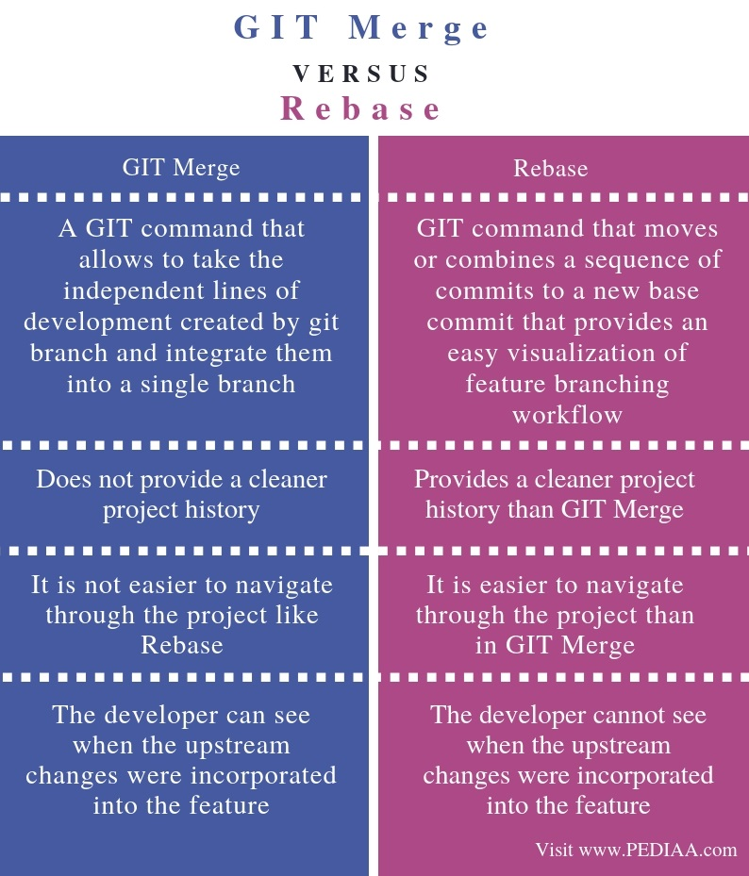
34. what is devops?
35. what is devops life cycle?
36. what are branching strategies in git?
37. types of Jenkins pipelins?
38. how to trigger pipeline?

Ans: Prerequisites
- Set up Jenkins as a continuous integration system in your Spinnaker deployment.
- Enable artifact support .

Adding a Jenkins trigger
- Create a pipeline .
- In the Configuration stage of your new pipeline, add a trigger .
- Select Jenkins from the Type menu, which brings up the following screen:
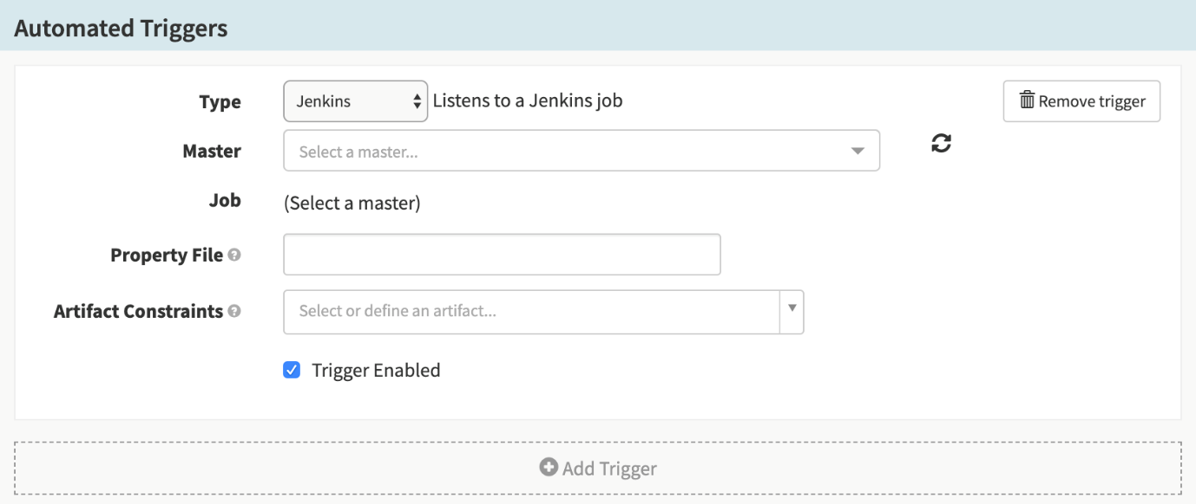
- Select a Jenkins master from the Master drop-down menu, then select a job from the Job drop-down.
- Add a property file, if desired. See the property files section of the Pipeline Expression Guide for more information about how to specify and use property files.

Build Artifacts

39. handlers in Ansible?
40. how you give security credentials in jenkins?
Ans: From the Jenkins home page (i.e. the Dashboard of the Jenkins classic UI), click Manage Jenkins > Manage Credentials. Under Stores scoped to Jenkins on the right, click on Jenkins. Under System, click the Global credentials (unrestricted) link to access this default domain. Click Add Credentials on the left.
Matrix based Security
41. what are tags in git?
42.difference between devops and agile?
Parru internal interview questions:
1.did you wrote any scripting in Jenkins?
Ans:shell scripting
2.there is a code .. and a change come in code now job should execute..? how wil you establish this?
3. any variable should run common in whole script?
4. u should create new agent?and attach new machine to our Jenkins?
5. how will you give permissions to user in Jenkins?
6. in a directory we should find out one particular word and how many times it is repeated?
7. git webhooks, API calls, get, post etc, and phython?
8. scenario there are two pipelines one pipeline is should always run only after first pipeline is passing?
9.how to put if condition
10. how to no of files count in a directory?
11.how to list of files in a directory?
12. how to create a file in a directory?
13. what is shared library?
14. we should access a file in one location in linux using python language in Jenkins?
15. how you take process list in linux?
16. what is grep command, awk and sed , find commands?
17 what is ps -ef command in linux?
18. What is api?
19. What is docker swarm?
Docker swarm is a container orchestration tool, meaning that it allows the user to manage multiple containers deployed across multiple host machines. One of the key benefits associated with the operation of a docker swarm is the high level of availability offered for applications.
20.what is docker compose?

