**Module 1 Activity 1: Installation of Tools (Integrated Development Environment)**

**Submitted By: Praveen Kumar Siddela**

**IFT 458 & IFT 554: Middleware Programming & Database Security**

**Dinesh Sthapit**

**Due Date: 01/21/2024**

1. **Visual Studio Code Installation Proof:**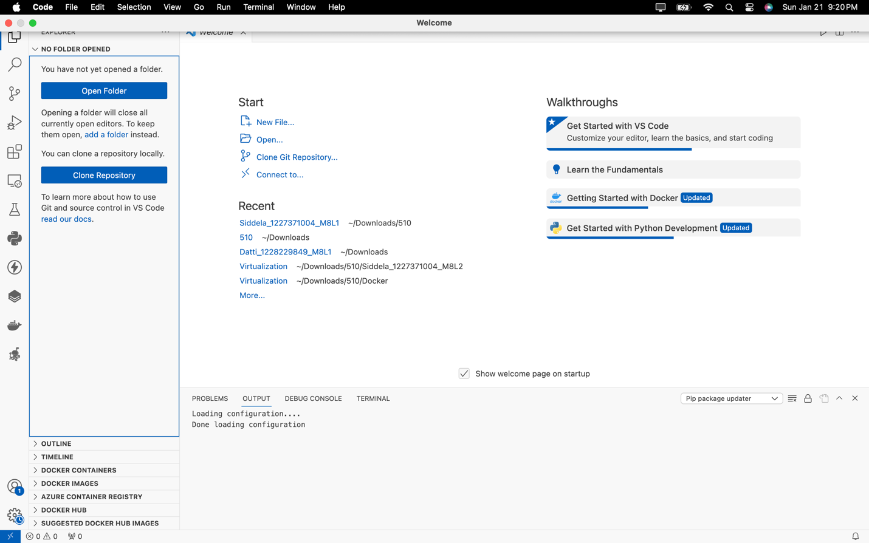
2. **Node.js Installation Proof:**

