# Module 1 Activity 2: Project Setup

**Submitted By: Praveen Kumar Siddela**

**IFT 458 & IFT 554: Middleware Programming & Database Security**

**Dinesh Sthapit**

**Due Date: 01/21/2024**

**Screenshot 1:**

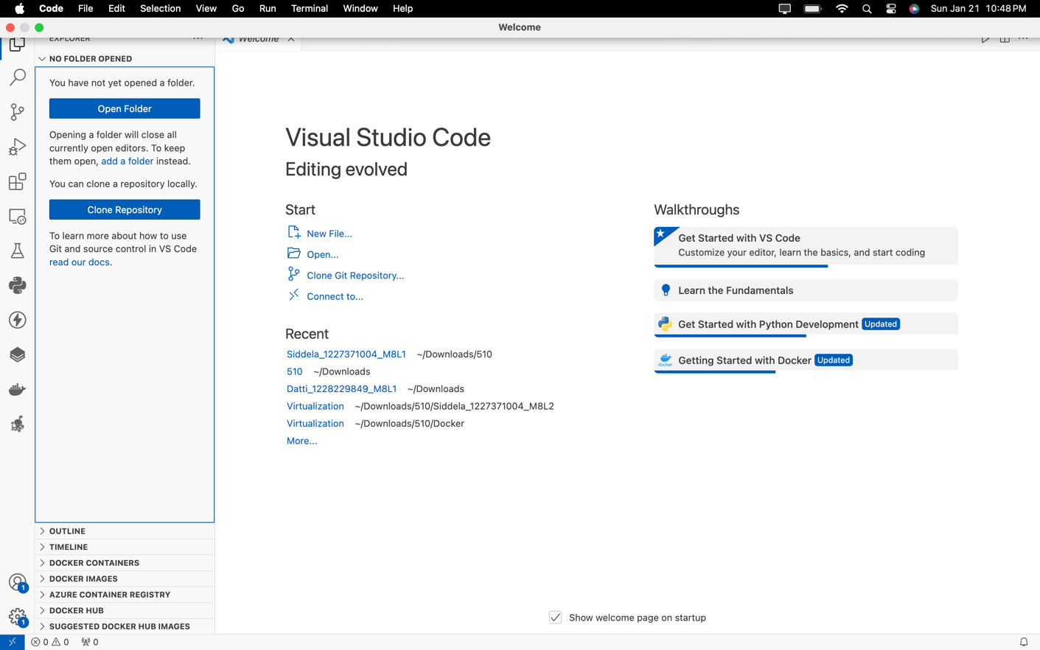

**Screenshot 2:**

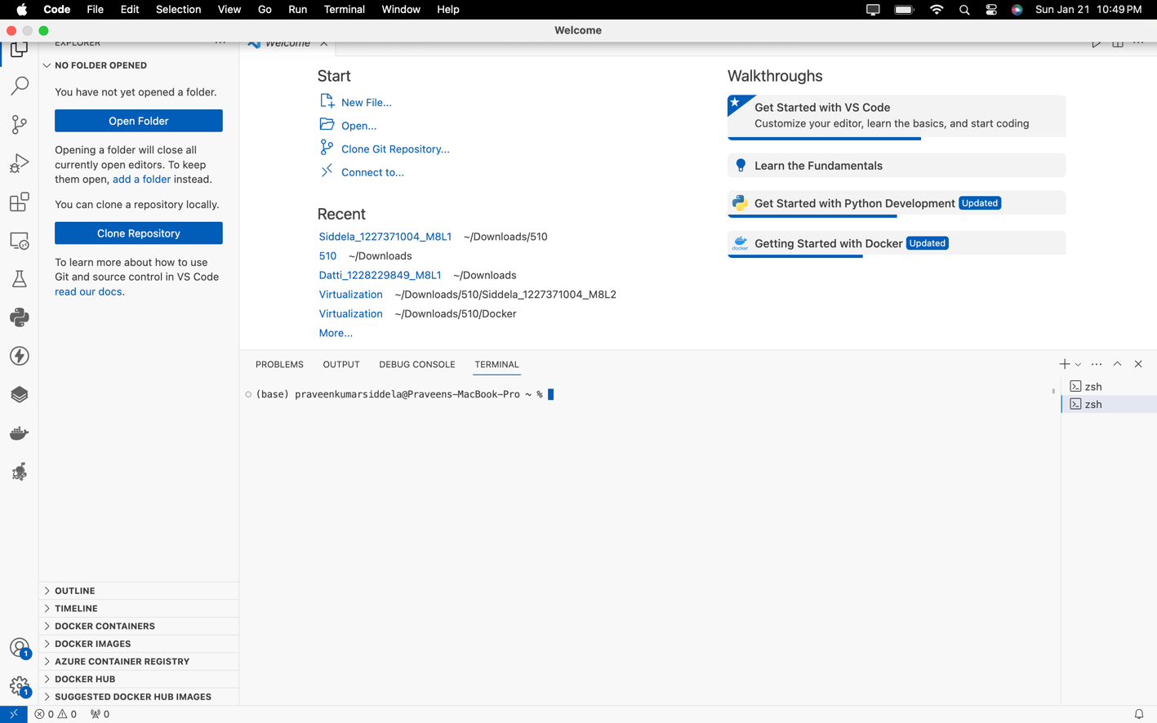

**Screenshot 3:**

**Screenshot 4:**

**Screenshot 5:**

**Screenshot 6:**

**Screenshot 7:**

**Screenshot 8:**

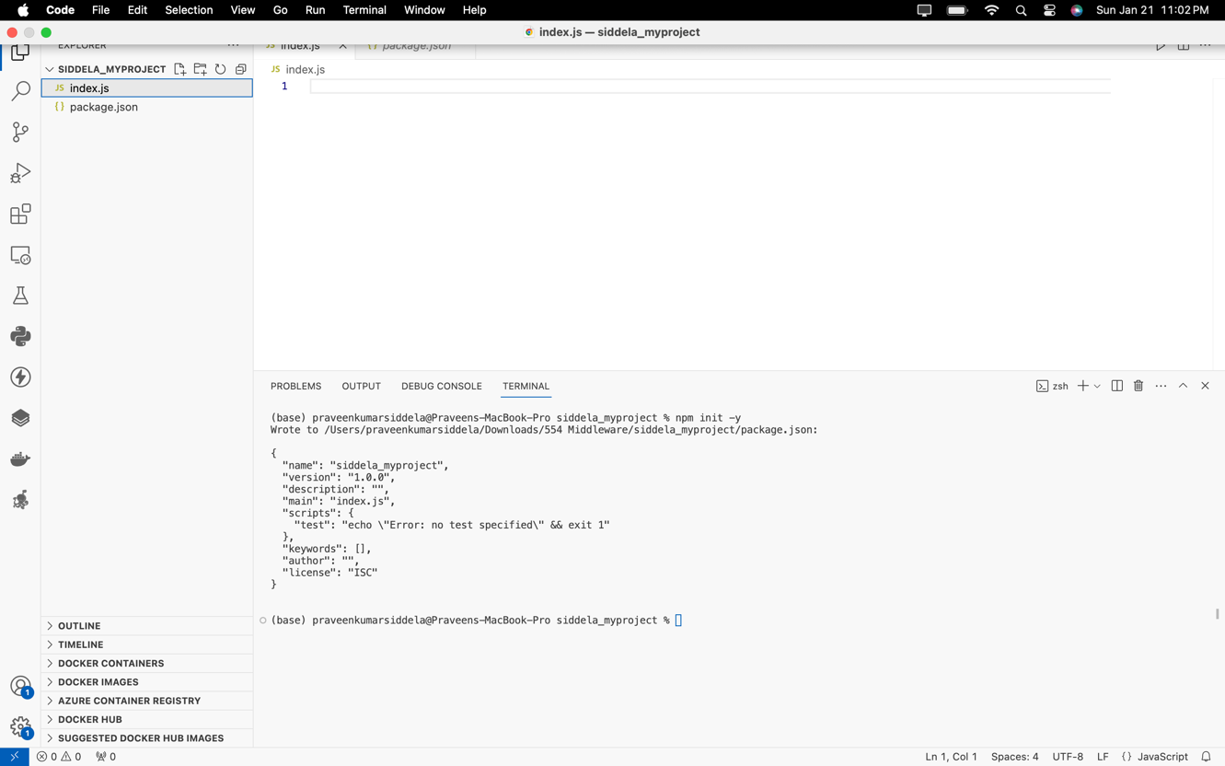

**Screenshot 9:**

**Screenshot 10:**

**Screenshot 11:**

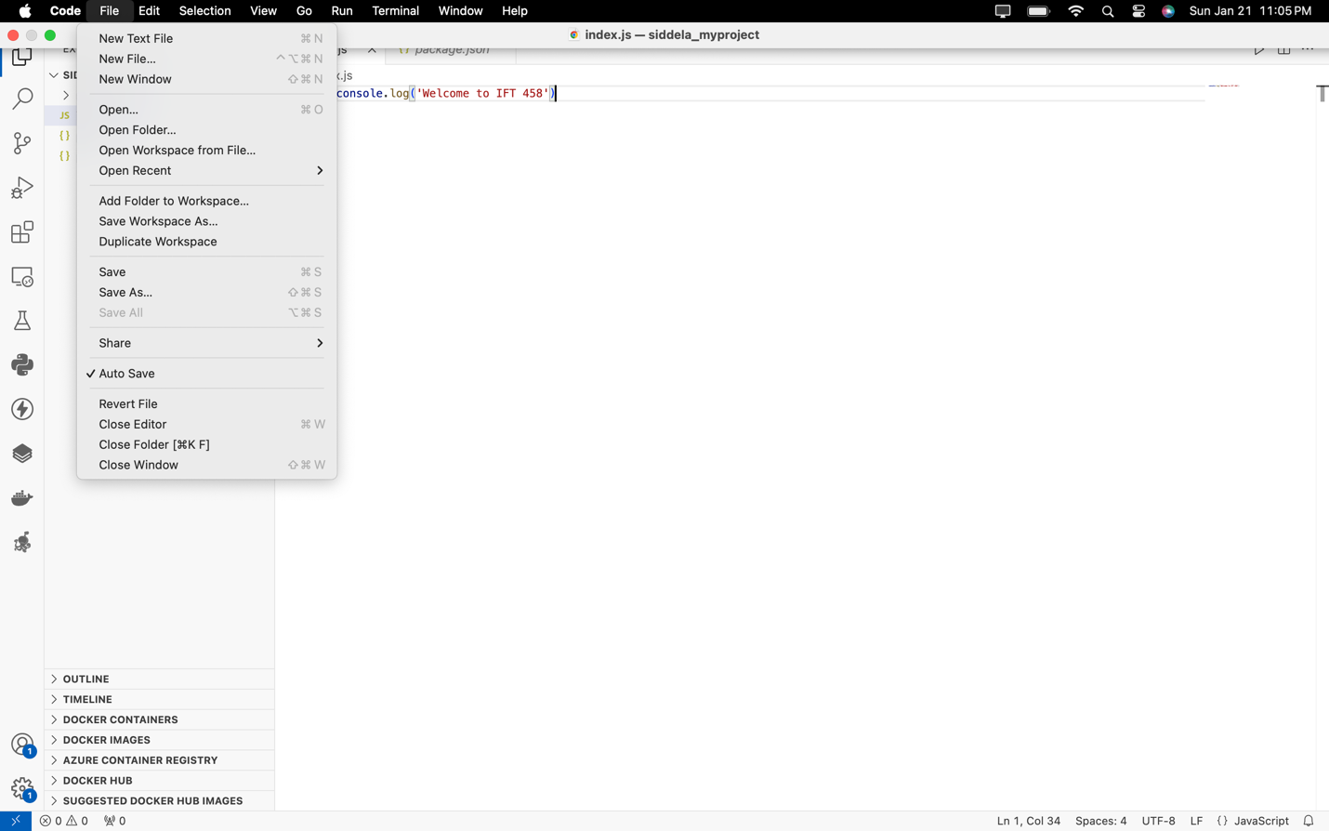

**Screenshot 12:**

