# Module 1 Lab 1: JavaScript Hello World

**Submitted By: Praveen Kumar Siddela**

**IFT 458 & IFT 554: Middleware Programming & Database Security**

**Dinesh Sthapit**

**Due Date: 01/21/2024**

**Screenshot 1:**

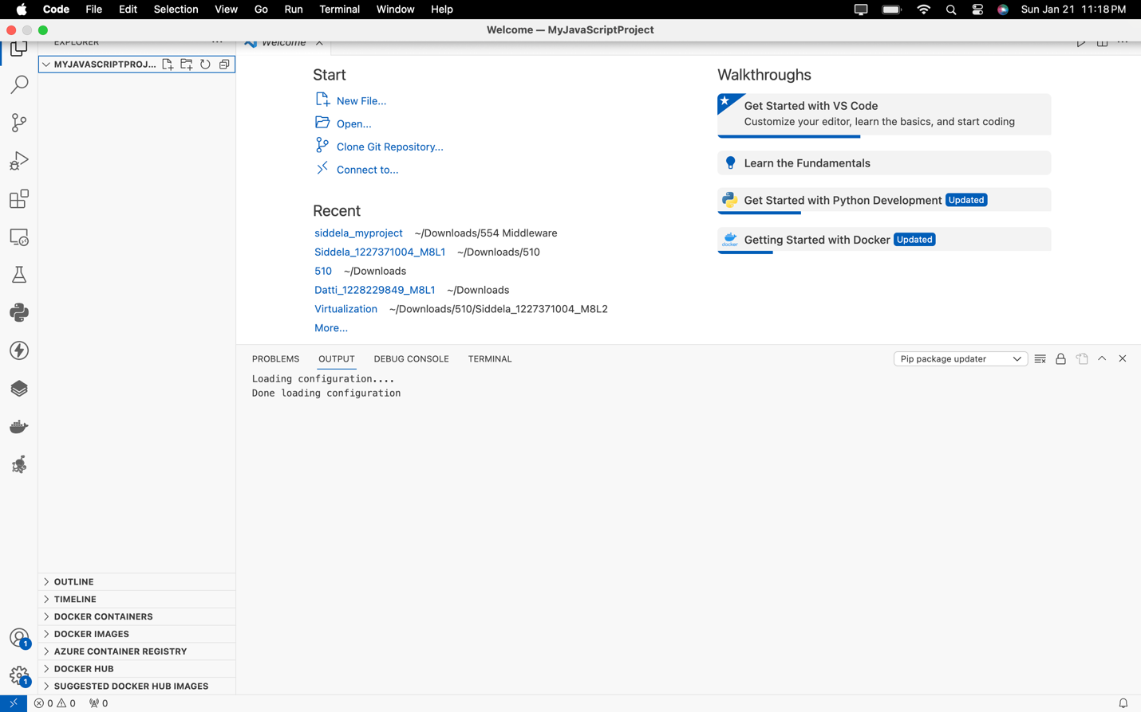

**Screenshot 2:**

**Screenshot 3:**

**Screenshot 4:**

**Screenshot 5:**

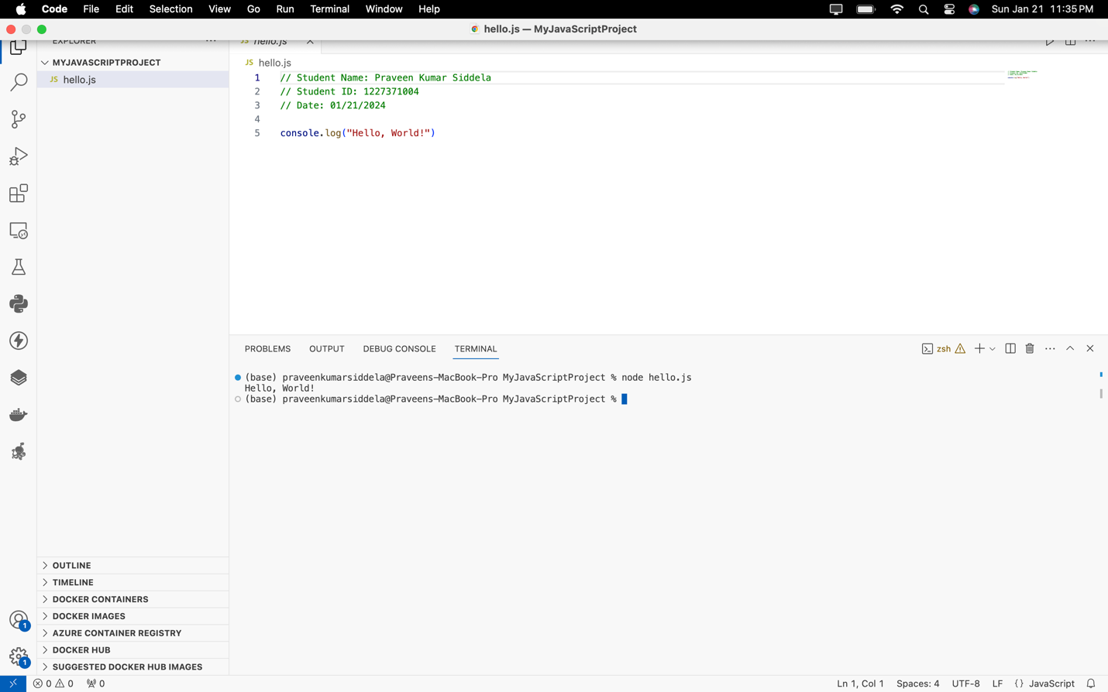

**Screenshot 6:**

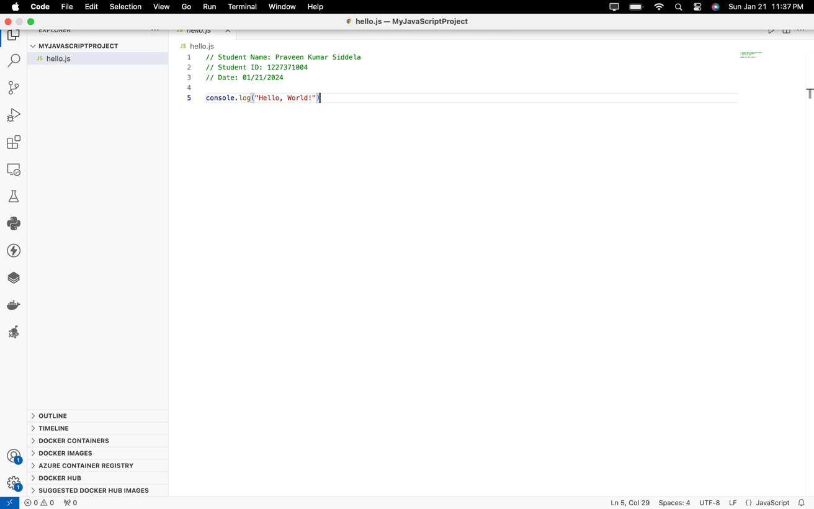

**Screenshot 7:**

